Customer Segmentation using Machine Learning
A machine learning project that segments retail customers using RFM analysis and compares multiple clustering algorithms.

Project Overview
Customer segmentation groups customers with similar purchasing behaviour to support marketing and business decisions. This project uses the Online Retail dataset, performs data cleaning, creates RFM (Recency, Frequency, Monetary) features, and applies unsupervised learning algorithms to discover meaningful customer groups.

Objectives
- Clean and preprocess transactional data.
- Create customer-level RFM features.
- Standardize features before clustering.
- Train and compare K-Means, DBSCAN and Gaussian Mixture models.
- Visualize clusters and summarize business insights.

Dataset
The project uses the Online Retail dataset containing over 541,000 retail transactions from a UK-based online retailer between 2010 and 2011.

Technologies Used
- Python
- Google Colab
- Pandas
- NumPy
- Matplotlib
- Seaborn
- Scikit-learn
- OpenPyXL

Project Workflow
- Load the Online Retail dataset.
- Clean missing values, duplicates and invalid transactions.
- Perform RFM feature engineering.
- Scale features using StandardScaler.
- Determine the optimal number of clusters with the Elbow Method.
- Train K-Means, DBSCAN and Gaussian Mixture models.
- Evaluate clustering performance.
- Interpret clusters and generate business insights.

Machine Learning Models
K-Means was selected as the primary clustering algorithm and compared against DBSCAN and Gaussian Mixture Models using clustering evaluation metrics.

Evaluation Metrics
Models were evaluated using the Silhouette Score, Davies–Bouldin Index and Calinski–Harabasz Index. Based on these metrics, the best-performing model was selected for customer segmentation.

Visualizations
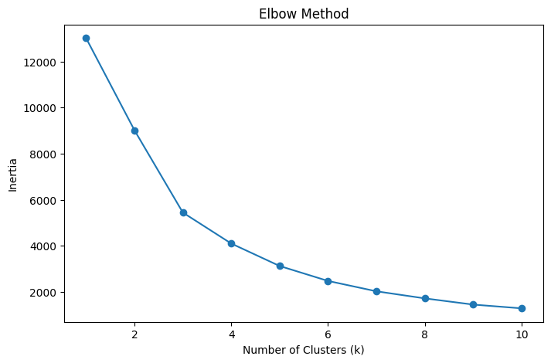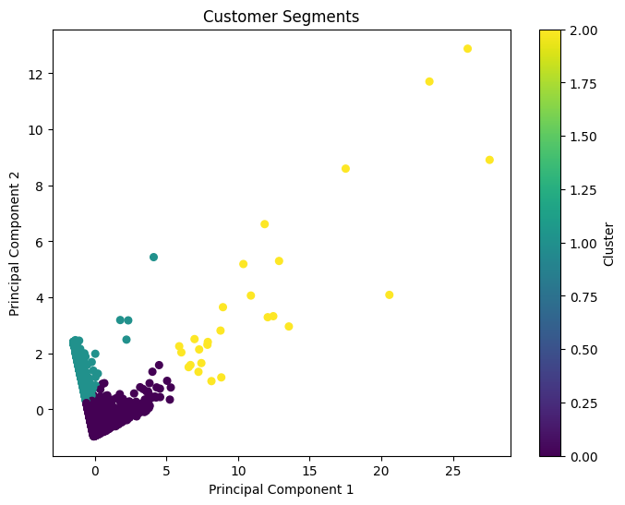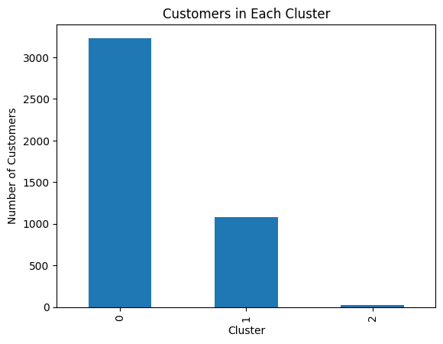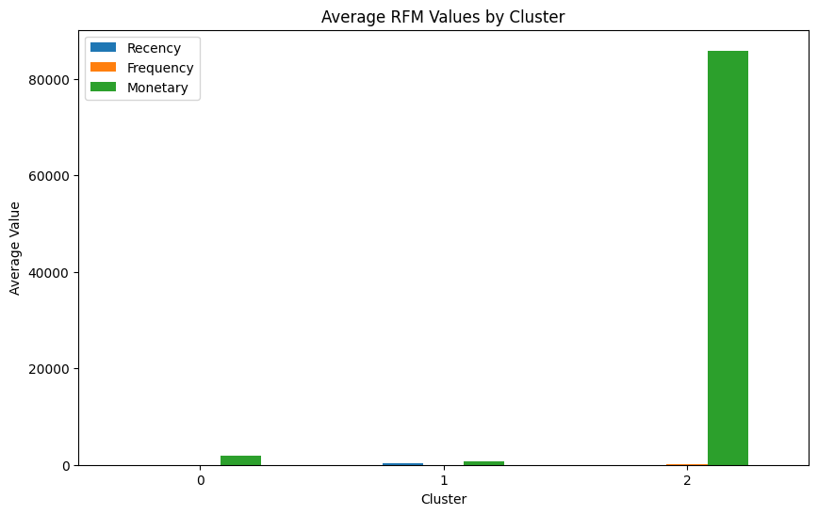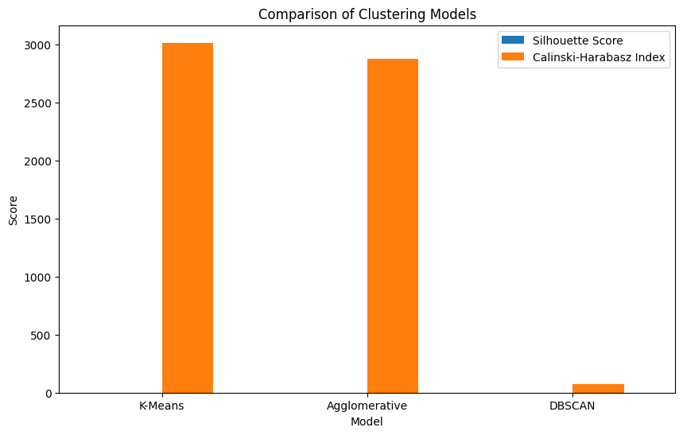

Business Insights
- Identify high-value loyal customers.
- Identify frequent but low-spending customers.
- Identify customers at risk of churn.
- Support personalized marketing campaigns and retention strategies.

Project Structure
customer-segmentation-ml/
├── data/
├── Images/
├── Notebook/
├── README.md
├── requirements.txt
└── LICENSE

How to Run
1. Clone the repository.
2. Install the required Python packages.
3. Open the notebook in Google Colab or Jupyter.
4. Place the dataset in the data folder.
5. Run all notebook cells to reproduce the analysis.

Future Improvements
- Hyperparameter tuning.
- Additional clustering algorithms.
- Interactive dashboards.
- Deployment as a web application.

Conclusion
This project demonstrates an end-to-end machine learning workflow for customer segmentation, from data preprocessing and feature engineering to clustering, evaluation and business interpretation.

Author
Name: Sree Vardhan Pottigari
Institution: Mahindra University
Year: 2026

