Machine Learning and Deep Learning Approaches for Fake News Detection A Systematic Review of Techniques Challenges and Advancements

Abstract
In response to the escalating threat of fake news on social media, this systematic literature review analyzes the recent advancements in machine learning and deep learning approaches for automated detection. Following the PRISMA guidelines, we examined 90 peer-reviewed studies published between 2020 and 2024 to evaluate the model effectiveness, identify limitations, and highlight emerging trends. Our analysis shows that deep learning models, particularly transformer-based architectures such as BERT, consistently outperform traditional machine learning methods, often achieving a high accuracy (Acc), precision (P), recall (R), and F1-score (F1). For instance, a BERT-based model reported up to 99.9% accuracy on the Kaggle fake news dataset and above 98% accuracy on other public datasets, including ISOT, Fake-orReal, and D3. Similarly, the GANM model demonstrated robust performance on the FakeNewsNet dataset by integrating text and social features. Transfer learning and multimodal models that incorporate user behaviour and network information significantly improve detection in diverse, low-resource environments. However, challenges persist in terms of the dataset quality, model interpretability, domain generalisability, and realtime deployment. This review also underscores the limited adoption of few-shot and zero-shot learning techniques, highlighting a promising direction for future research on handling emerging misinformation using minimal training data. To support practical deployment, we advocate the development of explainable, multilingual, and lightweight models with greater emphasis on human-centred evaluation and ethical considerations. Our findings provide a foundation for researchers and practitioners to build scalable, trustworthy, and context-aware fake news detection systems for global use.
Existing System and Disadvantages
Existing fake news detection systems mainly rely on traditional machine learning methods or early deep learning models that focus only on textual features. While they achieve reasonable accuracy on certain datasets, they often struggle to adapt to new domains, lack interpretability, and fail in low-resource or real-time environments. Additionally, few current models incorporate user behavior, social network information, or multilingual capabilities, limiting their effectiveness on global social media platforms.
- Lack of Scalability: Manual fact-checking and human analysis are not scalable to the massive volume of information generated on social media platforms.
- Time-Consuming: The process of manually verifying news is slow, allowing fake news to spread widely before it can be debunked.
- Bias and Subjectivity: Human fact-checkers can be subject to their own biases, which may affect the objectivity of their conclusions.
- Ineffectiveness against Sophisticated Fakes: Modern fake news is often crafted to be highly believable, making it difficult for humans to identify without extensive research.
Proposed System and Advantages
The proposed system leverages advanced deep learning approaches, especially transformer-based models like BERT, along with multimodal methods that combine text, social features, and user behavior data for robust fake news detection. It also promotes the use of transfer learning, few-shot and zero-shot learning to handle emerging misinformation with minimal labeled data. Designed to be explainable, multilingual, and lightweight, this system aims to deliver scalable, accurate, and trustworthy real-time fake news detection for diverse global social media environments.
- Advanced NLP Techniques: The system will utilize sophisticated NLP techniques to analyze various linguistic and stylistic features of text, such as sentiment, grammar, and emotional tone, to identify markers of fake news.
- Hybrid ML/DL Approach: The system will explore a hybrid approach that integrates traditional machine learning classifiers (e.g., Support Vector Machines) with deep learning models (e.g., Recurrent Neural Networks and Convolutional Neural Networks) for enhanced performance.
- High Accuracy and Speed: The automated system can analyze vast amounts of data in real-time, providing rapid and accurate detection of fake news, thereby mitigating its spread.
- Scalability: The model is designed to be highly scalable, capable of handling the high-velocity, high-volume data streams typical of social media.
System Architecture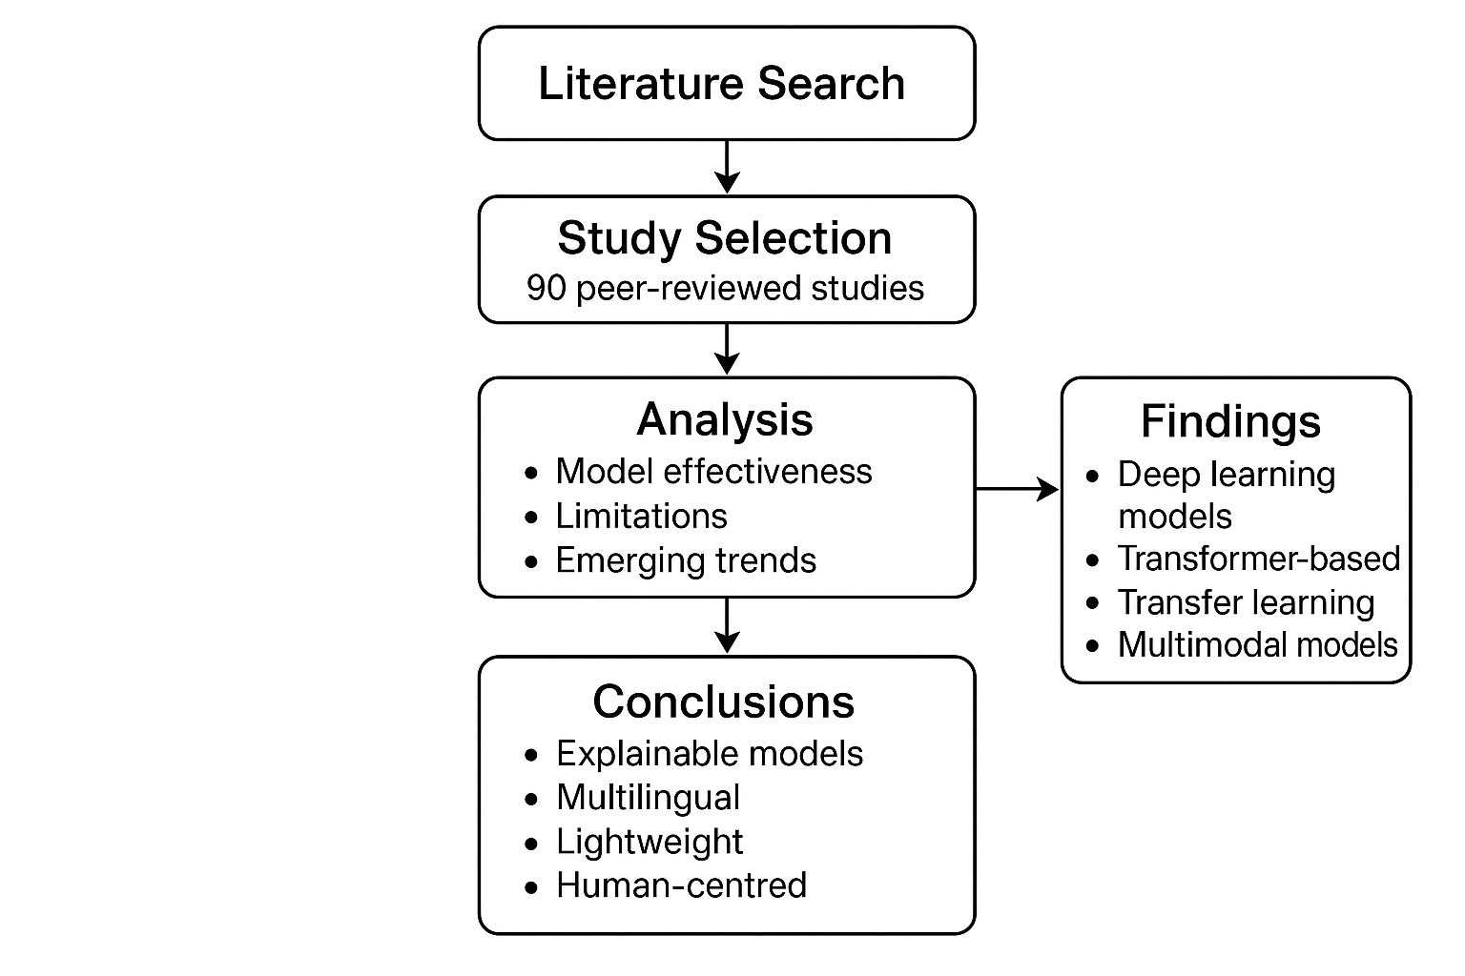
Module Description
The system will consist of the following modules:
- Web Scraping Module:
  - Connects to news websites and social media platforms to collect data.
- NLP Processing Module:
  - Handles all text pre-processing and feature extraction tasks.
- Modeling Module:
  - Contains the implementation of various ML and DL models.
  - Manages the training and prediction workflows.
- Database Module:
  - A database to store news articles, their classifications, and model training data.
- API and UI Module:
  - Provides the interface for users to interact with the system and a dashboard for monitoring performance.
Hardware and Software Requirements
Hardware Requirements:
- Processor: A multi-core processor is crucial for parallel processing of text data.
- GPU: A dedicated GPU is highly recommended for training deep learning models, which are computationally intensive.
- RAM: A minimum of 16 GB of RAM is needed to handle large-scale text datasets.
- Storage: An SSD is recommended for faster data read/write operations.
Software Requirements:
- Operating System: Windows, macOS, or Linux.
- Programming Language: Python.
- Libraries and Frameworks:
  - Data Manipulation: Pandas and NumPy.
  - NLP: NLTK, spaCy.
  - Machine Learning: Scikit-learn.
  - Deep Learning: TensorFlow or PyTorch.
  - Web Framework: Flask or Django for the web interface.

Functional Requirements
User Module Functional Requirements
1.1 Account Management
- 1.1.1 User registration with email/social login.
- 1.1.2 User login and logout functionality.
- 1.1.3 Password reset and profile management.
1.2 News Submission & Verification
- 1.2.1 Users can submit articles, URLs, or text content for verification.
- 1.2.2 The system provides real-time analysis of news content using AI/ML models.
- 1.2.3 Users receive detailed reports on whether the news is likely fake or real (with probability scores).
1.3 Feedback & Reporting
- 1.3.1 Users can provide feedback on system predictions (e.g., “correct” or “incorrect”).
- 1.3.2 Users can report suspicious content or misclassified news.
1.4 Dashboard & Analytics
- 1.4.1 Display history of user-submitted news and system predictions.
- 1.4.2 Visualization of trends (e.g., types of fake news detected, topics, and sources).
- 1.4.3 Notifications for newly verified fake news matching user interests or subscriptions.
1.5 Explainability
- 1.5.1 Highlight which parts of the news content contributed to the prediction (keywords, sentiment, sources).
- 1.5.2 Provide confidence scores and reasoning in user-friendly language.

2. Admin Module Functional Requirements
2.1 User Management
- 2.1.1 View, edit, suspend, or delete user accounts.
- 2.1.2 Assign roles and permissions (e.g., moderator, analyst).
2.2 Dataset & Model Management
- 2.2.1 Upload, manage, and update datasets for training and testing AI models.
- 2.2.2 Train, fine-tune, or deploy new ML/DL models (e.g., BERT, GANM, multimodal).
- 2.2.3 Monitor model performance metrics (accuracy, precision, recall, F1-score).
2.3 Content Monitoring & Moderation
- 2.3.1 View and verify user-submitted news.
- 2.3.2 Approve or reject content flagged as suspicious.
- 2.3.3 Moderate feedback and reports from users.
2.4 System Analytics & Reporting
- 2.4.1 Track overall system usage, detection statistics, and trends.
- 2.4.2 Generate reports on false positives/negatives and model effectiveness.
- 2.4.3 Identify gaps in dataset coverage and suggest areas for model improvement.
2.5 Explainability & Audit
- 2.5.1 Review model decision rationale for transparency.
- 2.5.2 Audit AI predictions for ethical compliance and bias detection.
2.6 Maintenance & Security
- 2.6.1 Backup datasets, models, and logs.
- 2.6.2 Manage system access, roles, and security policies.
- 2.6.3 Monitor real-time system performance and uptime.

