GIT

Versioning Control System
- It maintains different versions of same document
- It provide to integrate all the changes done by different developers/authors
- It provide to revert the changes to previous version
- Say, Tortoise, CVS

Distributed Versioning Control system
- GIT

Git init | Initialize an empty or bare local repository
Git status | List the status of tracked and untracked files
Git add . | Adds in to staging
Git config –gloabal user.name <usrername> | Configuring user name
Git config --global user.email <emailed> | Configuring email id
Git commit –m <message> | It commit the changes in local repo
Git remote add origin <url> | It references the remote repo to local repo
Git push origin <branchname> | Pushes the changes from local repo to remote repo
Git pull –rebase origin <branch_name> | It get the latest changes and merges the code  Git fetch + git merge
Git branch | List all the branches
Git branch <branch name> | Create a new branch
Git switch <branch_name> | Switches to the branch
Git checkout branchname | Switches to the branch and also copies the code from current branch to witched branch
Git rebase --continue | This command is given only in conflict scenario  It rebases the versions of remote repo to local repo

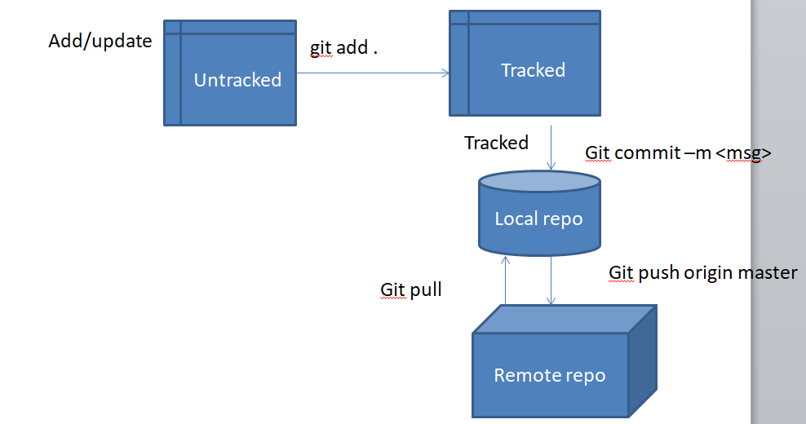

Creating a new Project and push it ito Remote repo
Step1
- create a Remote Repo in Git HUB
- Add Collabarotors

Step2:
- Create a folder say “emprepo” and go to Command prompt
- Initialize bare/empty local repository
- git init
Step 3
- Create a document or java project in “emprepo” folder
- Added a new package and new class
Step 4
- type git status
- make all untracked to tracked
  - git add <path>
  - git add . (all files under the current folder)
Step5
- find status , type git status
- For the very firt time configure your name and email
  - Git config –global user.name <username>
  - Git config –global user.email <email>
Step6
- Commit the changes to local repo
  - Git commit –m <message>
Step7
- reference the remote url to local repo
  - git remote add origin <url>
- Push the changes to remote repo
  - Git push origin master

Collbarotors have to work on the same project, They have to clone it
Clone the project from remote and do the changes and push it to remote repo
Step1
- Clone the project from remote repo
  - git clone <url>
- Make a duplicate copy of the project from remote repo in to local repo
- url is set as Origin automatically
- emprepo repository name
- EmpJdbcProject is under emprepo folder

Step2
- Goto eclipse and import the project by the local repo folder name, say “emprepo”

Step 3
- Create a new java class/ update the changes in any existing class
- Changed classes and new classes are untracked
- find status , type git status
- To make it to track
  - Git add .
Step 4
- find status , type git status
- For the very firt time configure your name and email
  - Git config –global user.name <username>
  - Git config –global user.email <email>
Step5
- Commit the changes to local repo
  - Git commit –m <message>
Step6
- Get the latest chages from remote repo
  - Git pull –rebase origin master
- Push the changes to remote repo, if theres is no conflict
  - git push origin master

Resolving conflicts
- When the latest version is having the changes in the same class and same line and the developer working in current version having the changes in same class and same line
- Conflict occurs when pulling the latest changes from remote repo

How to resolve conflict?
<<<<<<<< Head
display()
========
The above changes are from latest version

viewResults()
>>>>>>>4da13469
The changes are from current version
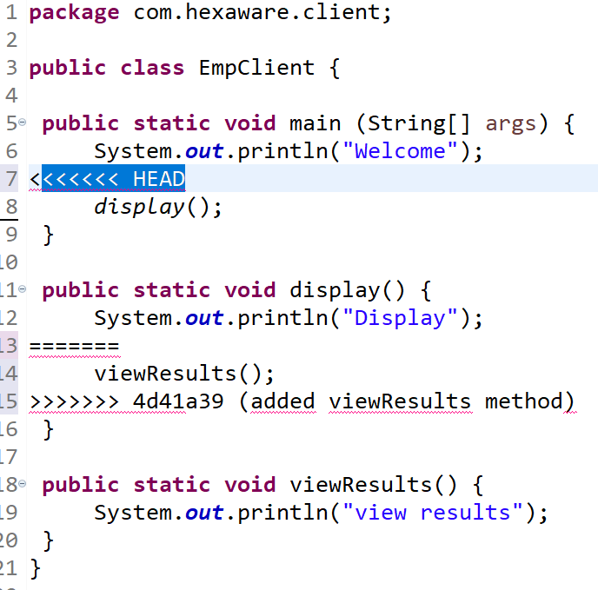

Decide which version have to keep it or require both the changes
Aftter doing the changes manually, save the files
Step1: add it to staging
git add .
Step 2: commit the changes to local repo
Git commit –m “msg”
Step3: Continue rebasing the versions from remote to local
git rebase –continue
Step 4: push the changes to Remote repo
git push origin master

Branching
Create a new branch in local
- git branch <branch_name>

Copy all the code from master branch to branch “branch1”
- be in master branch
- git checkout branch1
  - it will copy the code from master to branch1 and also switch to branch1
To list the branches and it will highlight the working branch
- git branch

To switch the branch
- git switch <branch_name>

When the sprint starts, They create a branch and checkout the code from master
Entire sprint will work in the branch
On successful completion, it is merged to master

Master branch
- will contain all the modules and latest code
Sub branch
- It will have only that sprint tasks

