**GLOBAL ENERGY TRENDS: A COMPREHENSIVE ANALYSIS OF KEY REGIONS AND GENERATION MODES USING POWER BI**

**INTRODUCTION**

Energy plays a vital role in various aspects of modern life, and its importance is expected to increase further as electric vehicles and heat pumps become more prevalent for transportation and heating. Although power generation currently accounts for a significant portion of global CO2 emissions, it is also leading the way in transitioning to net-zero emissions by rapidly adopting renewable energy sources like solar and wind power.

The energy landscape is undergoing a substantial transformation with a strong focus on sustainability and effectiveness. In this context, incorporating renewable energy sources and optimizing energy usage are crucial. Enhancing energy efficiency and integrating renewable generation are key elements in moving towards a more sustainable energy future. Utilizing data analysis techniques within the energy sector holds considerable promise for achieving these goals.

**Scenario 1:**

**Smart Grid Implementation in Urban Areas:**

 In a bustling urban city, the local government has embarked on a project to upgrade its energy infrastructure to meet the increasing demands sustainably. They have implemented a smart grid system that integrates renewable energy sources like solar and wind power into the existing grid. This system allows for more efficient distribution of electricity, minimizing energy loss during transmission. Moreover, smart meters installed in households provide real-time data on energy consumption, enabling residents to monitor and adjust their usage patterns. As a result, the city experiences reduced reliance on fossil fuels, lower CO2 emissions, and increased resilience to power outages.

**Scenario 2:**

**Industrial Energy Management in Manufacturing Plants:**

A large manufacturing plant recognizes the importance of optimizing energy usage to enhance its sustainability and cost-effectiveness. Leveraging data analysis techniques, the plant implements an advanced energy management system that monitors energy consumption across various processes in real-time. Through predictive analytics, the system identifies areas of inefficiency and suggests optimization strategies, such as scheduling production during off-peak hours or upgrading equipment to more energy-efficient models. Additionally, the plant integrates renewable energy sources like rooftop solar panels to offset its reliance on grid electricity further. This initiative not only reduces the plant's carbon footprint but also leads to substantial cost savings over time.

**Scenario 3:**

**Rural Electrification Project in Developing Countries**

In a remote rural community in a developing country, access to reliable electricity has been a longstanding challenge. To address this issue sustainably, a non-profit organization initiated a rural electrification project focused on utilizing renewable energy sources. They install solar microgrids to power homes, schools, and community centres, providing access to clean and affordable electricity for the first time. Data analytics are employed to optimize the operation of these microgrids, ensuring efficient energy distribution and minimal wastage. As a result, the community experiences significant improvements in living standards, with enhanced educational opportunities, better healthcare facilities, and economic empowerment through small-scale enterprises powered by electricity. This project serves as a model for sustainable development in similar rural areas worldwide, demonstrating the transformative potential of renewable energy and data-driven solutions.

**Technical Architecture:**

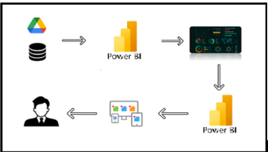

**PROJECT FLOW**

The activities listed below must be completed:

1. Data Collection

* Collect the dataset
* Connect Data to Tableau

2. Data Preparation

* Prepare the Data for Visualization

3. Data Visualizations

* Number of Unique Visualizations

4. Dashboard

* Response and Design of Dashboard

5. Report

* Report Creation

6. Performance Testing

* Utilization of Data Filters
* Number of Calculated Columns/Measures
* Number of Visualizations/Graphs

7. Project Demonstration & Documentation

* Record explanation Video for project end-to-end solution
* Project Documentation - Step by step project development procedure

**MILESTONE 1: DATA COLLECTION & EXTRACTION FROM DATABASE**

Data collection is the process of gathering and measuring information on variables of interest, in an established systematic fashion that enables one to answer stated research questions, test hypotheses, evaluate outcomes and generate insights from the data.

**Dataset**:<https://www.kaggle.com/datasets/jamesvandenberg/renewable-power-generation>

**Description of the Dataset:**

There are six data files that collectively form our dataset. The list of files is as follows:

1. Continent Consumption TWH

1. Year
2. World
3. OECD
4. BRICS
5. Europe
6. North America
7. Latin America
8. Asia
9. Pacific
10. Africa
11. Middle East
12. CIS

2. Country Consumption TWH

Columns in the dataset:

1. Year
2. China
3. United States
4. Brazil
5. Belgium
6. Czechia
7. France
8. Germany
9. Italy
10. Netherlands
11. Poland
12. Portugal
13. Romania
14. Spain
15. Sweden
16. United Kingdom
17. Norway
18. Turkey
19. Kazakhstan
20. Russia
21. Ukraine
22. Uzbekistan
23. Argentina
24. Canada
25. Chile
26. Colombia
27. Mexico
28. Venezuela
29. Indonesia
30. Japan
31. Malaysia
32. South Korea
33. Taiwan
34. Thailand
35. India
36. Australia
37. New Zealand
38. Algeria
39. Egypt
40. Nigeria
41. South Africa
42. Iran
43. Kuwait
44. Saudi Arabia
45. United Arab Emirates

3. Non-Renewable – Total Power Generation

Columns in the dataset:

1. Mode of Generation
2. Contribution (TWH)

4. Renewable – Total Power Generation

Columns in the dataset:

1. Mode of Generation
2. Contribution (TWH)

5. Renewable Power Generation 1997-2017

Columns in the dataset:

1. Year
2. Solar (TWH)
3. Biofuel (TWH)
4. Hydro (TWH)
5. Geothermal (TWH)

6. Top 20 Countries Power Generation

            Columns in the dataset:

1. Country
2. Solar PV (TWH)
3. Biofuel (TWH)
4. Hydro (TWH)
5. Geothermal (TWH)
6. Total (TWH)

**MILESTONE 2: DATA PREPARATION**

Preparing the data for visualization involves cleaning the data to remove irrelevant or missing data, transforming the data into a format that can be easily visualized, exploring the data to identify patterns and trends, filtering the data to focus on specific subsets of data, preparing the data for visualization software, and ensuring that the data is accurate and complete.

**DATA TRANSFORMATION**

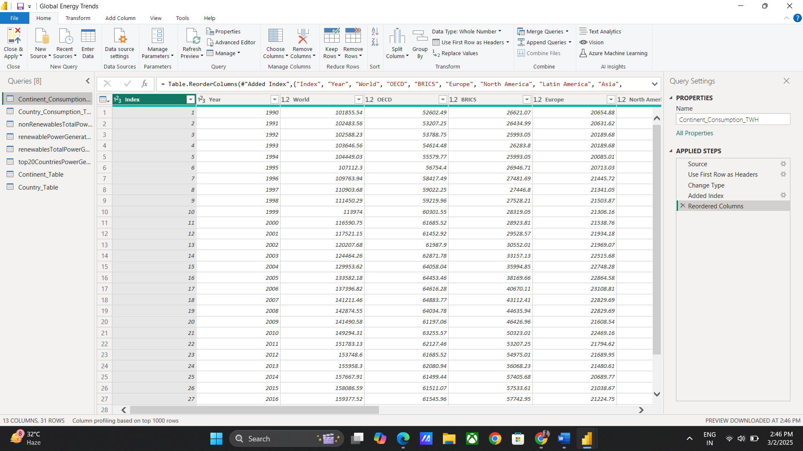

**MILESTONE 3: DATA VISUALIZATION**

Data visualization is the process of creating graphical representations of data to help people understand information. The goal of data visualization is to make complex data sets more accessible, intuitive, and easier to interpret. By using visual elements such as charts, graphs, and maps, data visualization can help people identify patterns, trends, and outliers quickly in the data.

**Number of unique visualizations**

The number of unique visualizations that can be created with a given dataset. Some common types of visualizations that can be used to analyse include bar charts, line charts, heat maps, scatter plots, pie charts, maps, etc. These visualizations can be used to compare, and track changes over time, show distribution, relationships between variables, breakdown of one category, and much more.

**Country wise consumption**

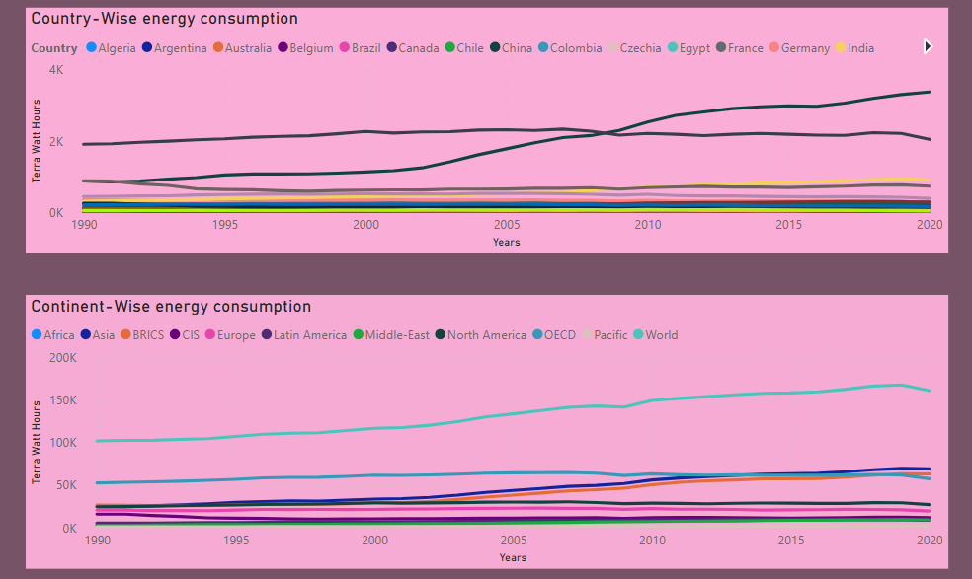

**Continent Consumption**



**Continent Average**

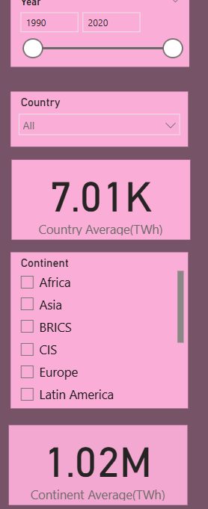

**Country Average**



**Non-Renewable Sources**

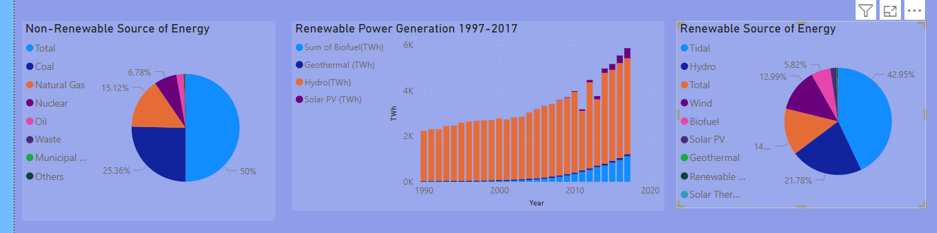

**Renewable Generation 1997-2017**

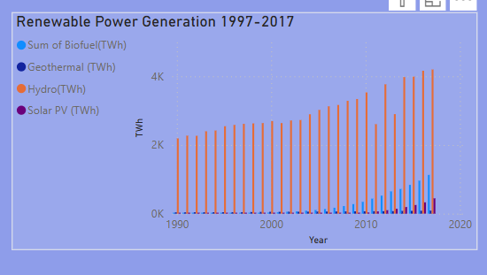

**Cards- Sum, Median, Standard Deviation and Variance of Contribution**

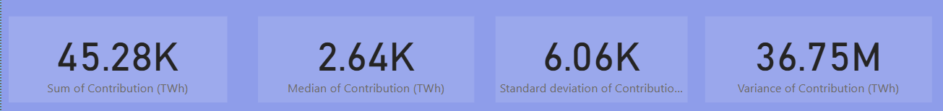

**Renewable Sources**



**Cards - Geothermal, Biofuel, Hydro and Solar PV**

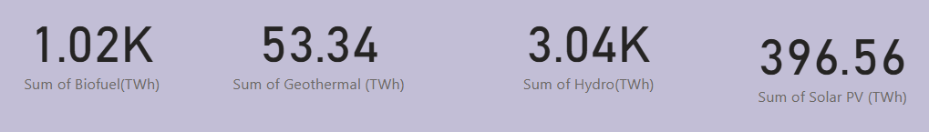

**Report Narrative**

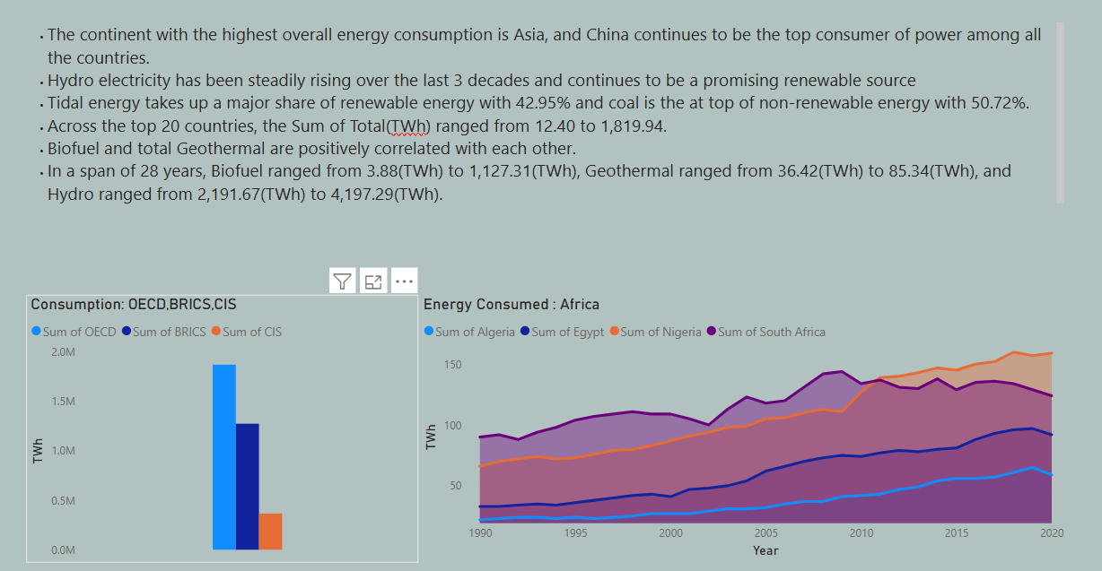

**BRICS, OECD and CIS**

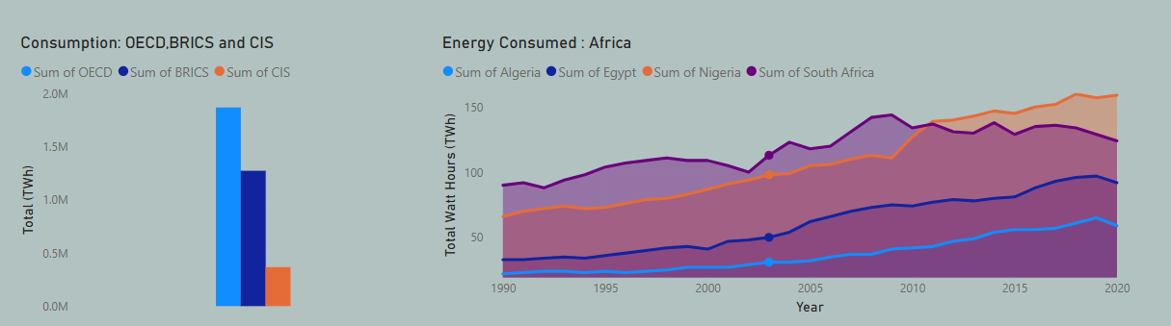

**Energy Consumption in Africa**

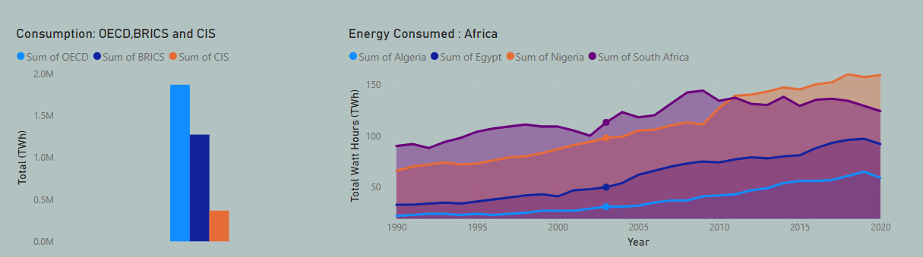

**MILESTONE 4: DASHBOARD**

A dashboard is a graphical user interface (GUI) that displays information and data in an organized and easy-to-read format. Dashboards are often used to provide real-time monitoring and analysis of data. They are typically designed for a specific purpose or use case. Dashboards can be used in a variety of settings, such as business, finance, manufacturing, healthcare, and many other industries. They can be used to track key performance indicators (KPIs), monitor performance metrics, and display data in the form of charts, graphs, and tables.

**RESPONSIVE AND DESIGN OF DASHBOARD**

**Global Energy consumption Over Time**

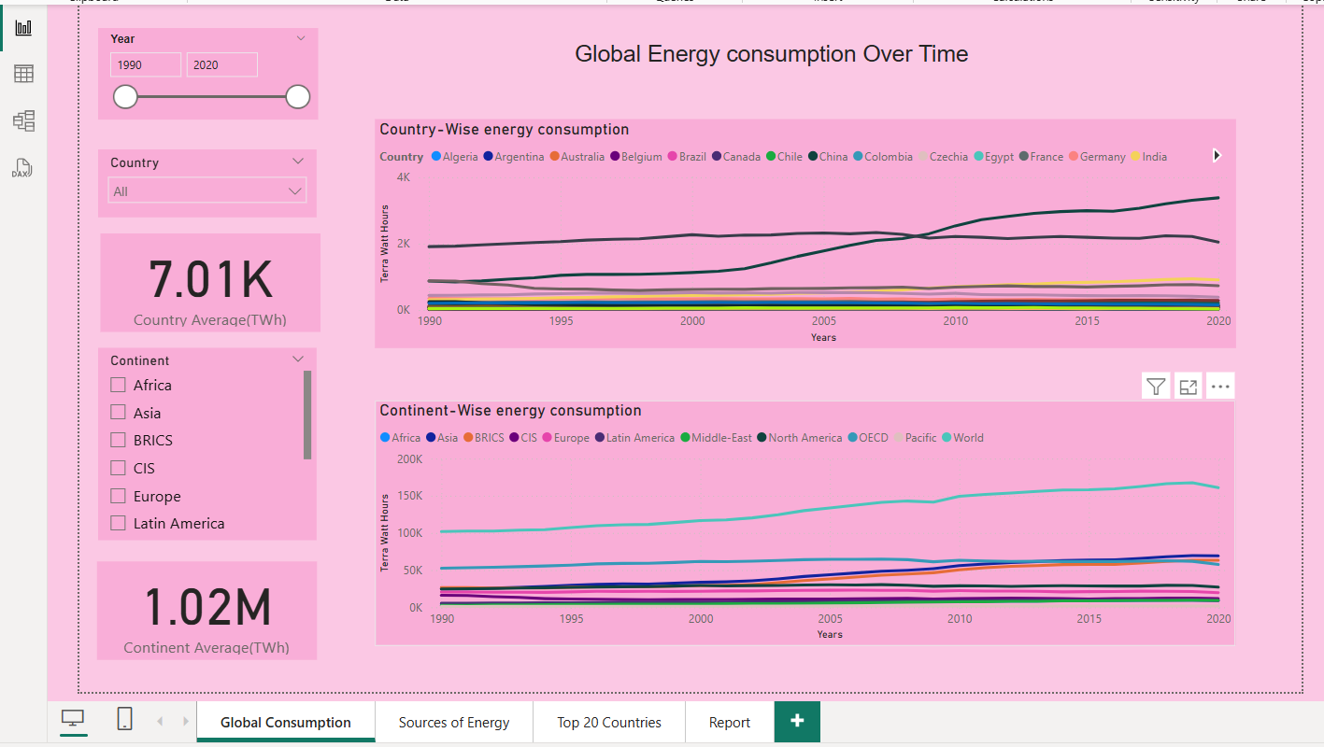

**Energy Production: Sources**

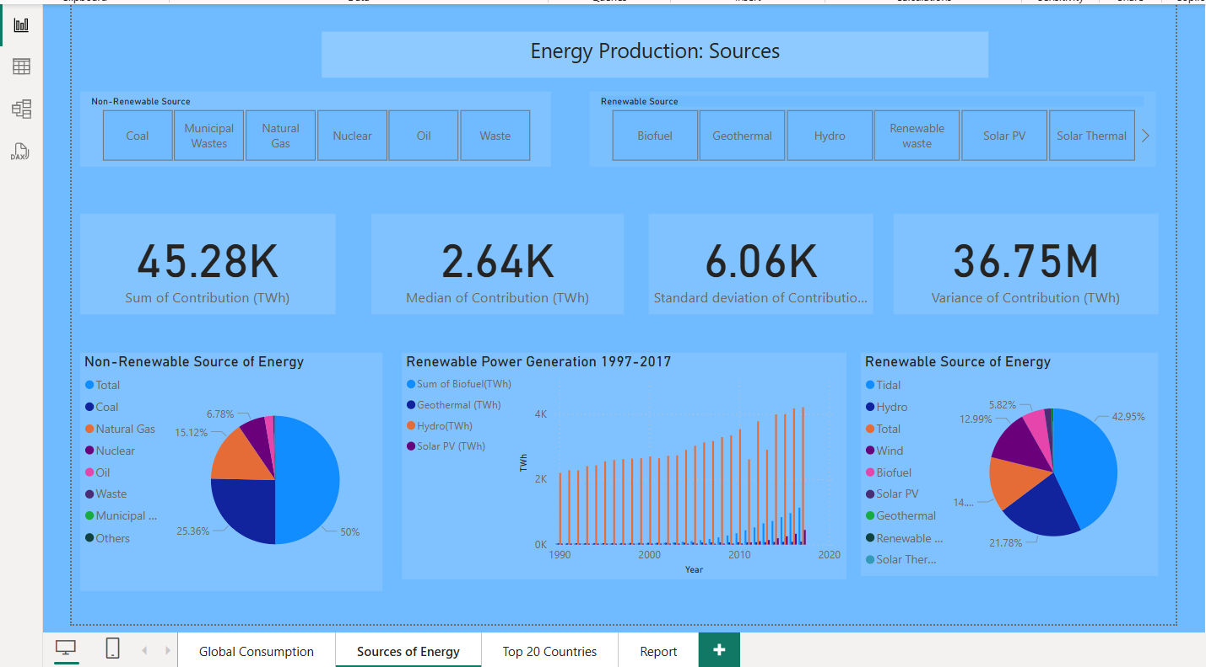

**Power Generation: Top 20 Countries**

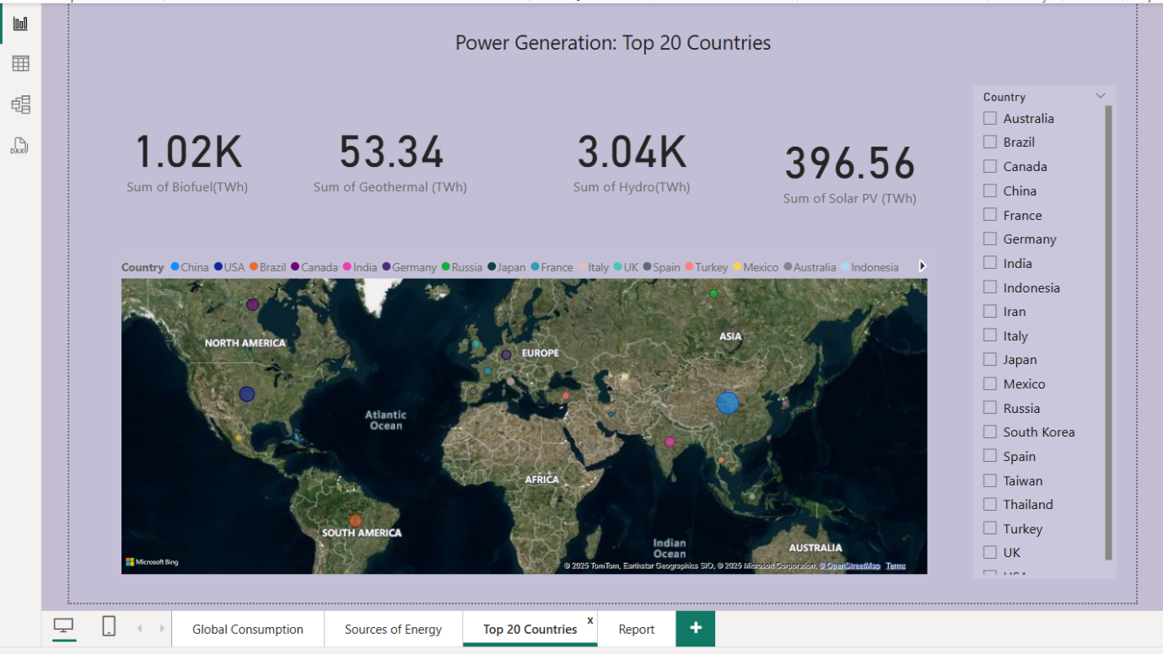

**MILESTONE 5: REPORT**

A report is a way of presenting data and analysis in a narrative format, with the goal of making information more engaging and easier to understand. It typically includes a clear introduction that sets the stage and explains the context for the data, a body that presents the data and analysis in a logical and systematic way, and a conclusion that summarizes the key findings and highlights their implications. Data stories can be told using a variety of media, such as reports, presentations, interactive visualizations, and videos.

**Design of Report**

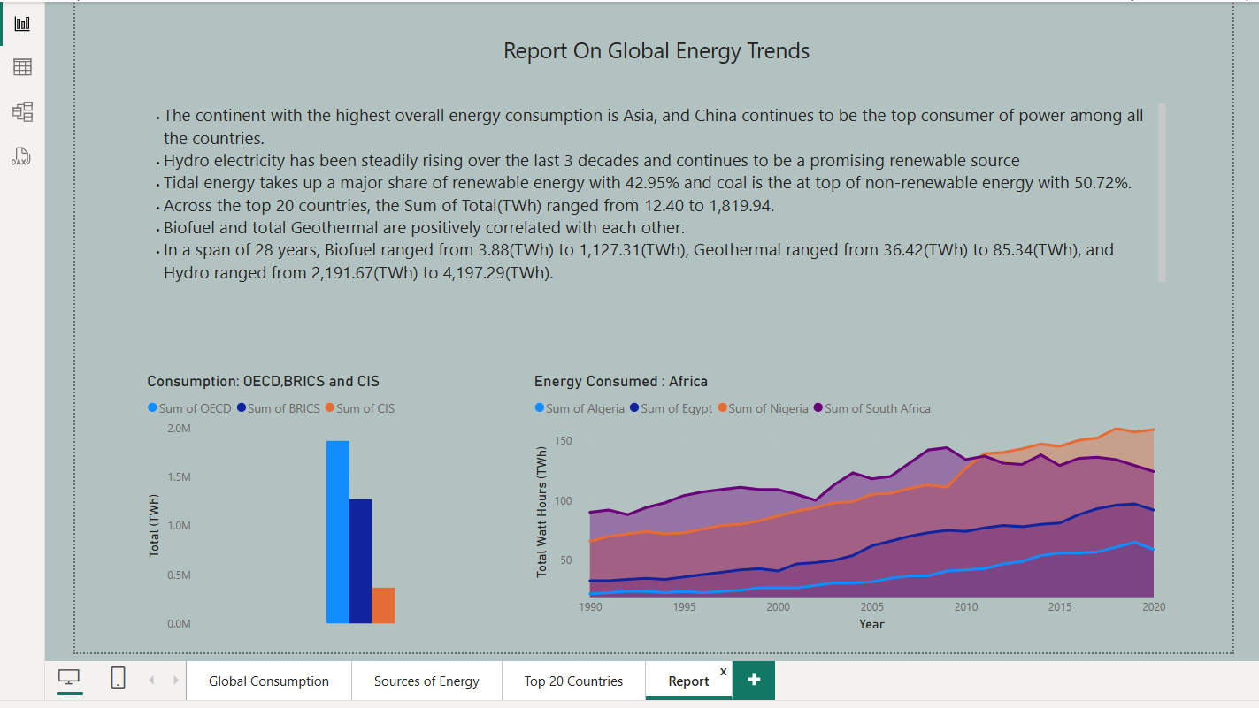

**MILESTONE 6: PERFORMANCE TESTING**

**Application of Data Filters**

Selections within the data allow users to filter data based on individual fields or dimensions. Users can choose specific values within a field to include or exclude from analysis. Complex filters based on predefined conditions and logic can also be created.  
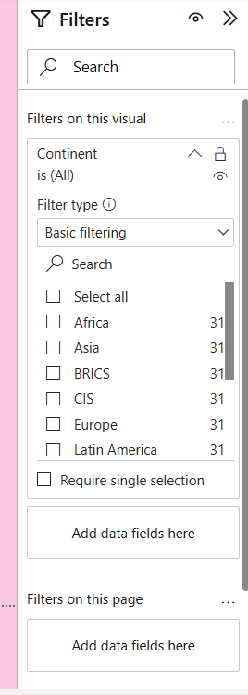 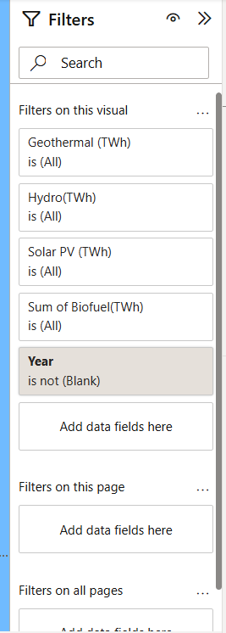

**Use of Measures/Calculated Columns**

Power BI allows the creation of reusable filter objects like Measures, and Calculated Columns which can simplify the process of applying consistent filters across multiple visualizations and dashboards.

**Country Average (TWh)**

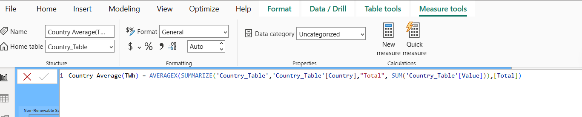

**Continent Average(TWh)**

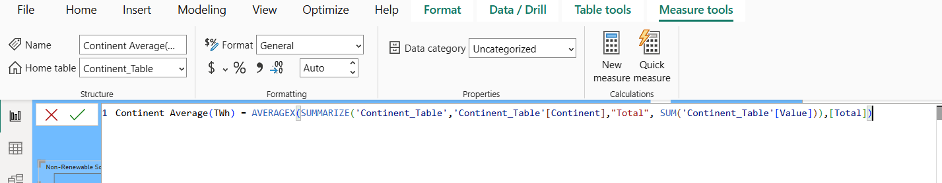

**Number of Graphs/ Visualizations**

1. Country-wise energy consumption
2. Continent Energy Consumption
3. Continent Average(TWh)
4. Country Average(TWh)
5. Non-renewable sources of Energy
6. Renewable Generation 1997-2017 (TWh)
7. Cards - Sum, Median, Standard Deviation and Variance of Contribution(TWh)
8. Renewable Sources of Energy
9. Cards - Geothermal, Biofuel, Hydro and Solar PV
10. BRICS, OECD, and CIS Comparison
11. Report Narrative
12. Energy Consumption in African countries

**MILESTONE 7: PROJECT DEMONSTRATION & DOCUMENTATION**

Git Hub repository link :https://github.com/sreevemula21/GLOBAL-ENERGY-TRENDS-A-COMPREHENSIVE-ANALYSIS-OF-KEY-REGIONS-AND-GENERATION-MODES-USING-POWER-BI

https://drive.google.com/drive/folders/1S7BHuWcCUWix6BD-OEMo1CdxCnaGZwaI?usp=drive_link