1. Create one IAM user and assign EC2 and S3 full access roles.
create an IAM user from root and login via user account.
While creating the user in IAM
Give a name:Test-1
Give Permissions to get logged in by Id and Password
Then create , you have to download .csv file in order to access the user
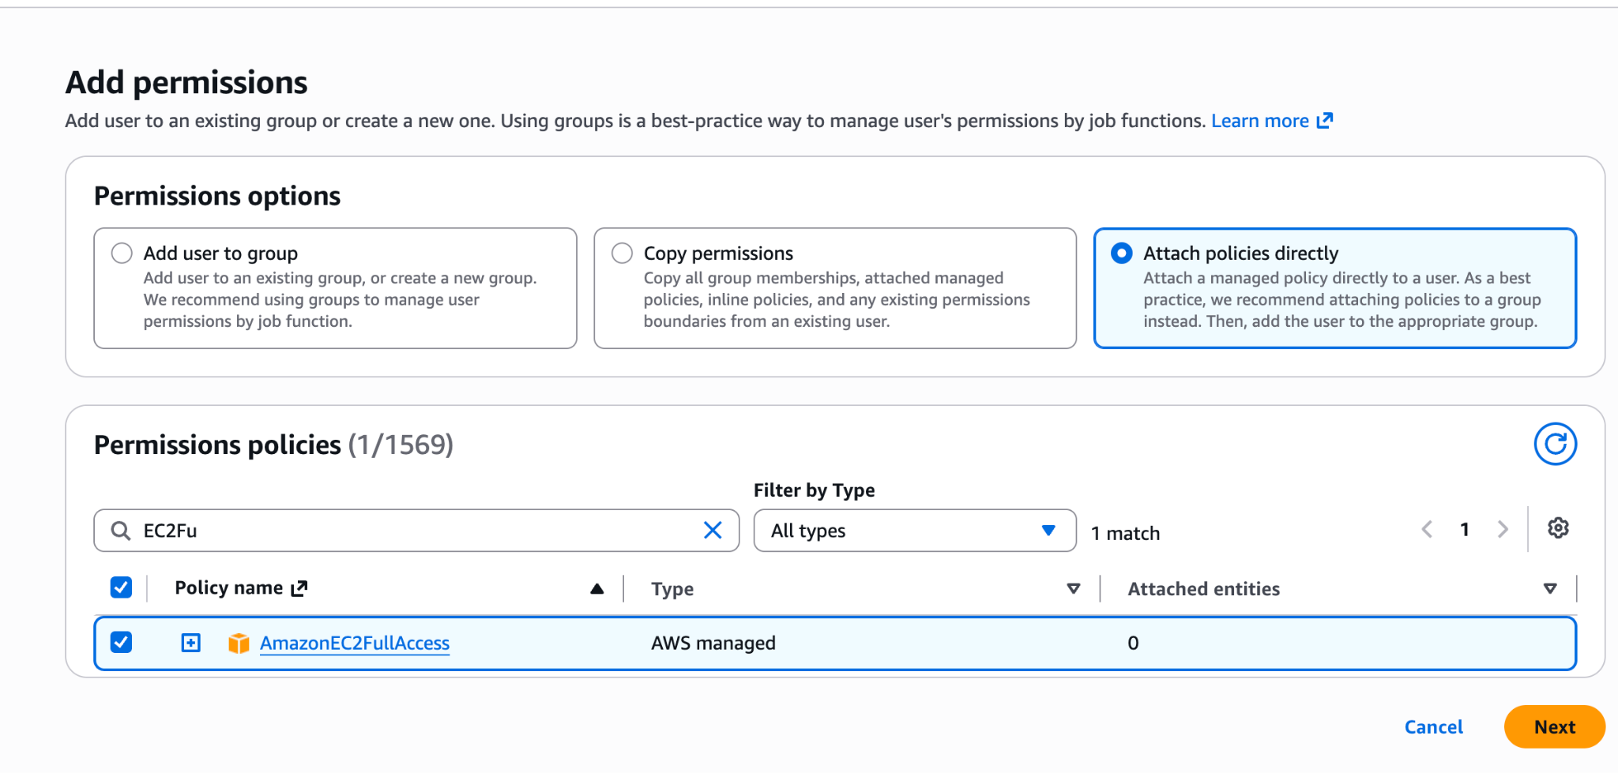
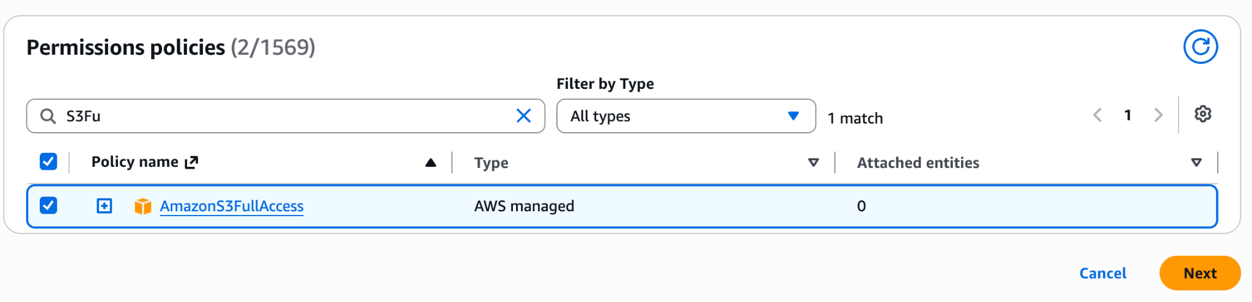
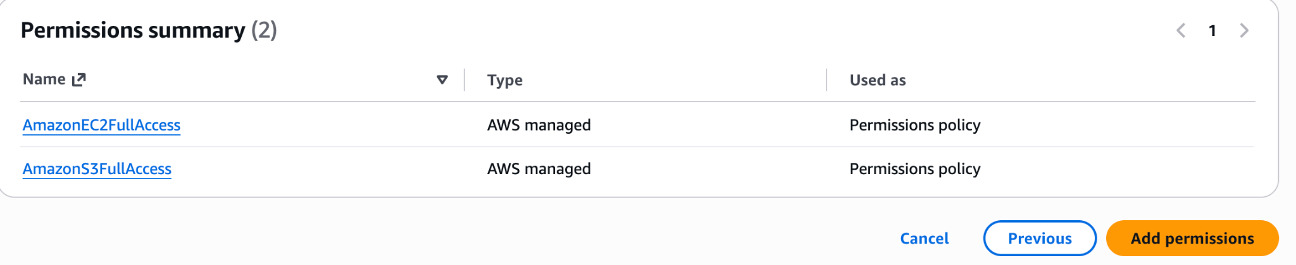
This below SS is from the USER Test-1
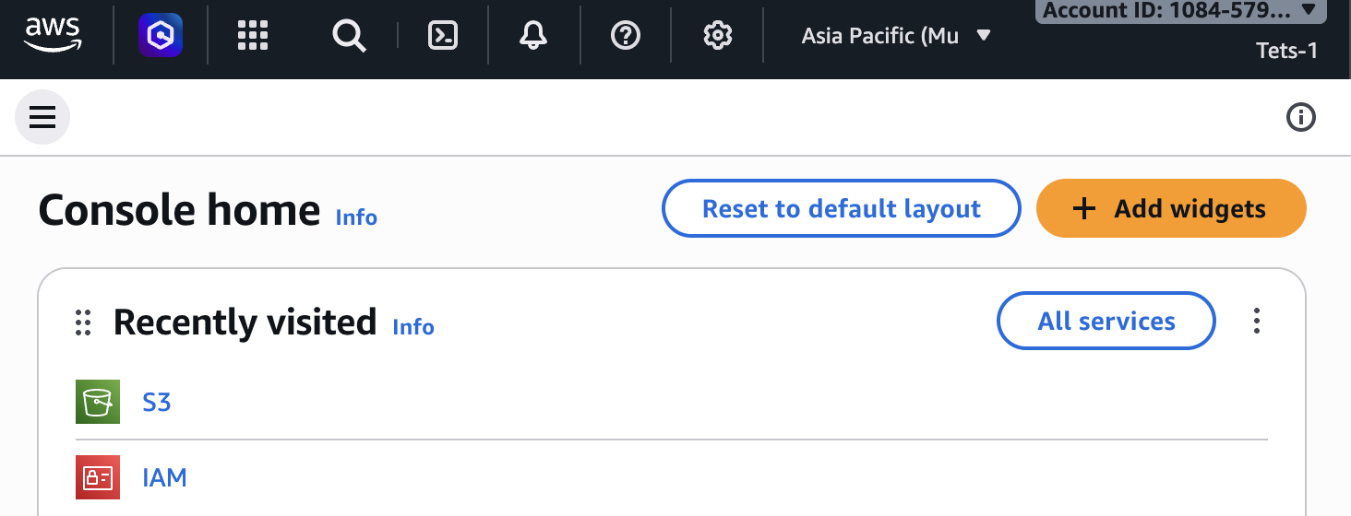
2. Create one group in IAM and assign read access for EC2.
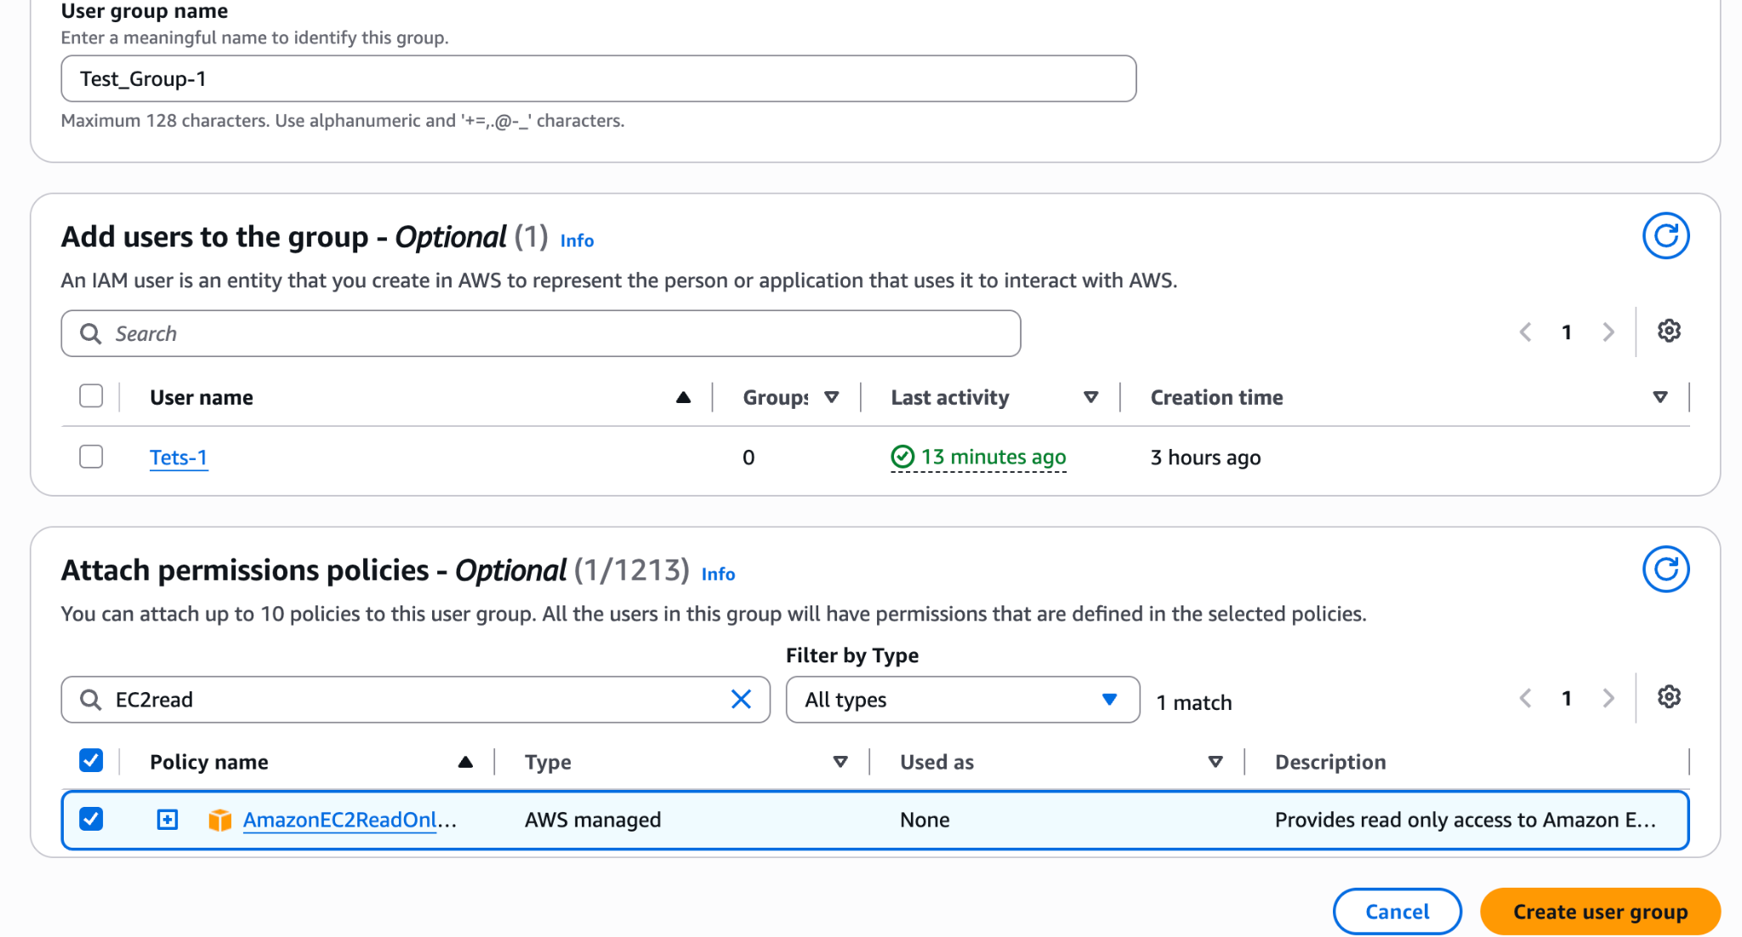
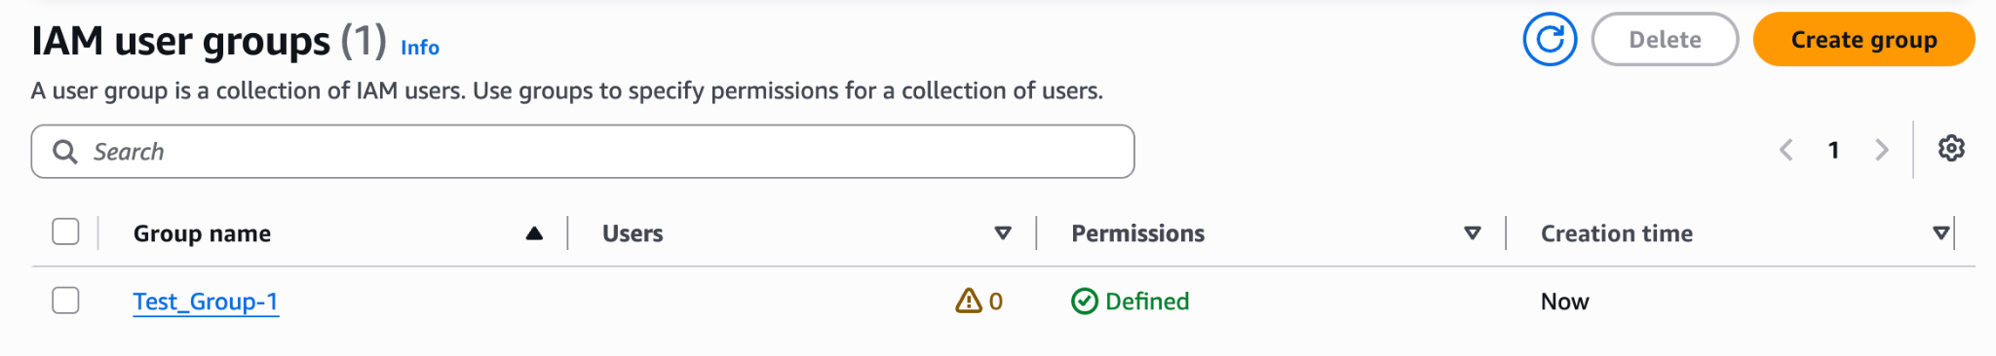
3. Create a new user named "Devops" and add to the group created in task 2.
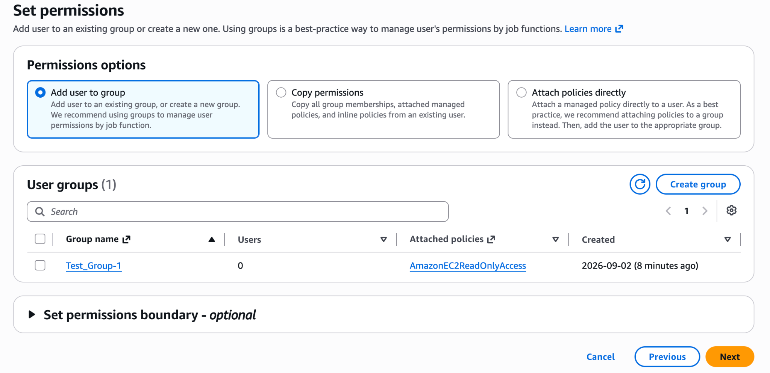
Created Devops added to the existed group Test_Group-1
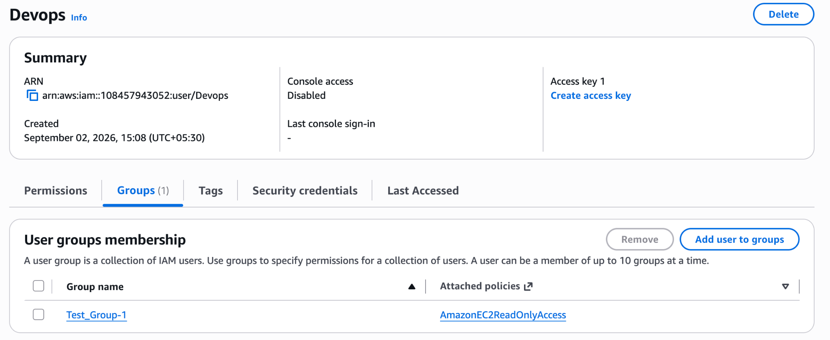

4. Write a bash script to create an IAM user with VPC full access.
Go to Root account on the right top corner→ Security credentials
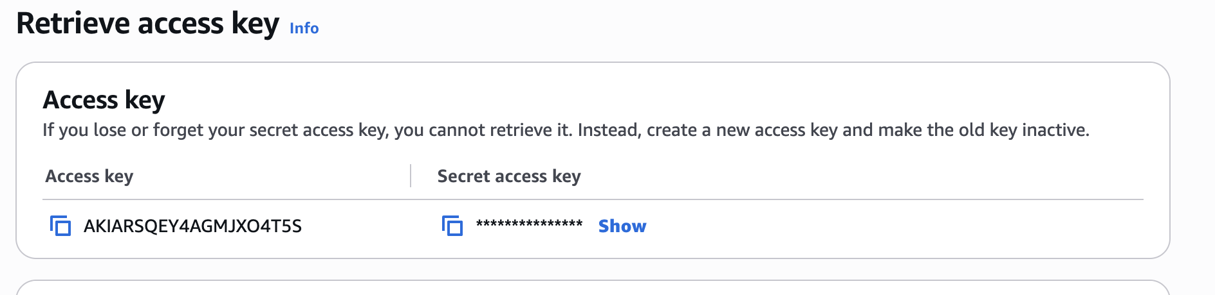
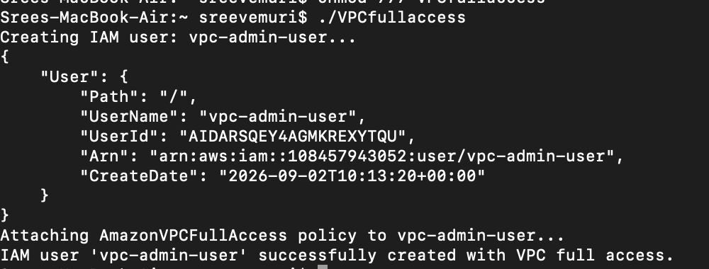
IAM User
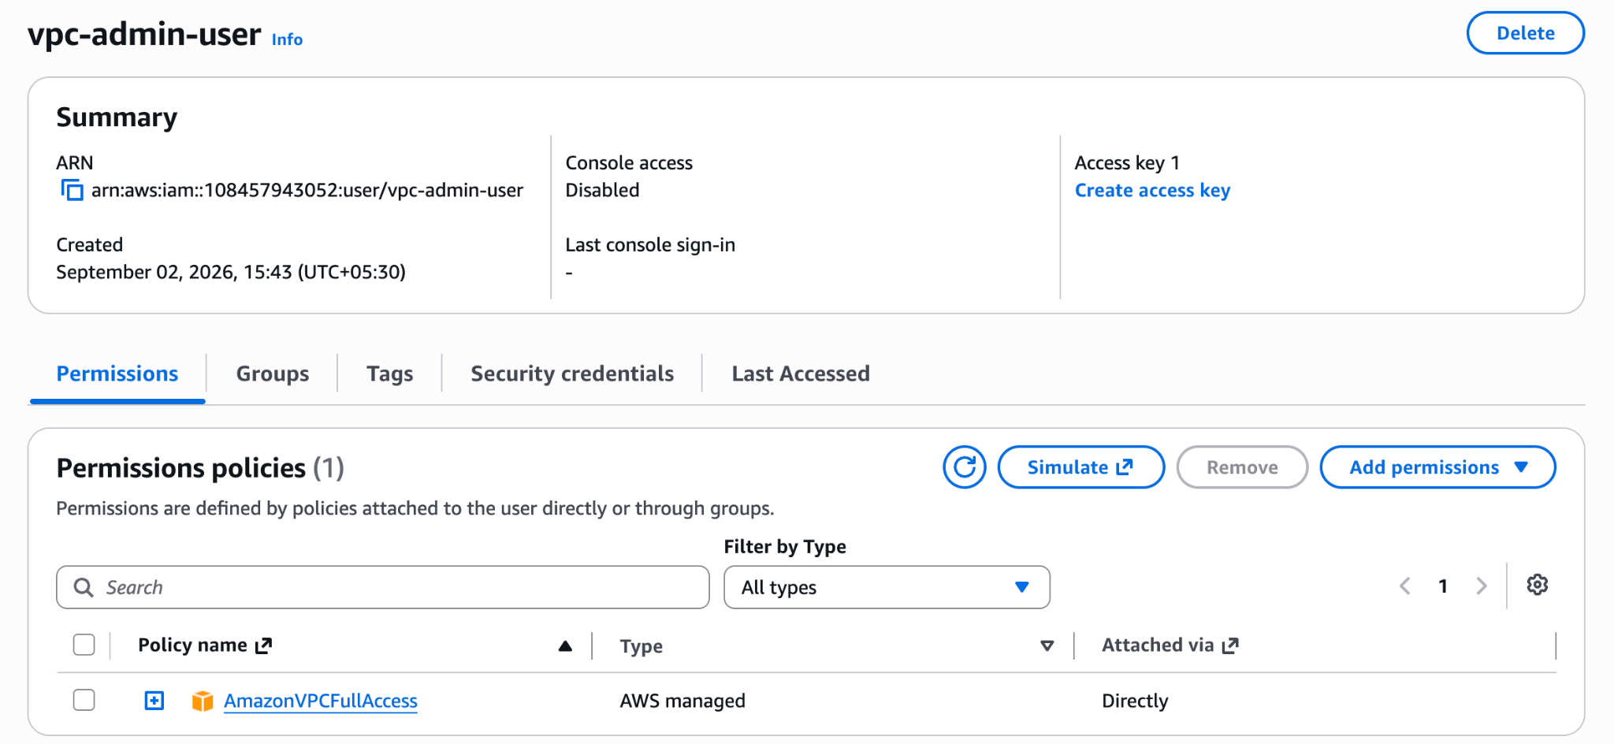
Code :
#!/bin/bash

# Exit immediately if a command exits with a non-zero status
set -e

# Set your desired IAM username
IAM_USER="vpc-admin-user"

# Amazon VPC Full Access policy ARN
VPC_POLICY_ARN="arn:aws:iam::aws:policy/AmazonVPCFullAccess"

echo "Creating IAM user: $IAM_USER..."
aws iam create-user --user-name "$IAM_USER"

echo "Attaching AmazonVPCFullAccess policy to $IAM_USER..."
aws iam attach-user-policy \
--user-name "$IAM_USER" \
--policy-arn "$VPC_POLICY_ARN"

echo "IAM user '$IAM_USER' successfully created with VPC full access."
Commands to follow
→ Aws configure
→ Aws sts get-caller-identity
→ Aws s3 ls for is there any S3 bucket is there/ available.
→ Aws s3 ls --profile=default if any profile is there with the name of ‘default’.
5. Create an IAM policy to allow EC2 access for a specific user in specific regions only.
IAM →Policies → Create Policies —> select Json format → Give Name to the Policy to Appear on search → click create. → search with name you created→ select the screen→ type will be Customer Managed
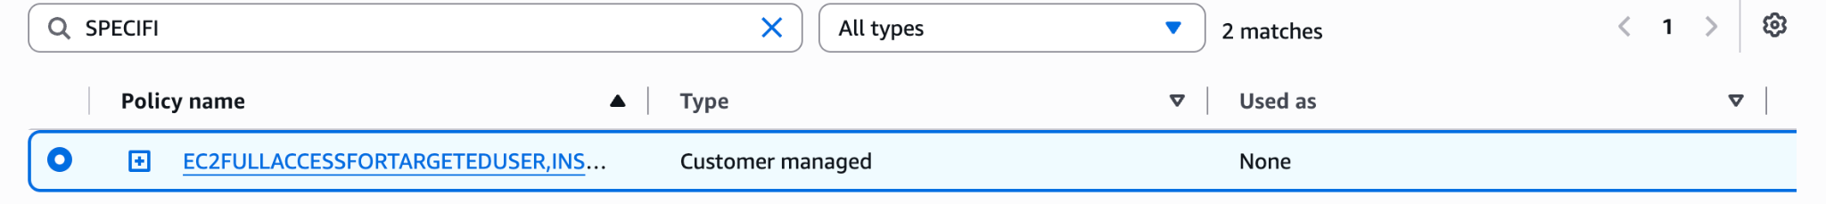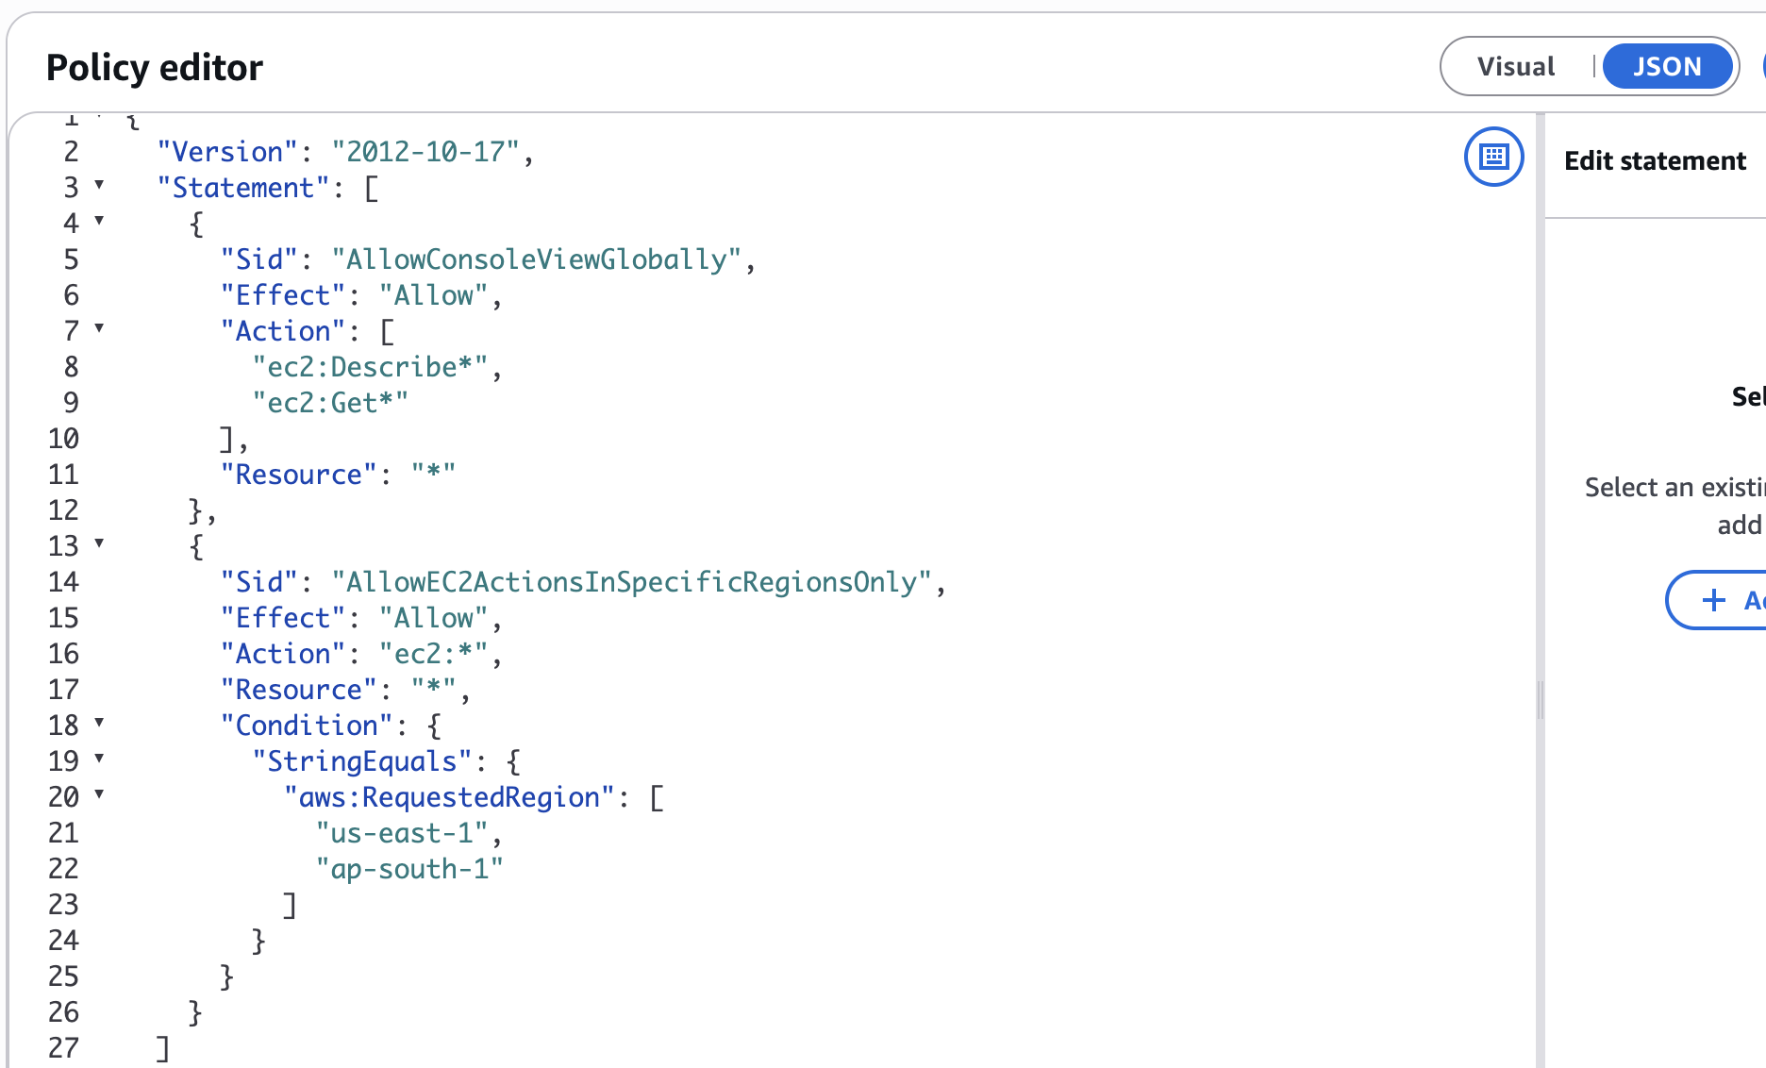

6. We have two accounts: Account A and Account B. Account A user should access an S3 bucket in Account B.
(Collaborate with a team member and execute this. This is mostly asked in every interview.)
Objective
- Enable an IAM user (S3-swap) in Account A to access an S3 bucket (task654321) located in Account B (Cross-Account Access).
Account Details
- Account A (108457943052): Houses the IAM user S3-swap.
- Account B (567487919764): Houses the S3 bucket task654321.
Step-by-Step Process
- Step 1: Create the S3 Bucket in Account B
⚬ Created the target S3 bucket named task654321 inside Account B.
- Step 2: Generate IAM User Access Keys in Account A
⚬ Created an Access Key and Secret Key for the IAM user S3-swap to authenticate via the AWS CLI.
- Step 3: Configure the AWS CLI Profile on the Laptop
⚬ Identified that the CLI was initially active under the Account A root user.
⚬ Configured a dedicated named profile using:
aws configure --profile S3-swap
- ⚬ Verified the profile identity using aws sts get-caller-identity --profile S3-swap to confirm it matched arn:aws:iam::108457943052:user/S3-swap.
Step 4: Attach Outbound IAM Permissions in Account A
⚬ Attached an IAM policy to user S3-swap allowing permissions (ListBucket, GetObject, PutObject) to target the external bucket.
- Step 5: Apply Inbound Bucket Policy in Account B
⚬ Configured a resource-based Bucket Policy on task654321 to explicitly Allow the principal arn:aws:iam::108457943052:user/S3-swap.
- Step 6: Verify and Test Cross-Account Access
⚬ Listed the contents of the remote bucket:
aws s3 ls s3://task654321 --profile S3-swap
⚬ Successfully uploaded a test file into the bucket:
aws s3 cp test.txt s3://task654321/test.txt --profile S3-swap
Key Issue & Resolution
- Issue: Initial CLI attempts threw an AccessDenied error because the commands executed under the root identity instead of the permitted IAM user.
- Resolution: Passed the --profile S3-swap flag to execute operations strictly under the authorized IAM user identity.
{
"Version": "2012-10-17",
"Statement": [
{
"Effect": "Allow",
"Action": "s3:ListBucket",
"Resource": "arn:aws:s3:::task654321"
},
{
"Effect": "Allow",
"Action": [
"s3:GetObject",
"s3:PutObject",
"s3:DeleteObject"
],
"Resource": "arn:aws:s3:::task654321/*"
}
]
}

