Create one VPC, with 1 public subnet and 1 private subnet.
Go to:
VPC → Your VPCs → Create VPC
VPC → Subnets → Create subnet → Pvt-Sub & Pub-Sub
VPC → Internet Gateways → Create internet gateway
Actions → Attach to VPC
VPC → Route Tables → Create route table
Routes → Edit routes → Add route
Public-RT → Subnet associations → Edit subnet associations.--> Add Pub-Sub
VPC → Subnets → Public-Subnet → Actions → Edit subnet settings
Enable VPC peering for cross-region → Enable auto-assign public IPv4 address.
VPC → Route Tables → Create route table
Associate → Private-Subnet → with → Private-RT
Enable VPC peering for cross-region.
Create VPC Peering
VPC → Peering connections → Create peering connection
Name: East-to-West-Peering
Requester VPC: DevOps-VPC
Account: My account
Region: Another Region
Region: us-west-2
Accepter VPC: Default VPC
Accept Peering
Switch to: us-west-2
Go: VPC → Peering connections
You should see: Pending Acceptance
Select it: Actions → Accept request
Add Routes
VPC-1 route table Go to:
us-east-1 → Route Tables → Public-RT
Destination: 172.31.0.0/16
VPC TASK - 2
Target:
→Peering Connection: pcx-xxxxxxxx
VPC-2 Route table Default
Destination:
10.0.0.0/16
Target:
→Peering Connection: pcx-xxxxxxxx
IN MY case It din/t Worked For me so For this Testing purpose
in Sccurity groups I opened all traffic 0.0.0.0./0 = its connected Succesfully
Security Groups → All Traffic → 0.0.0.0/0
Instead Of Opening all ports I tried this its Worked
Security Groups → All Traffic → I entered N.Virgnia→cidr 10.0.1.0/16 = it’s worked
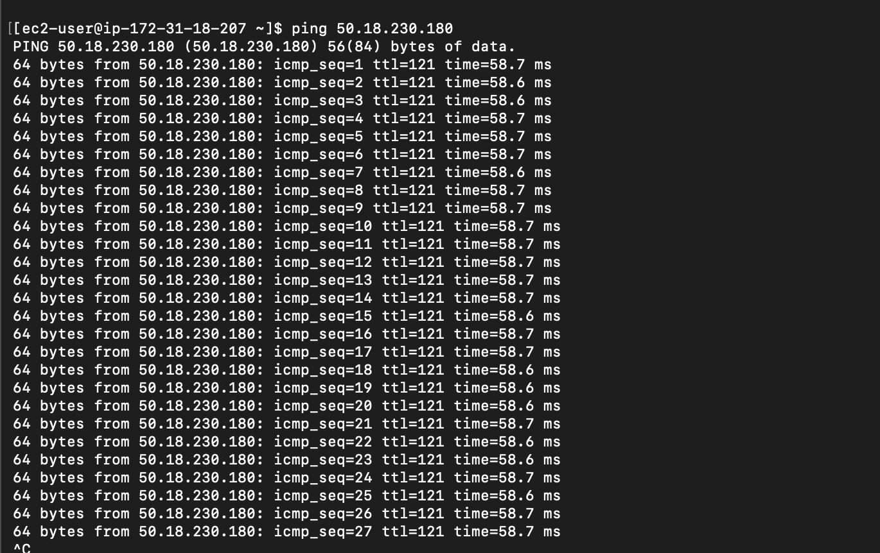

Set up a VPC Transit Gateway.
VPC → Transit Gateways
Configure:
Name: DevOps-TGW
Description:
DevOps Lab Transit Gateway
Amazon side ASN: 64512
Attach VPC-1
VPC → Transit Gateway Attachments → Create transit gateway attachment
Attachment type: VPC
Transit Gateway: DevOps-TGW
VPC: DevOps-VPC
Select the subnet: Public-Subnet
Attach VPC-2 : Do the same for: in uswest – 2a/Another Region vpc
VPC → Transit Gateway Route Tables → Select your TGW route table.
Added new → transit gateway →wait for until it’s available→ gateway attachements
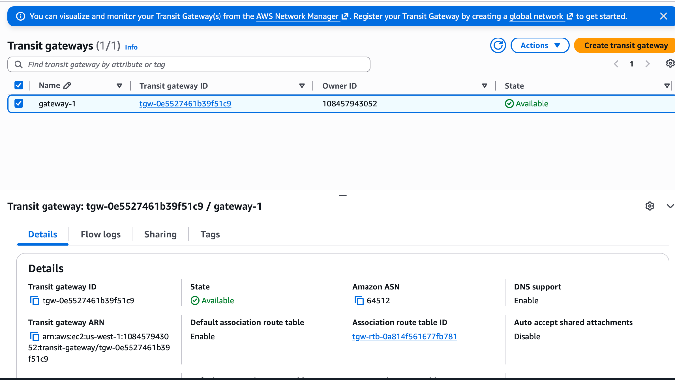
Set up a VPC Endpoint.

