- Create a bash script to check if a directory is available or not.
step -1 : create a directory
Step-2 : create and Edit the file ith vi filename
Step-3: give the script
#!/bin/bash
if [ “find / -name filename” ]
then
echo file is there
else
else file is not there
fi
:wq!
step-4: ./filename
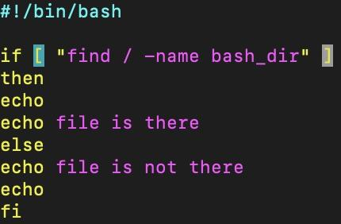
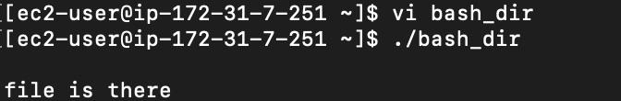
- Create a bash script to create multiple files.
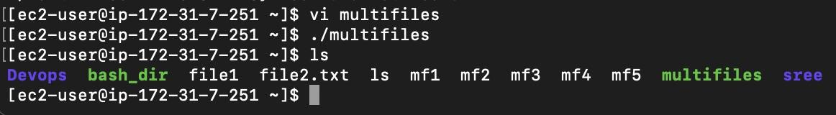
- Create a bash script to take a backup of a directory.
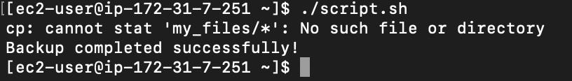
- Create a bash script to install Nginx on an EC2 server.
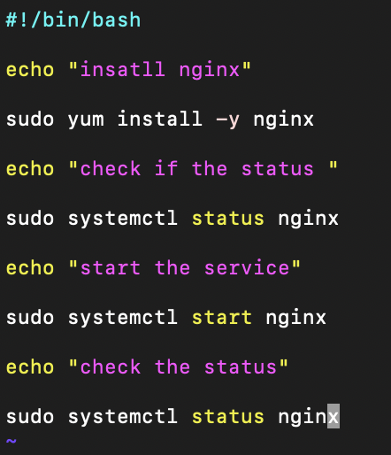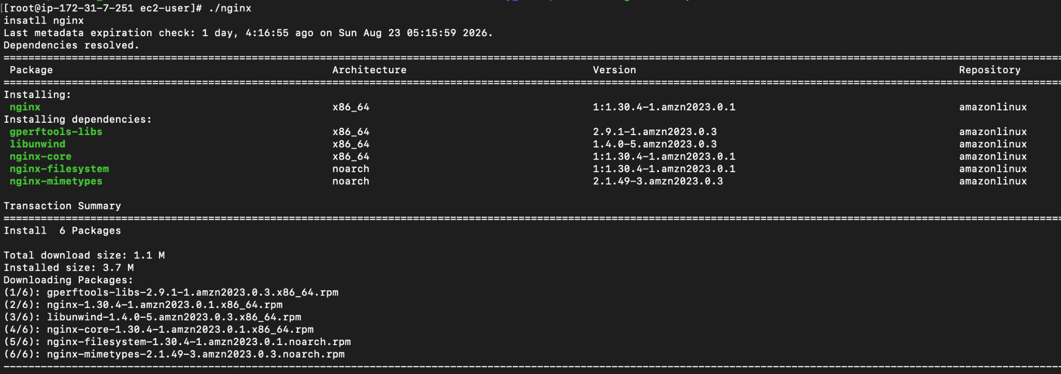
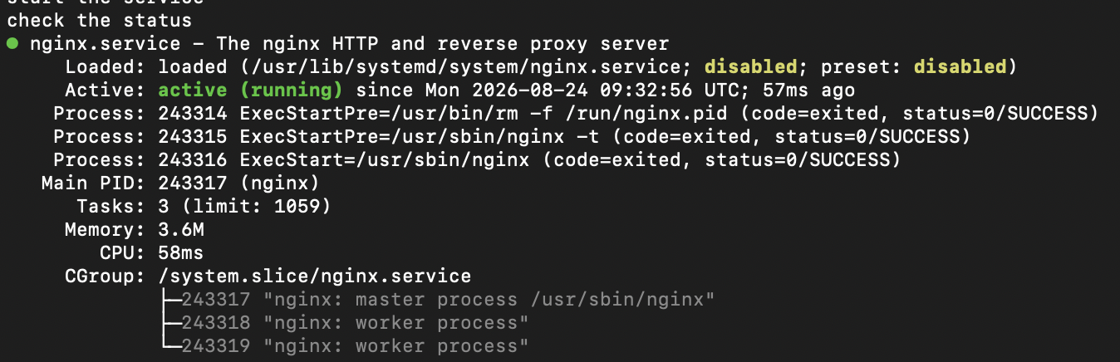
- Create a bash script to install Apache Tomcat on an EC2 server.
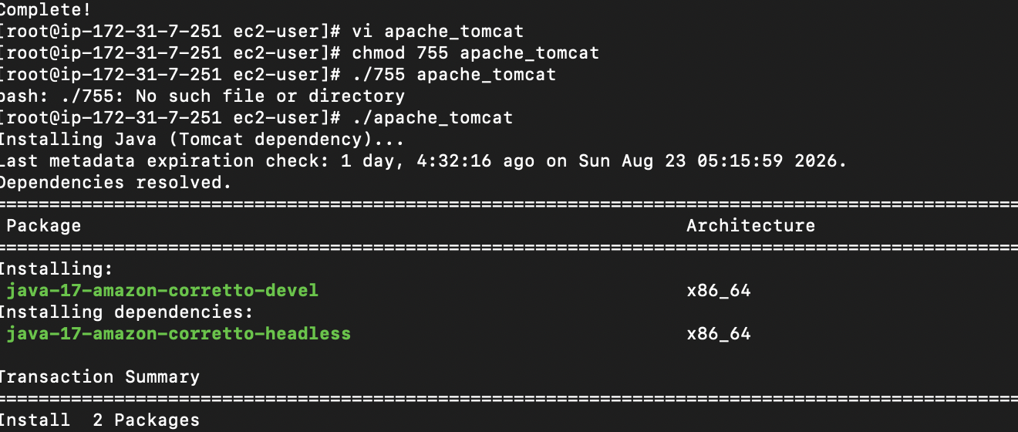
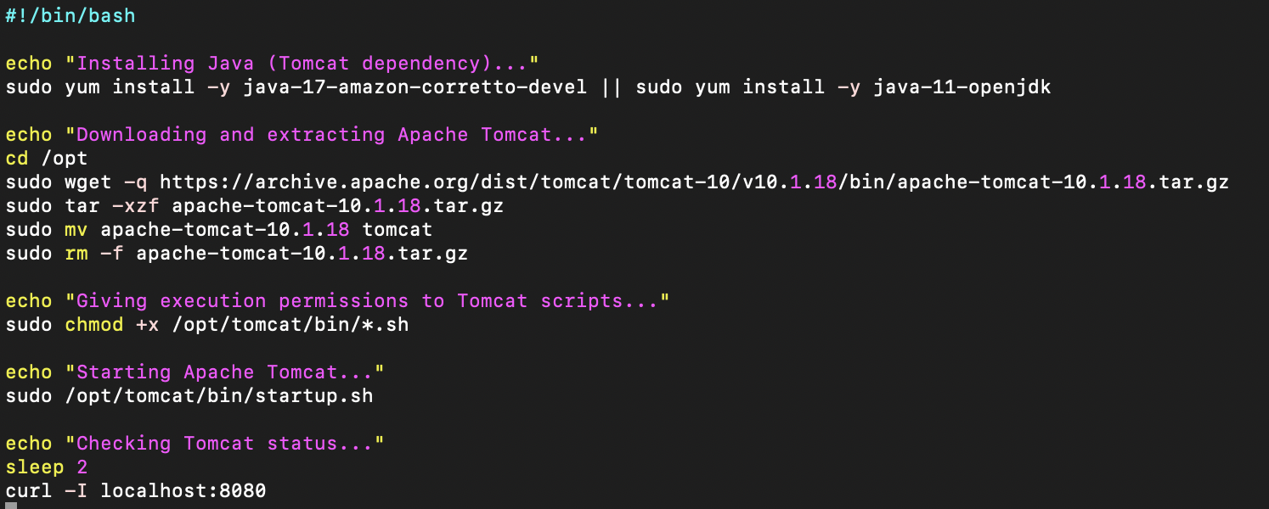
- Create a bash script to check if the Nginx service is running, if not running then script should start the service.
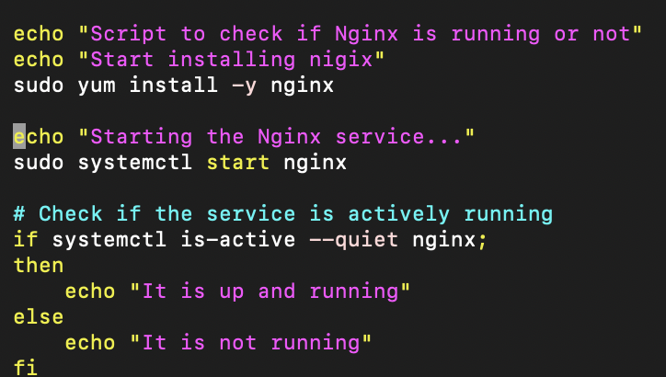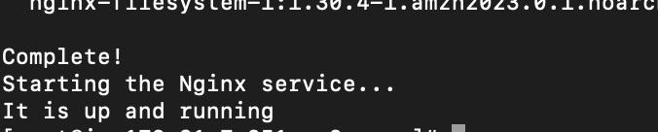
- Create a bash script for a calculator.
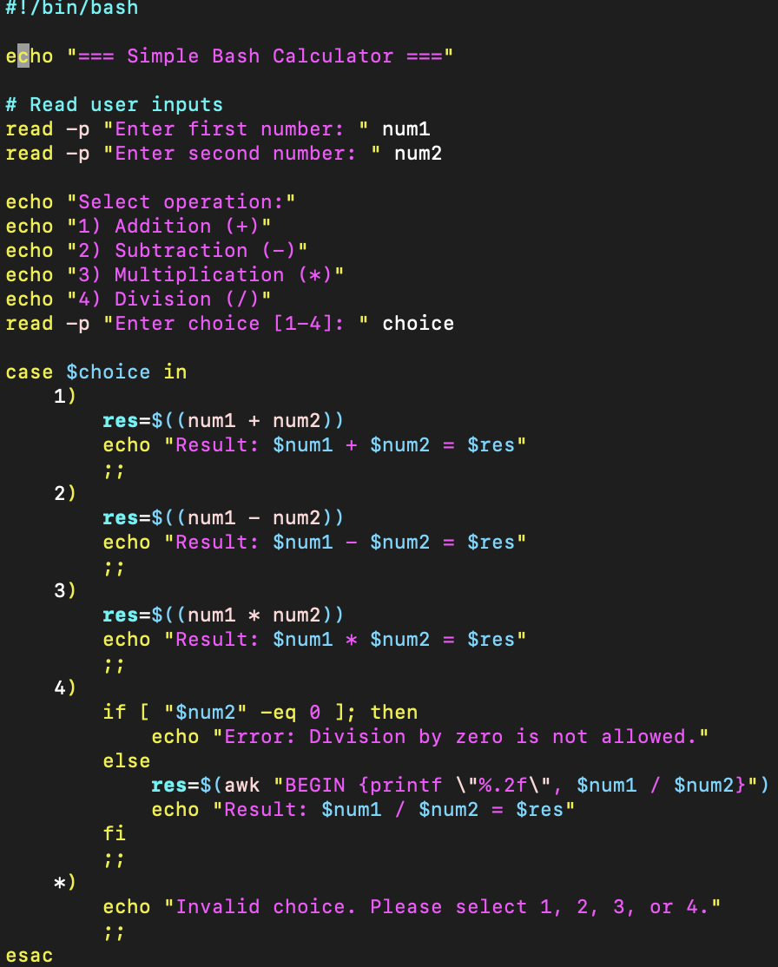
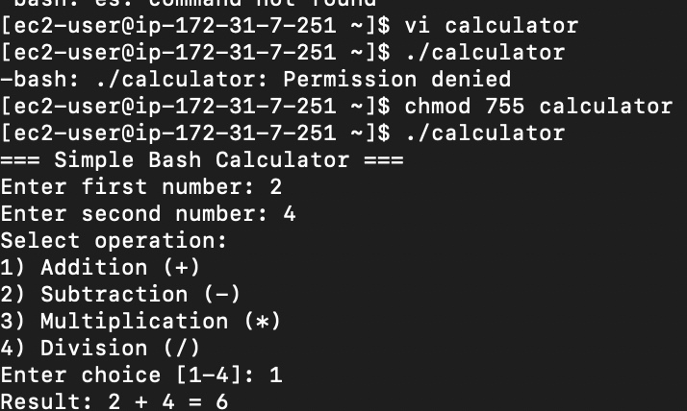
- Create a bash script to check if a directory exists, if not then create a directory.
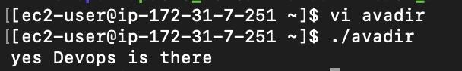
- Bash script to monitor cpu and if it is more than 80% then send email notification.
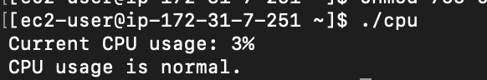
- Bash script to monitor disk space and if it is more than 80% then send email notification.
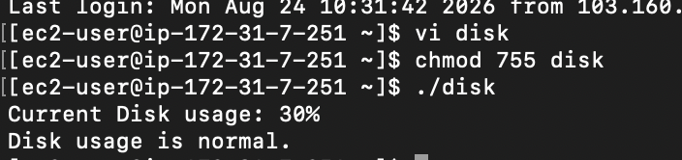
- Bash script to monitor memory and if it is more than 80% then send email notification.
