- Create a tomcat container on 8080 and deploy sample application in tomcat

yum install docker -y
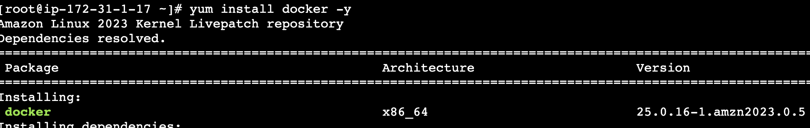
Systemctl start docker
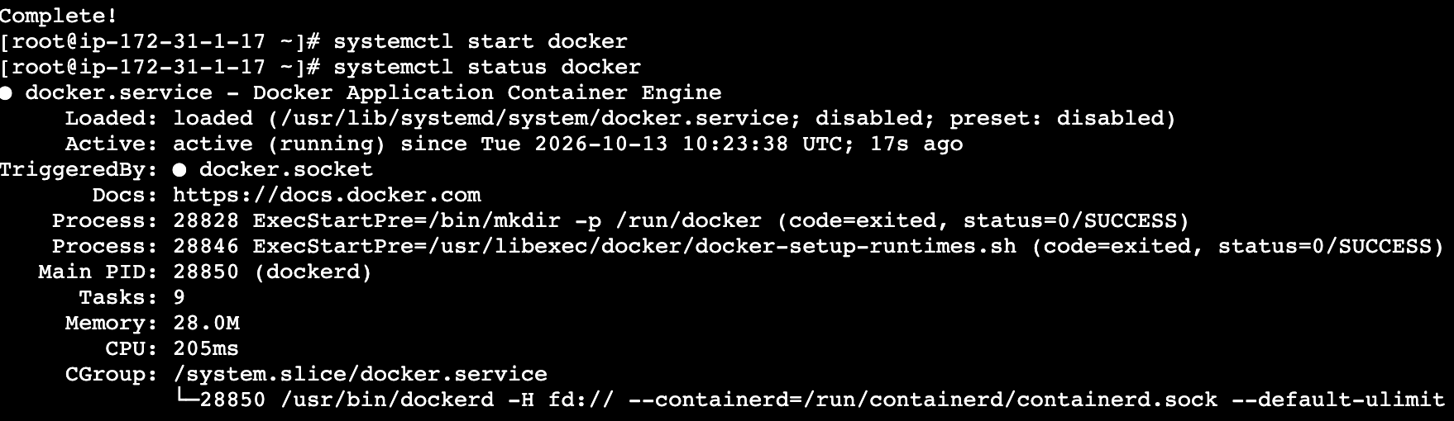
Pull the tomcat server image;
docker pull tomcat:latest
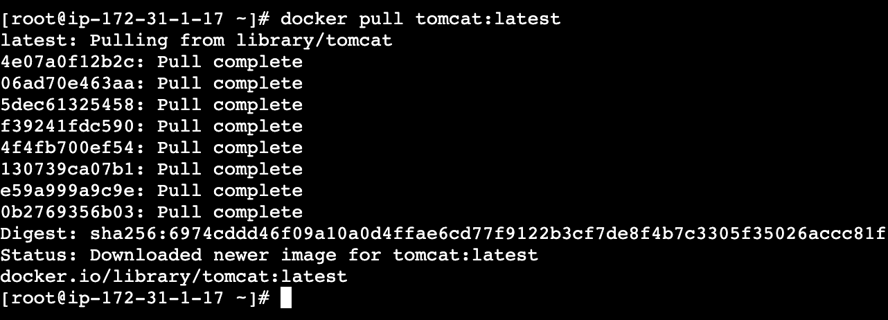
Docker images
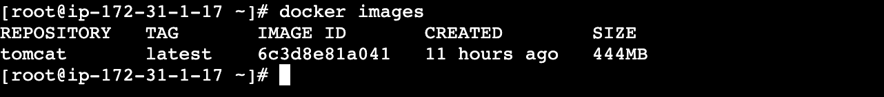

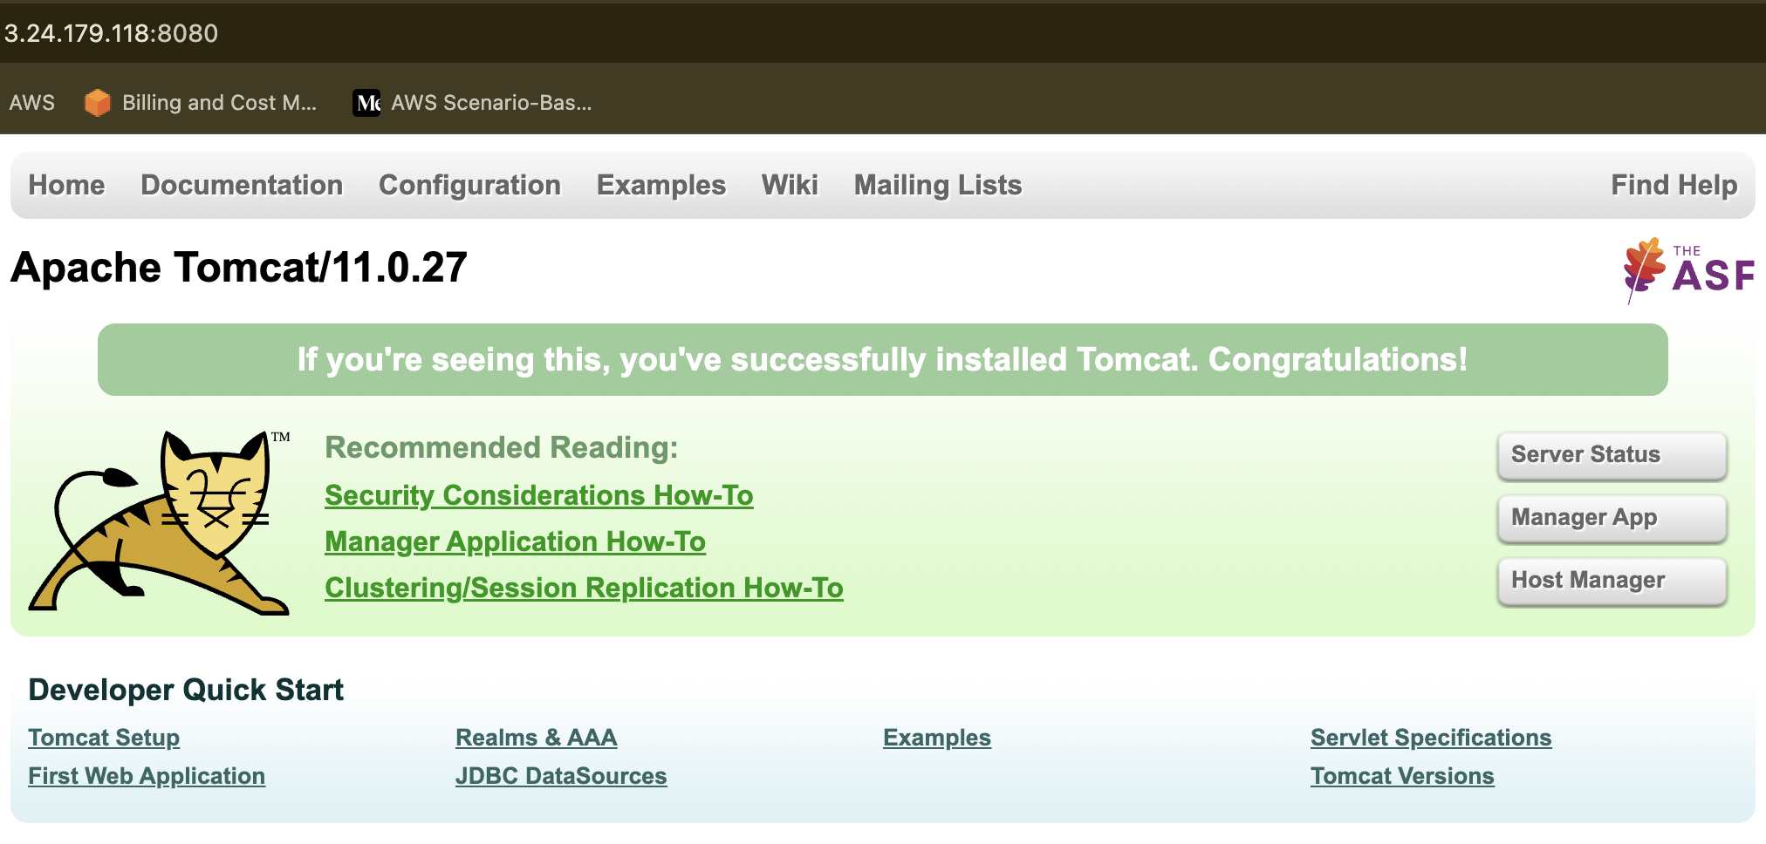
- Create volume and deploy tomcat container on port 8081.
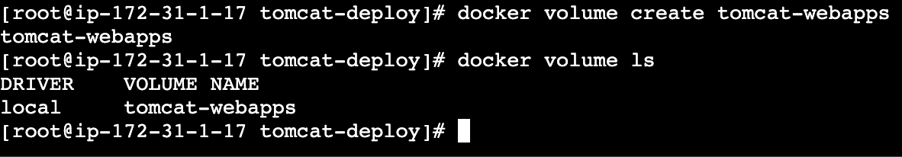

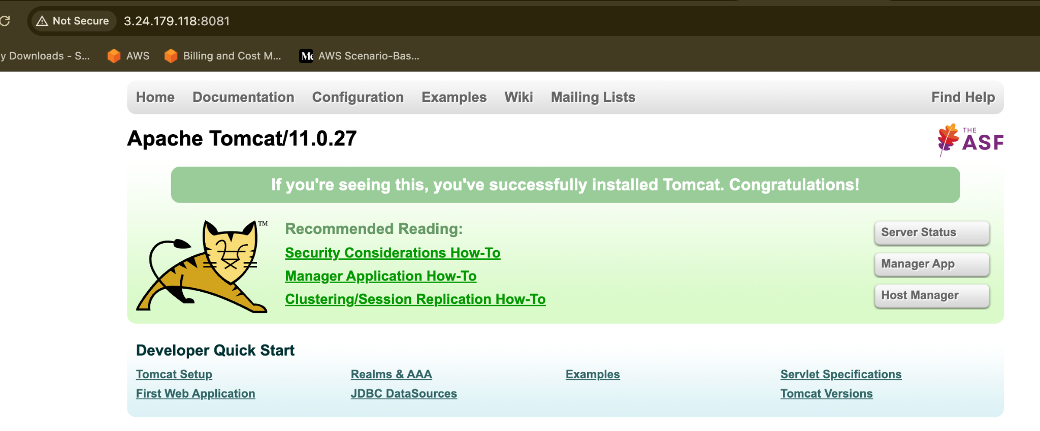

- Limit the nginx container to 500 MB.
→ docker pull nginx
→ docker container run --itd -p 8082:8080 –memory=500m nginx
→ docker stats { to view the memory allocation}
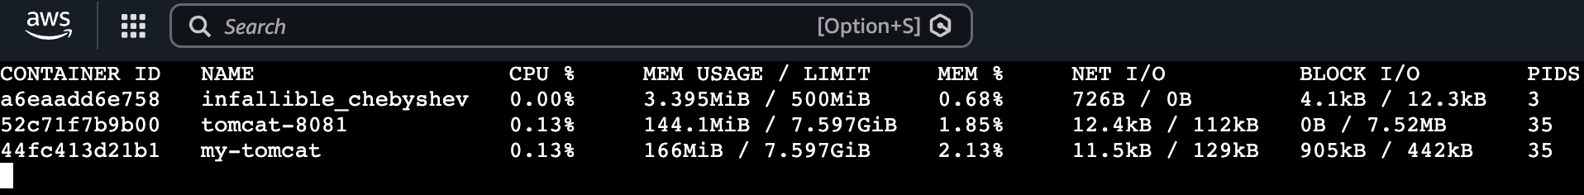
- Create a sample docker file using below instructions.
  - Base module as amazonlinux:latest
  - Maintainer you name
  - Install nginx
  - COPY one index.html file to image
  - Expose on port 80
  - Command to start the nginx container

Here are the clean, error-free steps to create and run this Docker setup from scratch:
Create index.html using single quotes to avoid Bash history expansion errors:
echo '<h1>Hello from Nginx on Amazon Linux!</h1>' > index.html

2. Create the Dockerfile
Create a file named exactly Dockerfile:
cat << 'EOF' > Dockerfile
FROM amazonlinux:latest
LABEL maintainer="Sree N R L Pradeep Vemuri"
RUN dnf update -y && \
dnf install -y nginx && \
dnf clean all
COPY index.html /usr/share/nginx/html/index.html
EXPOSE 80
CMD ["nginx", "-g", "daemon off;"]
EOF

3. Build the Image
Build the container image using the current directory context:
docker build -t amazonlinux-nginx:latest .

4. Run the Container
Start the container mapping host port 80 to container port 80:
docker run -d --name my-nginx -p 80:80 amazonlinux-nginx:latest

5. Verify Deployment
Verify that Nginx is serving the custom page:
curl http://localhost:80

Or view the site in a web browser at `
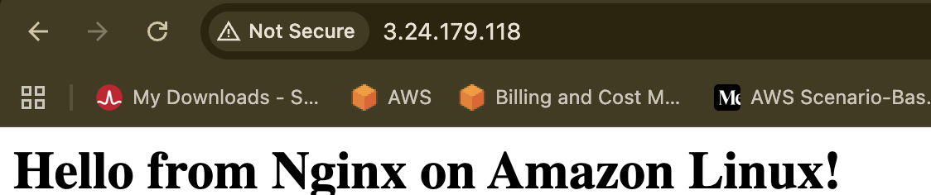

5 ) Push image to Docker hub
1. Log in to Docker Hub
Authenticate with your Docker Hub account:
docker login

(Enter your Docker Hub username and password/personal access token when prompted.)
2. Tag the Image
Docker Hub expects the image format to be your-dockerhub-username/repository:tag:
docker tag amazonlinux-nginx:latest <YOUR_DOCKERHUB_USERNAME>/amazonlinux-nginx:latest

3. Push to Docker Hub
docker push <YOUR_DOCKERHUB_USERNAME>/amazonlinux-nginx:latest

- 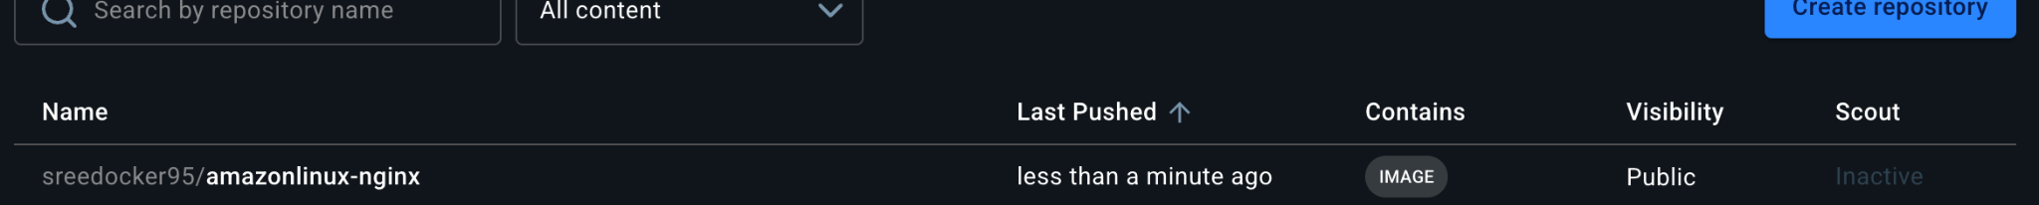
- push image to AWS ECR
TASK 6: Push the Image to AWS ECR
Amazon Elastic Container Registry (ECR) is an AWS service used to store Docker container
images.
Step 1: Create an ECR repository
1. Open https://console.aws.amazon.com/ecr/
2. Select your required AWS Region.
3. Open Private repositories.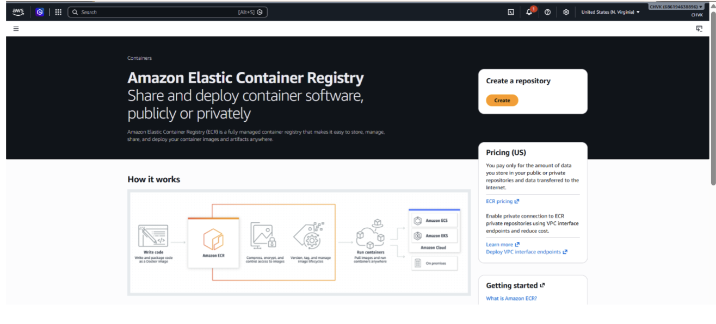
4. Click Create repository.
5. Enter the repository name:
amazon-nginx
6. Keep the repository private.
7. Click Create repository.

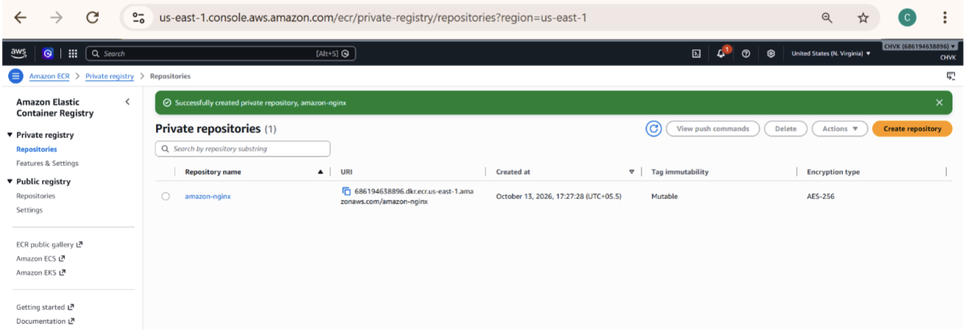
Copy your AWS Account ID and Region.
Step 2: Install AWS CLI
Execute on Ubuntu:
sudo apt update
sudo apt install awscli -y
Verify:
aws --version

Step 3: Configure AWS credentials
If using an IAM user with appropriate ECR permissions:
If the EC2 instance has an IAM role with the necessary permissions, use that role instead of
storing access keys.
Step 4: Log in to AWS ECR
Replace YOUR_AWS_ACCOUNT_ID and YOUR_REGION with your actual values.
aws ecr get-login-password --region YOUR_REGION | docker login --username AWS
--password-stdin YOUR_AWS_ACCOUNT_ID.dkr.ecr.YOUR_REGION.amazonaws.com
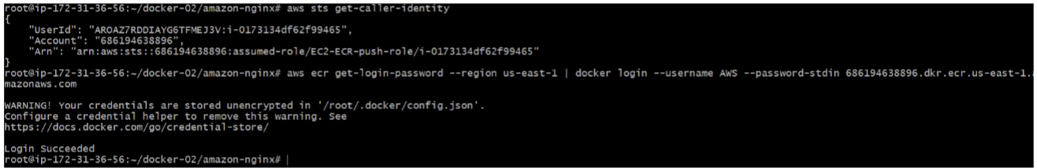Example registry format:
123456789012.dkr.ecr.ap-south-2.amazonaws.com
The account ID above is only an example.
Step 5: Tag the image for ECR
docker tag amazon-nginx:v1
YOUR_AWS_ACCOUNT_ID.dkr.ecr.YOUR_REGION.amazonaws.com/amazon-nginx:v1
Step 6: Push the image
docker push
YOUR_AWS_ACCOUNT_ID.dkr.ecr.YOUR_REGION.amazonaws.com/amazon-nginx:v1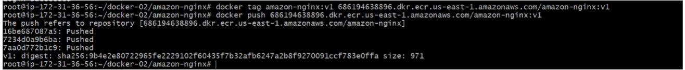

Step 7: Verify the image
1. Open the AWS ECR Console.
2. Open the amazon-nginx repository.
3. Select the Images tab.
4. Verify that the v1 image tag is available.

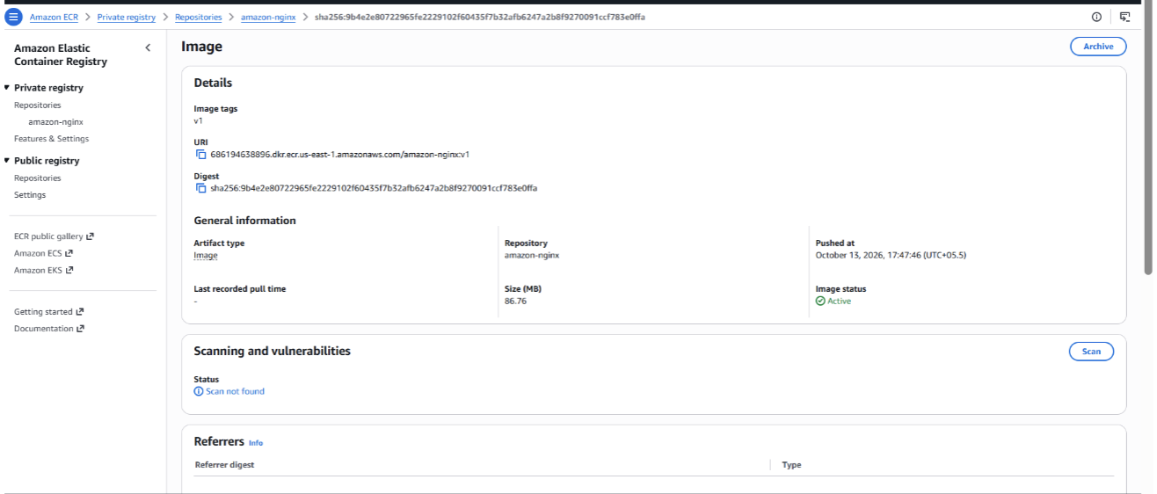

The IAM identity needs the appropriate permissions to authenticate and push images to ECR.

FINAL VERIFICATION CHECKLIST
● Tomcat container running on port 8080.
● Sample application deployed to Tomcat 8080.
● Docker volume tomcat-data created.
● Tomcat container running on port 8081 with volume.
● Nginx container limited to 500 MB.
● Amazon Linux Dockerfile created.
● Custom Docker image built successfully.
● Custom Nginx application tested on port 8082.
● Image pushed to Docker Hub.
● Image pushed to AWS ECR.
TROUBLESHOOTING
If the application does not open in your browser:
1. Check running containers:
docker ps
2. Check container logs:
docker logs tomcat-8080
docker logs tomcat-8081
docker logs nginx-500mb
docker logs amazon-nginx-container
3. Check the EC2 Security Group inbound rules.
4. Verify that the required host port is mapped correctly.
5. Confirm that the application file exists inside the container.
Conclusion
In this assignment, we created Tomcat containers, deployed a sample web application, created
and used a Docker volume, limited Nginx memory, built a custom Docker image using Amazon
Linux, and pushed the image to Docker Hub and AWS ECR

