Create an Image from a Running Container
- Objective: Take a running container where you manually created a file, and save its state as a brand-new reusable Docker image.
- Scope: Starting an Ubuntu container, creating a sample file inside it, and saving it with docker commit.
- What, Where & When:
What is changed: A new image is created that remembers the manual file you created inside the container.
Where to look for changes: Run docker images to see the new image name at the top of your list.
When is it changed: Right after you run the docker commit command.
Pin-to-Pin Steps & Command Breakdown
- Start an Ubuntu container and go inside it:
docker run -it --name my-container ubuntu /bin/bash
Command Breakdown:
docker run: Tells Docker to create and start a new container.
-it: Combines -i (interactive) and -t (terminal) so you can type commands inside the container.
--name my-container: Gives the container a friendly name (my-container) instead of a random name.
ubuntu: The base image name we are downloading and running.
/bin/bash: Opens the Bash shell inside the container.
How to verify: Your terminal prompt changes to root@<container-id>:/#.
Create a simple file inside the container and exit:
touch /my-new-file.txt
ls /
Exit
Command Breakdown:
touch /my-new-file.txt: Creates an empty file named my-new-file.txt in the root (/) folder.
ls /: Lists all files in the root folder.
exit: Leaves the container and brings you back to your main Linux server terminal.
How to verify: You see my-new-file.txt listed before returning to your normal server prompt.

Save (commit) the container as a new image:
docker commit my-container my-custom-ubuntu:v1
Command Breakdown:
docker commit: Takes a snapshot of a container and turns it into an image.
my-container: The name of the container we want to snapshot.
my-custom-ubuntu:v1: The new image name (my-custom-ubuntu) and version tag (v1) we are creating.
How to verify: Run docker images and confirm my-custom-ubuntu with tag v1 appears in the list.
Test the new image:
docker run -it my-custom-ubuntu:v1 ls /
Command Breakdown:
docker run -it my-custom-ubuntu:v1: Starts a brand-new container from your new image.
ls /: Runs the list command inside that new container.
How to verify: You will see my-new-file.txt is already inside this brand-new container.

Copy image from local machine to docker server and load the image.
- The Question / Objective: Save a Docker image as a portable archive file (.tar), move it to a Docker server, and unpack (load) it back into the Docker engine without using an internet registry like Docker Hub.
- Scope: Exporting, restoring, and verifying a Docker image using local archive commands.

Pin-to-Pin Commands Used
Save the Docker image into a .tar archive file:
docker save -o my-image.tar my-custom-ubuntu:v1
  - What it means: docker save packs the image into a single file, and -o my-image.tar names the output file my-image.tar.
Verify the archive file exists on disk:
ls
  - What it means: Lists files in the current folder to confirm my-image.tar is present.
Remove the existing image to test restoring it:
docker rmi -f my-custom-ubuntu:v1
  - What it means: Force-removes (rmi -f) the image from Docker's current memory so we can prove the .tar file actually restores it.
Load the image back into Docker from the .tar file:
docker load -i my-image.tar
  - What it means: docker load unpacks the archive file, and -i my-image.tar specifies the input file to read from.
Verify the image was successfully restored:
docker images
  - What it means: Lists all local images to confirm my-custom-ubuntu:v1 is back and ready to use.
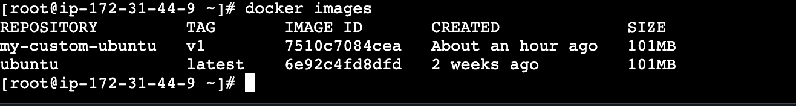

Create Docker image using alpine and customize with tomcat.
- Objective: Write a simple Dockerfile starting from a tiny Alpine Linux image, install Java, and unpack Apache Tomcat so it runs as a web server.
- Scope: Creating a Dockerfile, building the image, and starting a container on port 8080.
- What, Where & When:
What is changed: A custom image is built containing Alpine OS, Java 11, and Tomcat 9 inside /opt/tomcat.
Where to look for changes: Check docker images in your terminal and visit http://<SERVER_IP>:8080 in your browser.
When is it changed: Built during docker build, and running live when docker run executes.
Pin-to-Pin Steps & Command Breakdown
- Create a folder for this task and enter it:
mkdir tomcat-folder
cd tomcat-folder
- Command Breakdown:
mkdir tomcat-folder: Makes a new directory named tomcat-folder.
cd tomcat-folder: Changes your current directory to go inside tomcat-folder.
How to verify: Run pwd to confirm you are inside tomcat-folder.
- Create and edit the Dockerfile:
vi Dockerfile
- Paste these lines and save (Esc, then type :wq and press Enter):
FROM alpine:3.18
RUN apk update
RUN apk add openjdk11-jre wget tar bash
RUN mkdir /opt/tomcat
WORKDIR /opt/tomcat
RUN wget https://archive.apache.org/dist/tomcat/tomcat-9/v9.0.86/bin/apache-tomcat-9.0.86.tar.gz
RUN tar -xvzf apache-tomcat-9.0.86.tar.gz
RUN mv apache-tomcat-9.0.86/* /opt/tomcat/
EXPOSE 8080
CMD ["/opt/tomcat/bin/catalina.sh", "run"]
- Dockerfile Instruction Breakdown:
FROM alpine:3.18: Starts with the lightweight Alpine Linux version 3.18 base image.
RUN apk update: Refreshes Alpine's package manager (apk) list of software.
RUN apk add openjdk11-jre wget tar bash: Installs Java 11 (required by Tomcat), wget (to download files), tar (to unzip files), and bash (needed to run Tomcat scripts).
RUN mkdir /opt/tomcat: Creates a folder /opt/tomcat inside the image.
WORKDIR /opt/tomcat: Moves into /opt/tomcat so all following commands run inside that folder.
RUN wget https://...: Downloads the official Apache Tomcat 9 zip file from the internet.
RUN tar -xvzf apache-tomcat-9.0.86.tar.gz: Extracts (-x), shows progress (-v), uncompresses gzip (-z), from the file (-f).
RUN mv apache-tomcat-9.0.86/* /opt/tomcat/: Moves all extracted Tomcat files directly into /opt/tomcat/.
EXPOSE 8080: Documents that the container listens on port 8080.
CMD ["/opt/tomcat/bin/catalina.sh", "run"]: The startup command that turns Tomcat on when the container starts.
How to verify: Run cat Dockerfile to confirm the text is saved properly.
- Build the image:
docker build -t my-alpine-tomcat:v1 .
- Command Breakdown:
docker build: Reads the Dockerfile and builds an image step by step.
-t my-alpine-tomcat:v1: -t means "tag"—names the image my-alpine-tomcat with version v1.
.: The dot tells Docker to look for the Dockerfile in your current folder.
How to verify: Run docker images and see my-alpine-tomcat listed.
- Start the Tomcat container:
docker run -d -p 8080:8080 --name my-tomcat my-alpine-tomcat:v1
- Command Breakdown:
docker run: Starts a new container.
-d: Detached mode—runs the container in the background so your terminal stays free.
-p 8080:8080: Port forwarding—connects port 8080 on your Linux server to port 8080 inside the container.
--name my-tomcat: Names the running container my-tomcat.
my-alpine-tomcat:v1: The image to run.
How to verify: Run curl http://localhost:8080 and see HTML output from Tomcat.
You built a working Tomcat web server image from scratch on top of Alpine Linux using basic Dockerfile instructions.
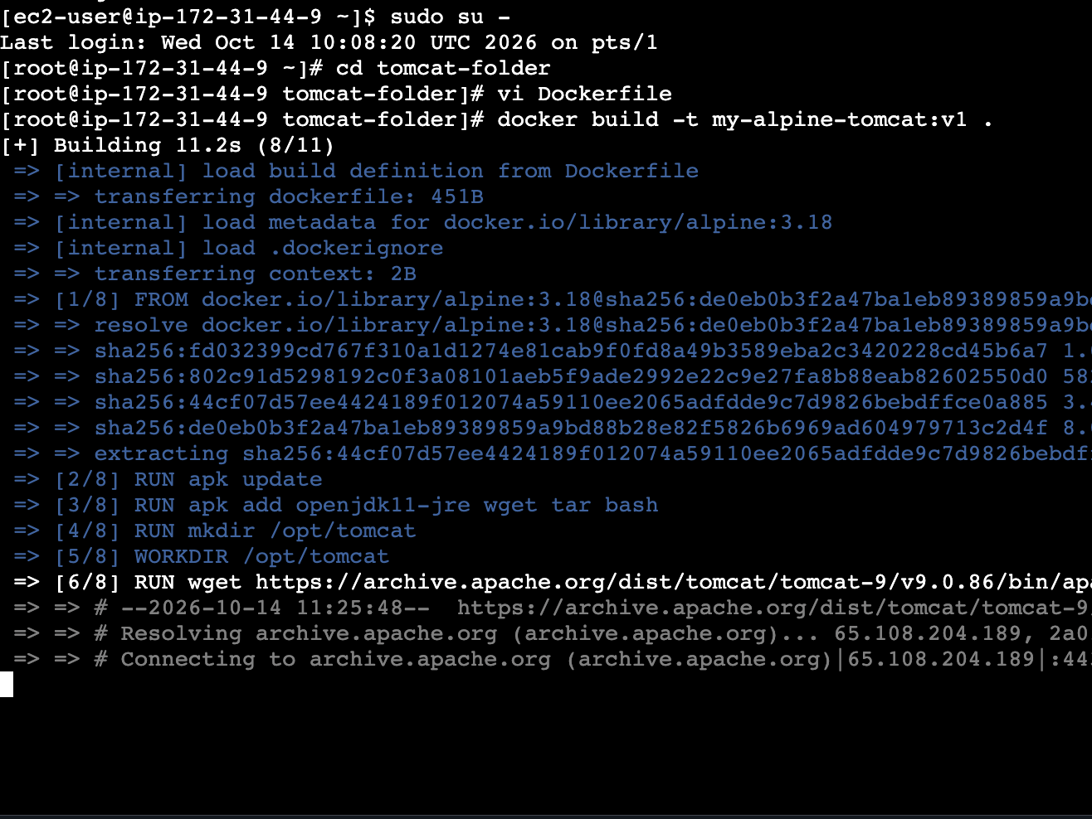

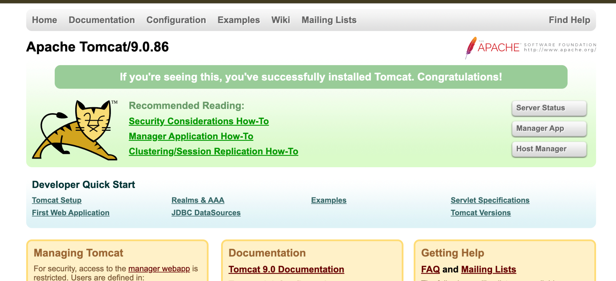

Create single stage and multi stage docker file using this source code
https://github.com/betawins/multi-stage-example.git

The Question / Objective
Build the sample Java application from the provided GitHub repository ([https://github.com/betawins/multi-stage-example.git](https://github.com/betawins/multi-stage-example.git)) in two different ways:
- Single-Stage Build: Keeps the build tools (Maven) and source code inside the final production image, resulting in a large image size.
- Multi-Stage Build: Uses Stage 1 to compile the code with Maven, and Stage 2 to copy only the final .jar file into a clean, lightweight runtime image, resulting in a significantly smaller image size.

Scope
Cloning a Git repository, writing two separate Dockerfiles (Dockerfile.single and Dockerfile.multi), building both images, and comparing their final file sizes using the Docker CLI.

What, Where & When Changed
- What is changed:
  - Single-Stage: The final container retains the heavy Maven compiler, source files, and dependencies.
  - Multi-Stage: The build tools are discarded, and only the compiled Java application binary (.jar) is packaged into the final runtime image.
- Where to look for changes: In the SIZE column on the far right when running docker images.
- When is it changed: Immediately after executing each respective docker build command.

Pin-to-Pin Steps & Command Breakdown

Step 1: Download the source code from GitHub
Bash
cd ~
git clone https://github.com/betawins/multi-stage-example.git
cd multi-stage-example

- Command Breakdown:
  - cd ~: Changes directory to your home folder.
  - git clone <URL>: Downloads the project files from GitHub onto your server.
  - cd multi-stage-example: Enters the newly downloaded project directory.
- How to verify: Run ls and confirm you see pom.xml and the src folder.

Step 2: Create the Single-Stage Dockerfile (Dockerfile.single)
Bash
vi Dockerfile.single

Paste these exact lines, save, and exit (Esc, then type :wq and press Enter):
Dockerfile
FROM maven:3.8.5-openjdk-17
WORKDIR /app
COPY . .
RUN mvn clean package
EXPOSE 8080
CMD ["java", "-jar", "target/spring-boot-web.jar"]

- Instruction Breakdown:
  - FROM maven:3.8.5-openjdk-17: Pulls a heavy base image containing both Java 17 and the Maven build tools.
  - WORKDIR /app: Creates and sets /app as the active working directory inside the container.
  - COPY . .: Copies all files from your current Linux folder (first dot) into the container's working directory (second dot).
  - RUN mvn clean package: Compiles the Java source code and packages it into a .jar file inside the target/ directory.
  - EXPOSE 8080: Documents that the application listens on port 8080.
  - CMD ["java", "-jar", "..."]: Specifies the command to execute when the container starts.

Step 3: Build the Single-Stage Image
Bash
docker build -f Dockerfile.single -t java-app:single .

- Command Breakdown:
  - docker build: Tells Docker to build an image.
  - -f Dockerfile.single: -f specifies a custom Dockerfile filename instead of the default Dockerfile.
  - -t java-app:single: Tag (-t) names the image java-app with the version tag single.
  - .: Tells Docker to use the current folder as the build context.
- How to verify: Run docker images and confirm java-app with tag single appears in your list.

Step 4: Create the Multi-Stage Dockerfile (Dockerfile.multi)
Bash
vi Dockerfile.multi

Paste these exact lines, save, and exit (Esc, then type :wq and press Enter):
Dockerfile
# Stage 1: Build the code
FROM maven:3.8.5-openjdk-17 AS builder
WORKDIR /app
COPY . .
RUN mvn clean package

# Stage 2: Create a tiny final runtime image
FROM openjdk:17-jdk-slim
WORKDIR /app
COPY --from=builder /app/target/*.jar app.jar
EXPOSE 8080
CMD ["java", "-jar", "app.jar"]

- Instruction Breakdown:
  - FROM maven:3.8.5-openjdk-17 AS builder: Starts Stage 1 and gives it the alias builder.
  - RUN mvn clean package: Compiles the application inside Stage 1.
  - FROM openjdk:17-jdk-slim: Starts Stage 2 using a lightweight Java runtime image (omitting Maven and source files entirely).
  - COPY --from=builder /app/target/*.jar app.jar: Reaches back into Stage 1 (--from=builder), extracts only the compiled .jar file, and places it into Stage 2 as app.jar.

Step 5: Build the Multi-Stage Image and Compare Sizes
Bash
docker build -f Dockerfile.multi -t java-app:multi .
docker images

- Command Breakdown:
  - docker build -f Dockerfile.multi -t java-app:multi .: Builds the second image using the multi-stage file.
  - docker images: Lists all local images so you can compare their file sizes side by side.
- How to verify: Look at the SIZE column on the right. You will see that java-app:multi is hundreds of megabytes smaller than java-app:single.

Conclusion for Task 4
By implementing a multi-stage build, we separated the build environment (which requires heavy compilers like Maven and SDKs) from the runtime environment (which only needs a lightweight JRE). This successfully reduces the final container image size, lowers security risks by removing unnecessary source files, and optimizes storage and deployment speeds.

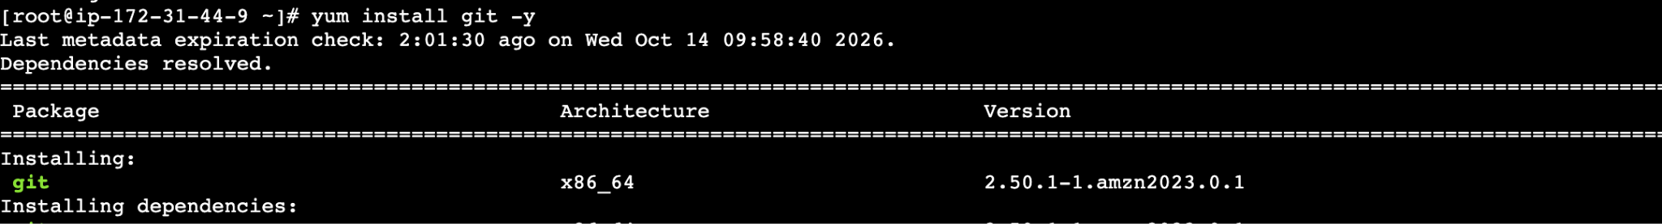

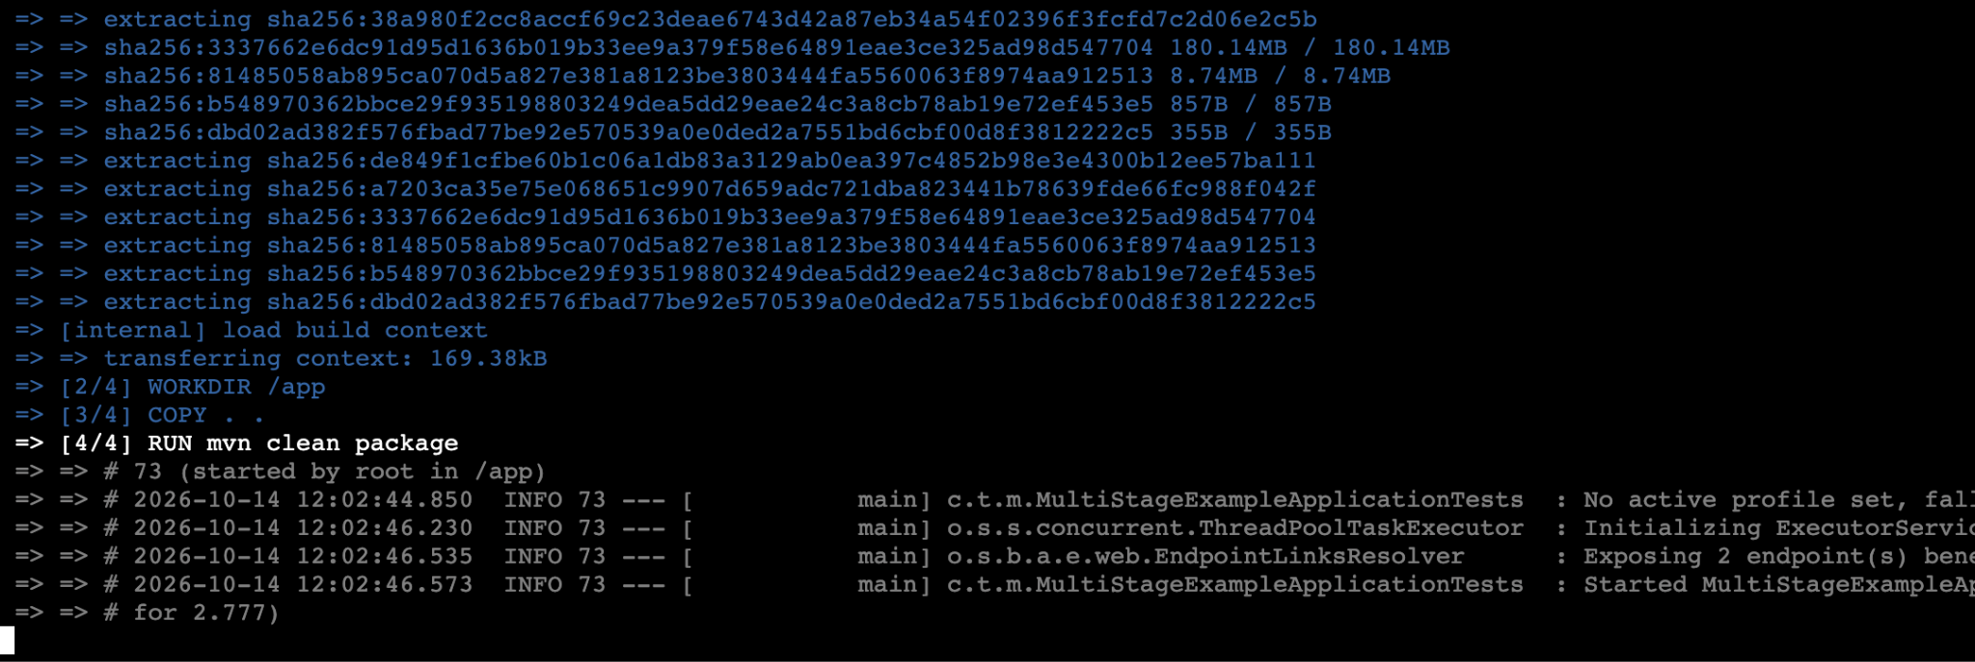

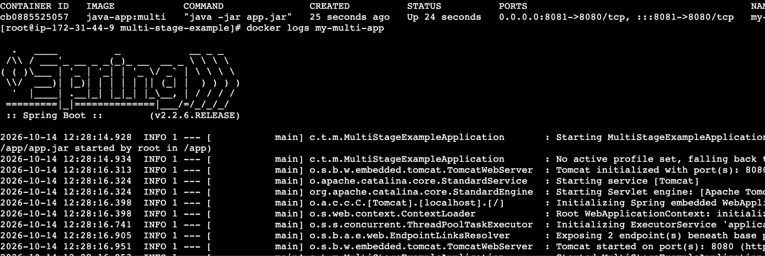

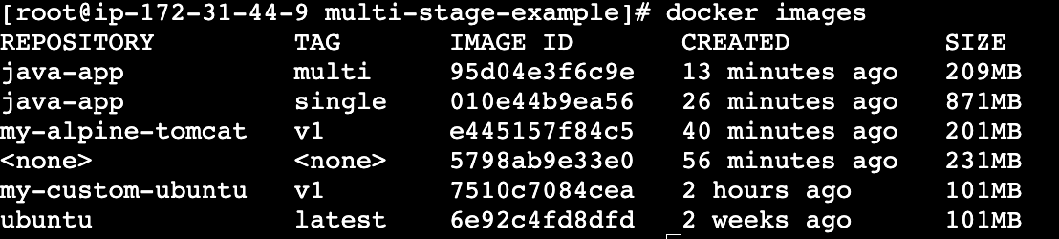

Install docker compose and execute sample application.
- Download docker-compose:
- Bash
sudo curl -L "https://github.com/docker/compose/releases/download/v2.24.0/docker-compose-linux-x86_64" -o /usr/local/bin/docker-compose

  - Command Breakdown:
    - sudo: Runs the command as administrator (root).
    - curl -L "https://...": Downloads the file from the URL (-L follows any website redirects).
    - -o /usr/local/bin/docker-compose: Saves the downloaded file into /usr/local/bin/ with the name docker-compose.
  - How to verify: Download reaches 100%.
- Make the downloaded file executable:
- Bash
sudo chmod +x /usr/local/bin/docker-compose

  - Command Breakdown:
    - chmod +x: Adds execute (+x) permission so Linux allows you to run docker-compose as a command.
  - How to verify: Run docker-compose --version and see Docker Compose version v2.24.0.
- Create a folder and write docker-compose.yml:
- Bash
mkdir ~/compose-test
cd ~/compose-test
vi docker-compose.yml

- Paste and save:
- YAML
version: '3'
services:
my-web:
image: nginx:alpine
ports:
- "8085:80"
my-db:
image: redis:alpine

  - YAML Breakdown:
    - services:: Defines the containers we want to run.
    - my-web: & my-db:: Names of our two services (web server and Redis database).
    - ports: - "8085:80": Connects port 8085 on the server to port 80 inside the Nginx container.
- Start both containers together:
- Bash
docker-compose up -d

  - Command Breakdown:
    - docker-compose up: Reads docker-compose.yml, creates the network, and starts all listed containers.
    - -d: Runs them in the background (detached mode).
  - How to verify: Run docker-compose ps to see both my-web and my-db in the Up state.
- Stop and remove the containers:
- Bash
docker-compose down

  - Command Breakdown:
    - docker-compose down: Stops and deletes all containers and networks created by up.
  - How to verify: Run docker ps and verify both containers are removed.
Instead of typing multiple docker run commands one by one, you used Docker Compose to start and stop multiple containers with one command.

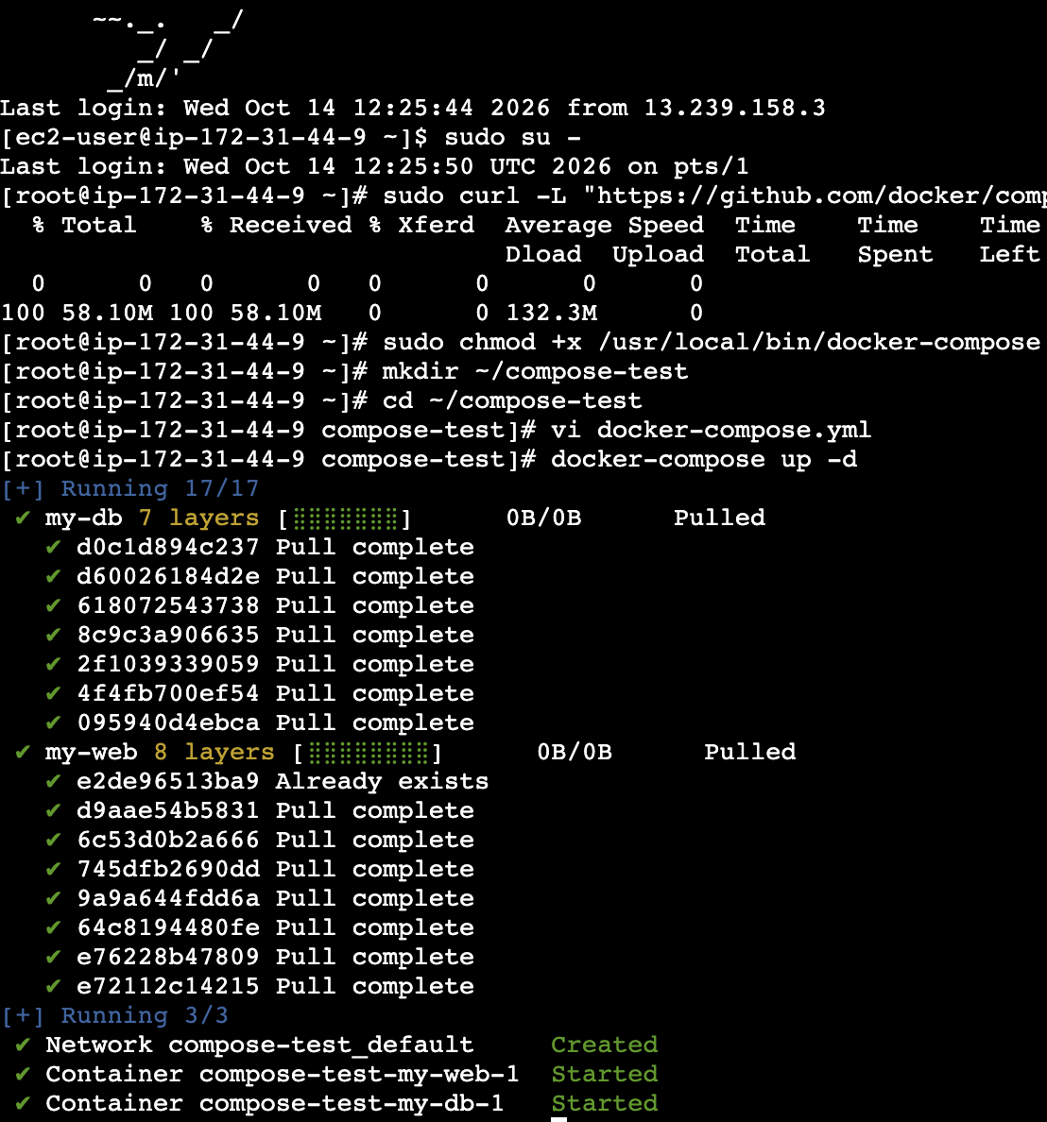

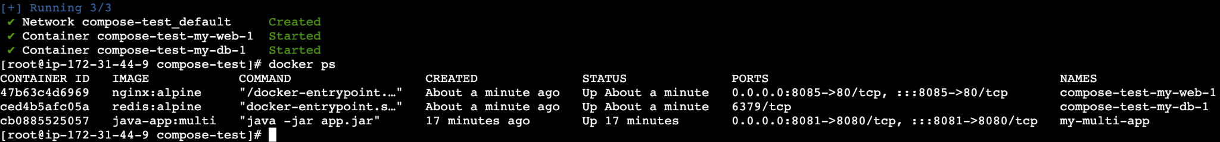

Implement solution to scan images when pushed to docker registry.

The Question / Objective
Implement an automated security workflow to scan local container images for Common Vulnerabilities and Exposures (CVEs) using Trivy before publishing them, and securely push the scanned image to a public or private Docker Hub repository.

Scope
Installing the Trivy vulnerability scanner on the Linux server, executing a static security analysis scan on a custom image (my-alpine-tomcat:v1), authenticating with Docker Hub via the Docker CLI, tagging the image with a valid Docker Hub namespace, and pushing the artifact.

What, Where & When Changed
- What is changed:

  - Local image layers are analyzed against a vulnerability vulnerability database.
  - The image is renamed (tagged) to match your Docker Hub username and uploaded to the cloud registry.
- Where to look for changes:
  - Vulnerability severity breakdown table printed directly in your terminal output.
  - Your repository dashboard online at hub.docker.com.
- When is it changed:
  - Scan findings appear immediately during the execution of trivy image.
  - The image record and layers appear on Docker Hub right after docker push completes.

Pin-to-Pin Steps & Command Breakdown

Step 1: Install the Trivy Vulnerability Scanner
Bash
curl -sfL https://raw.githubusercontent.com/aquasecurity/trivy/main/contrib/install.sh | sudo sh -s -- -b /usr/local/bin

- Command Breakdown:
  - curl -sfL <URL>: Downloads the official installation script silently (-s), failing quietly on server errors (-f), and following any URL redirects (-L).
  - | sudo sh -s -- -b /usr/local/bin: Pipes (|) the downloaded script directly into the shell interpreter (sh) with administrator privileges (sudo), placing the compiled trivy binary inside /usr/local/bin so it can be run globally.
- How to verify: Run trivy --version and confirm it prints the installed version number.

Step 2: Execute a Security Vulnerability Scan on the Image
Bash
trivy image my-alpine-tomcat:v1

- Command Breakdown:
  - trivy image: Instructs Trivy to perform a static artifact scan on a local container image.
  - my-alpine-tomcat:v1: The name and tag of the local image being scanned.
- How to verify: Trivy downloads its vulnerability database and outputs a categorized summary table showing any LOW, MEDIUM, HIGH, or CRITICAL software flaws found in the underlying OS packages or application libraries.

Step 3: Authenticate with Docker Hub
Bash
docker login

- Command Breakdown:
  - docker login: Connects your local Docker CLI daemon to the official Docker Hub registry. It prompts you interactively for your Docker Hub Username and Password (or Personal Access Token).
- How to verify: Terminal prints Login Succeeded.

Step 4: Tag the Image with Your Docker Hub Namespace
(Replace your-actual-username with your real Docker Hub username)

Bash
docker tag my-alpine-tomcat:v1 your-actual-username/my-alpine-tomcat:v1

- Command Breakdown:
  - docker tag: Creates a new alias/reference pointing to your existing local image.
  - my-alpine-tomcat:v1: The source local image name and tag.
  - your-actual-username/my-alpine-tomcat:v1: The required target naming convention for Docker Hub, where the prefix matches your exact user account name.
- How to verify: Run docker images and confirm both the original name and the new prefixed name appear in the list.

Step 5: Push the Scanned Image to Docker Hub
Bash
docker push your-actual-username/my-alpine-tomcat:v1

- Command Breakdown:
  - docker push: Uploads the image layers over the internet into your cloud repository on Docker Hub.
- How to verify: Watch the layer upload progress bars complete in your terminal, ending with the cryptographic digest hash string (e.g., sha256:...). You can also log into hub.docker.com in your web browser to confirm the image tag is visible under your repositories.

Conclusion for Task 6
By integrating Trivy, we established a crucial security checkpoint to inspect container images for known vulnerabilities before deployment. Following the scan, we authenticated with Docker Hub and published the verified image successfully, making it accessible for deployment or further cloud-based scanning pipelines.

Implement solution to scan images when pushed to AWS ECR.

If someone is looking at this for the very first time, jumping straight into pushing an image without knowing what AWS ECR actually is or how to set up the repository can be confusing.

What is Amazon ECR? (Beginner Overview)
- Amazon Elastic Container Registry (ECR) is a fully managed Docker container registry hosted by Amazon Web Services (AWS). It allows developers to store, manage, and deploy container images securely, similar to Docker Hub but integrated directly into your AWS cloud environment.
- Scan-on-Push: When enabled (scanOnPush=true), ECR automatically scans your container image for security vulnerabilities (CVEs) the exact moment the image upload finishes, giving you immediate security feedback without needing external tools.

The Objective
Authenticate your local server with AWS ECR, tag your local container image (my-alpine-tomcat:v1), push it to a pre-existing ECR repository (my-ecr-repo) in the ap-southeast-2 region, and verify the automated security scan findings.

Prerequisites & Environment Details
- Active Environment: An EC2 instance running Docker and an AWS CloudShell or CLI environment.
- AWS Region: ap-southeast-2 (Sydney)
- AWS Account ID: 131708658152
- Target Repository Name: my-ecr-repo (pre-created with scanOnPush=true)

Pin-to-Pin Steps & Command Breakdown

Step 1: Generate an ECR Login Token and Authenticate Docker
Because Docker cannot talk to AWS by default, you must authenticate your local Docker daemon with your private AWS ECR registry.

Bash
aws ecr get-login-password --region ap-southeast-2 | docker login --username AWS --password-stdin 131708658152.dkr.ecr.ap-southeast-2.amazonaws.com

- Command Breakdown:
  - aws ecr get-login-password: Requests a secure, temporary authentication token from AWS.
  - | (Pipe): Feeds that password directly into the Docker login command securely.
  - --username AWS: AWS ECR strictly requires the literal string AWS as the username.
  - --password-stdin: Tells Docker to accept the incoming token securely through the pipe.
  - 131708658152.dkr.ecr.ap-southeast-2.amazonaws.com: Your unique AWS ECR registry endpoint URL.
- How to verify: The terminal prints Login Succeeded.

Step 2: Tag Your Local Image to Match the ECR Registry URI
Docker needs to know which remote repository and cloud address your local image belongs to before it can push it.

Bash
docker tag my-alpine-tomcat:v1 131708658152.dkr.ecr.ap-southeast-2.amazonaws.com/my-ecr-repo:v1

- Command Breakdown
  - docker tag: Creates a reference pointer to your existing local image.
  - my-alpine-tomcat:v1: Your original local image name and version tag.
  - [131708658152.dkr.ecr.ap-southeast-2.amazonaws.com/my-ecr-repo:v1](https://131708658152.dkr.ecr.ap-southeast-2.amazonaws.com/my-ecr-repo:v1): The mandatory naming format for ECR, combining your AWS Account ID, registry domain, repository name, and tag.
- How to verify: Run docker images and ensure the fully qualified ECR image name appears in your local list.

Step 3: Push the Image to AWS ECR
Upload your local container image layers up to your private cloud repository in AWS.

Bash
docker push 131708658152.dkr.ecr.ap-southeast-2.amazonaws.com/my-ecr-repo:v1

- Command Breakdown:
  - docker push: Uploads the image blocks (layers) over the internet into AWS ECR.
- How to verify: Watch the layer progress bars complete, ending with a cryptographic SHA-256 digest hash. Because scanOnPush=true is active on my-ecr-repo, AWS instantly triggers an automated security scan.

Step 4: Retrieve and Review the Automated Image Security Scan Results
Check the security report generated by AWS to see if any vulnerabilities were detected.

Bash
aws ecr describe-image-scan-findings \
--repository-name my-ecr-repo \
--image-id imageTag=v1 \
--region ap-southeast-2

- Command Breakdown:

  - aws ecr describe-image-scan-findings: Queries AWS for the vulnerability report of a specific image.
  - --repository-name my-ecr-repo: The name of your cloud repository.
  - --image-id imageTag=v1: Targets the specific image version tag
  - --region ap-southeast-2: Specifies the region.
- How to verify: The terminal outputs a JSON document showing imageScanStatus: { "status": "COMPLETE" } and breaking down any findings by severity (CRITICAL, HIGH, MEDIUM, LOW).

Conclusion for Task 7
By establishing this workflow, beginners can understand how local container images transition from a local development server into a secure, enterprise-grade cloud repository like Amazon ECR, complete with automated vulnerability auditing.

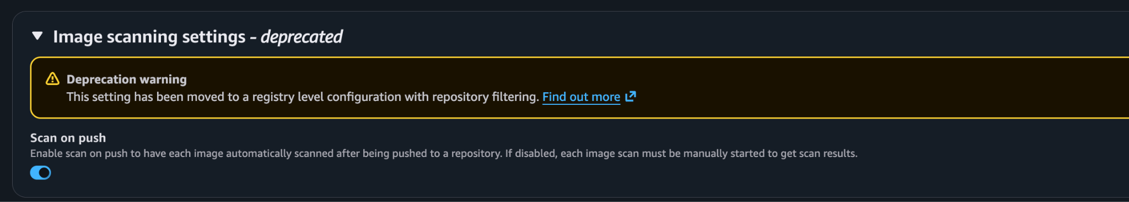

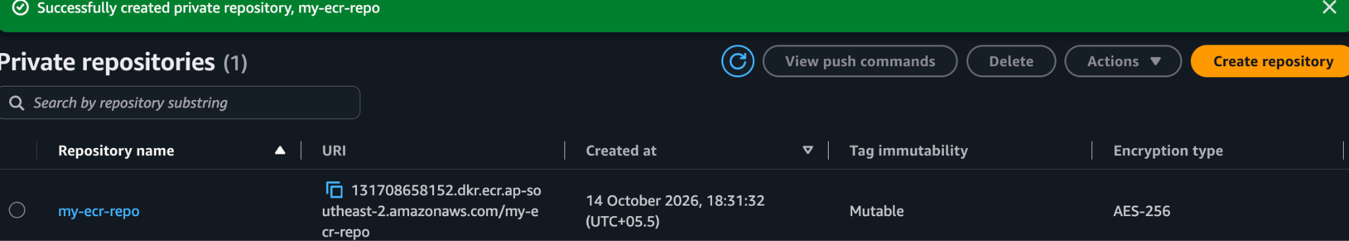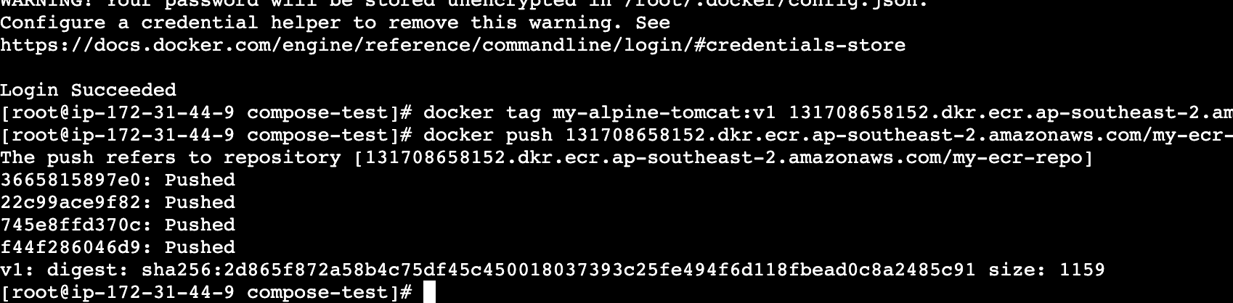

Create a Jenkins pipeline to create a docker image and push the image to Docker hub.

In order to complete this task, we need Java along with Jenkins installed in our EC2 instance. And then we have to get login here with the help of the predefined password which is been allocated the time when we are installing the Jenkins. We have to paste the password here in order to login and we have to install the Jenkins in build plugins to run the pipeline
What is a Jenkins Pipeline? (Beginner Overview)
- Jenkins Pipeline is a suite of plugins that allows you to define your entire build, test, and deployment workflow using code inside a Jenkinsfile.
- The Goal: Instead of running manual terminal commands, we automate the process so Jenkins handles building the container, authenticating with Docker Hub using securely stored credentials, and publishing the image automatically.

The Objective
Write and execute a Declarative Jenkins Pipeline on an AWS EC2 instance (running Java 21 and Docker) to build a custom Docker image from a Dockerfile workspace and push it directly to Docker Hub.

Prerequisites & Environment Details
- Active Environment: AWS EC2 instance running Jenkins (v2.580.1) configured with Java 21 (java-21-amazon-corretto) and Docker.
- Jenkins Workspace: /var/lib/jenkins/workspace/Docker (where Jenkins looks for project source files).
- Credentials Required: A saved global credential ID in Jenkins named dockerhub-credentials (Username with password).
- Target Image Tag: sreedocker95/my-alpine-tomcat:v1

Pin-to-Pin Steps & Command Breakdown

Step 1: Add Docker Hub Credentials to Jenkins
- Log into your Jenkins Dashboard (http://<YOUR-EC2-IP>:8080).
- Go to Manage Jenkins > Credentials > System > Global credentials (unrestricted).
- Click Add Credentials and configure:
  - Kind: Username with password
  - Username: Your Docker Hub username (sreedocker95)
  - Password: Your Docker Hub password or Personal Access Token
  - ID: dockerhub-credentials (Must match this exact ID)
- Click Create.

Step 2: Prepare the Workspace Directory for Jenkins
Because Jenkins looks inside its specific workspace directory for project files, ensure your Dockerfile is copied into the job's workspace:
sudo mkdir -p /var/lib/jenkins/workspace/Docker
sudo cp /root/tomcat-folder/Dockerfile /var/lib/jenkins/workspace/Docker/
sudo chown -R jenkins:jenkins /var/lib/jenkins/workspace/Docker/

- Command Breakdown:
  - sudo cp: Copies your source Dockerfile from its local creation path into the active Jenkins job workspace directory.
  - sudo chown: Grants ownership of the workspace files to the jenkins system user so the Jenkins daemon has permission to read them during builds.

Step 3: Create and Configure the Jenkins Pipeline Job
- Go back to the Jenkins Home page and click New Item.
- Name your job (e.g., Docker), select Pipeline, and click OK.
- Scroll down to the Pipeline section, set Definition to Pipeline script, and paste the following declarative script:
pipeline {
agent any

environment {
DOCKERHUB_CREDENTIALS = credentials('dockerhub-credentials')
IMAGE_NAME = 'sreedocker95/my-alpine-tomcat'
IMAGE_TAG = 'v1'
}

stages {
stage('Verify Directory & Dockerfile') {
steps {
echo 'Checking workspace files...'
sh 'pwd && ls -la'
}
}

stage('Build Docker Image') {
steps {
echo 'Building the Docker image...'
sh "docker build -t $IMAGE_{N}AME:${IMAGE_TAG} ."
}
}

stage('Login to Docker Hub') {
steps {
echo 'Logging into Docker Hub...'
sh 'echo "$DOCKERHUB_{C}REDENTIALS_{P}SW"|dockerlogin-u"$DOCKERHUB_CREDENTIALS_USR" --password-stdin'
}
}

stage('Push Docker Image') {
steps {
echo 'Pushing image to Docker Hub...'
sh "docker push $IMAGE_{N}AME:${IMAGE_TAG}"
}
}
}

post {
success {
echo 'Pipeline completed successfully! Image pushed to Docker Hub.'
}
failure {
echo 'Pipeline failed. Check console logs.'
}
}
}

- Pipeline Script Breakdown:
  - Verify Directory & Dockerfile: Prints the current directory and checks that the Dockerfile is present in the workspace.
  - Build Docker Image: Executes standard docker build using the local workspace context (.).
  - Login to Docker Hub: Securely unwraps the Jenkins credential block using _USR and _PSW suffixes to authenticate via docker login without exposing secrets in logs.
  - Push Docker Image: Uploads the built layers to your Docker Hub repository.

Step 4: Run and Verify the Pipeline
- Click Save, then click Build Now on the left menu.
- Click the active build number under Build History, then click Console Output to monitor the execution.
- Confirm that the final status displays Finished: SUCCESS.
- Log into Docker Hub to verify that your repository and tag (sreedocker95/my-alpine-tomcat:v1) are successfully published.

Conclusion for Task 8
By setting up a version-controlled Jenkins Pipeline integrated with proper workspace file management and secure credential handling, we achieved a fully automated CI/CD loop that builds container images and pushes them directly to Docker Hub.
