Install Jenkins and run Jenkins on port number 8081.
Install Java JDK 21 and jenkins, from documentation.
Systemctl edit jenkins.
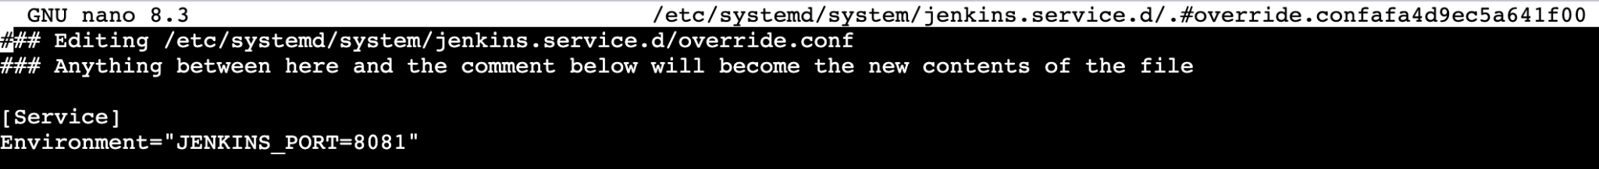
[Service]
Environment="JENKINS_PORT=8081"
control+o
enter
control+x
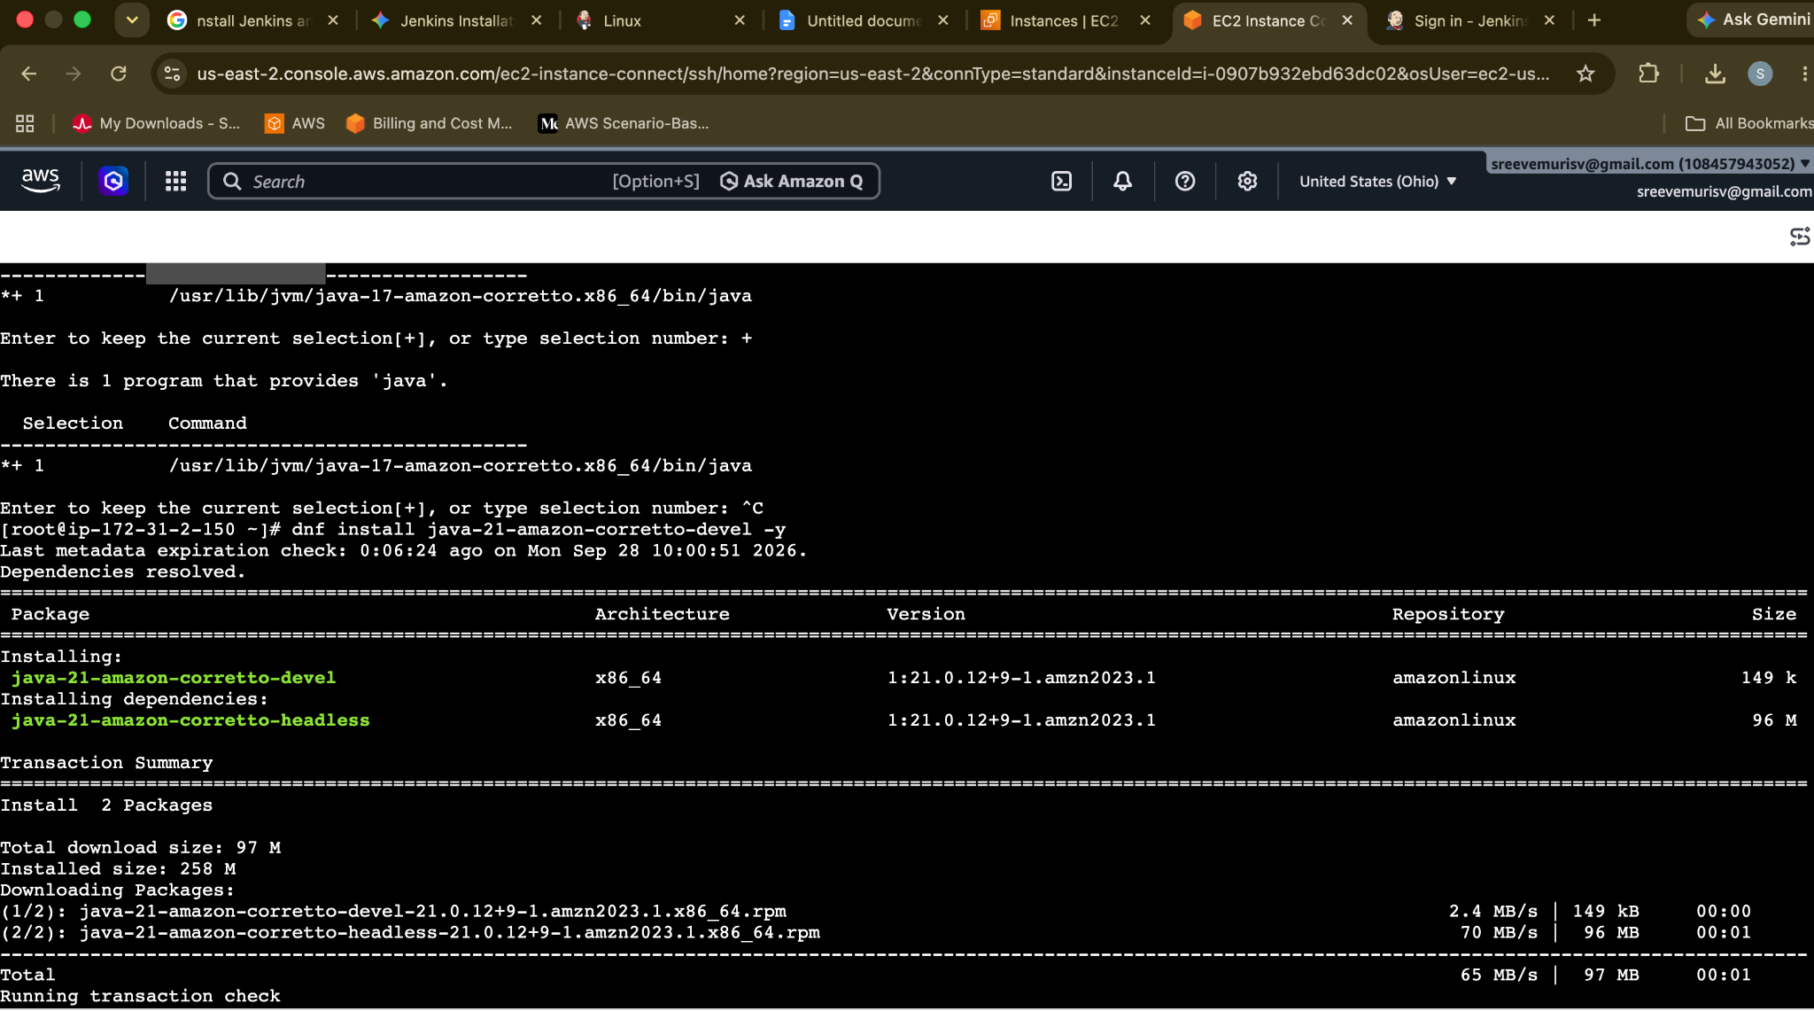
Copy the IPv4 url with port 8081
And also look for Inbound Security rule for that ec2 instance
8081– Port and CustomTCP
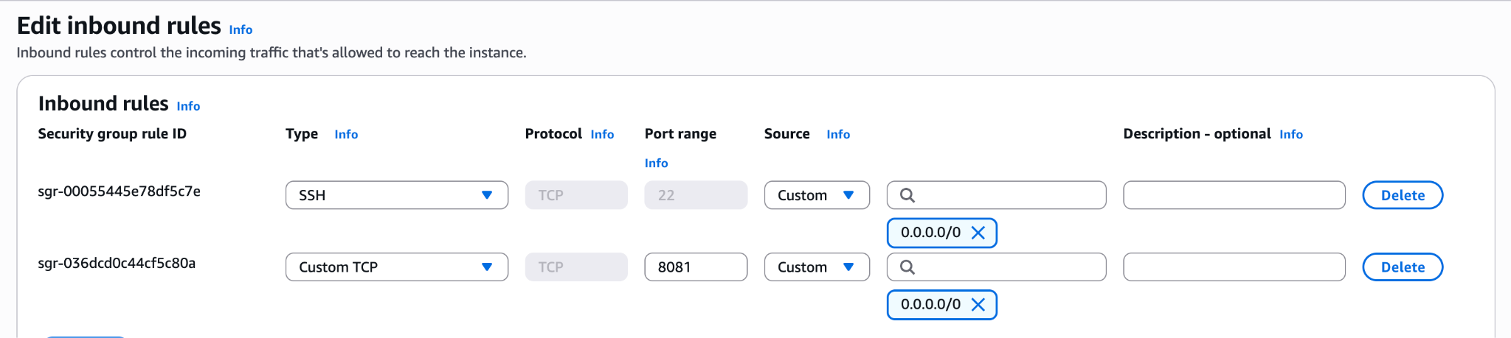
http://3.145.166.167:8081
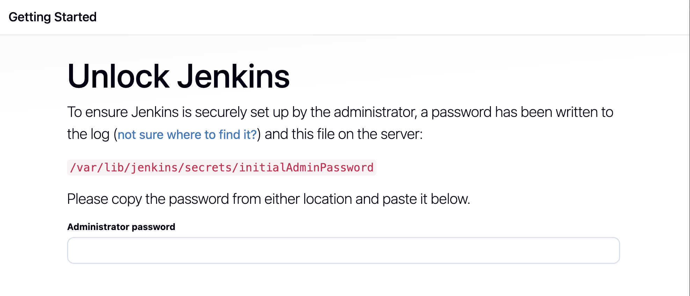
cd /var/lib/jenkins
cd secrets/
cat initalAdminPassword
Secure Jenkins server
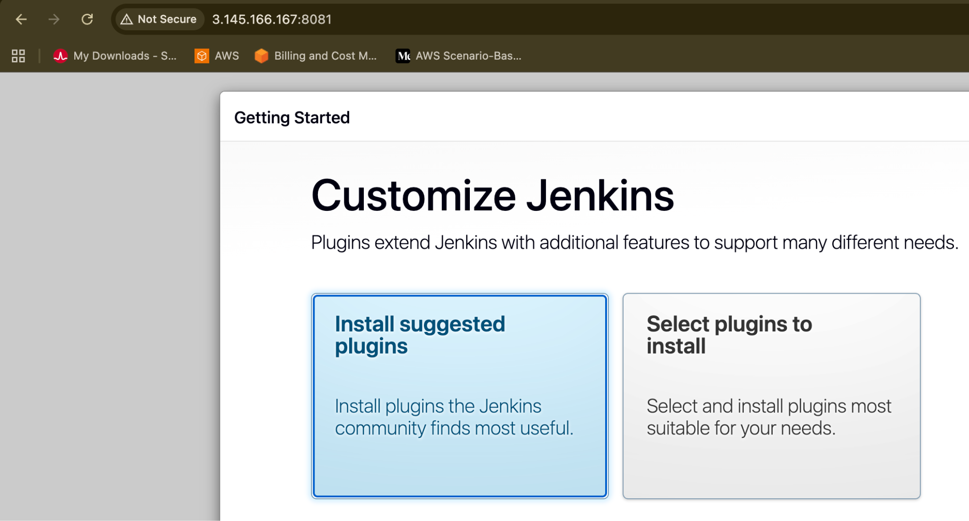
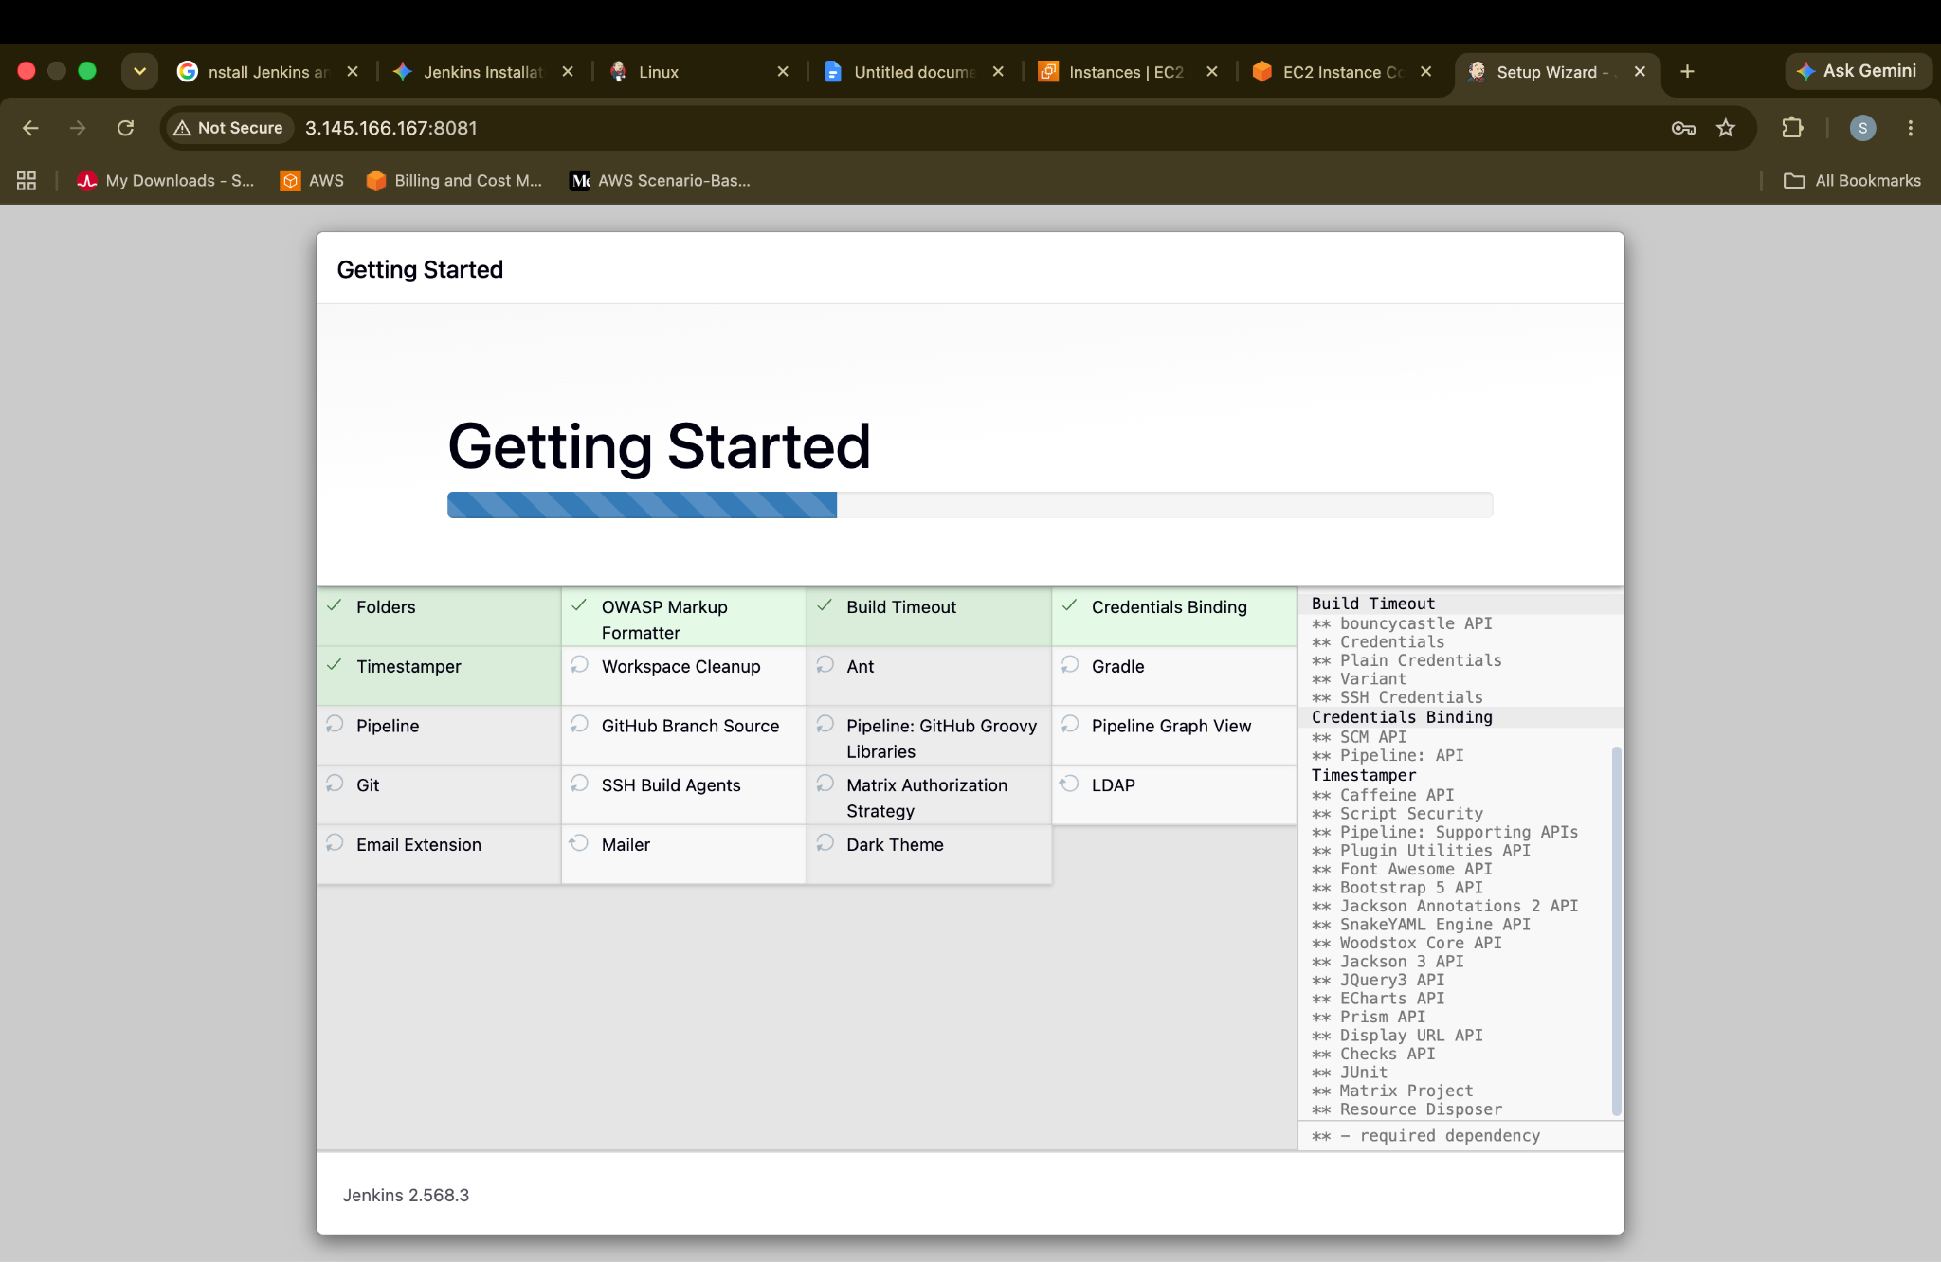
Keep all as admin and sreevemurisv@gmail.com save
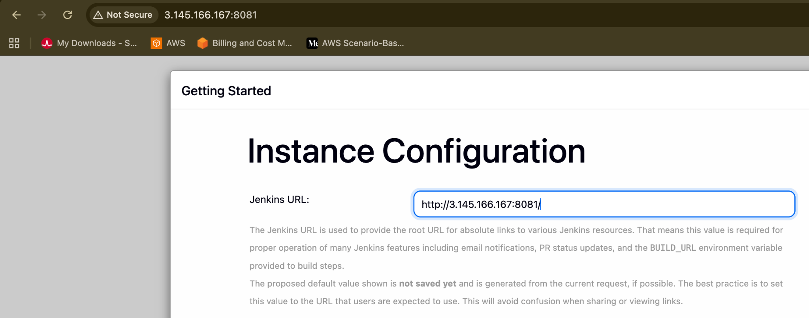
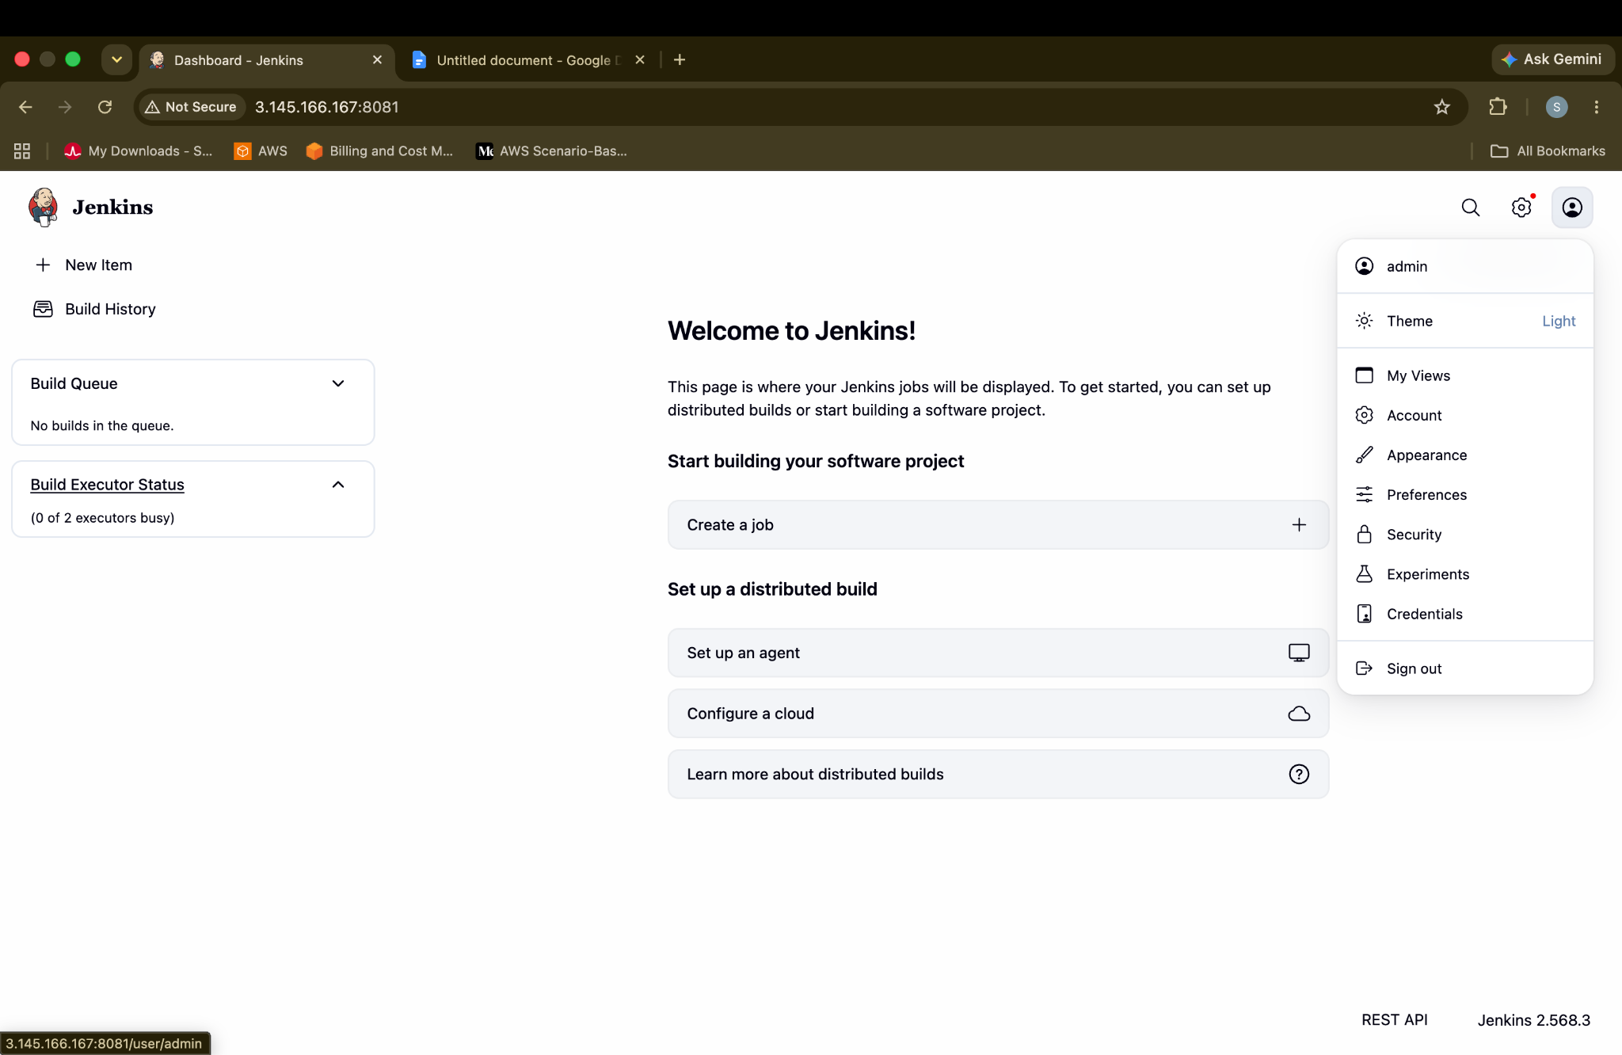
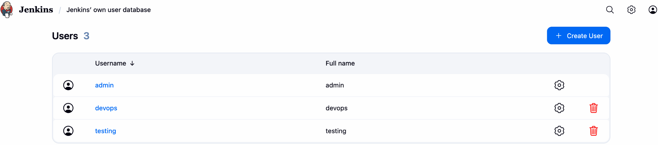
Securing the Jenkins admin password by updating to pradeep
Manage jenkins → users → admin → security → edit password & confirm password → Save
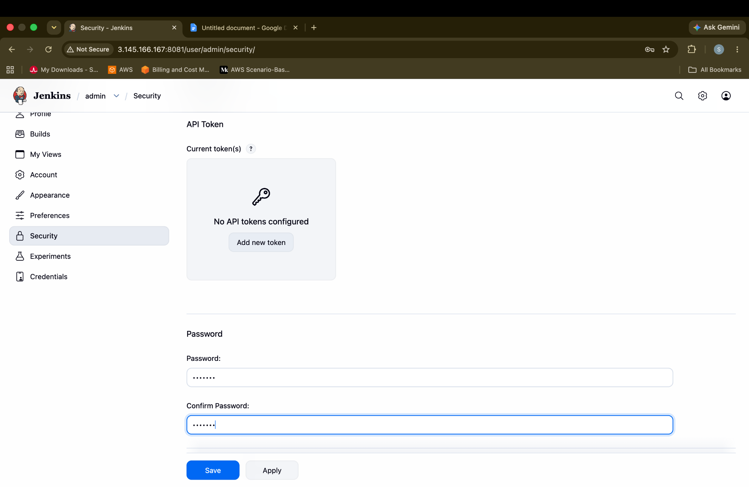
Create users called DevOps, Testing in Jenkins with Limited access.
Install
Plugin →” Role-based Authorization Strategy.”
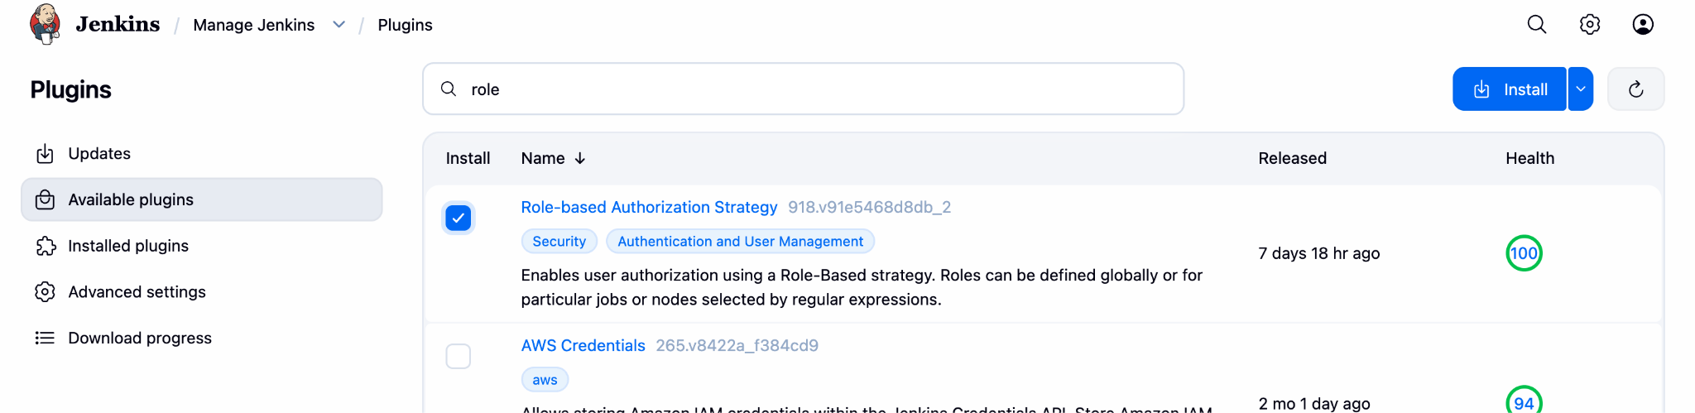
Once Installed
Navigate to Users and create users
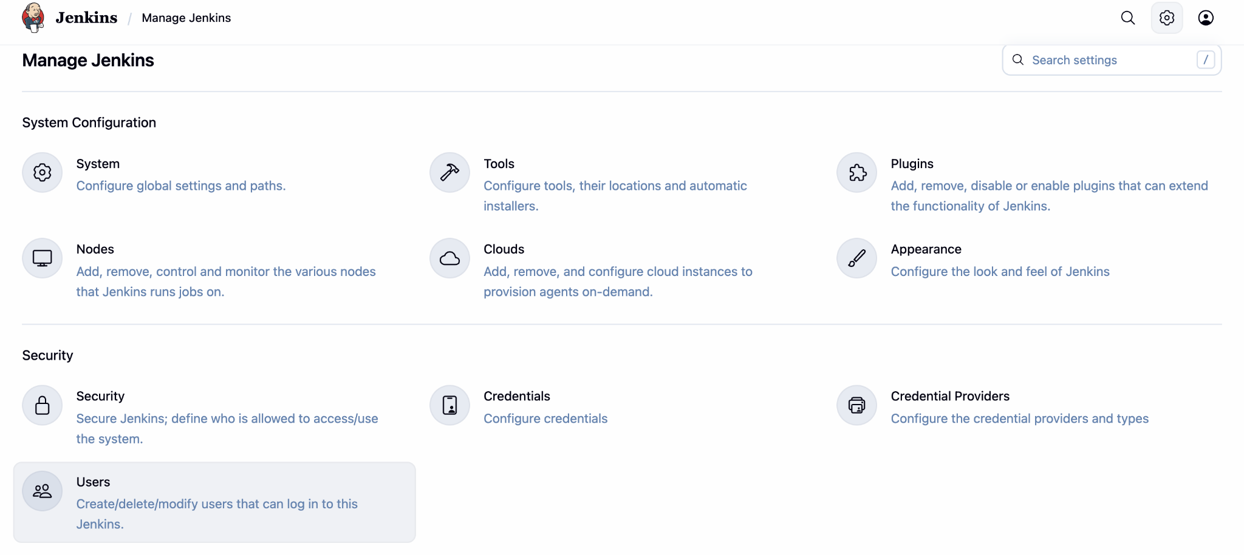
Managed jenkins → user → create user
Click on
create user → devops → sreevemurisv@gmail.com
create user → testing→ sreevemurisv@gmail.com
Now limit the access → for devops and testing
Manage Jenkins → security
Authorization:
Select dropdown → project based Matrix Authorization Stratergy.
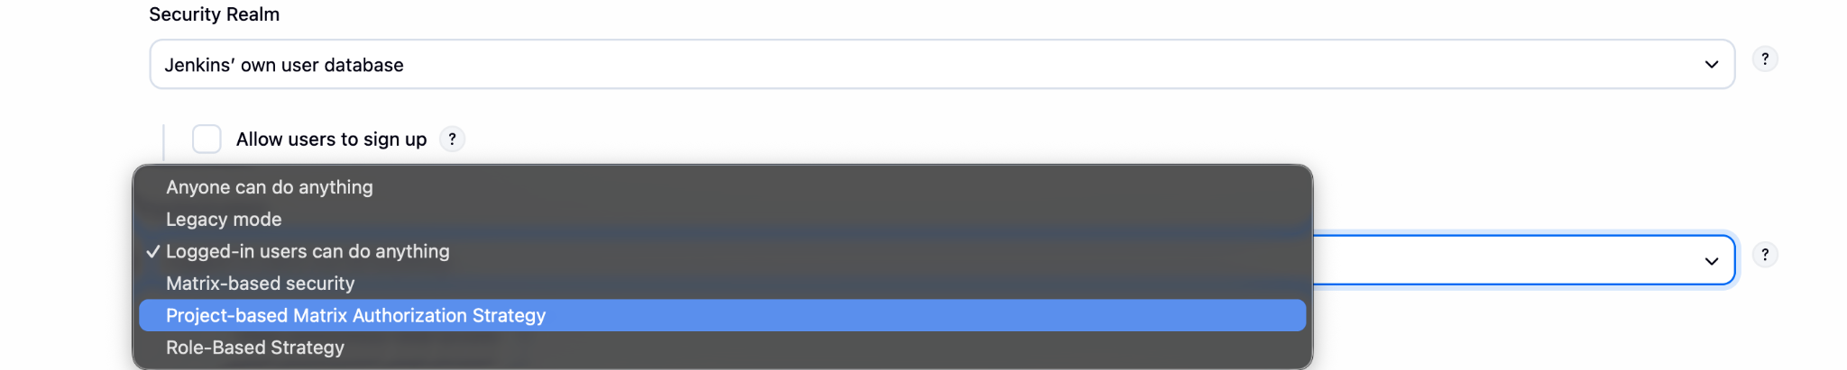
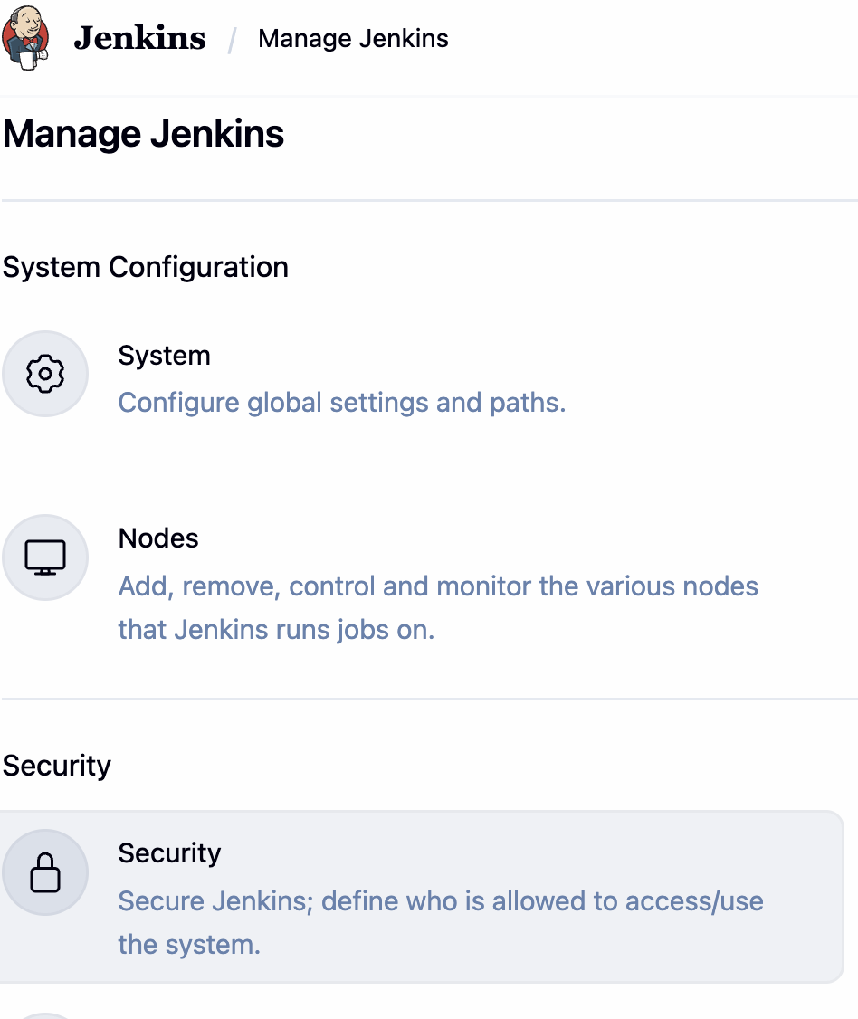
Security → Authorization → Role-based Authorization strategy —> Adduser
Security → Authorization → Role-based Authorization strategy —> Adduser → testing
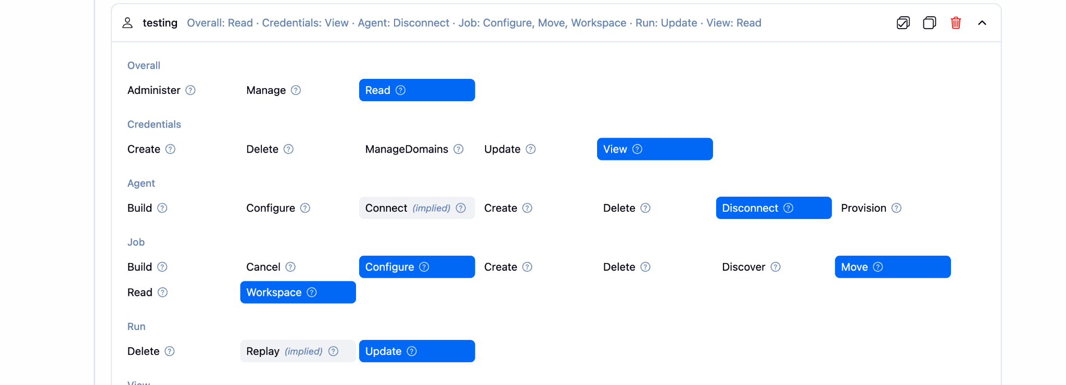
Security → Authorization → Role-based Authorization strategy —> Adduser → devops
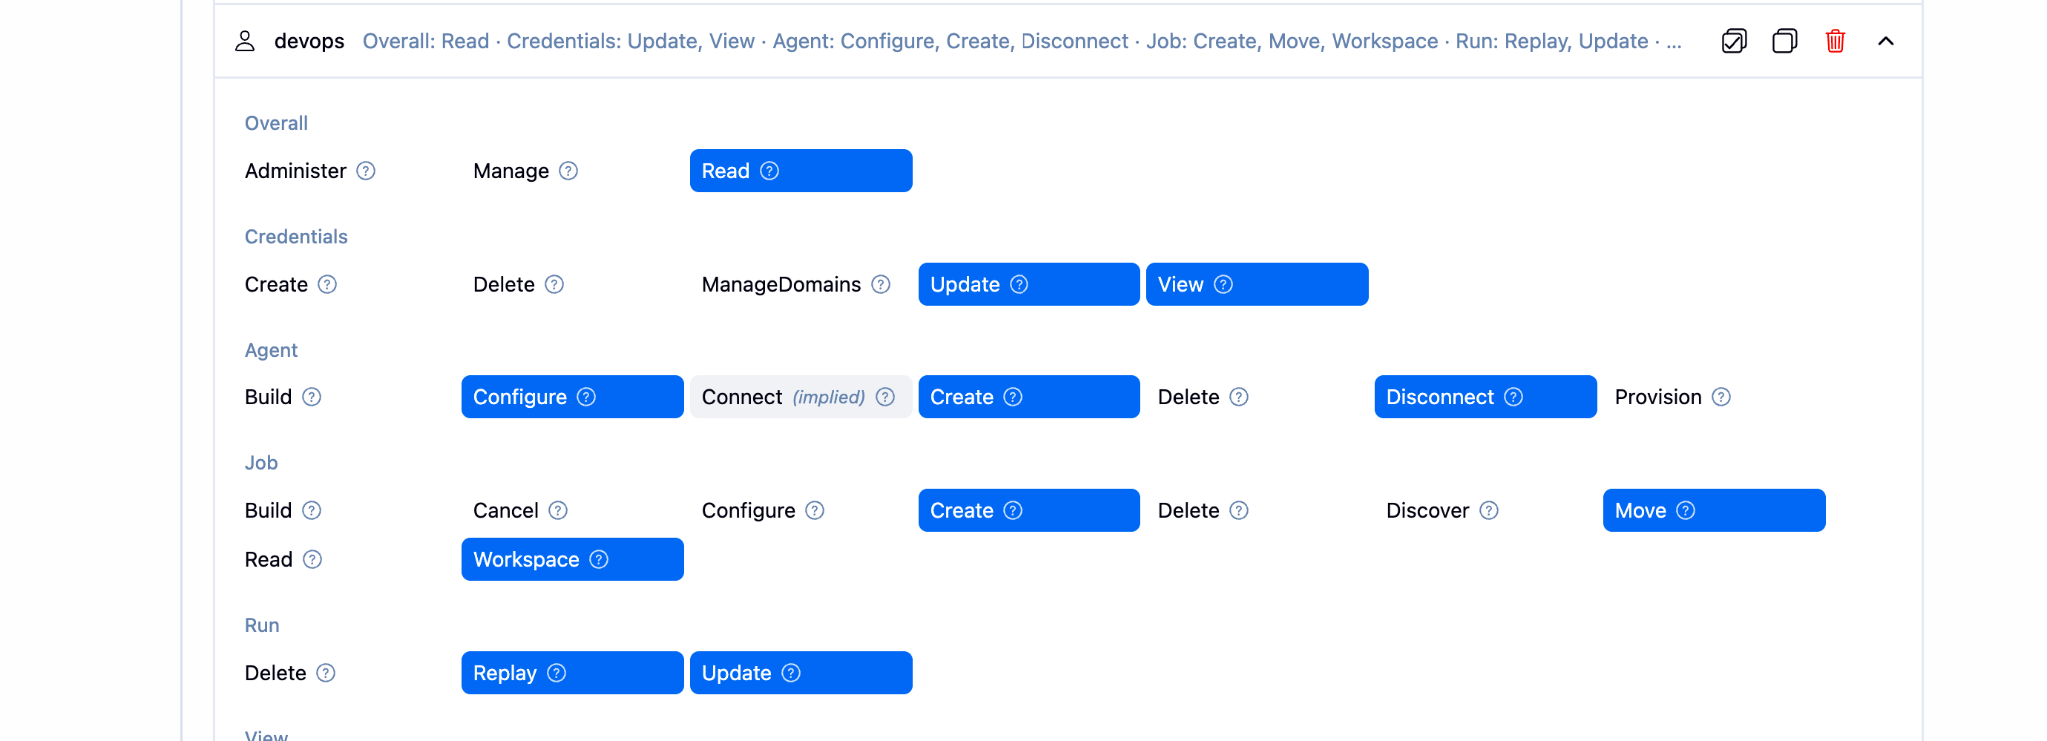
and save .

Configure labels and restrict the jobs to execute based on label only.
Install → node and label parameter
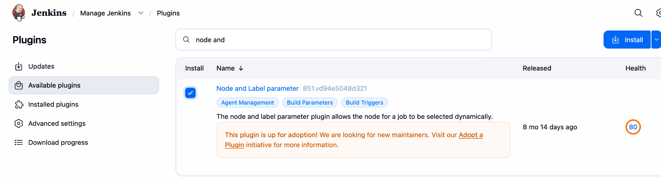
Manage Jenkins → nodes → Built-in-Node → Configuration → Labels → Save
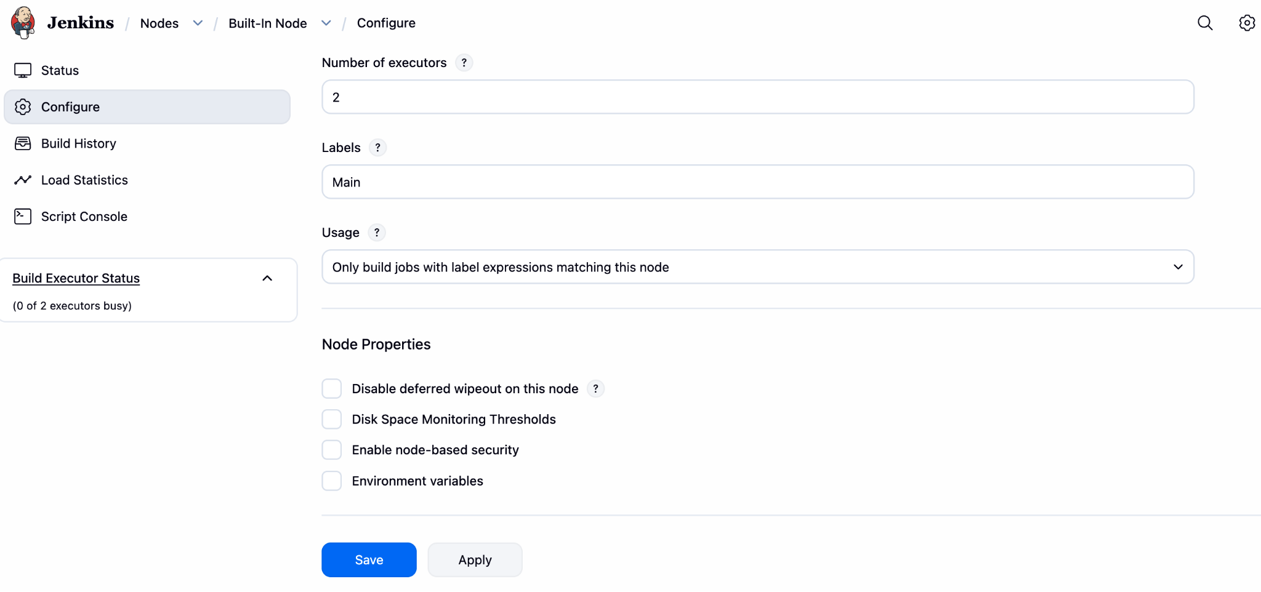
Create the 1st_job given Name Main
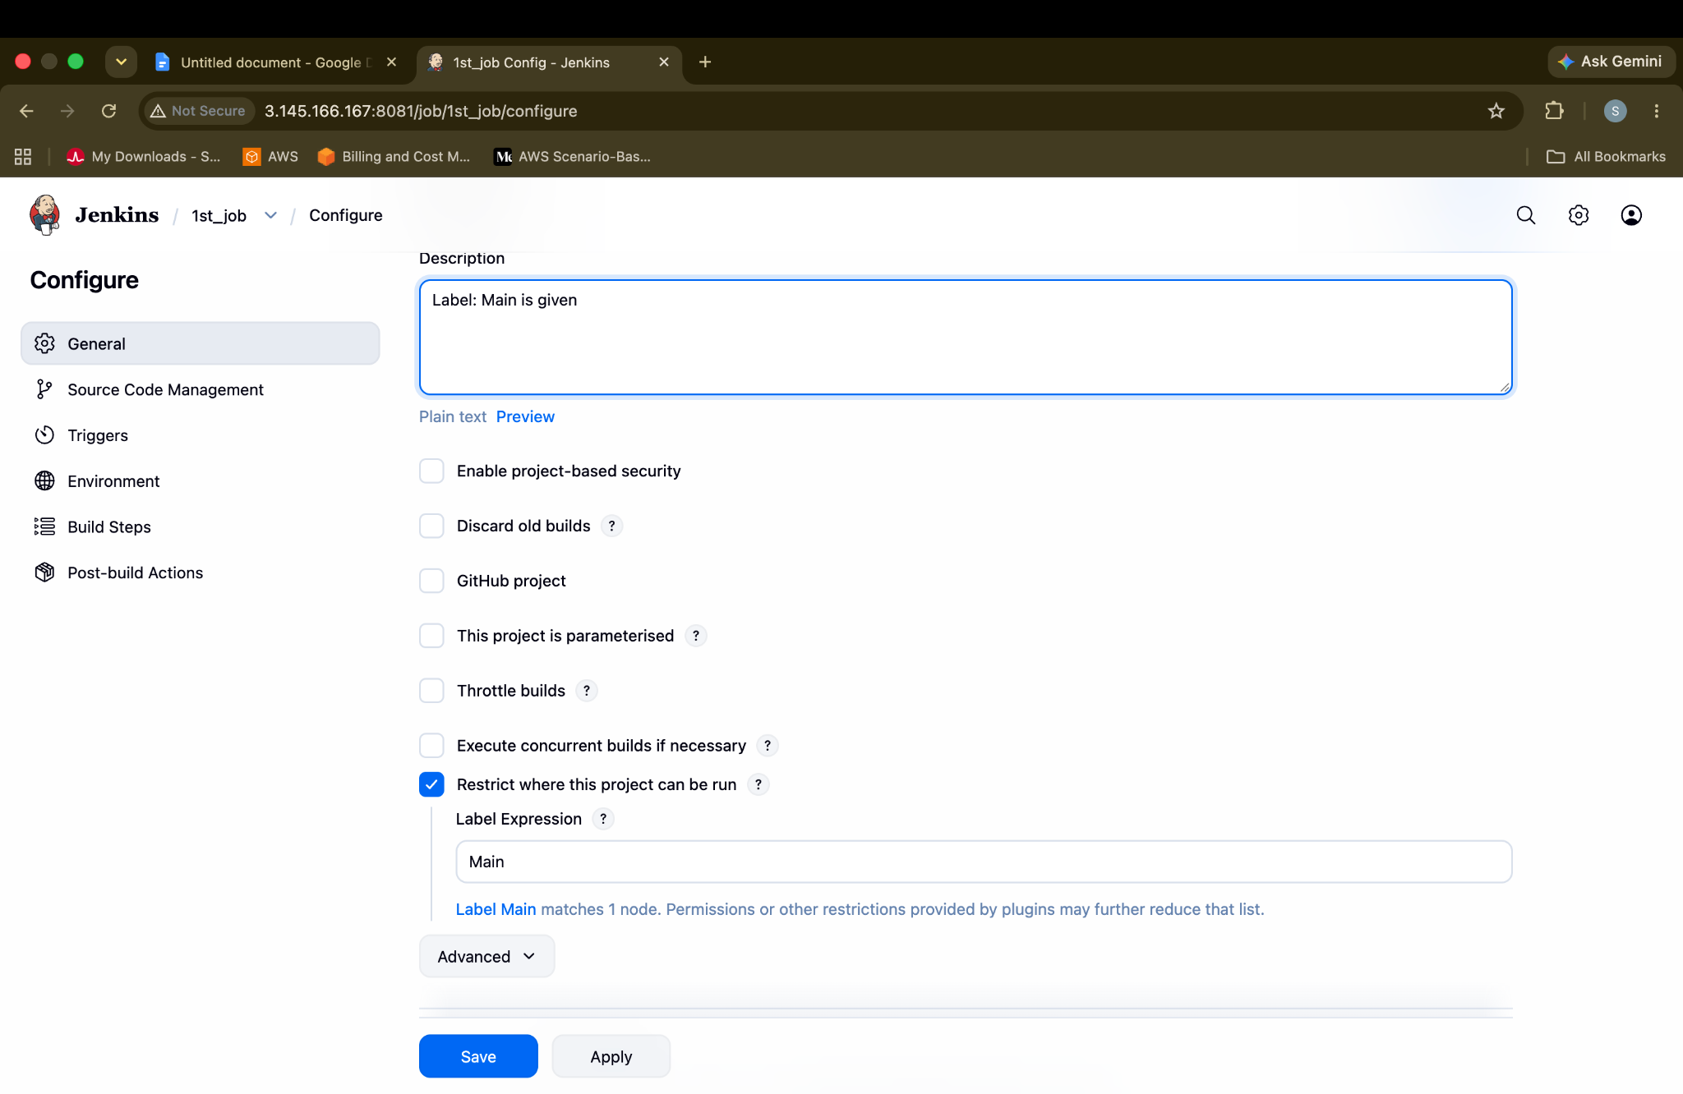
1St_job →Enable ✅ Restrict where this project can be run? → Main → Save
Only Main labeled jobs will work
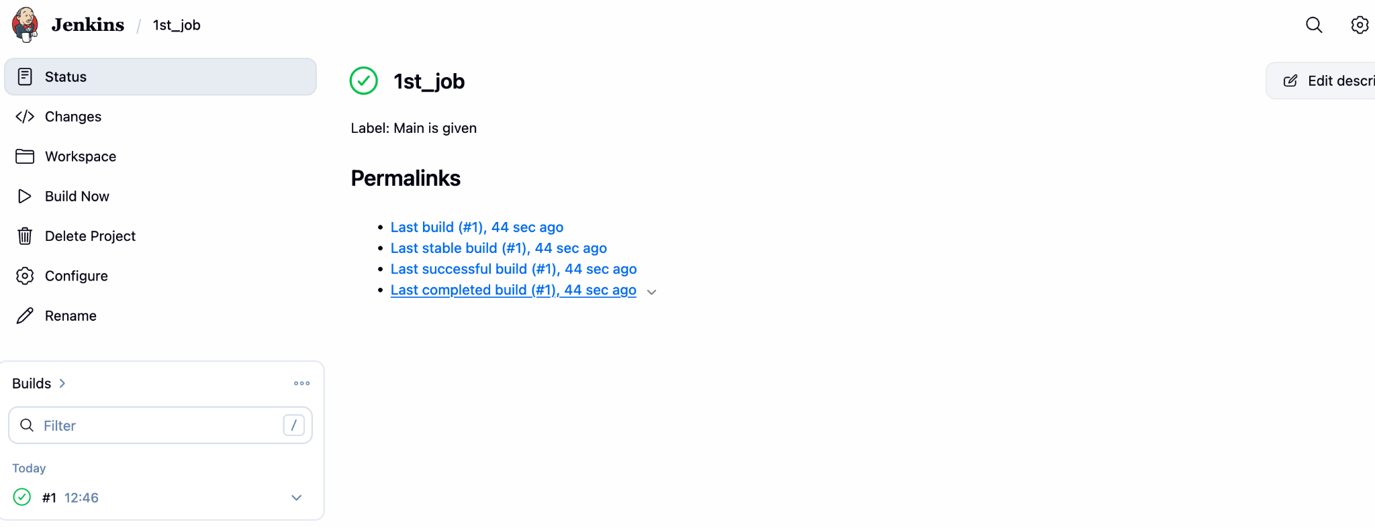
2St_job →Disable ❌ Restrict where this project can be run? → Main → Save
If no Main is given during a job creation, then it won't work even after a long time or so many years.
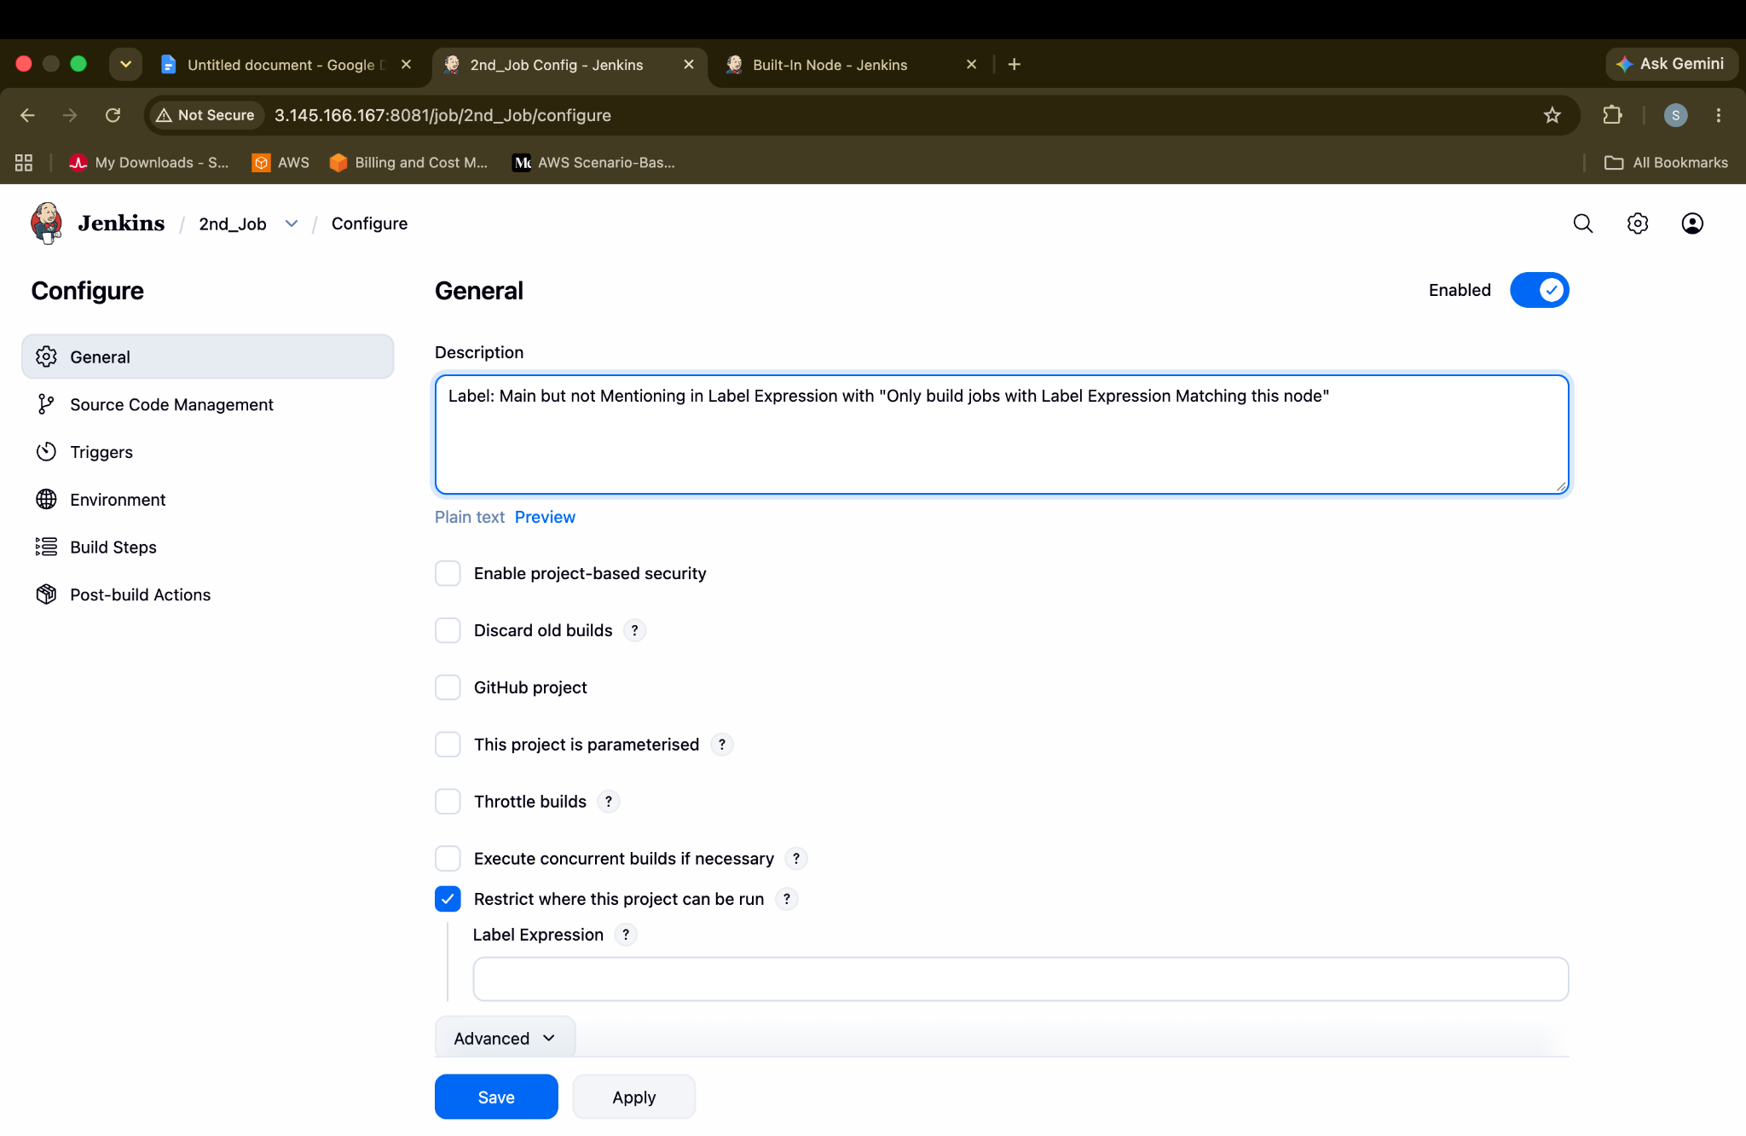
Here Main LAbel is not configured so it will not work
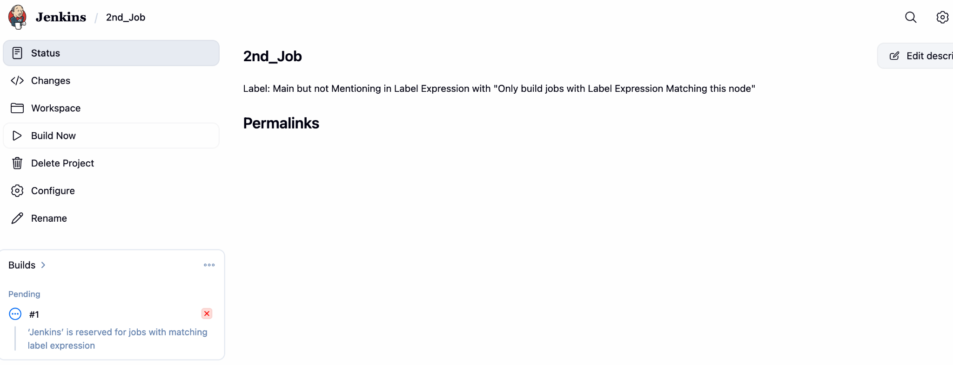
3St_job →Enable ✅ Use this node as much as possible? → Main → Save
The job will run even if there is Main/Without Main.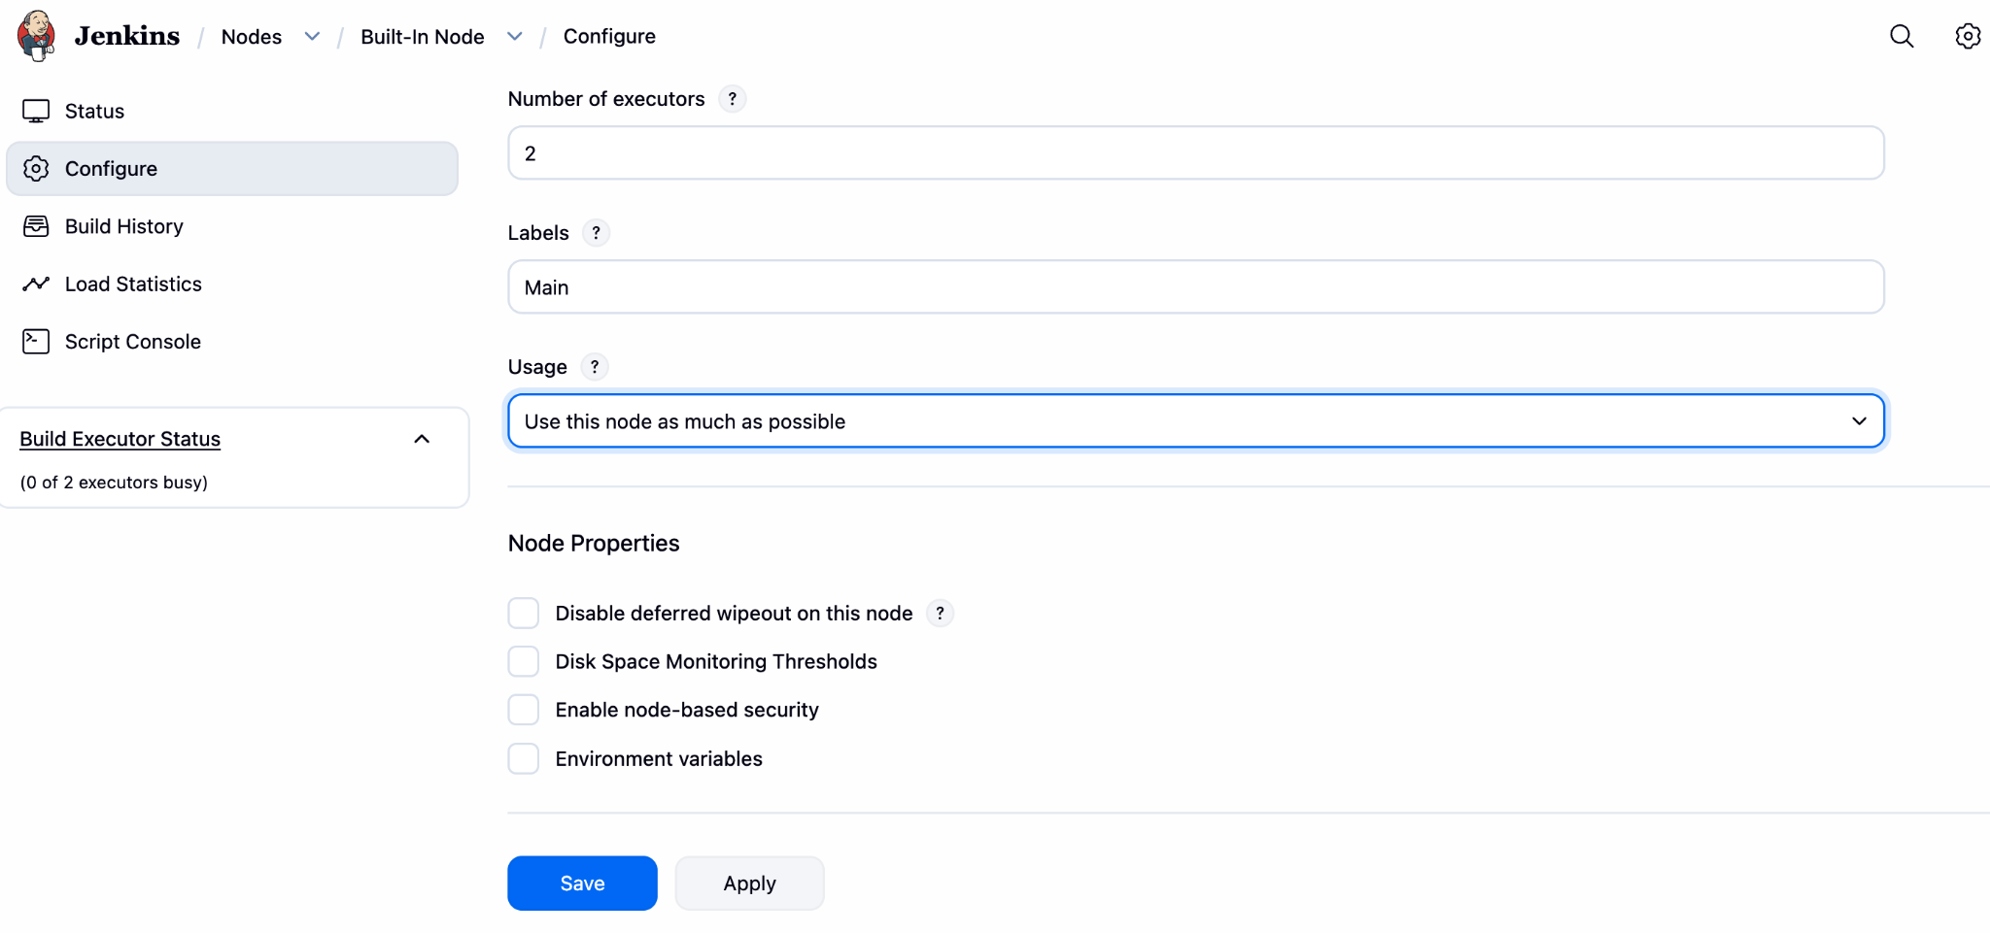
Even Main is not given during Job Creation it will work because of
“ Use this node as much as possible “
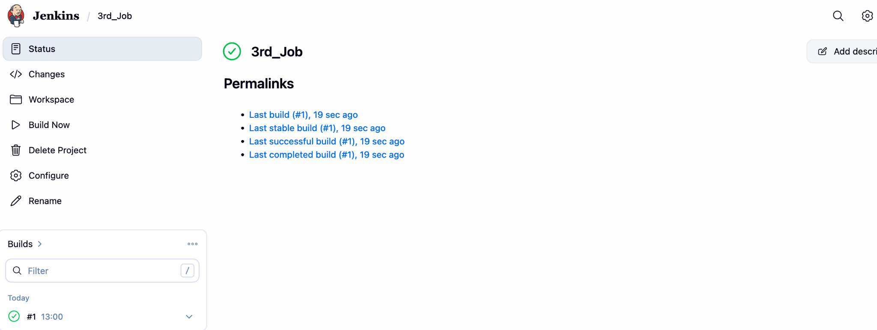
Create Three sample jobs using the below URL.
Source Code: https://github.com/betawins/Techie_horizon_Login_app.git
As we have not installed Git in Instance, we can download git and make it run. Error will be gone

Here we have
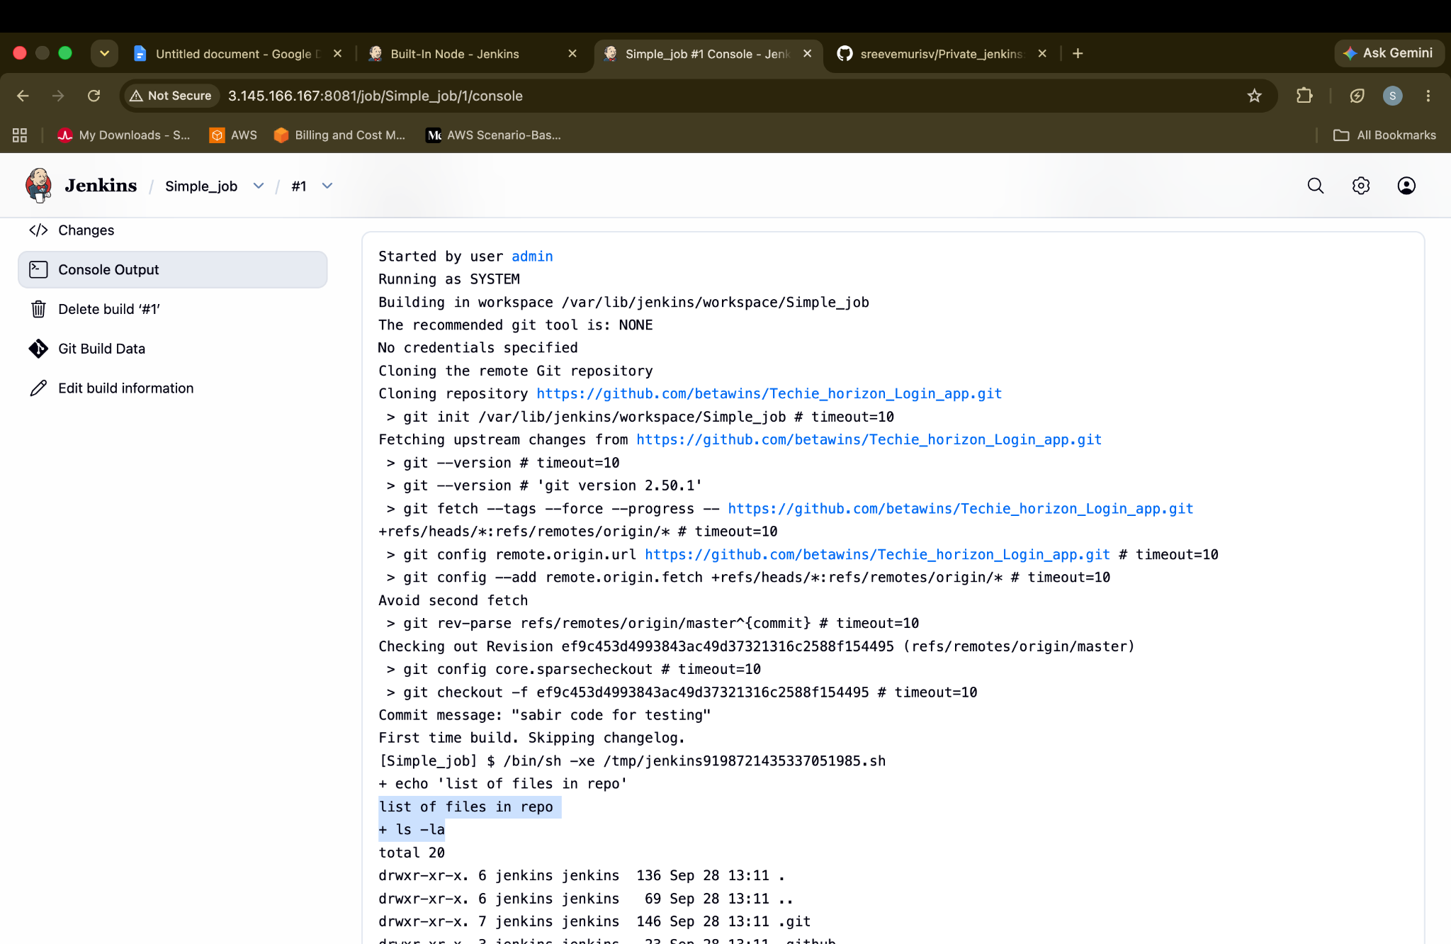
Create one Jenkins job using GitHub Private repository.
Create a repo in Github
Make it Private
Save
Now Create the token for your repo
Settings → Developer Settings → Tokens → Classic → Create new Token → Verify with Email → Copy and save it in Note
Jenkins → Git Https link → +Add Git
Give Name that you have created during token
Link with the password Error will be gone .
*/main
Done.
Create the job and Done
