1). Execute all the templates shown in the video.

There are 3 types
1st type :- creating a variable.tf file and keeping this variable name in main.tf is away of dynamic calling

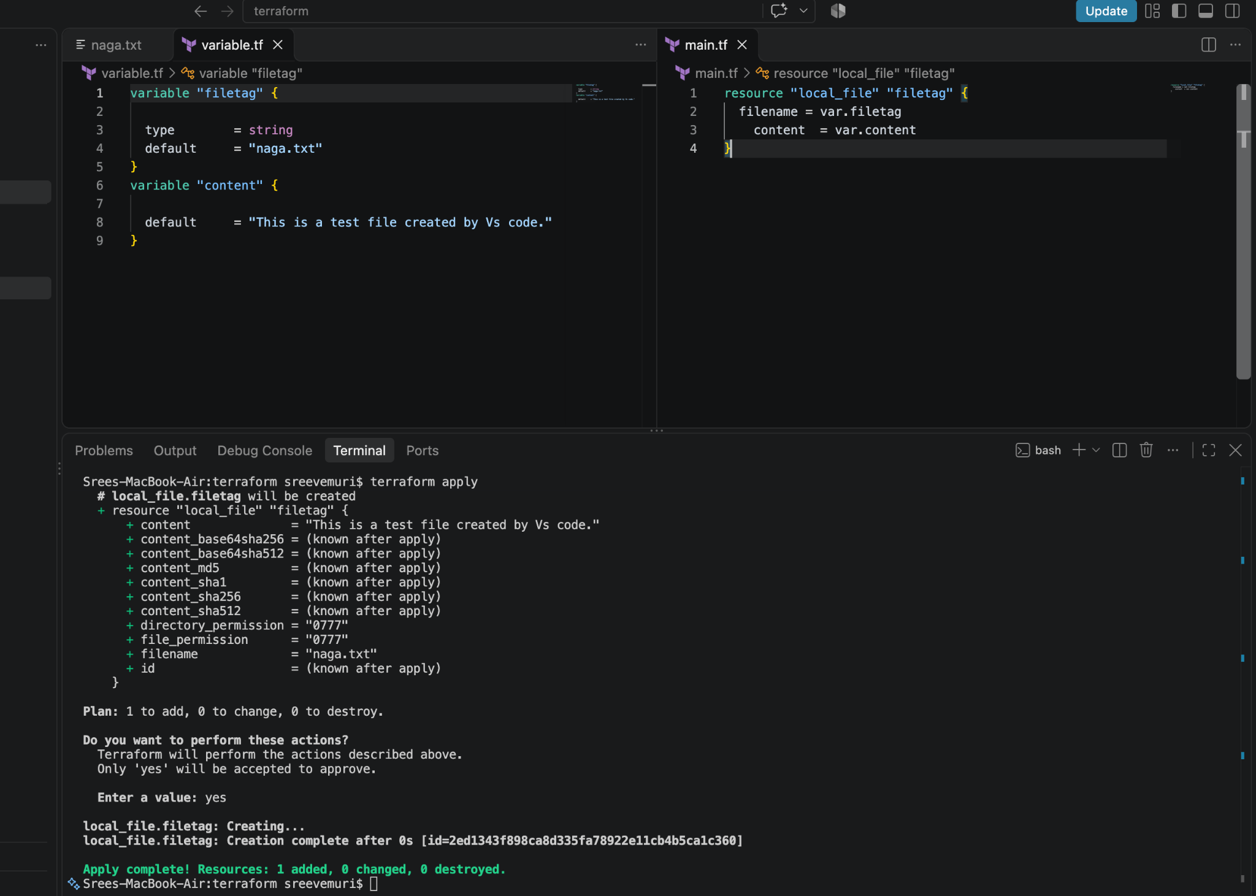

2nd type-:
i) Runtime calling: Creating variable.tf file and keeping it empty with
variable filename{
}
variable content{
}
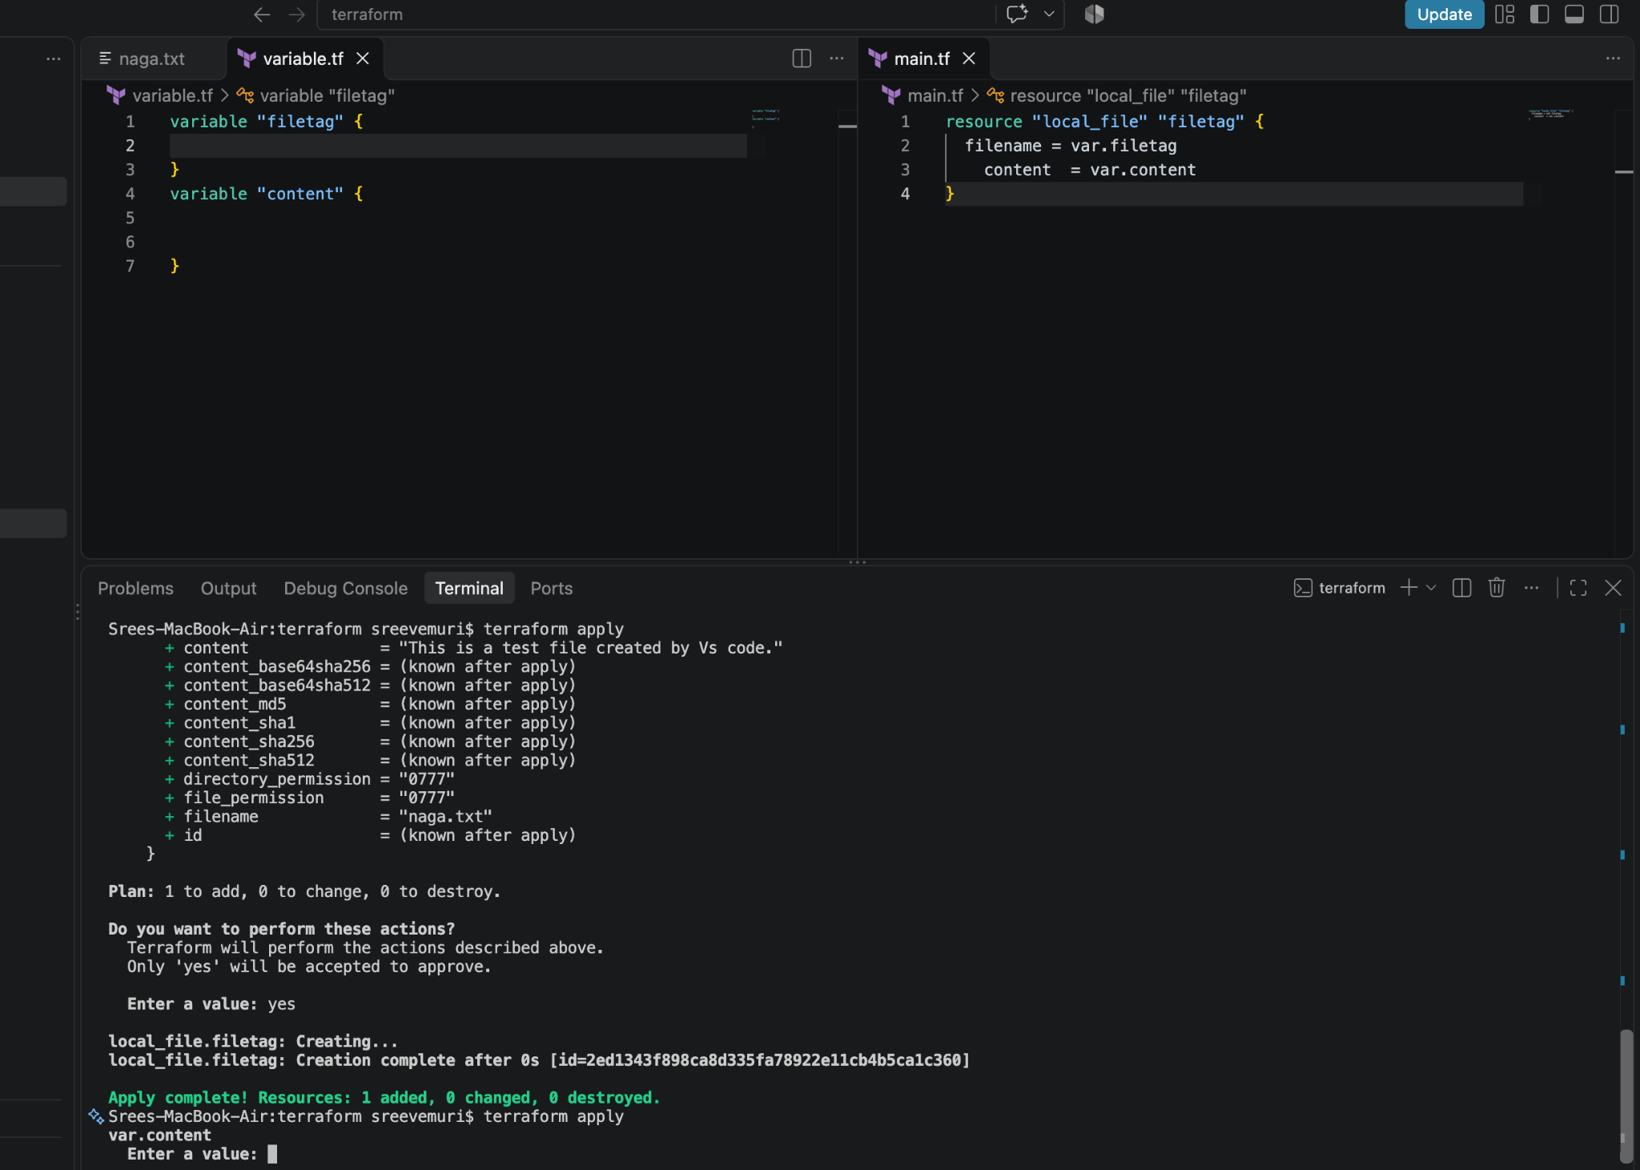

Here in this below screen shot it is asking to enter the value of filetag and content
In content :This is from CLI Runtime
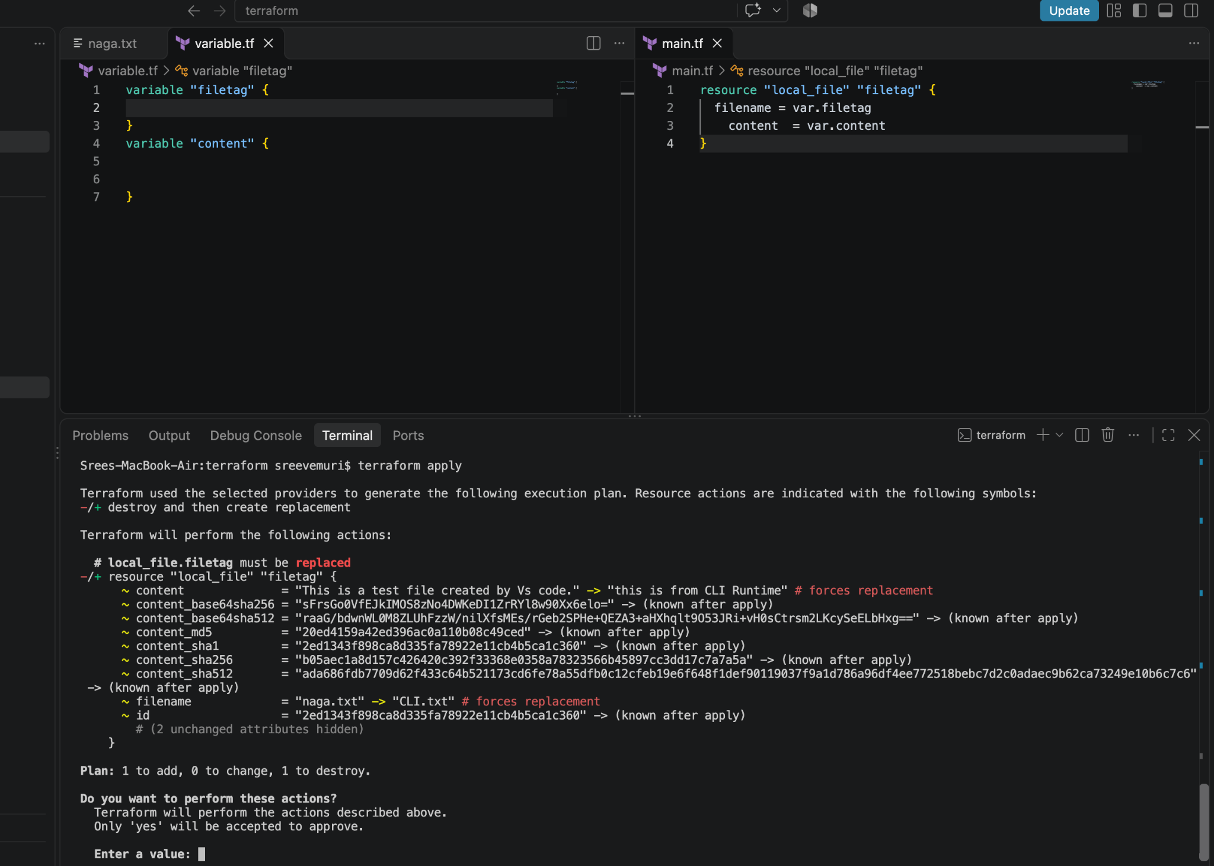

output:
This is from CLI Runtime
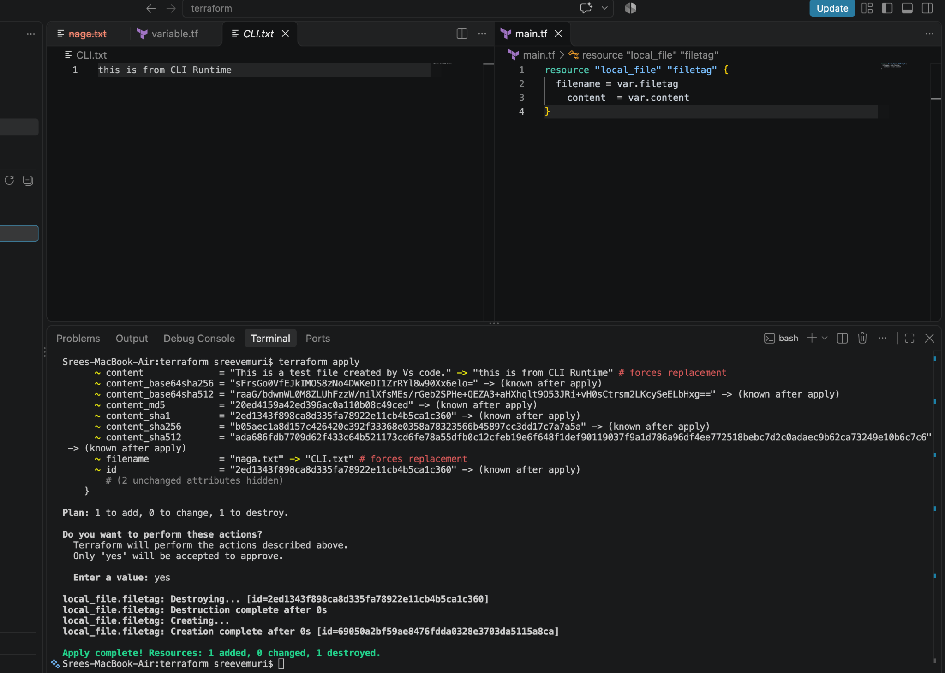

ii) Runtime calling: -: terraform apply -var “filetag=cli.txt” -var “content=this is from runtime -var”

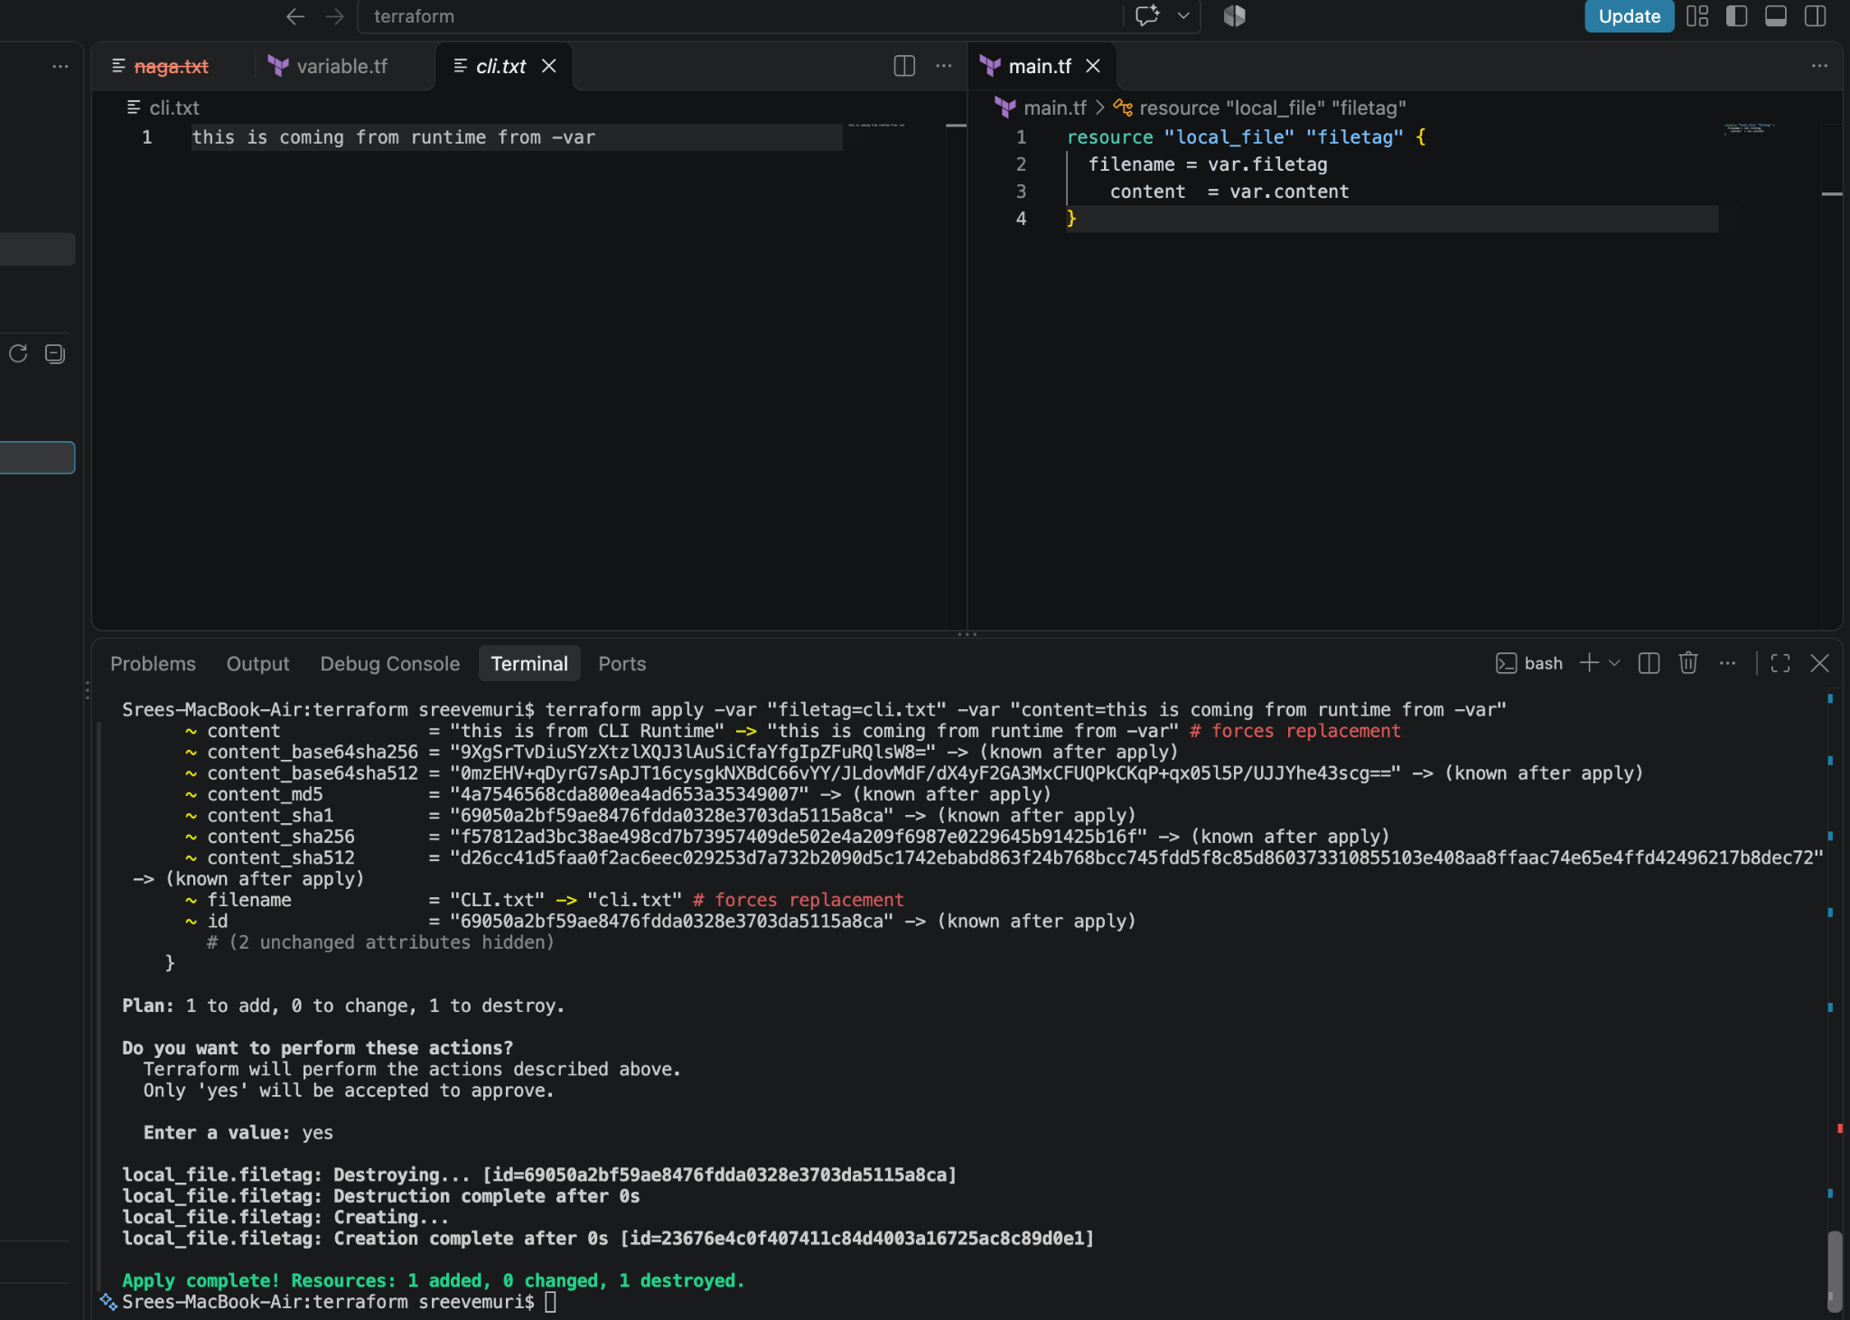

Life cycle:
In Lifecycle we have 3 types
→ create before destroy
→ignore changes
→ prevent destroy

create before destroy
Here in this below screen shot we can see after adding
“lifecycle {
Create_after_destroy = true”
}
Post running the output it has changed to creating then destroy as highlighted and the output has been updated in statefile
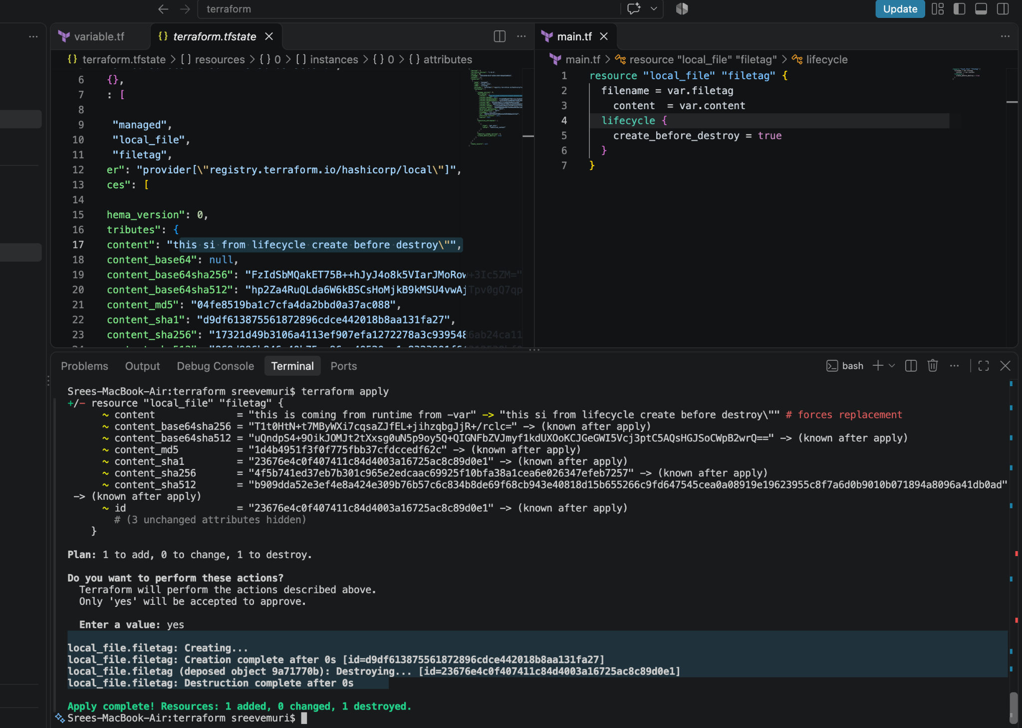

ignore_changes
Here in this below screen shot we can see after adding
lifecycle {
ignore_changes=[
content]
}
Post running the output the value won’t get updated in tfstate file despite being changed in cli because of
ignore_changes=[content]

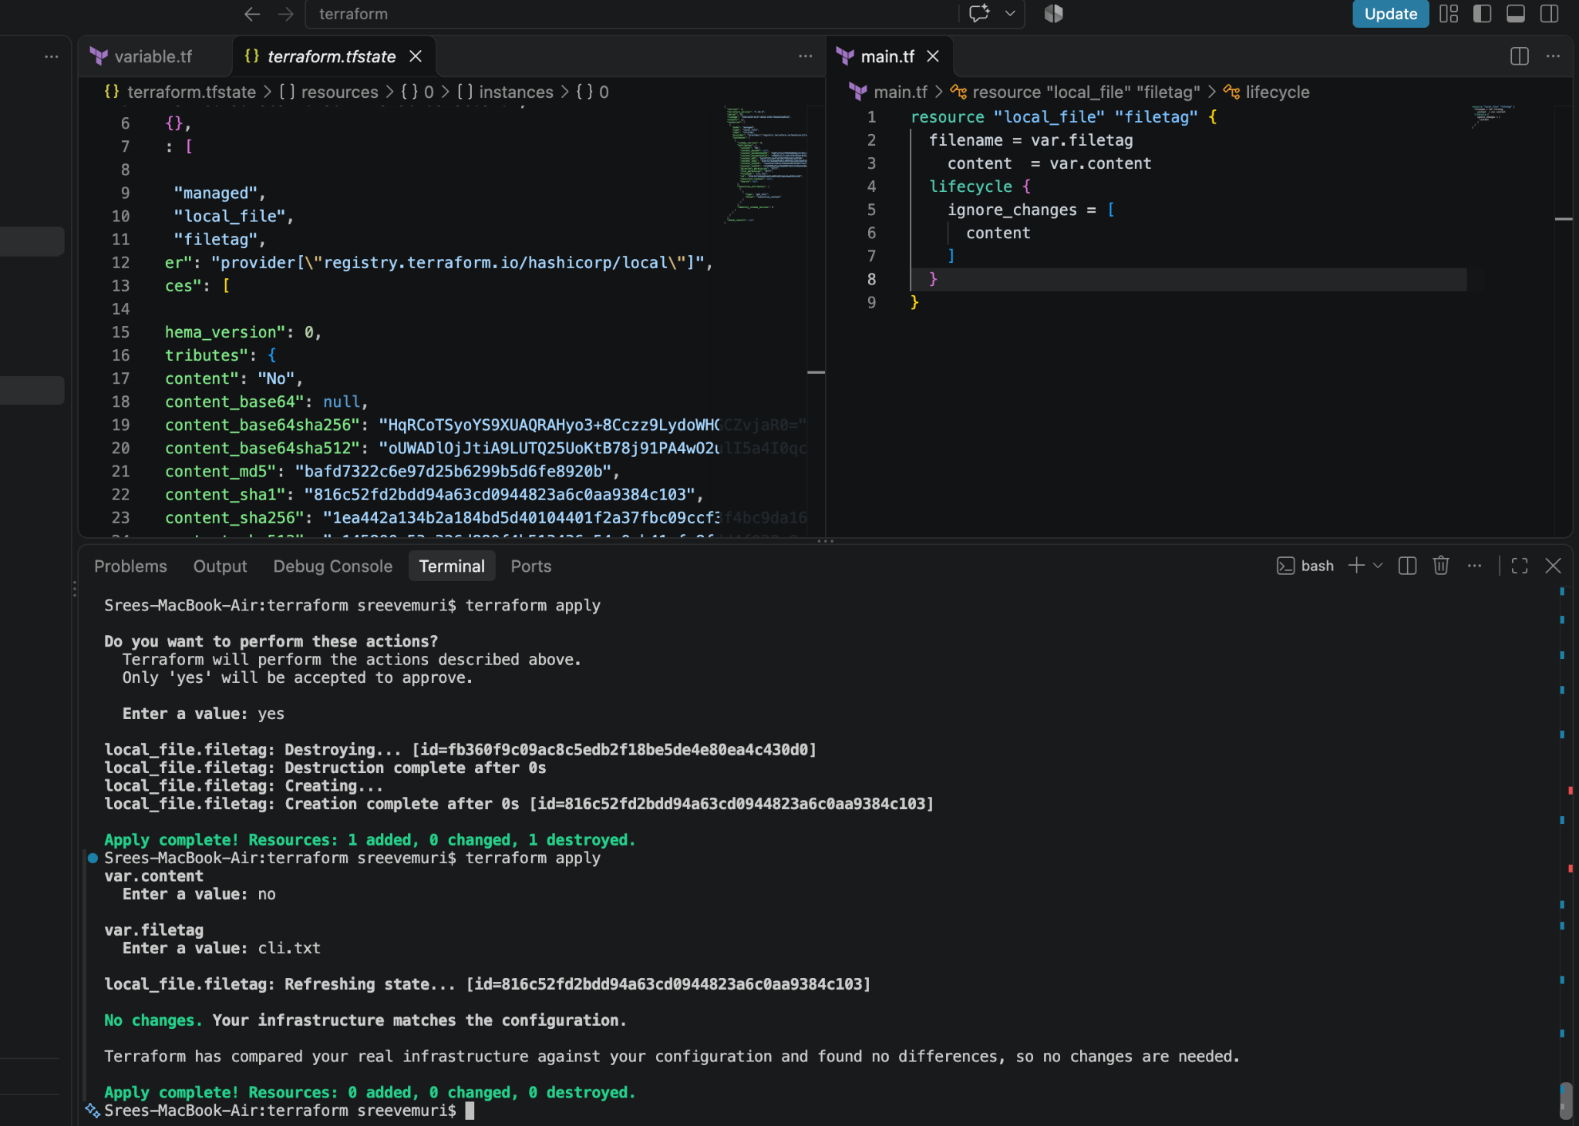

prevent destroy
Here in this below screen shot we can see after adding
lifecycle {
prevent_destroy = true
}
This will stop destroying the content of file because of prevent_destroy = true
If we still want to delete the file then we can do the terraform destroy
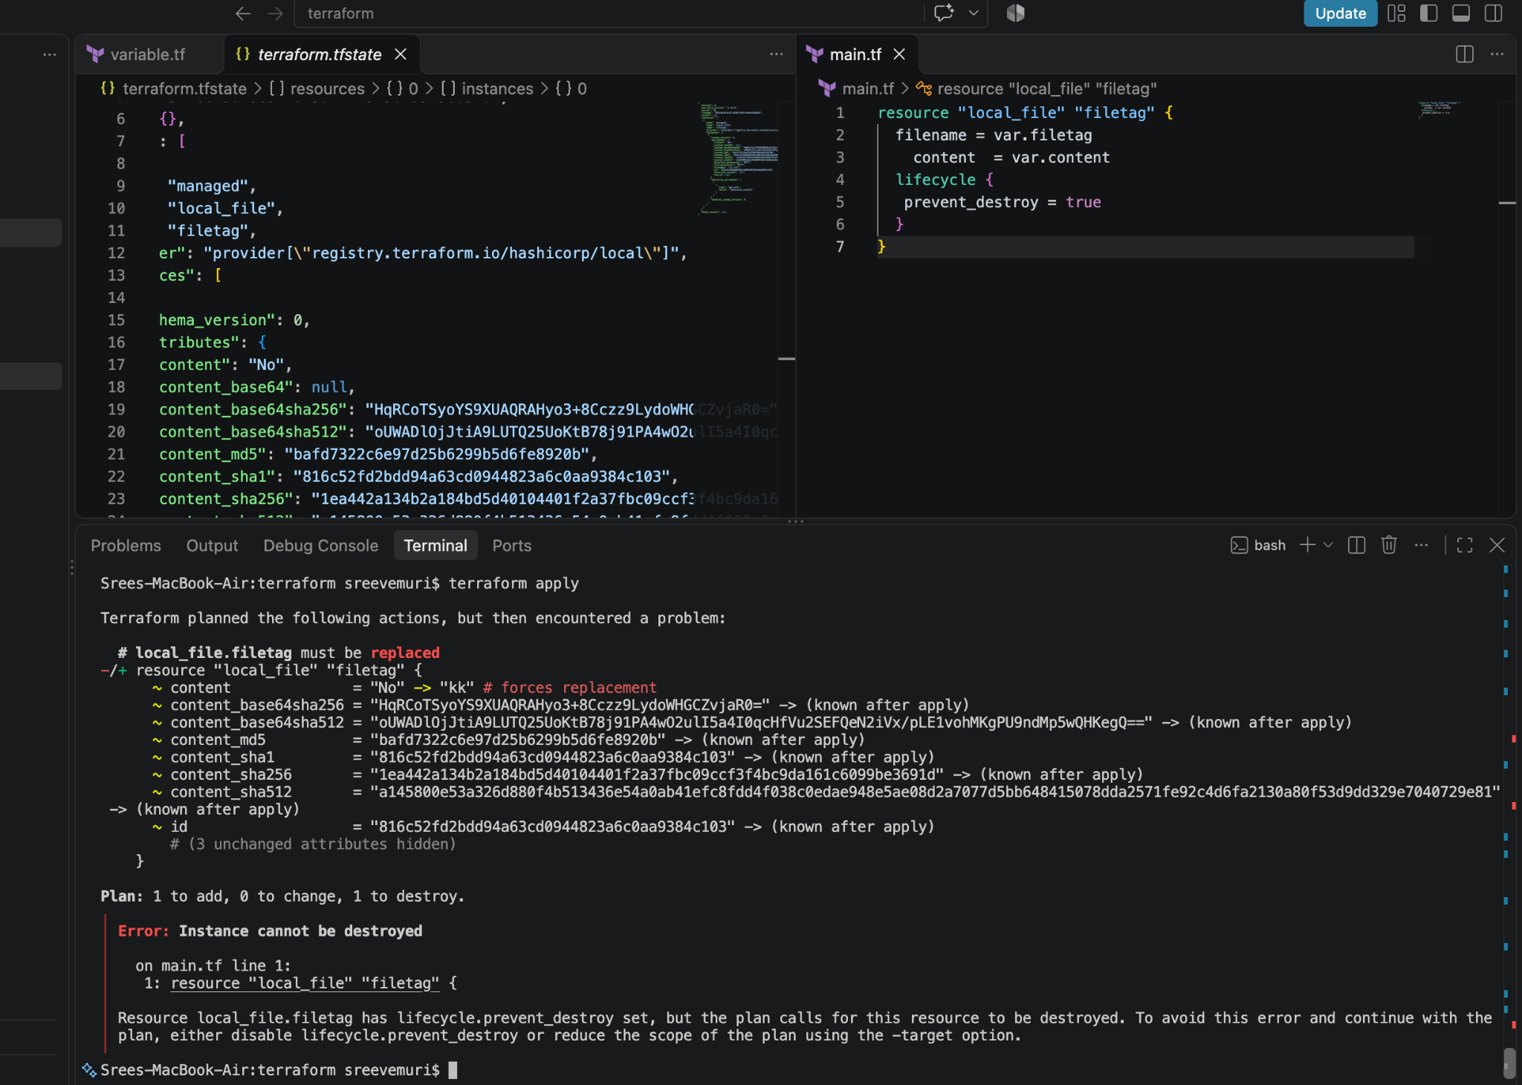

2). Integrate Terraform in Jenkins using the Terraform plugin.
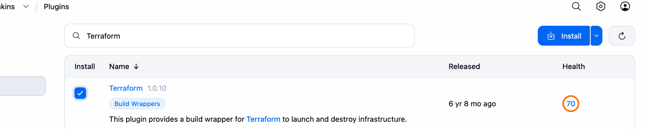

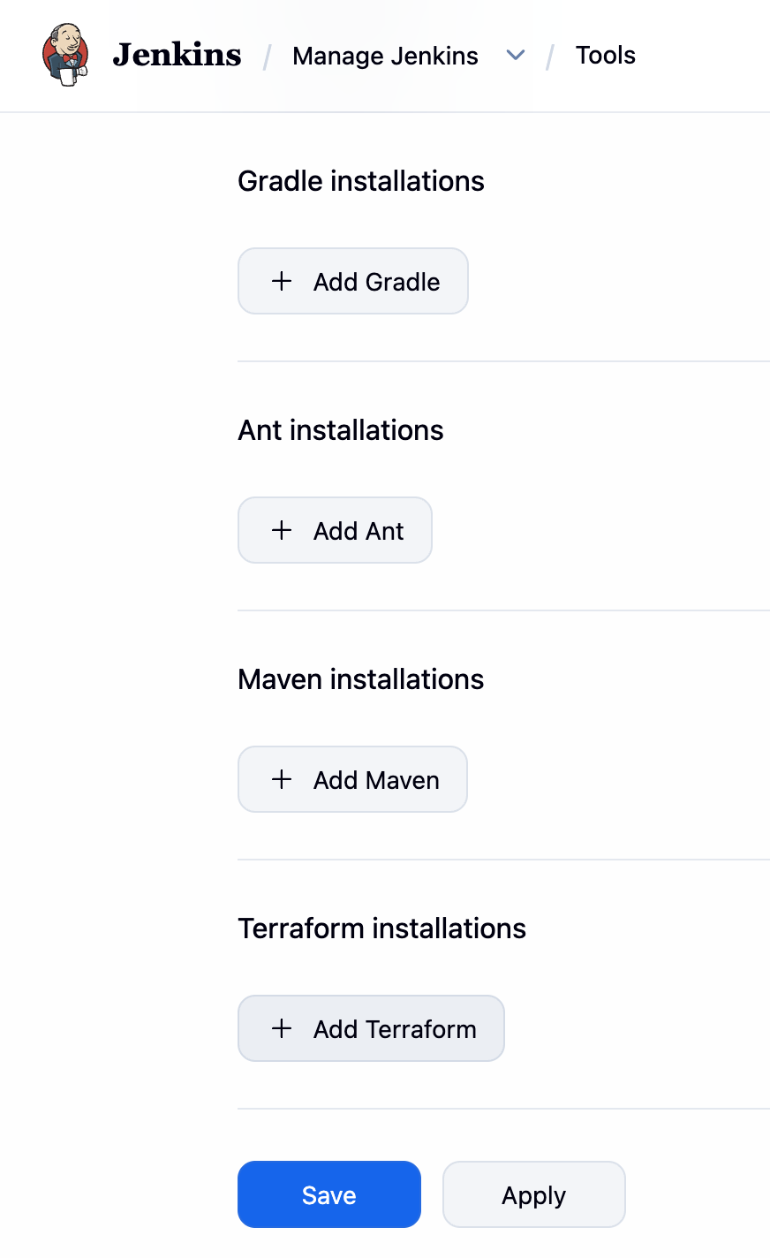

Jenkins & Terraform Integration Documentation
This document provides a complete guide for setting up an automation server (Jenkins) on an AWS EC2 instance and integrating it with HashiCorp Terraform using the Jenkins Terraform Plugin.

1. Architecture & Technology Stack
- Cloud Infrastructure: AWS EC2 (Amazon Linux 2023)
- CI/CD Orchestrator: Jenkins (running on port 8080)
- Runtime Environment: Java 17 (Amazon Corretto) & Terraform CLI
- Terraform Providers Used:
- hashicorp/local (Version ~> 2.0)
- hashicorp/random (Version ~> 3.0)

2. Infrastructure Setup (EC2 & Prerequisites)

Step A: Install Java and Jenkins
Execute the following commands on your Amazon Linux 2023 EC2 instance:

sudo dnf update -y
sudo dnf install java-17-amazon-corretto-devel -y
sudo wget -O /etc/yum.repos.d/jenkins.repo https://pkg.jenkins.io/redhat-stable/jenkins.repo
sudo rpm --import https://pkg.jenkins.io/redhat-stable/jenkins.io-2023.key
sudo dnf install jenkins -y
sudo systemctl enable jenkins
sudo systemctl start jenkins

step B: Install Terraform CLI

Install the official HashiCorp repository and package:

sudo dnf install -y yum-utils
sudo yum-config-manager --add-repo https://rpm.releases.hashicorp.com/AmazonLinux/hashicorp.repo
sudo dnf install -y terraform

Step C: Configure Jenkins Terraform Plugin
- Go to Manage Jenkins -> Plugins -> Available plugins, and install the Terraform plugin.

- Go to Manage Jenkins -> Tools (Global Tool Configuration).

- Under Terraform, click Add Terraform, uncheck "Install automatically", and provide the path to the local Linux Terraform binary (e.g., /usr/bin/terraform).

3. Terraform Configuration (main.tf)
The pipeline dynamically provisions a dependent Terraform configuration consisting of a random password generator and a local file writer:

terraform {
required_providers {
local = {
source = "hashicorp/local"
version = "~> 2.0"
}
random = {
source = "hashicorp/random"
version = "~> 3.0"
}
}
}

resource "random_password" "password" {
length = 16
special = true
}

resource "local_file" "secret_file" {
content = "Generated password: ${random_password.password.result}"
filename = "secret.txt"
}

4. Jenkins Declarative Pipeline Script
Create a new Pipeline job in Jenkins, set the definition to Pipeline script, and use the following template:

pipeline {
agent any

// Automatically hooks into the global tool config
tools {
terraform 'terraform'
}

stages {
stage('Checkout / Setup Code') {
steps {
sh '''
cat << 'EOF' > main.tf
terraform {
required_providers {
local = {
source = "hashicorp/local"
version = "~> 2.0"
}
random = {
source = "hashicorp/random"
version = "~> 3.0"
}
}
}

resource "random_password" "password" {
length = 16
special = true
}

resource "local_file" "secret_file" {
content = "Generated password via plugin: ${random_password.password.result}"
filename = "secret.txt"
}
EOF
'''
}
}

stage('Terraform Init') {
steps {
sh 'terraform init'
}
}

stage('Terraform Plan') {
steps {
sh 'terraform plan'
}
}

stage('Terraform Apply') {
steps {
sh 'terraform apply -auto-approve'
}
}
}
}

