- Create MariaDB DB on EC2.
Create an EC2 by MariaDB name.
Connect to the instance using SSH
Install the MariaDB in root location
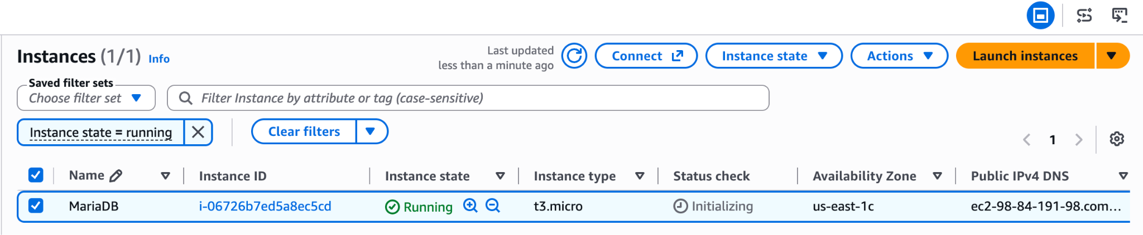
Bash Script to Create the MariaDB
sudo dnf update -y
sudo dnf install mariadb105-server -y
sudo systemctl enable --now mariadb
sudo systemctl start mariadb
sudo systemsctl status mariadb
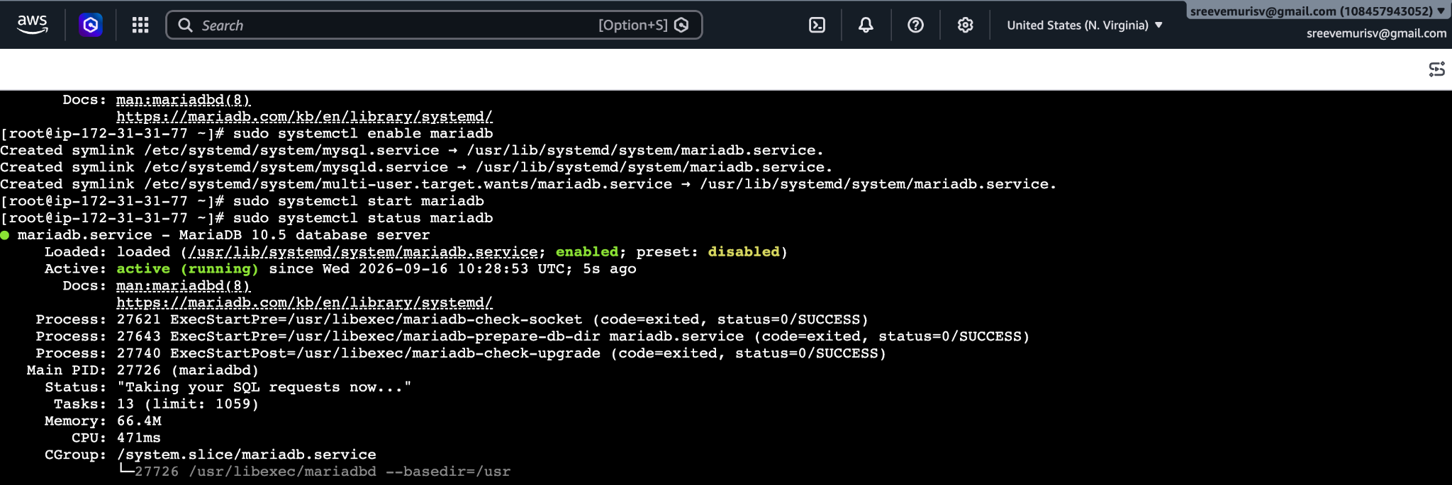
Insert some dummy data.
→ CREATE DATABASE PrajayHomesdb;
→ SHOW DATABASES;
→ CREATE TABLE employees (
id INT AUTO_INCREMENT PRIMARY KEY,
name VARCHAR(50),
department VARCHAR(50),
salary DECIMAL(10, 2)
);

→ INSERT INTO employees (name, department, salary) VALUES
('Alice Smith', 'Engineering', 85000.00),
('Bob Johnson', 'Marketing', 62000.00),
('Charlie Lee', 'Finance', 75000.00);
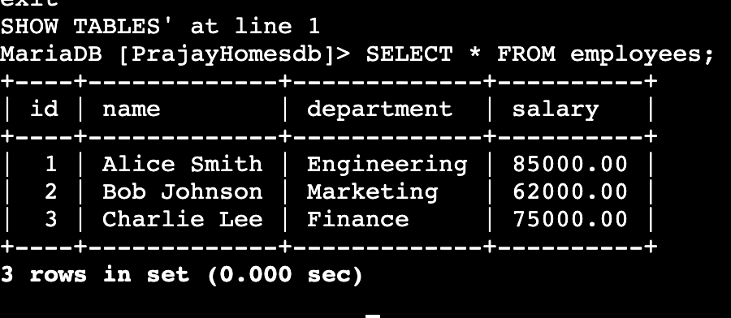
Take the backup of dummy data on EC2.
→ Exit; to exit from the database and back to root user in ec2
→ mariadb-dump -u root -p PrajayHomesdb > PrajayHomesdb_backup.sql {Backupfile name}
→ ls
→ cat {Backupfile name}
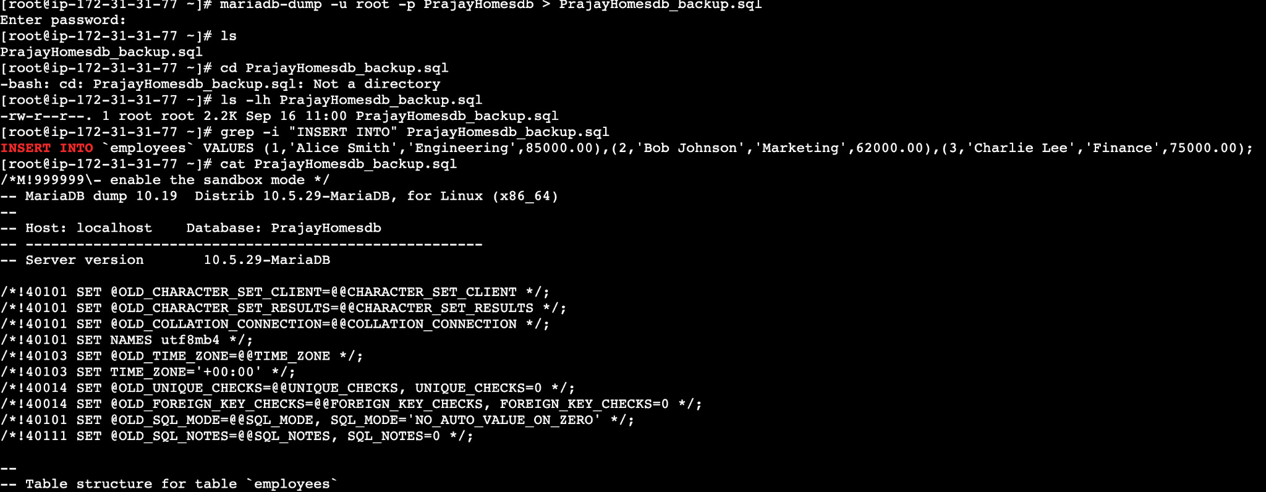
Launch MariaDB RDS instance.
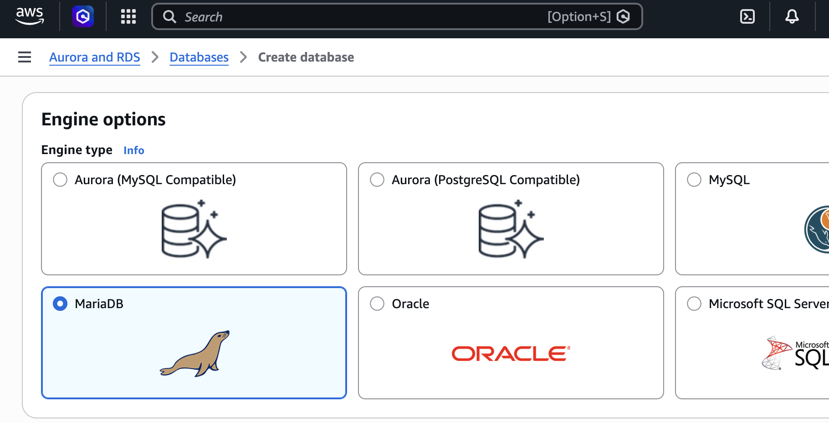
Migrate database from EC2 to RDS.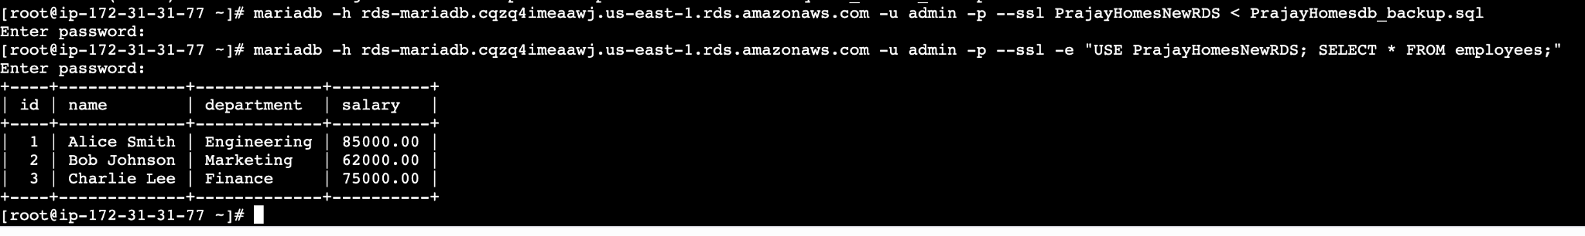
Install MySQL DB on EC2.
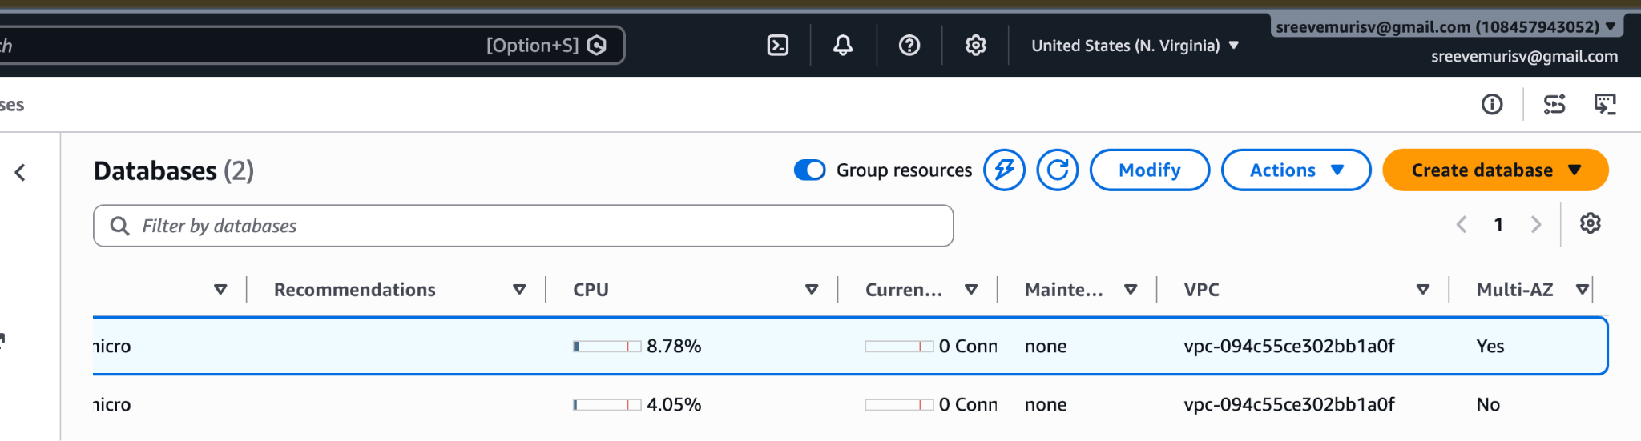
Launch MySQL RDS image.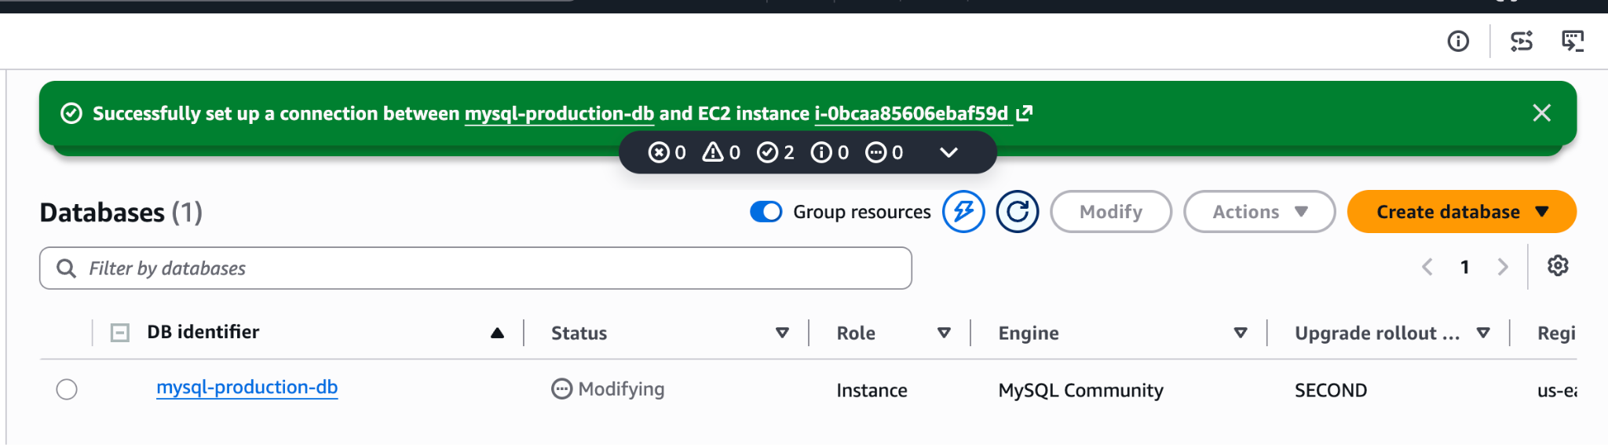
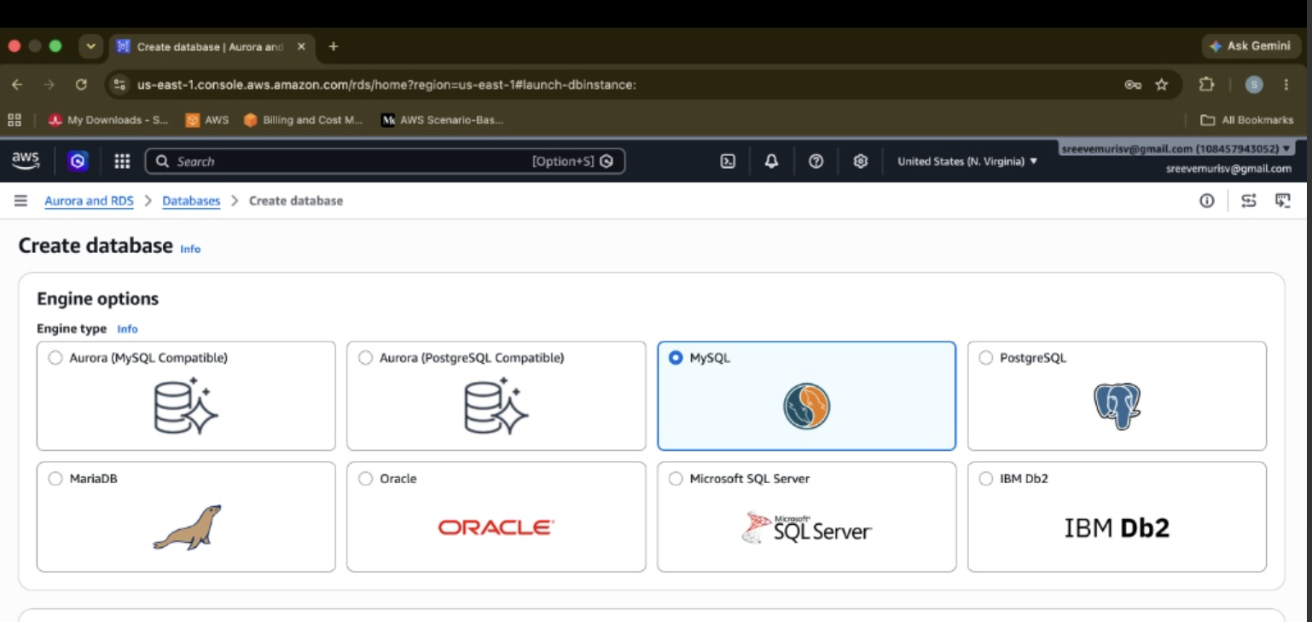
Engine: MySQL Community
- Template: Dev/Test
- Availability and Durability: Multi-AZ DB instance deployment (2instances)
- Settings: mys ql-production-db / admin / Password set
- Instance Class: db.t3.micro
- Storage: 20 GiB gp3
- Connectivity: Connected directly to EC2 i-0bcaa85606ebaf59d (Public access: No)
under Additional storage configuration, uncheck Enable storage autoscaling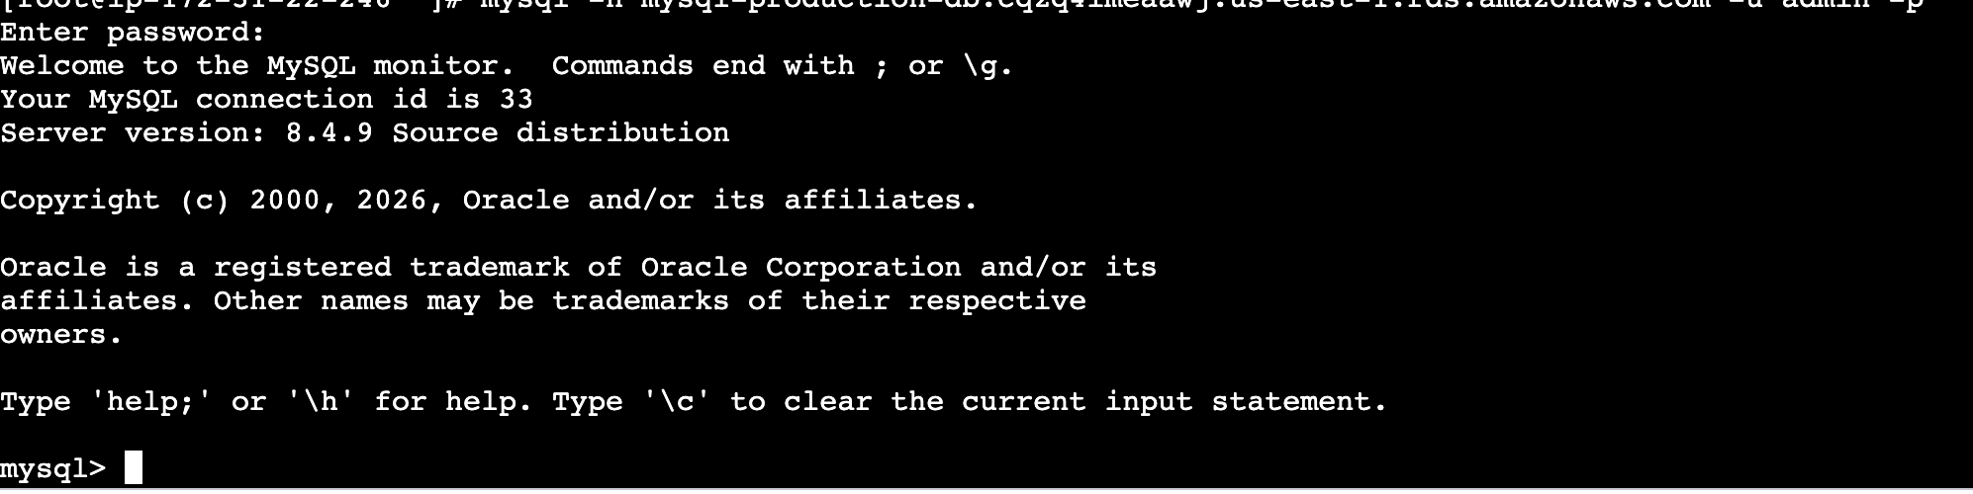
Configure Multi-AZ.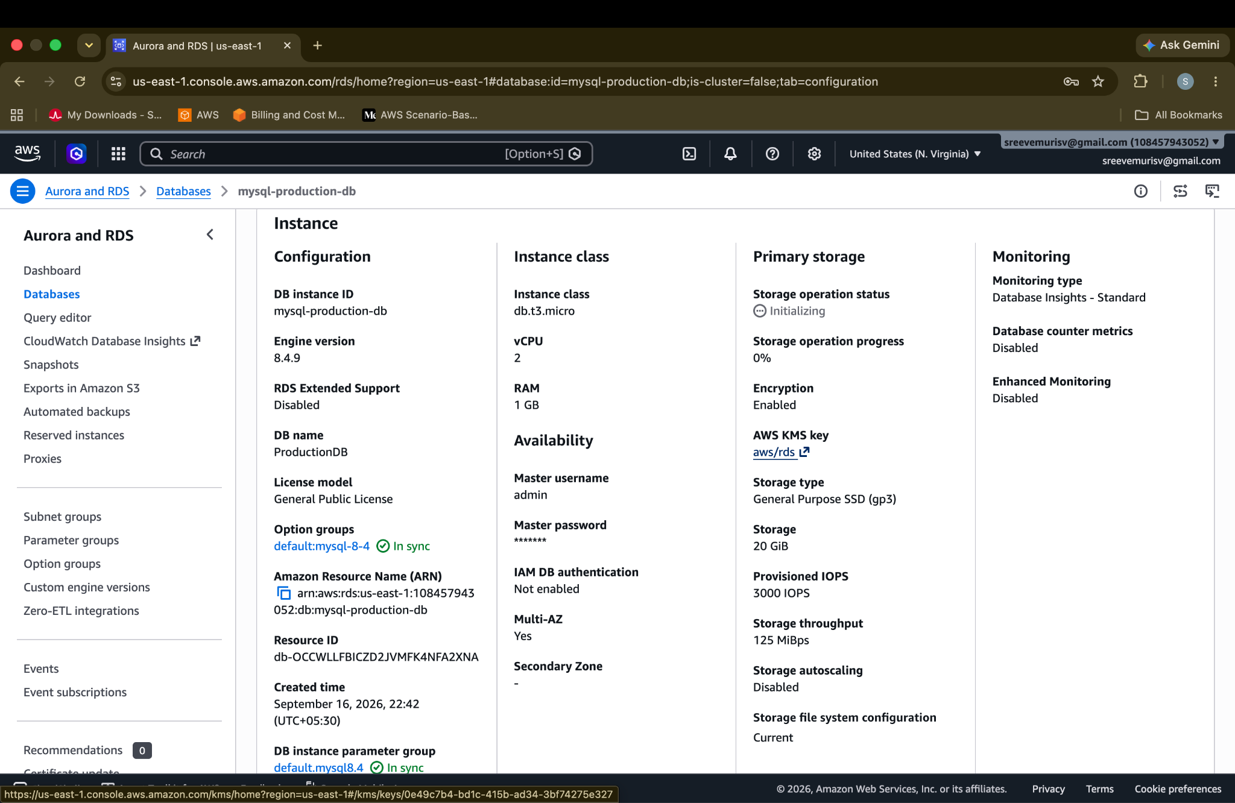
Take backup of DB and restore the DB.
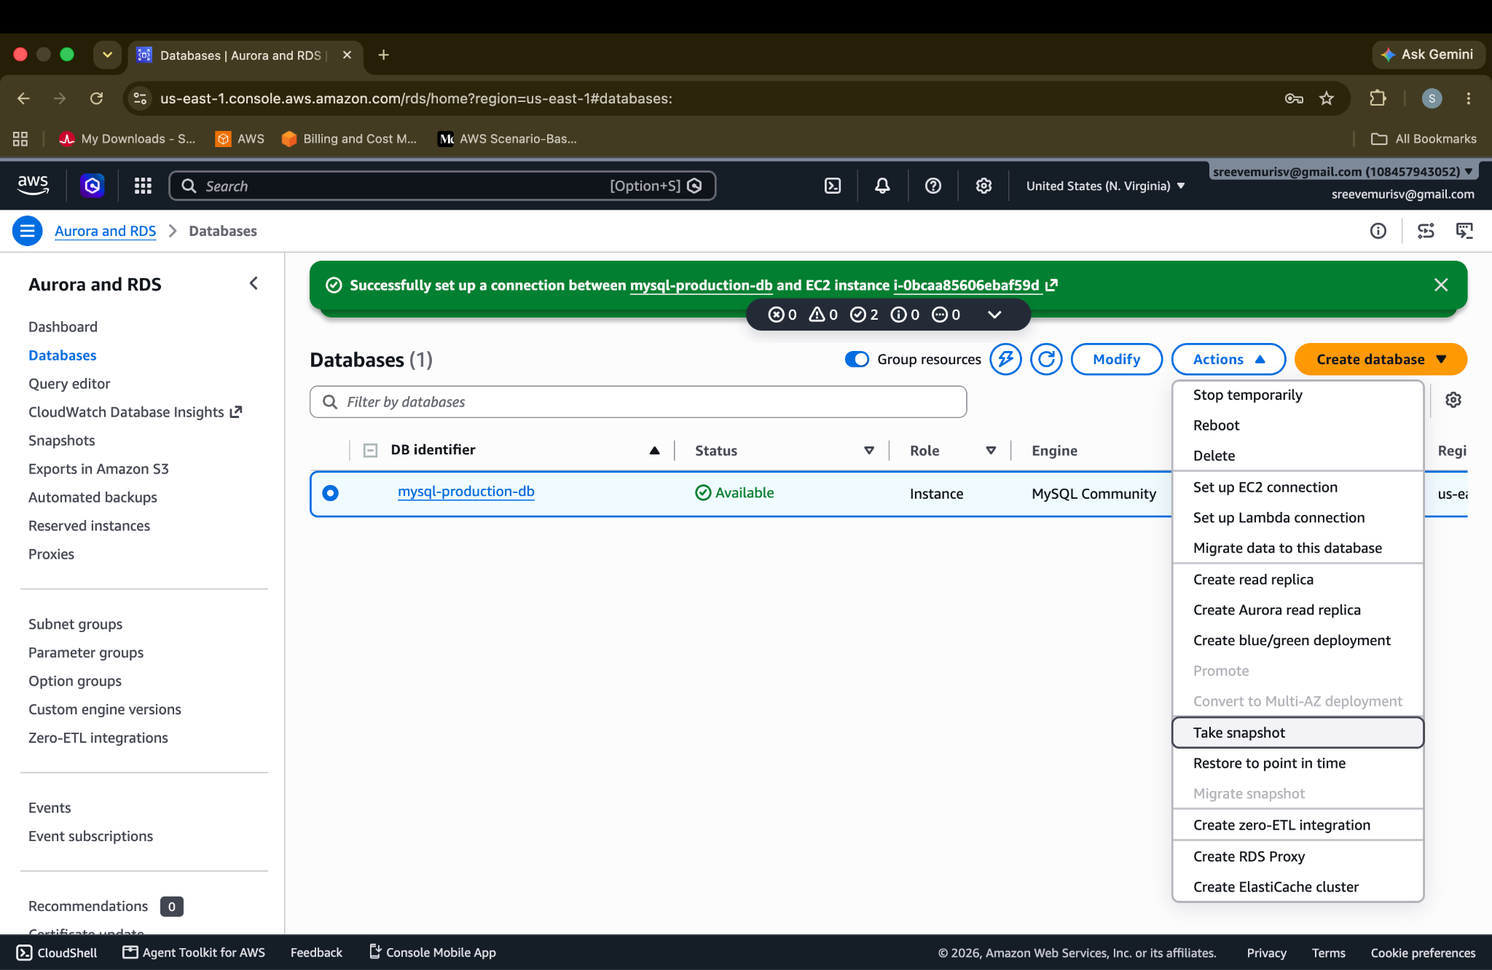

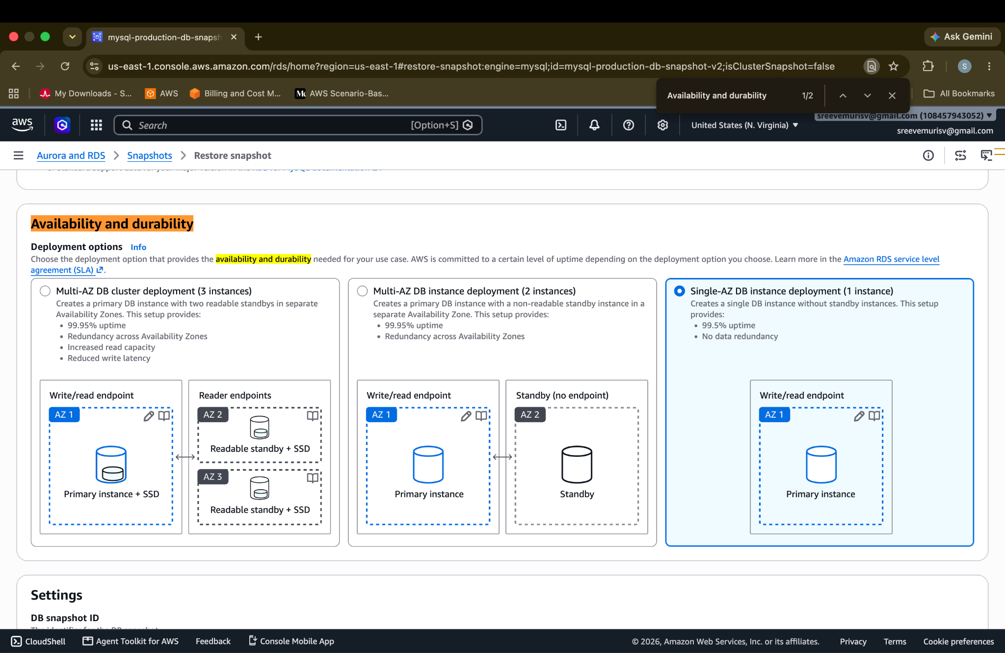
Click Restore DB instance.
Create read replica.