Launch one EC2 using Amazon Linux 2 image and add a script in user data to install Apache.
→ map to AWS
→ before clicking create instance , go to Advance options scroll down and find user do
→ In user do give the script to install and start the HTTPD service
#!/bin/bash
Sudo yum -y install httpd
echo “ this page is coming from the instance whic got created by user do” >> /var/www/html/index.html
sudo systemctl start httpd
→ now create the instance and connect from the CLI and run the
sudo systemctl status httpd.
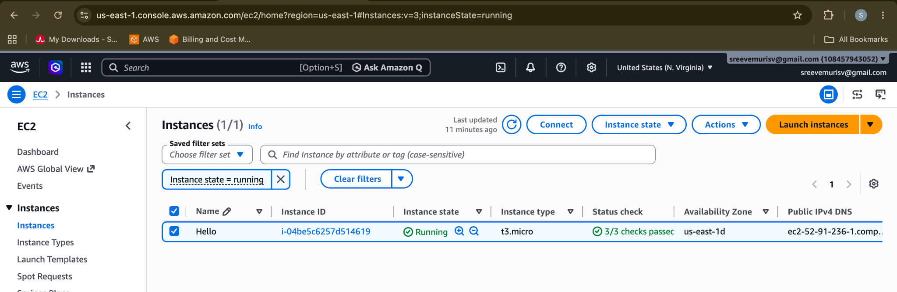
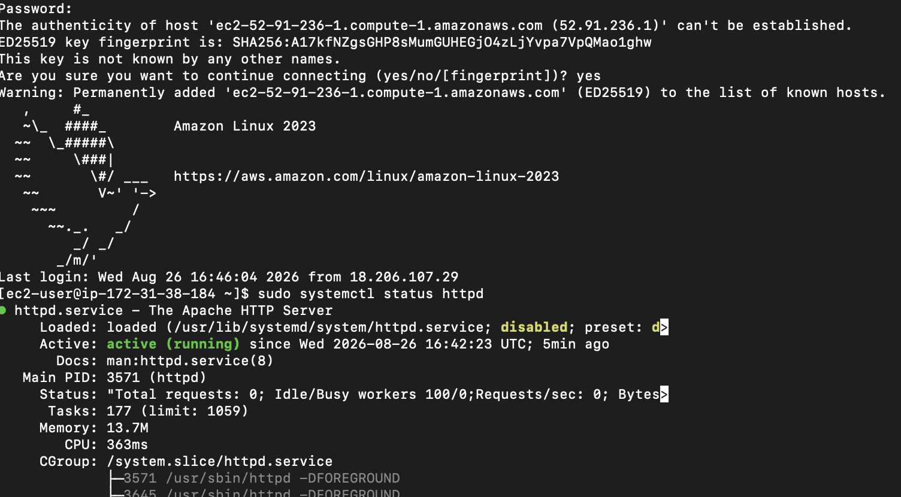
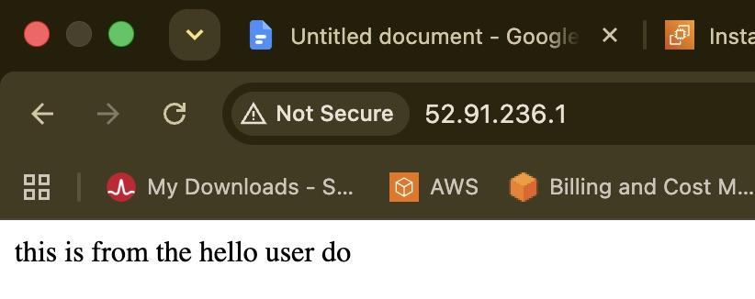
Launch one EC2 using Ubuntu image and add a script in user data to install Nginx.
→ map to AWS
→ select UBUNTU image
→ before clicking create instance , go to Advance options scroll down and find user data
→ In user do give the script to install and start the Nginx service
#!/bin/bash
Sudo apt update -y
Sudo apt -y install nginx
echo “ this page is coming from the instance whic got created by user do” >> /var/www/html/index.html
sudo systemctl start nginx
→ now create the instance and connect from the CLI and run the
sudo systemctl status httpd.
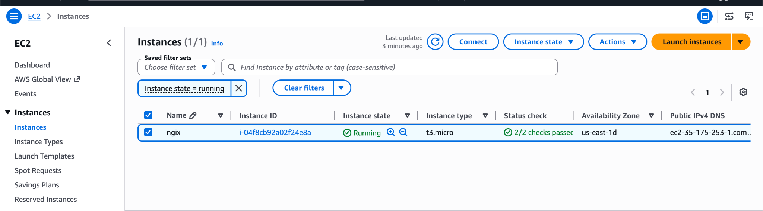
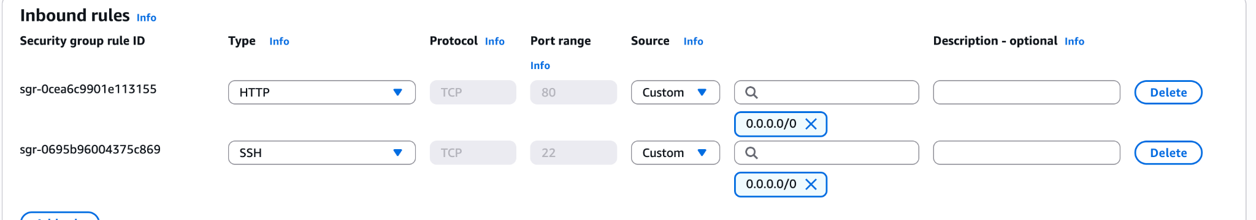

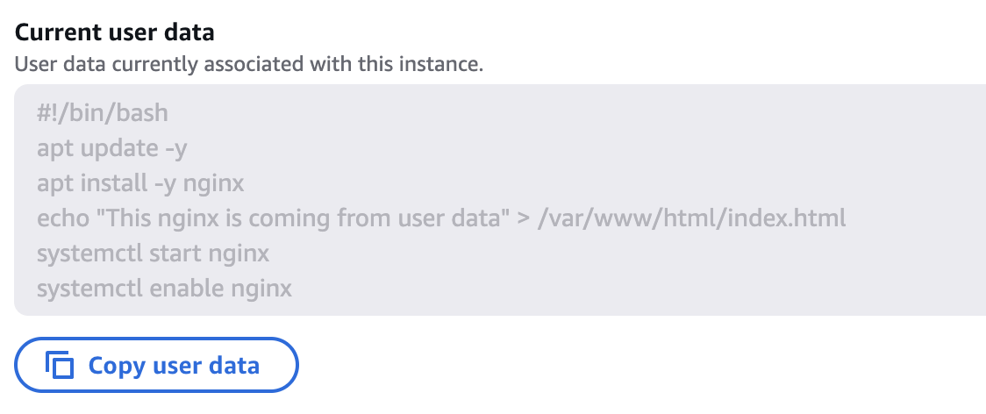

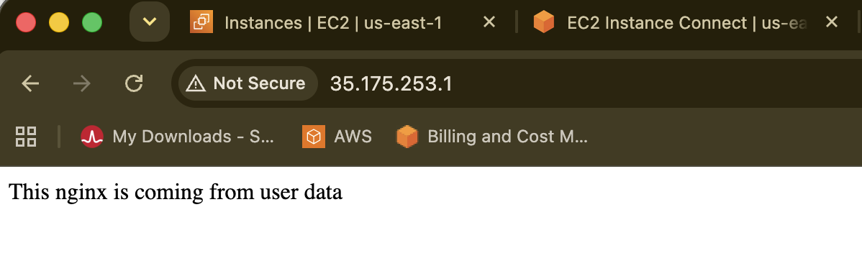
Launch one Windows server and install Tomcat on Windows.
→ map to AWS
→ select WINDOW Image
→ clicking create instance
→ Install Windows on the Mac via the Apple store.
→ During instance creation we will get the RDP along with the password link at last
→ Download the RDP file
→ click on get password link upload the .rpd file here and will get the encrypted key and click on decrypt, from download RDP
→ past on the windows password, to connect the rdp window

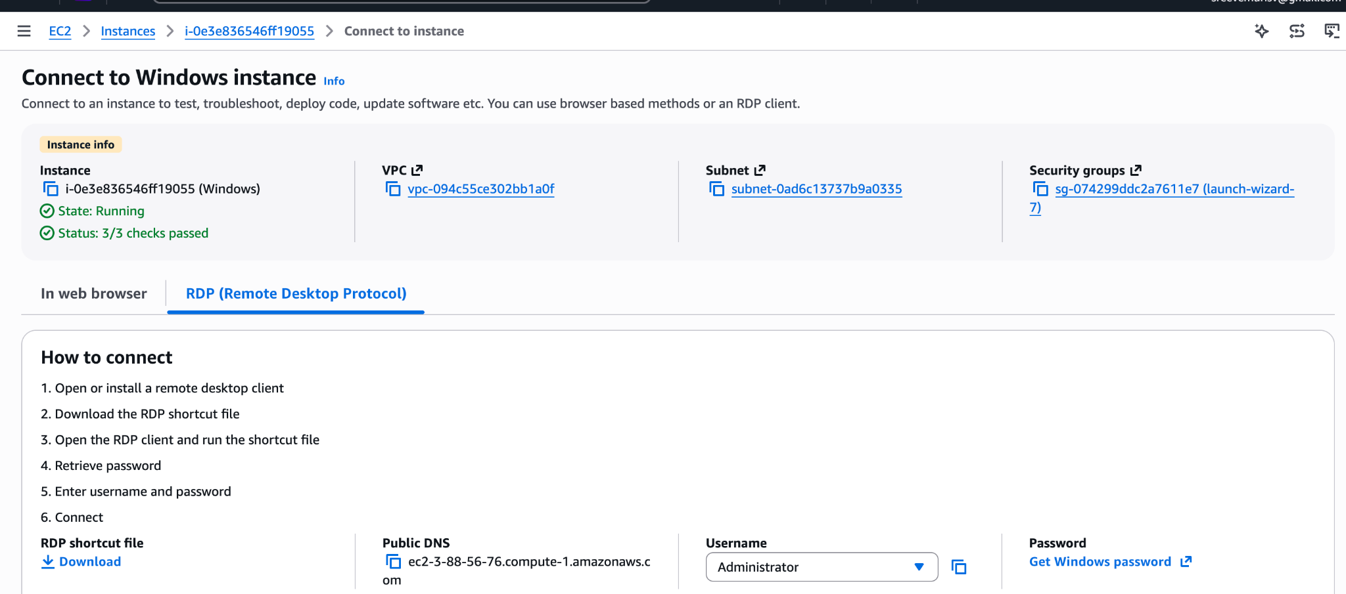

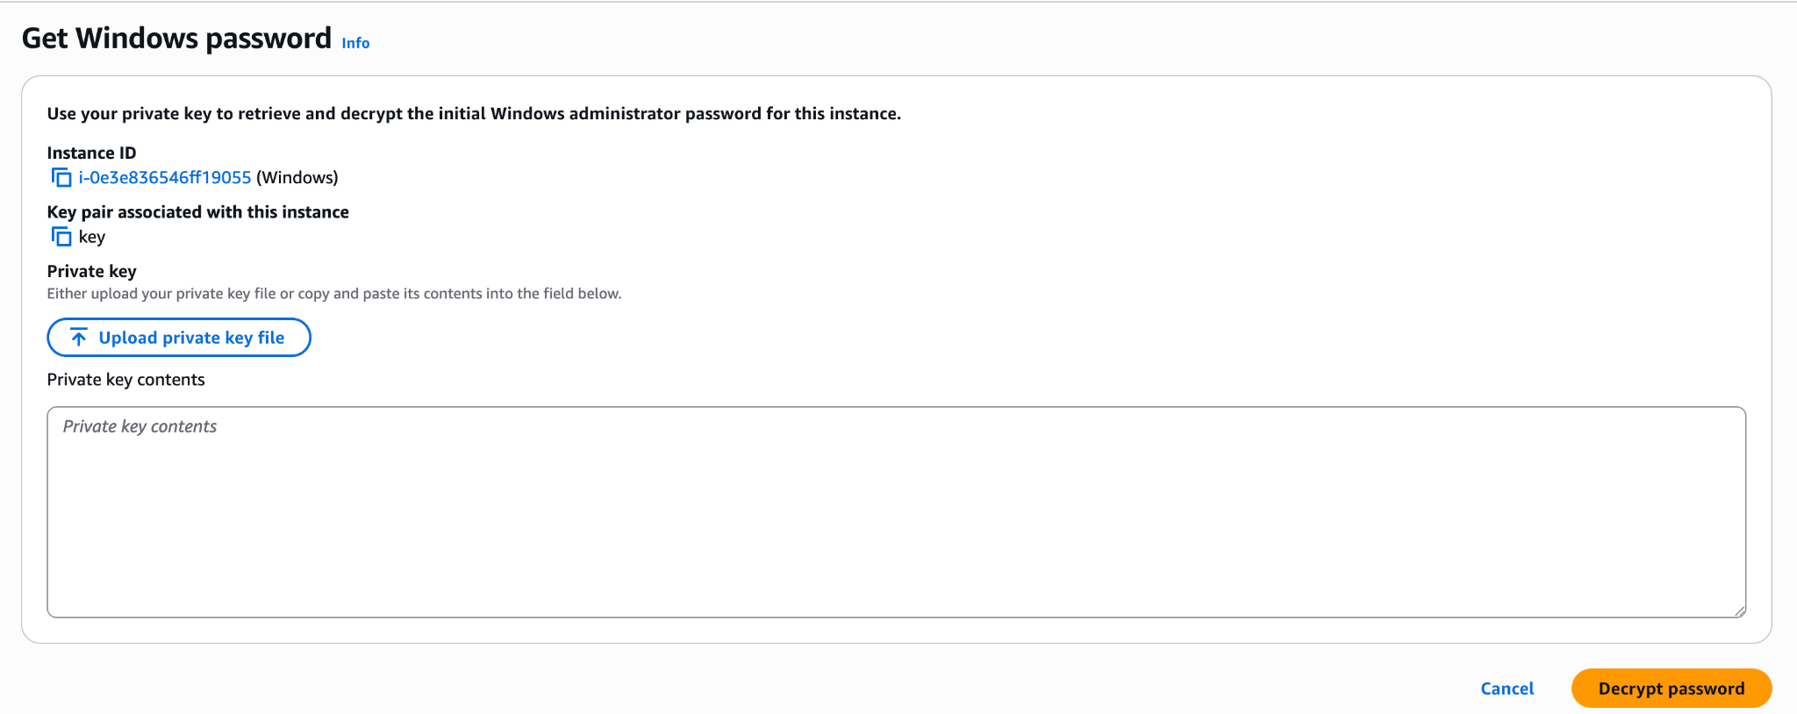

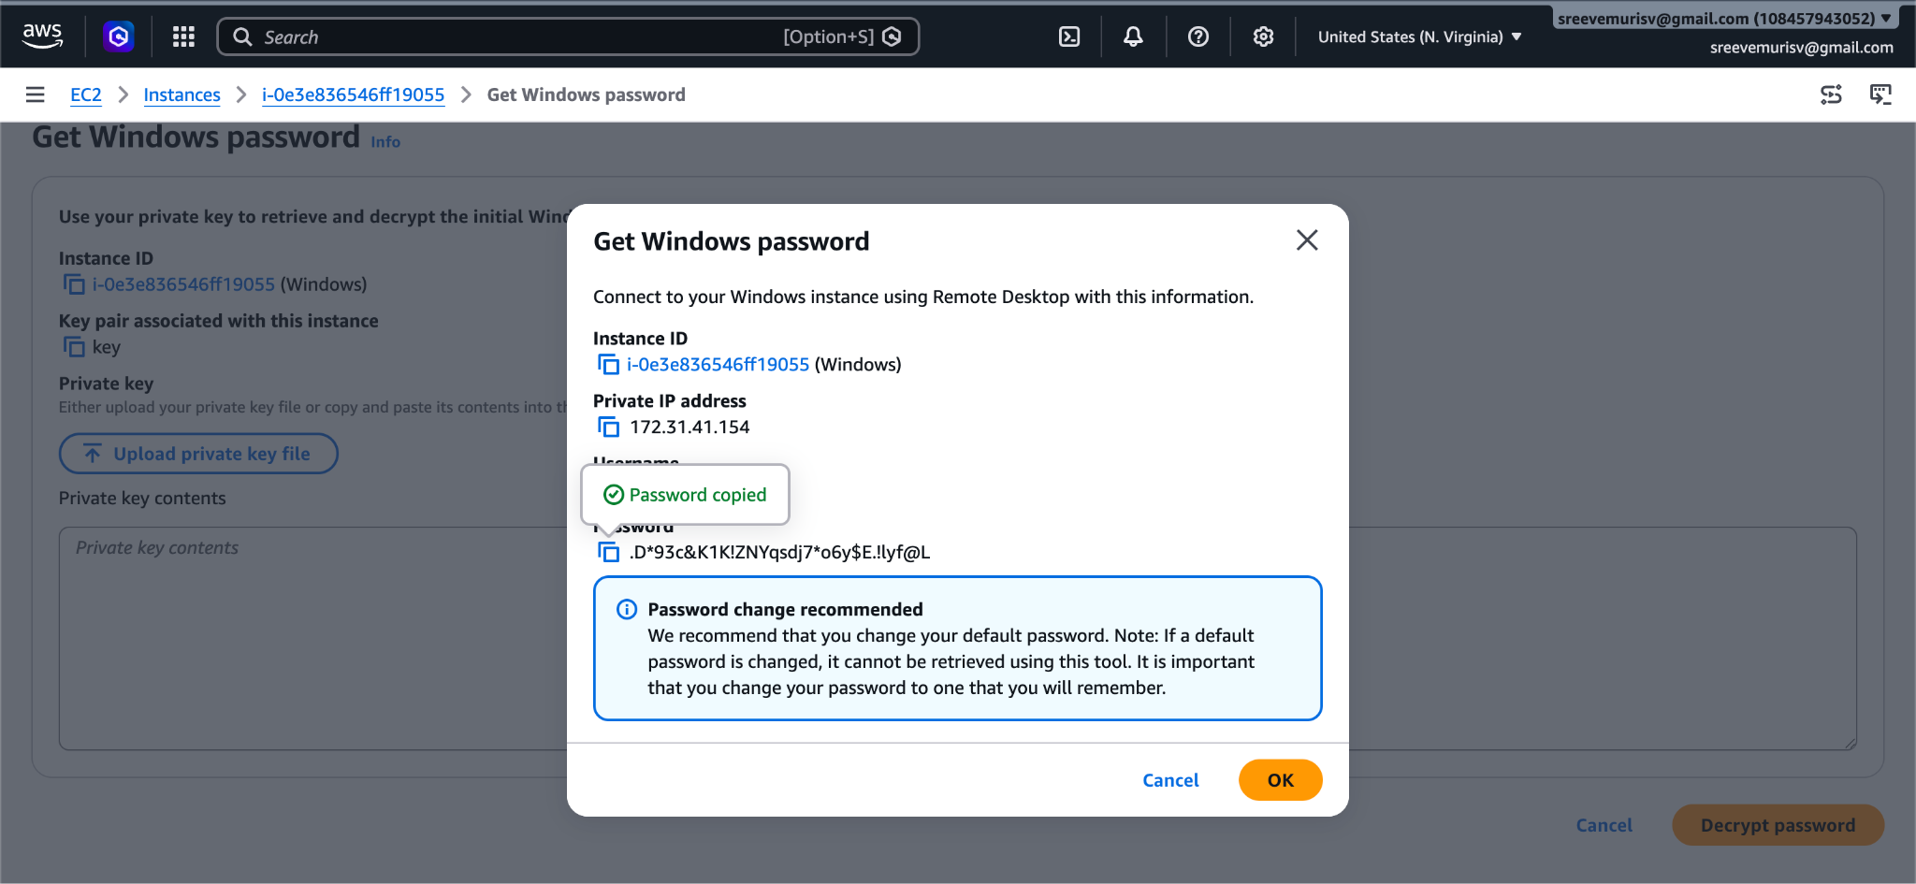

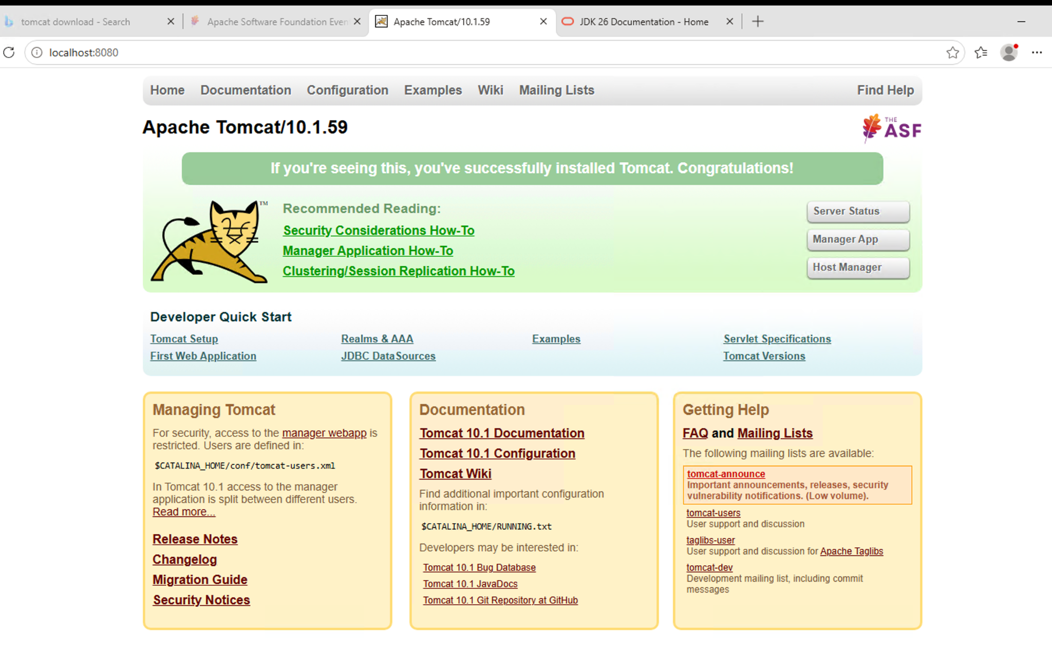
Set up EVN variables in RDP windows and set up java and run command
catalina.bat run
Run the below command wait till it stops
INFO [main] org.apache.catalina.startup.Catalina.start Server startup in [xxxx] milliseconds
And run in browser:
http://localhost:8080.
Launch any EC2 using the spot purchasing option.
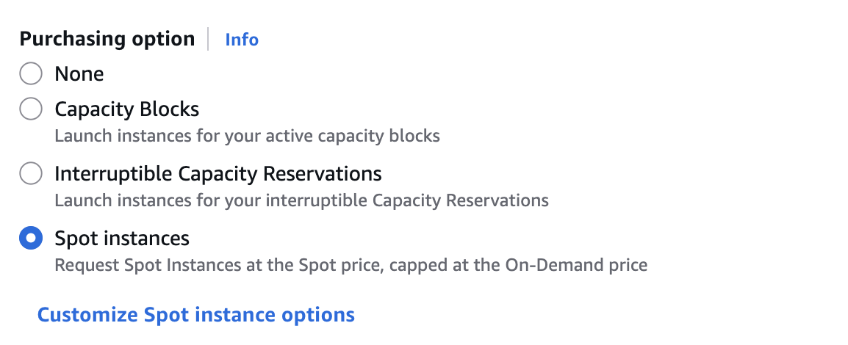

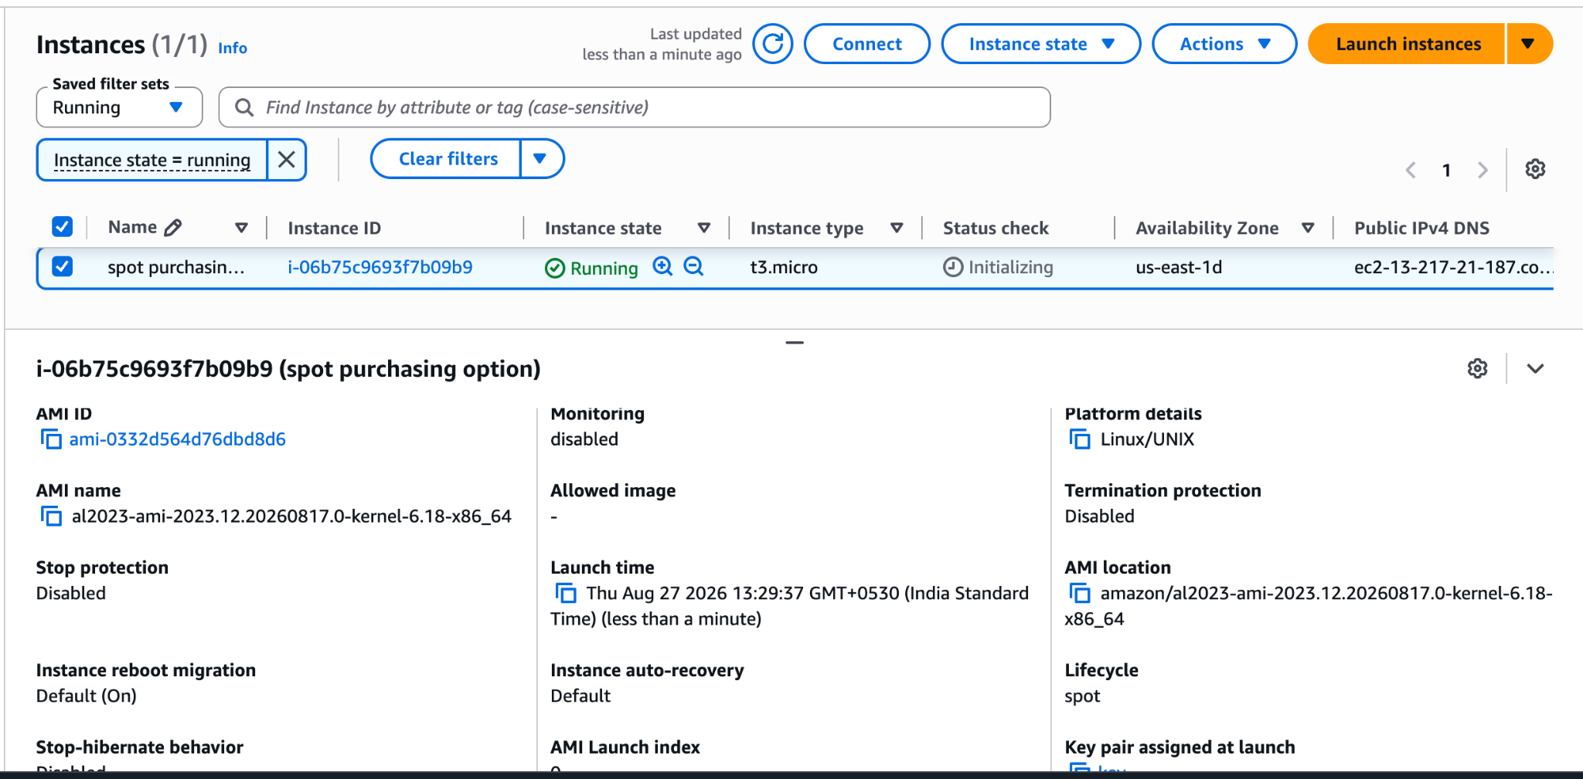
Enable termination policy on the EC2 created in Task 2.
