Configure VPC peering in cross regions.
Initiate Peering Connection from N. Virginia (us-east-1):
⚬ Switch the console region to N. Virginia (us-east-1).
⚬ Navigate to VPC > Peering connections > Create peering connection.
⚬ Requester VPC: Select your Default VPC (172.31.0.0/16).
⚬ Accepter: Choose Another Region > select US East (Ohio) us-east-2 > paste vpc-0dfdd13f480111988.
⚬ Click Create peering connection (generated pcx-0aea8f984f2e4db07).
Accept Connection in Ohio (us-east-2):
⚬ Switch back to Ohio (us-east-2).
⚬ Go to Peering connections, select pcx-0aea8f984f2e4db07, and click Actions > Accept request. Status changes to Active.

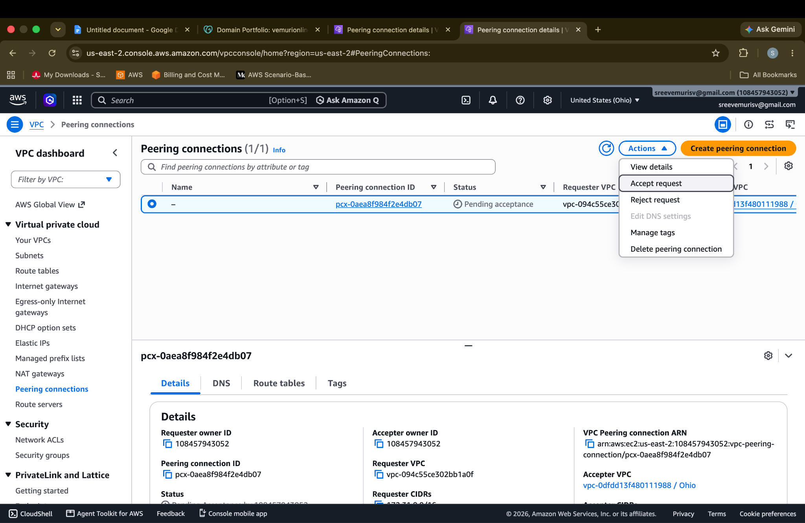
Update Route Tables on Both Sides:
⚬ In N. Virginia (us-east-1): Open your Default VPC route table (rtb-0b2b636e8295d7108) > Edit routes > add Destination 10.0.0.0/16 targeting pcx-0aea8f984f2e4db07
In Ohio (us-east-2): Open your Custom VPC route table (rtb-0fe520456ab47ebfb) > Edit routes > add Destination 172.31.0.0/16 targeting pcx-0aea8f984f2e4db07.

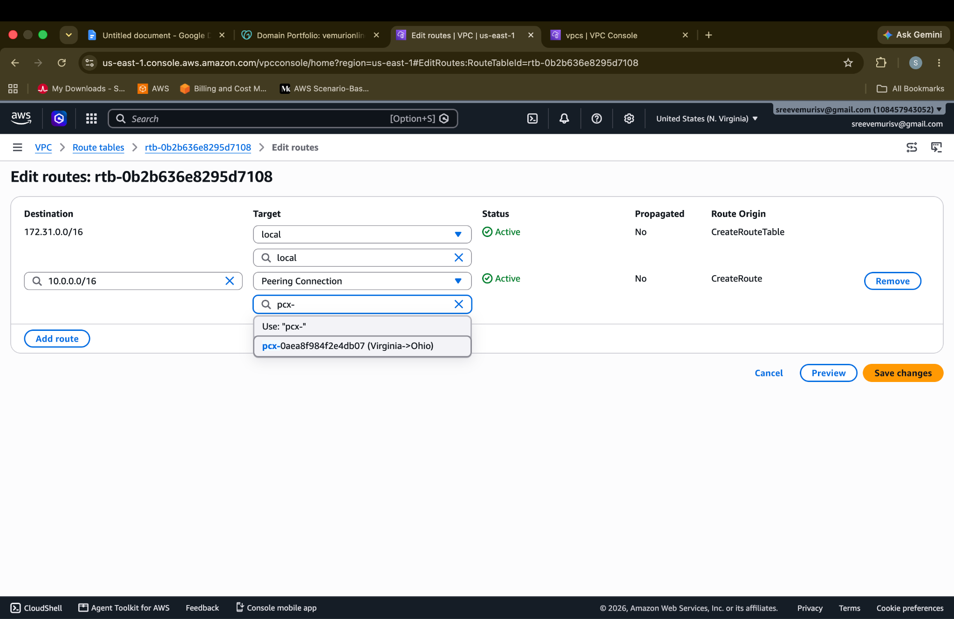
Step 2: S3 Static Website Hosting Configuration
When routing directly from Route 53 to S3 (bypassing CloudFront), AWS strictly requires the S3 bucket name to match your exact domain name.
- Create Bucket:
⚬ In S3, click Create bucket.
⚬ Bucket name: vemurionline.in (must match character-for-character).
⚬ Region: us-east-1 (or your chosen region).
⚬ Uncheck Block all public access (confirm warning).
⚬ Click Create bucket.
- Enable Static Website Hosting:
⚬ Open the bucket > go to the Properties tab.
⚬ Scroll down to Static website hosting > click Edit.
⚬ Select Enable.
⚬ Hosting type: Host a static website.
⚬ Index document: index.html.
⚬ Click Save changes and note the generated endpoint (e.g., [http://vemurionline.in.s3-website-us-east-1.amazonaws.com](http://vemurionline.in.s3-website-us-east-1.amazonaws.com)).
- Apply Public Read Bucket Policy:
⚬ Go to the Permissions tab > Bucket policy > click Edit.
⚬ Paste the following JSON policy:
​​{
- "Version": "2012-10-17",
- "Statement": [
- {
- "Sid": "PublicReadGetObject",
- "Effect": "Allow",
- "Principal": "*",
- "Action": "s3:GetObject",
- "Resource": "arn:aws:s3:::vemurionline.in/*"
- }
- ]
- }
Click Save changes.
Upload Content:
⚬Go to the Objects tab > click Upload > add your local index.html > click Upload.

Step 3: Domain Delegation (GoDaddy to Route 53)
- Create Route 53 Public Hosted Zone:
⚬ Navigate to Route 53 > Hosted zones > Create hosted zone.
⚬ Domain name: vemurionline.in.
⚬ Type: Public hosted zone.
⚬ Click Create hosted zone.
⚬ Locate the 4 assigned AWS Name Server (NS) records (e.g., ns-xxx.awsdns-xx.com).
- Update Nameservers in GoDaddy:
⚬ Log into GoDaddy > navigate to Domain Portfolio > select vemurionline.in.
⚬ Go to DNS > Nameservers > Change Nameservers.
⚬ Choose Enter my own nameservers (advanced).
⚬ Paste the 4 Route 53 NS addresses (without trailing dots) and save changes.

Step 4: Map Route 53 Directly to S3 Endpoint
- In Route 53, open the vemurionline.in hosted zone.
- Click Create record:
⚬ Record name: Leave blank (for apex domain vemurionline.in).
⚬ Record type: A - Routes traffic to an IPv4 address and some AWS resources.
⚬ Alias: Toggle to ON.
⚬ Route traffic to: Select Alias to S3 website endpoint.
⚬ Choose Region: Select the region where your bucket resides (e.g., us-east-1).
⚬ Choose S3 endpoint: Select s3-website-us-east-1.amazonaws.com. (the matching vemurionline.in bucket auto-populates).
- Click Create records.

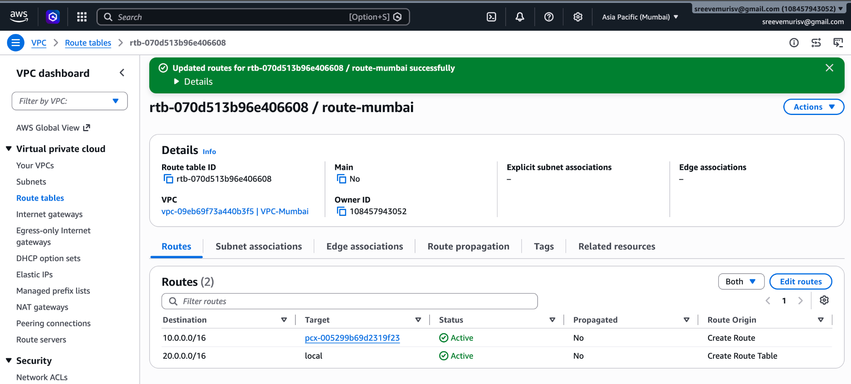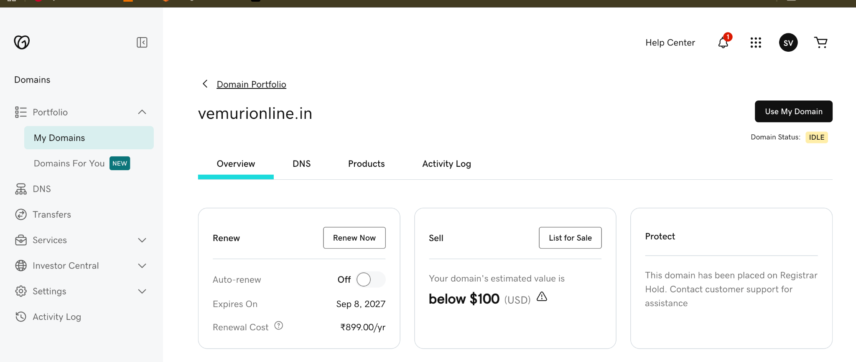
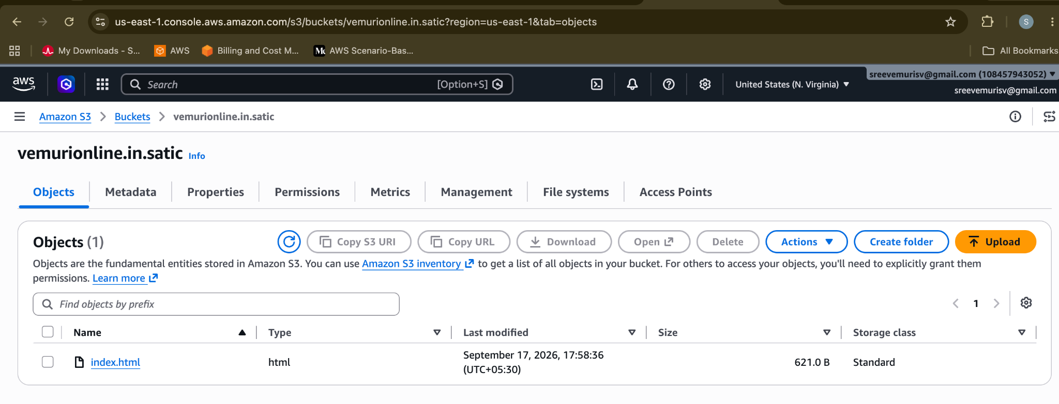ns-71.awsdns-08.com.
ns-1308.awsdns-35.org.
ns-659.awsdns-18.net.
ns-1993.awsdns-57.co.uk.