- Install git.
- Create a repo in github with README.md and .ignore file.
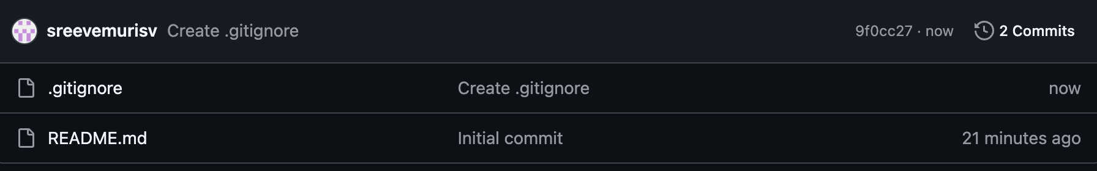
- Clone the created repo to local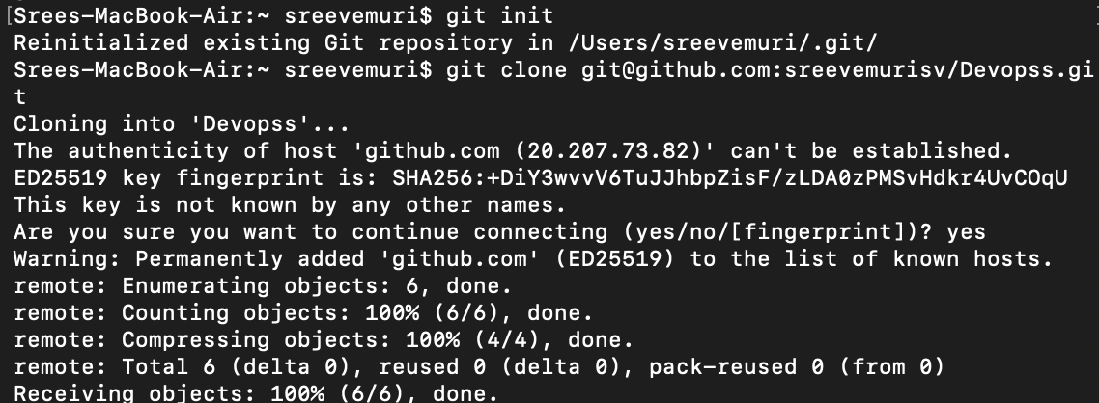
- Create two files in the local repo.
- Commit two files and push to the central Repository.
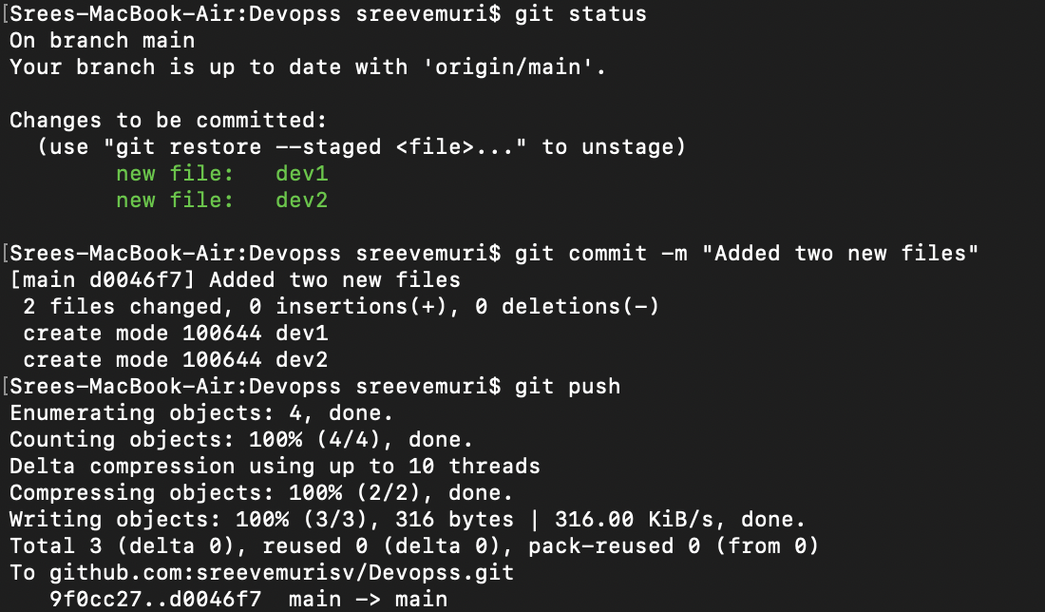
- Create a branch in local and create a sample file and push to central.
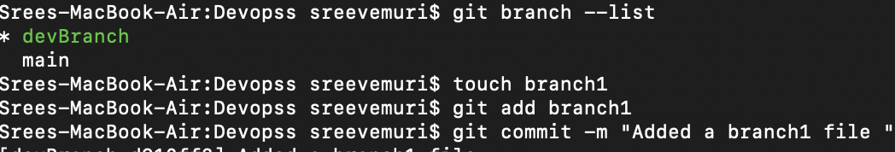
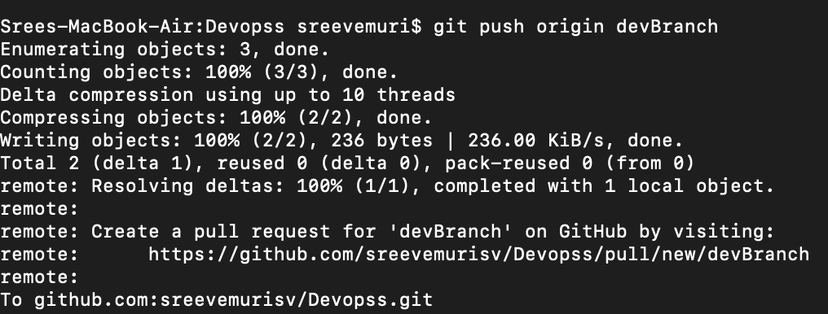
- Create a branch in github and clone that to local.
Git fetch origin
Git checkout devBranch2
Git branch –list
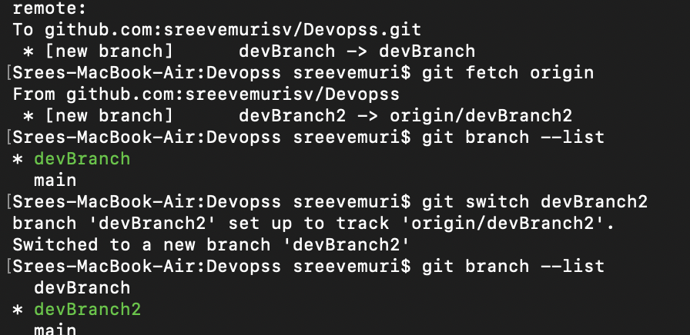
- Merge the created branch with master in git local.
- Merge the created branch with master in github by sending a pull request.
- Create a file in local and send that to the branch in github.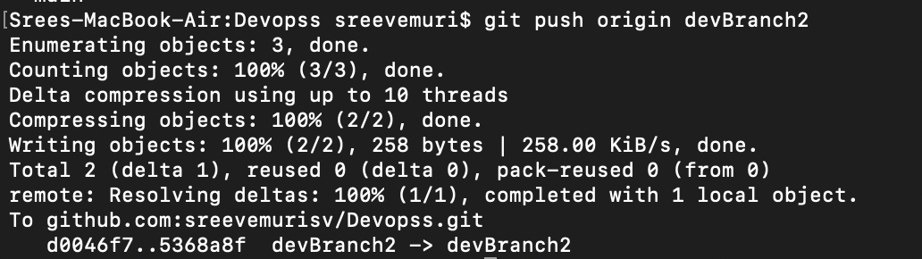
- Clone only a branch from github to local.
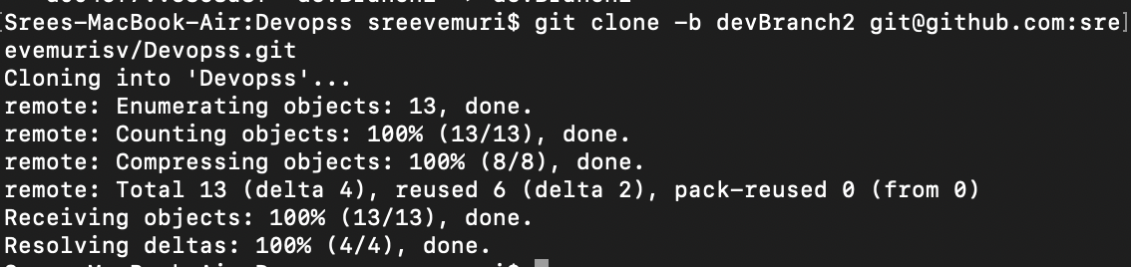
- Create a file with all passwords and make that untrackable with git.
To untrack : git reset and git status
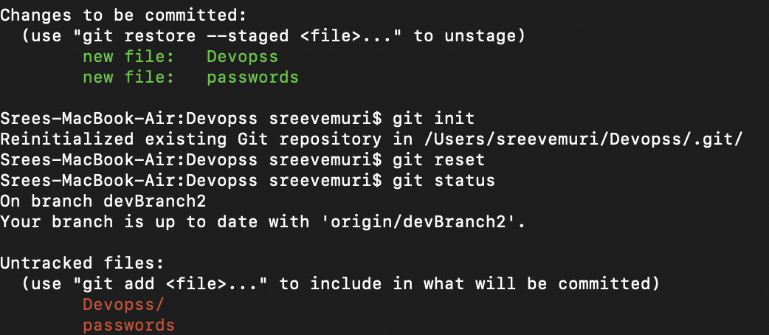
- Push a file to stash without savings the changes and work on another file.
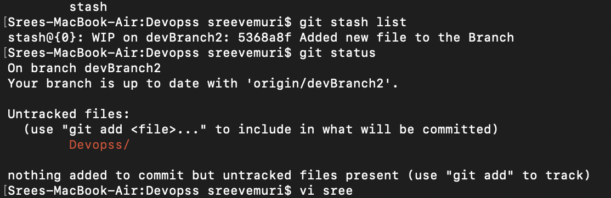
- Undo the stash file and start working on that again.
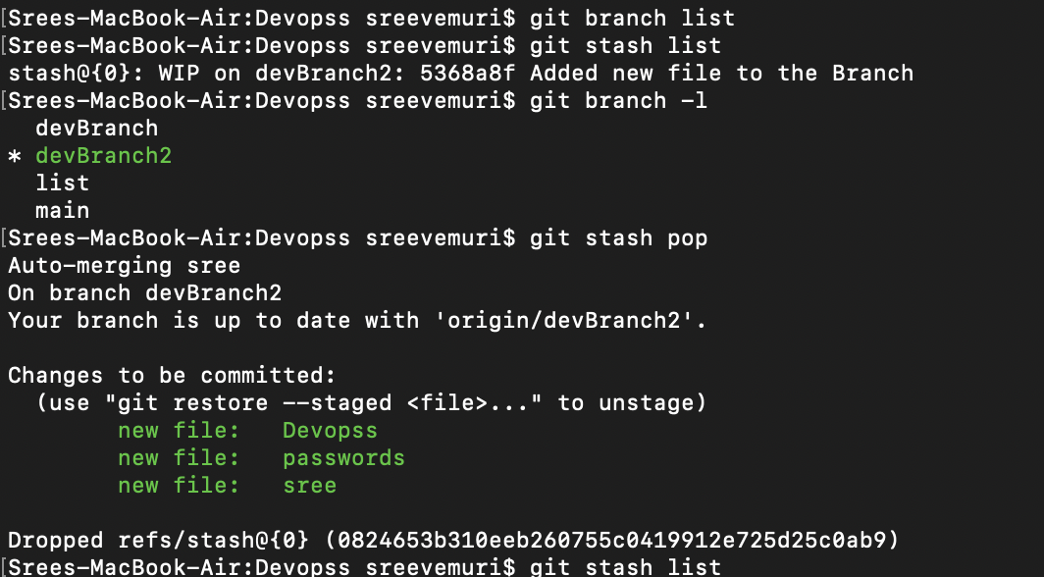

- Check all the logs of git.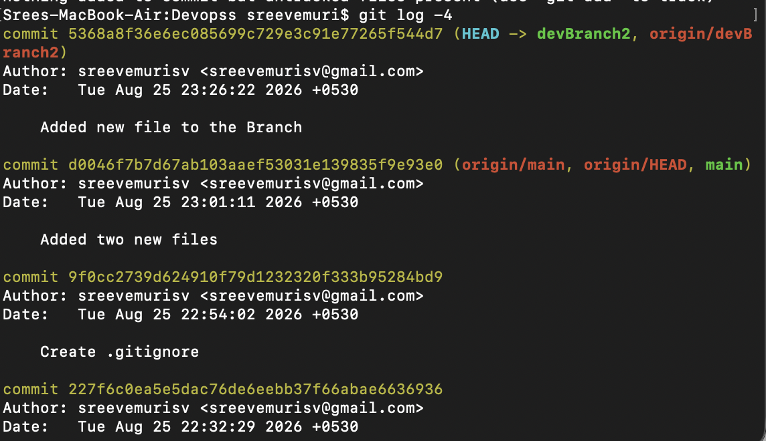
- Rename the commit message.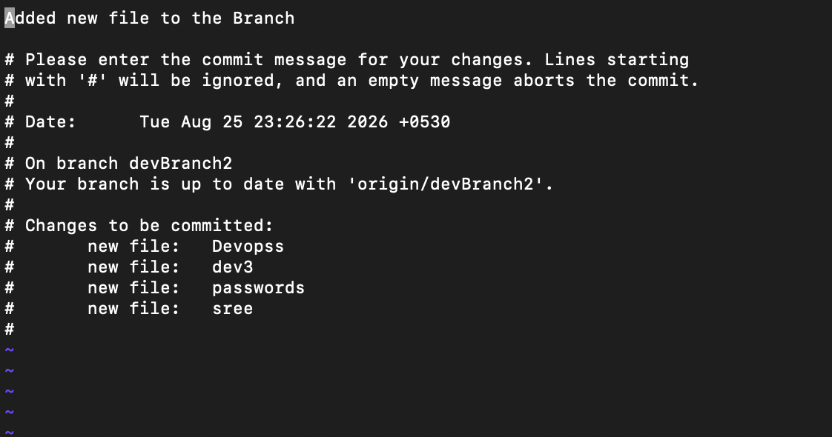
- Merge multiple commits into single commit.
