1). Install Terraform on your PC
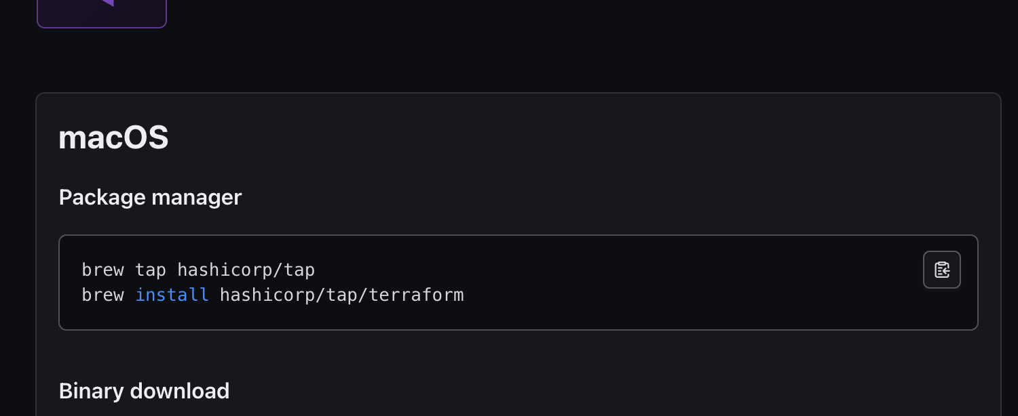

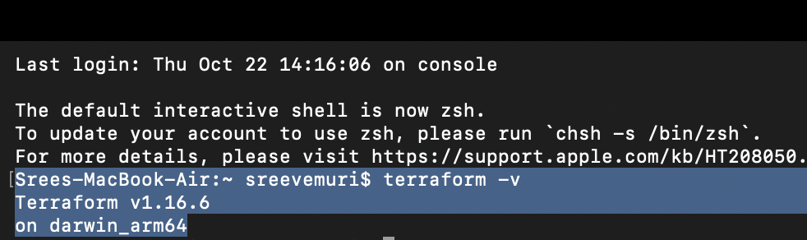

2). Execute all the templates shown in the video.

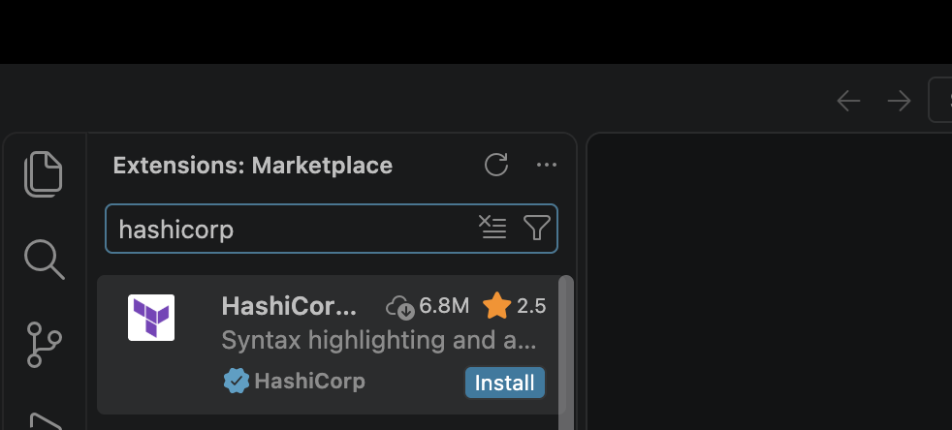
Install hashicorp plugin in VS code Editor
Create a file name with “main.tf”
i) Write a sample code/script to run to see the output.
resource "local_file" "file1" {
filename = "sree.txt"
content = "hello this is my first file in file1"
}
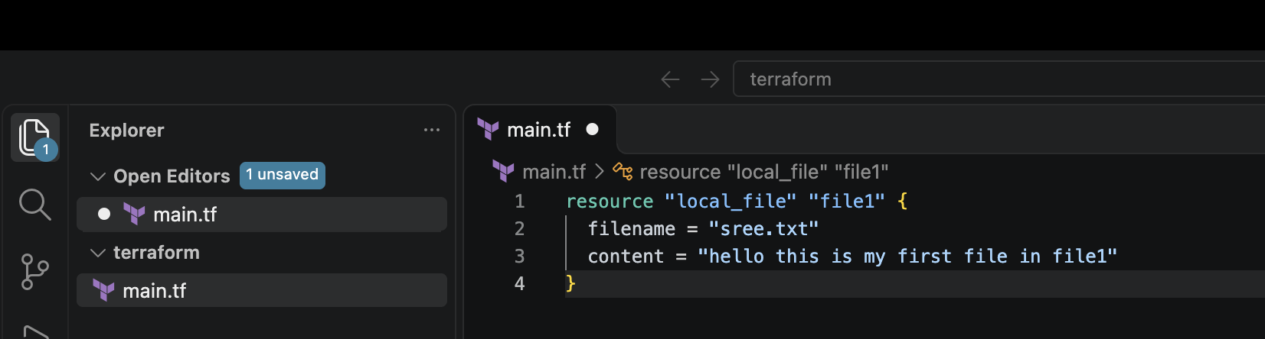

Do:
terraform init → terraform plan → terraform apply → yes
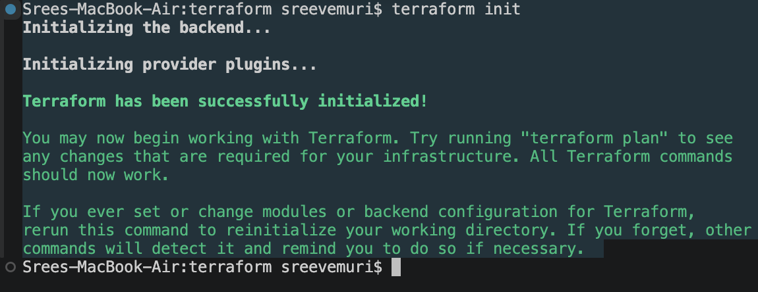

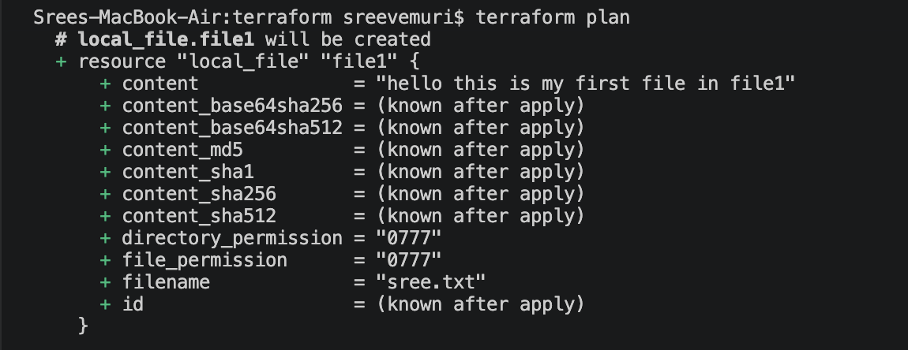

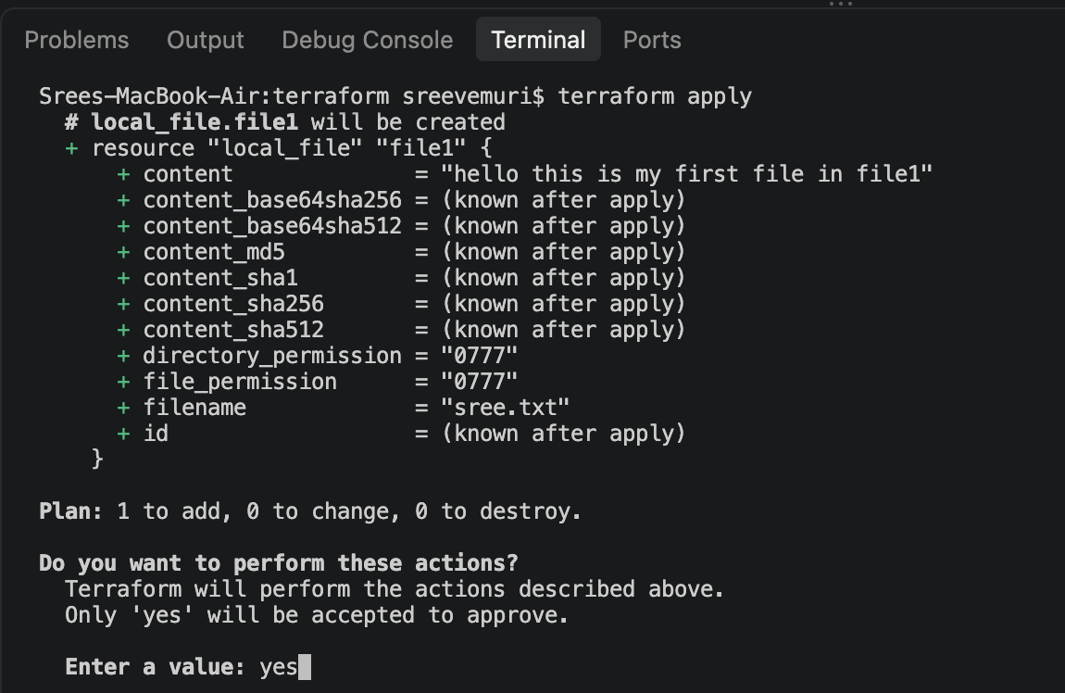

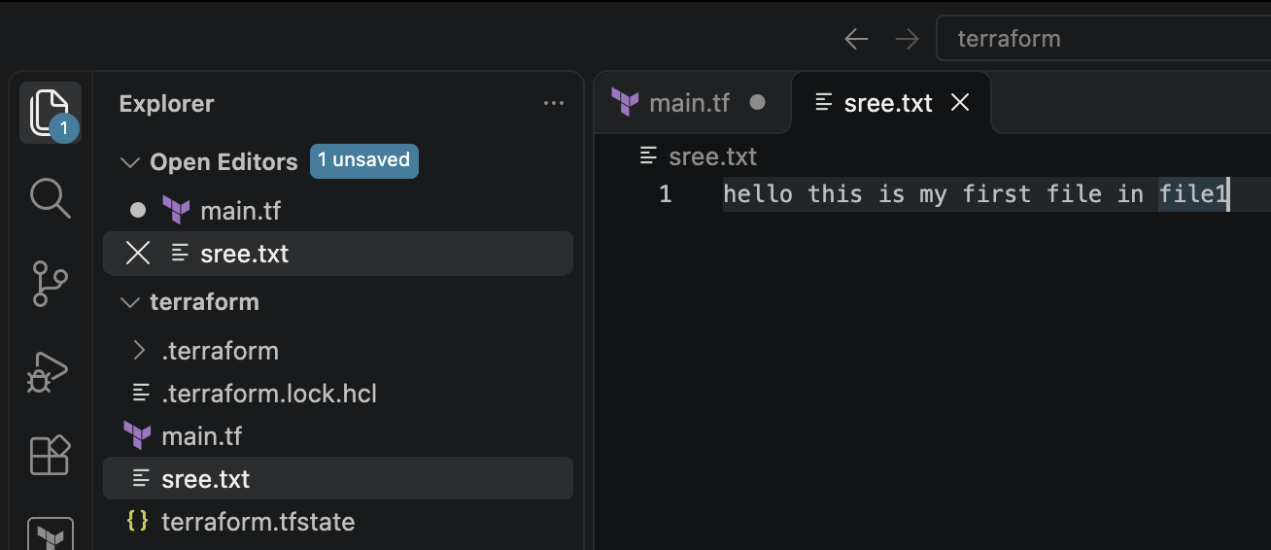

ii) Trying to change/modify the file information
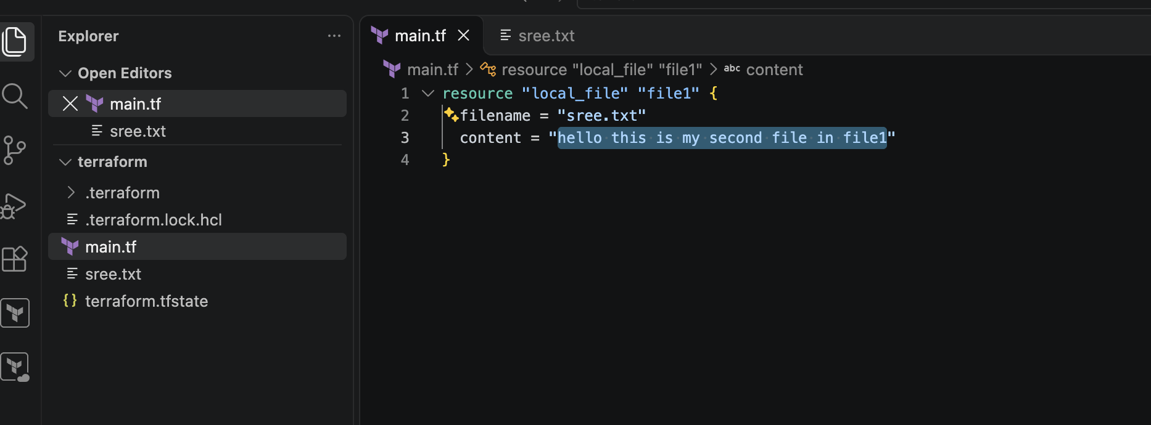

From
content “hello this is my first file in file1”
To
content “hello this is my second file in file1”

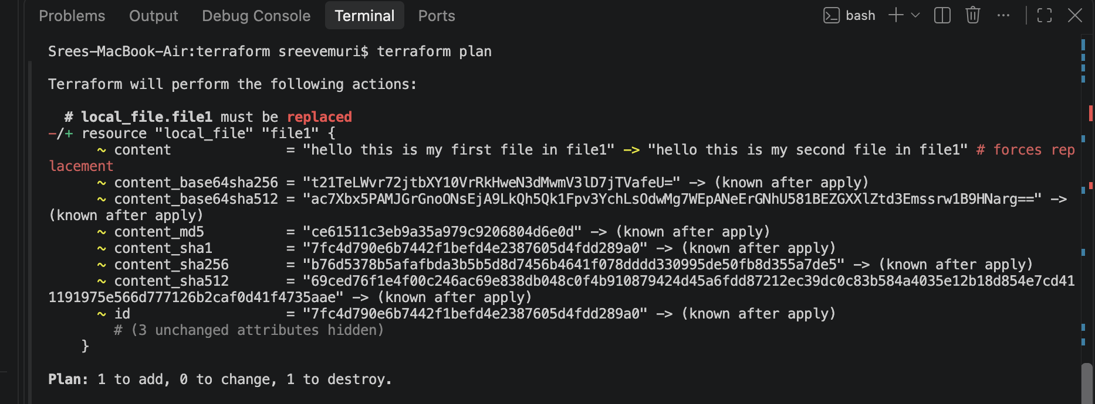
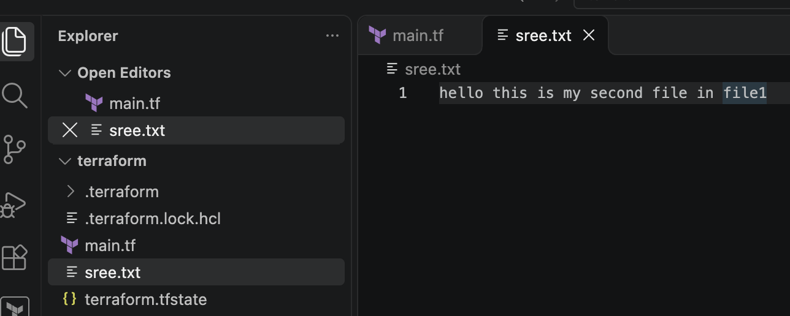

Random-pet
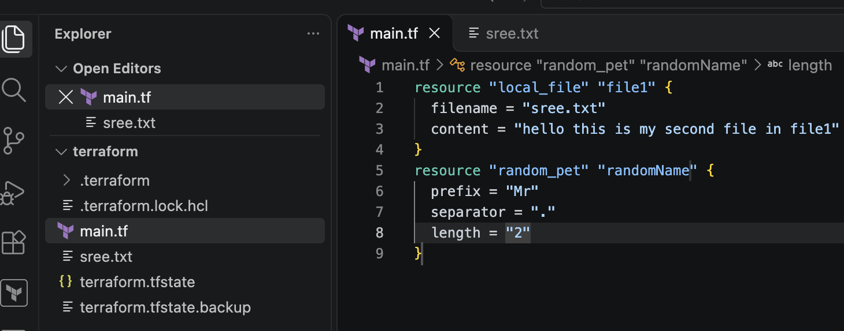

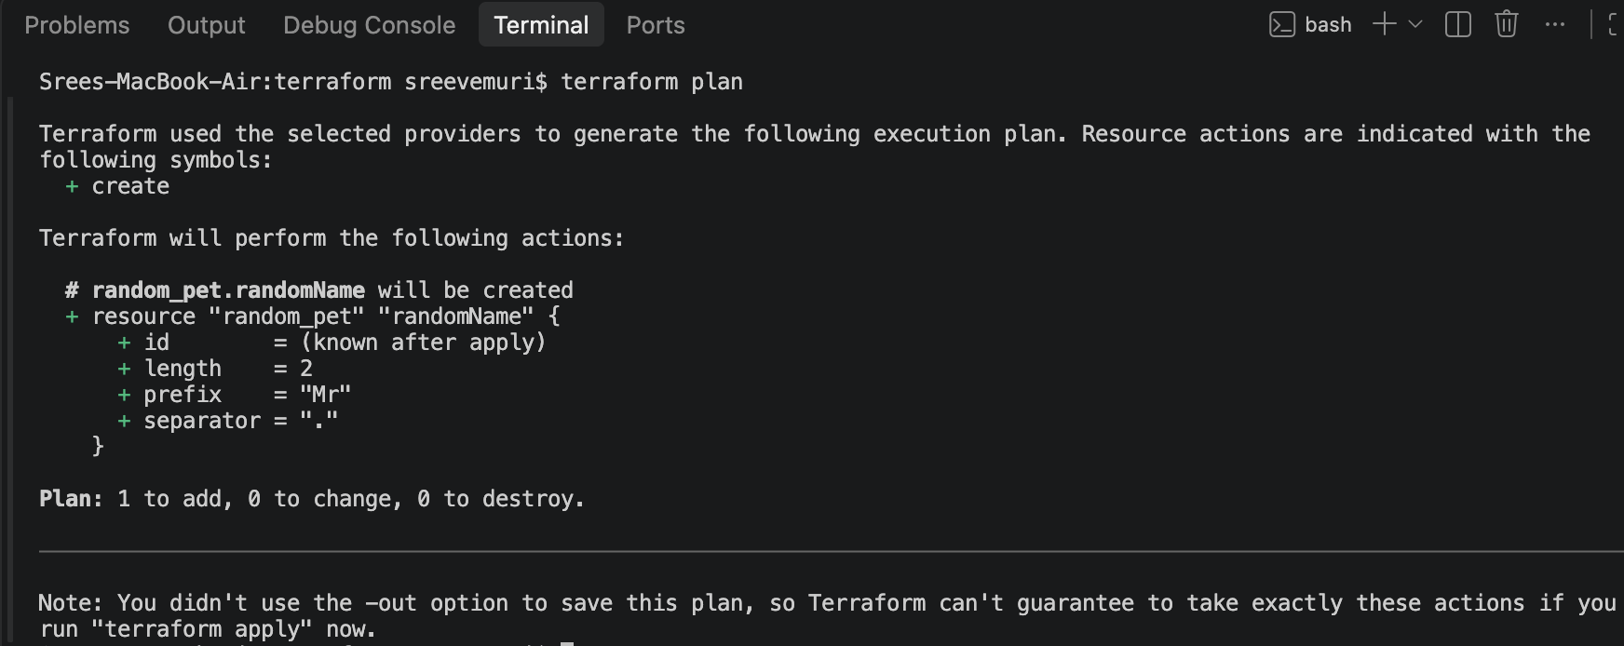
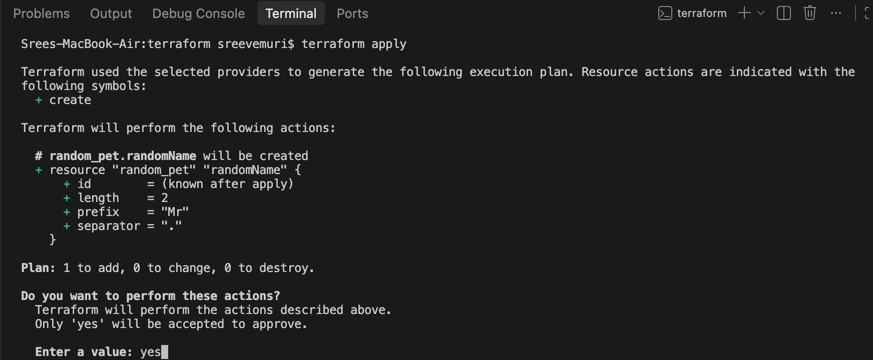
ii)random_pet (script)
resource "random_pet" "randomName" {
prefix = "Mr"
separator = "_"
length = "2"
}

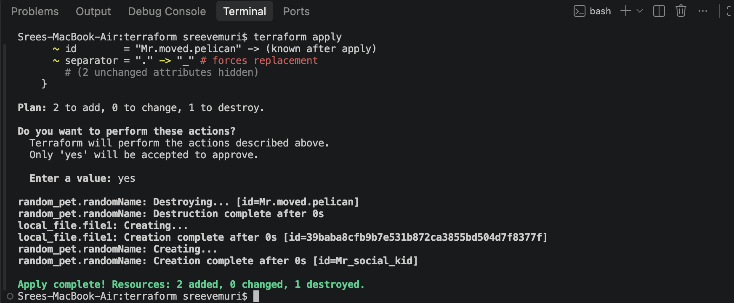

3). Note down below points,
Terraform Init :Initializes your working directory by downloading the required provider plugins and setting up the backend. Run this first before any other command.

Terraform Plan : It is the dry run of the script which used to identify the error before t_apply
Terraform Apply : After applying the t_plan if there are no errors the we can do terraform apply to run the script

Terraform Provider:A plugin (such as AWS, Azure, GitHub, or local system) that allows Terraform to communicate with the target API and manage its resources.

Terraform destroy: which will remove all the resources from the .tf file
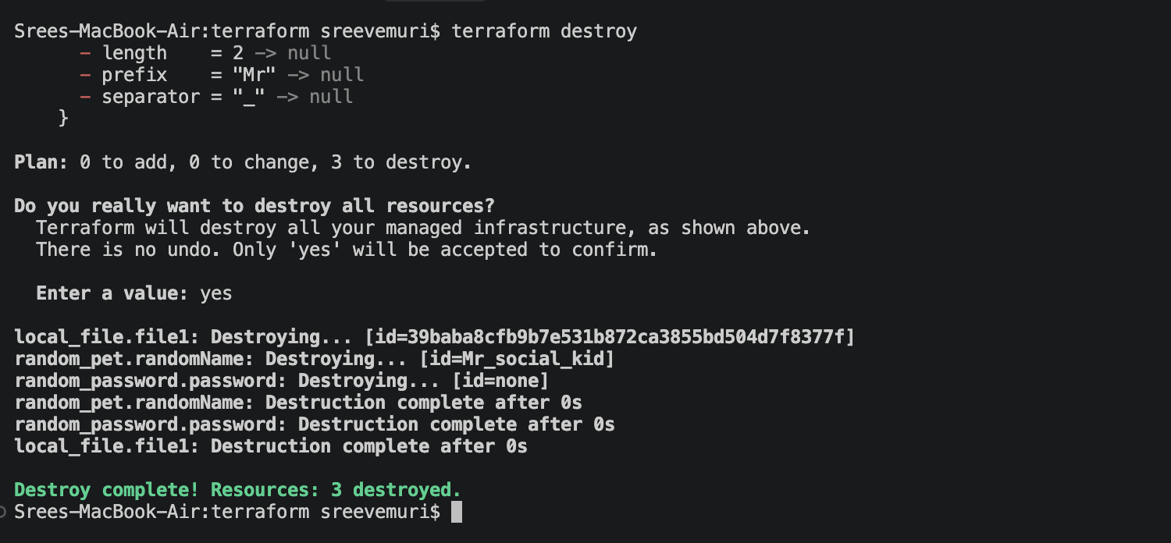

4) Integrate a sample Terraform template in Jenkins.

Here is a clean summary and reference guide of the complete end-to-end setup we just built to run Terraform inside a Jenkins pipeline on an AWS EC2 instance.
This architecture demonstrates how to provision an automation server (Jenkins) on an AWS EC2 instance, configure it with Terraform, and execute an automated pipeline that dynamically generates infrastructure/files using local and random providers.

1. Infrastructure Architecture Stack
- OS: Amazon Linux 2023 (EC2 instance)
- Automation Server: Jenkins (running on port 8080)
- Runtime Dependencies: Java 17 (Amazon Corretto) & HashiCorp Terraform CLI
- Pipeline Orchestrator: Jenkins declarative pipeline script (Jenkinsfile)

2. Quick Setup & Configuration Reference

A. Server Setup (EC2 Terminal)
To prep the EC2 instance, the following components were installed and verified:
- Java 17 & Jenkins: Installed via yum repositories and managed via systemctl.
- Terraform CLI: Installed via the official HashiCorp yum repository.
Permissions Check: Ensured the jenkins system user could execute Terraform globally:
sudo -u jenkins terraform -version

B. The Final Working Jenkins Pipeline Script
This declarative pipeline writes a Terraform configuration (main.tf) inline safely using single-quoted EOF to prevent shell/Groovy variable collision, then initializes, plans, and applies the code.
pipeline {
agent any

stages {
stage('Checkout Code') {
steps {
// Generates the Terraform config file dynamically
sh '''
cat << 'EOF' > main.tf
terraform {
required_providers {
local = {
source = "hashicorp/local"
version = "~> 2.0"
}
random = {
source = "hashicorp/random"
version = "~> 3.0"
}
}
}

resource "random_password" "password" {
length = 16
special = true
}

resource "local_file" "secret_file" {
content = "Generated password: ${random_password.password.result}"
filename = "secret.txt"
}
EOF
'''
}
}

stage('Terraform Init') {
steps {
// Downloads required providers (local, random)
sh 'terraform init'
}
}

stage('Terraform Plan') {
steps {
// Previews resource changes
sh 'terraform plan'
}
}

stage('Terraform Apply') {
steps {
// Executes and generates the secret.txt file in the workspace
sh 'terraform apply -auto-approve'
}
}
}
}

3. Key Troubleshooting Takeaways Learned
- Groovy vs. Shell Variables: When writing multi-line text files (cat << EOF) inside Jenkins pipelines using Groovy strings ('''), always use single quotes around the delimiter ('EOF') to prevent syntax errors (bad substitution).
- PATH Availability: Jenkins runs builds under a restricted system user (jenkins). Ensuring Terraform is installed globally in system paths (/usr/bin or /usr/local/bin) prevents command not found exit errors (code 127).
