- Enable CloudTrail monitoring and store the events in S3 and CloudWatch log events.
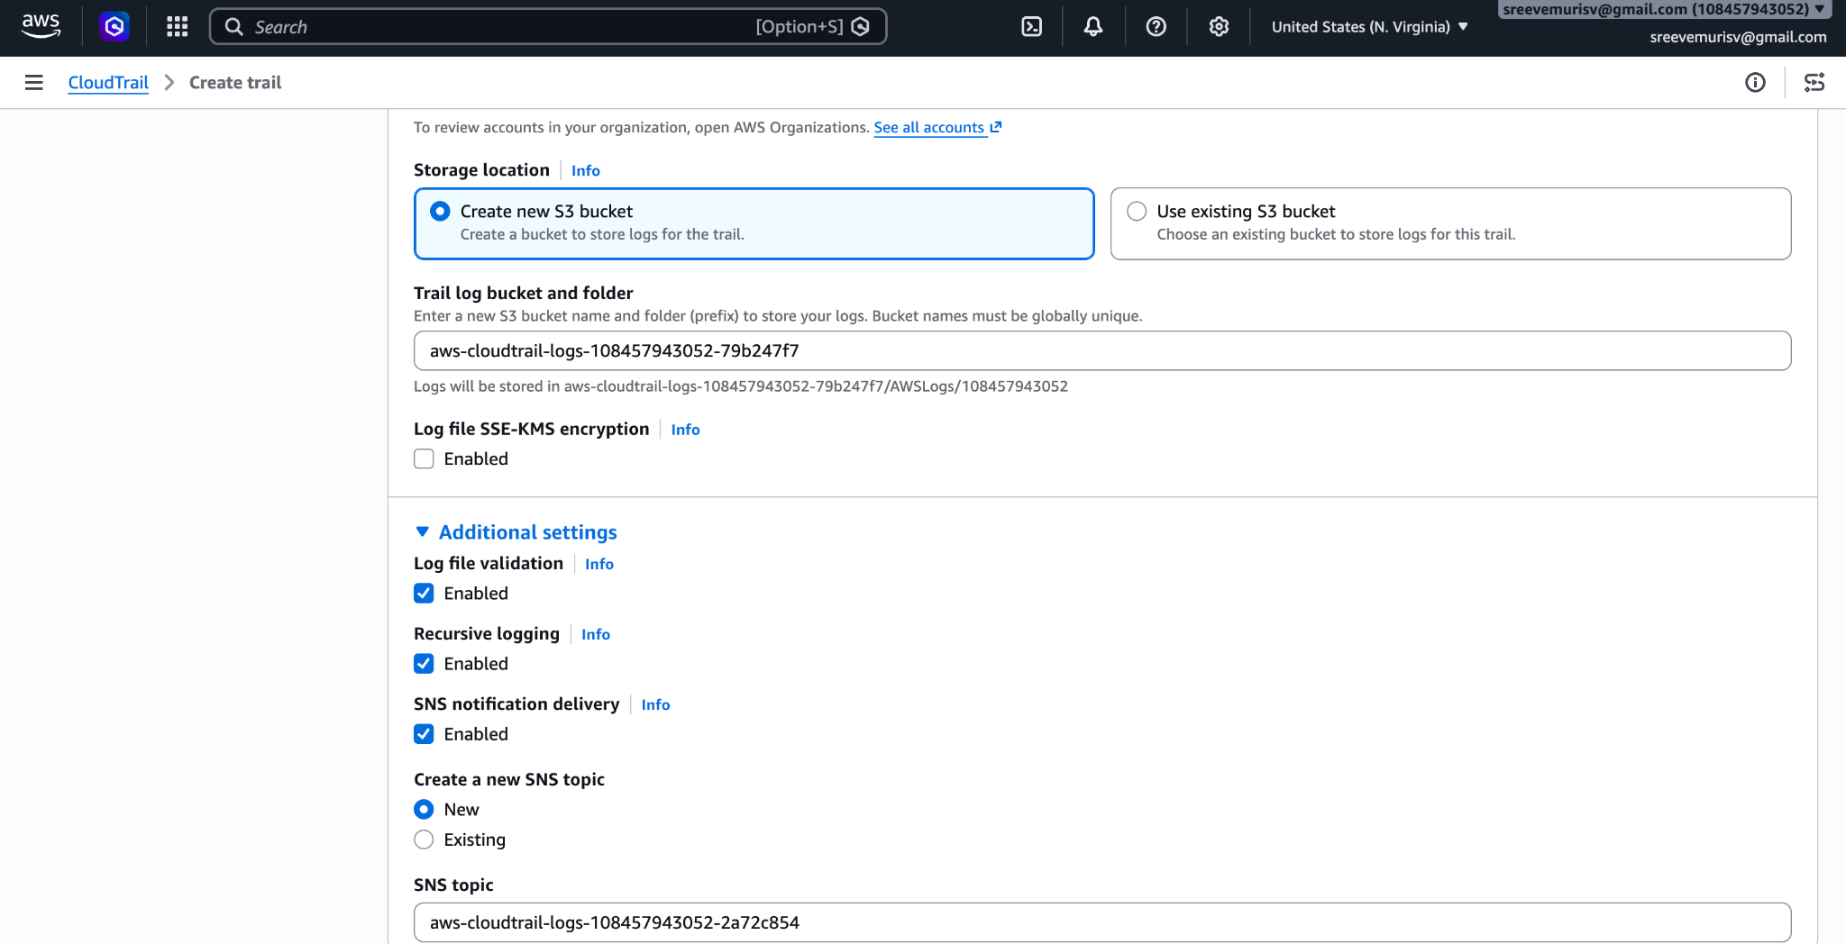
- Enable the Email
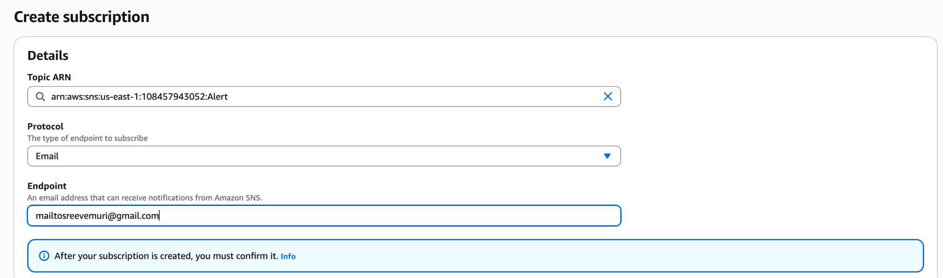
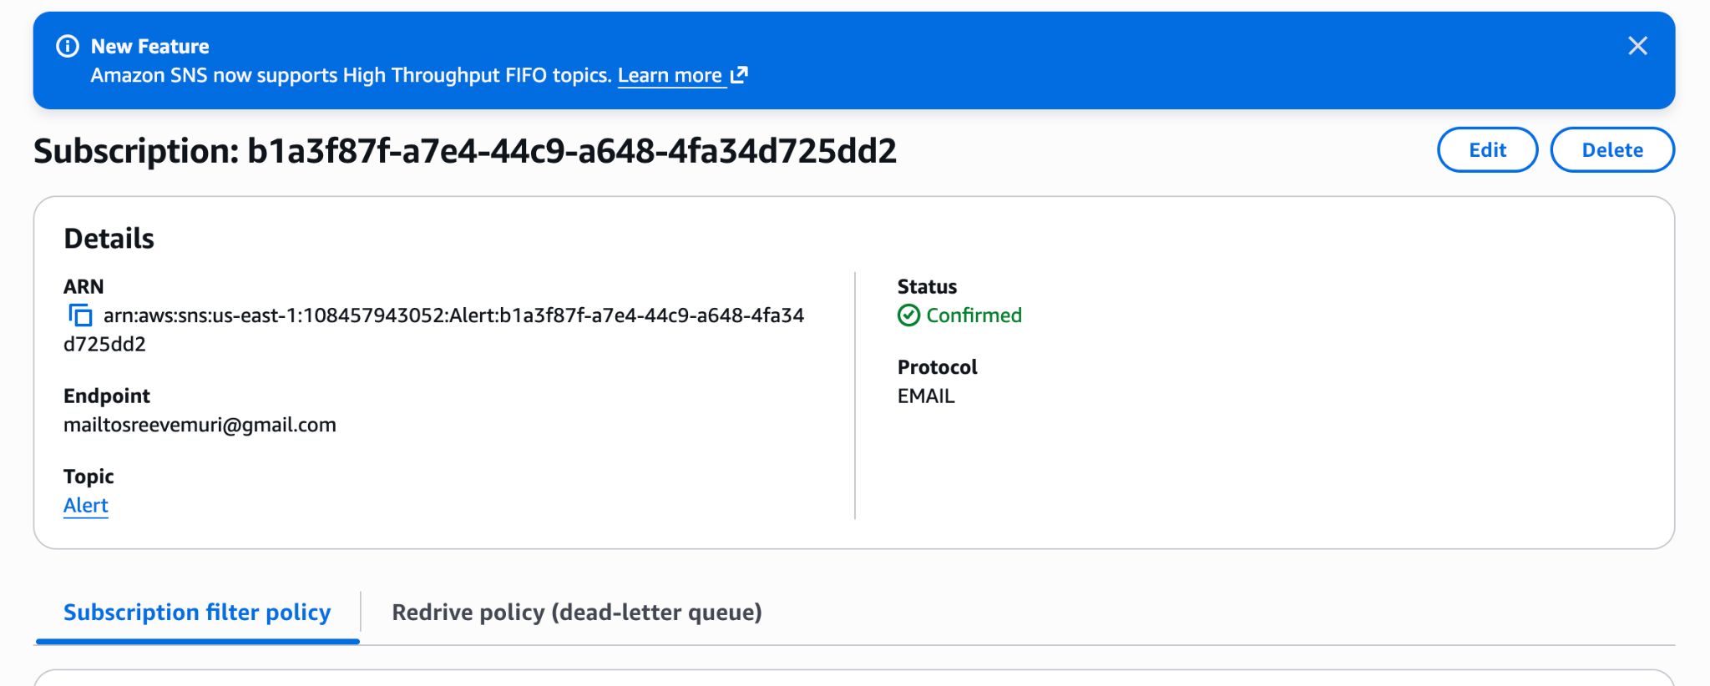
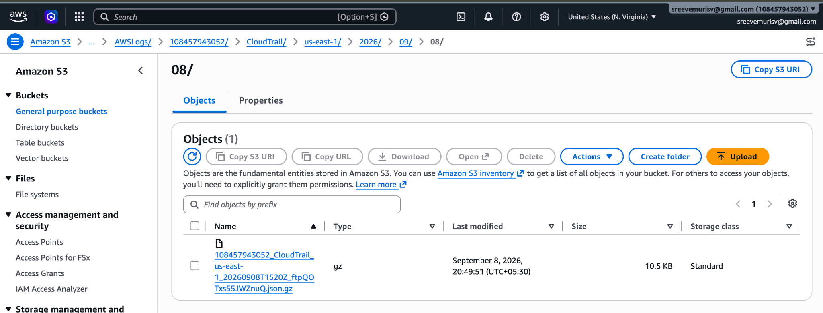
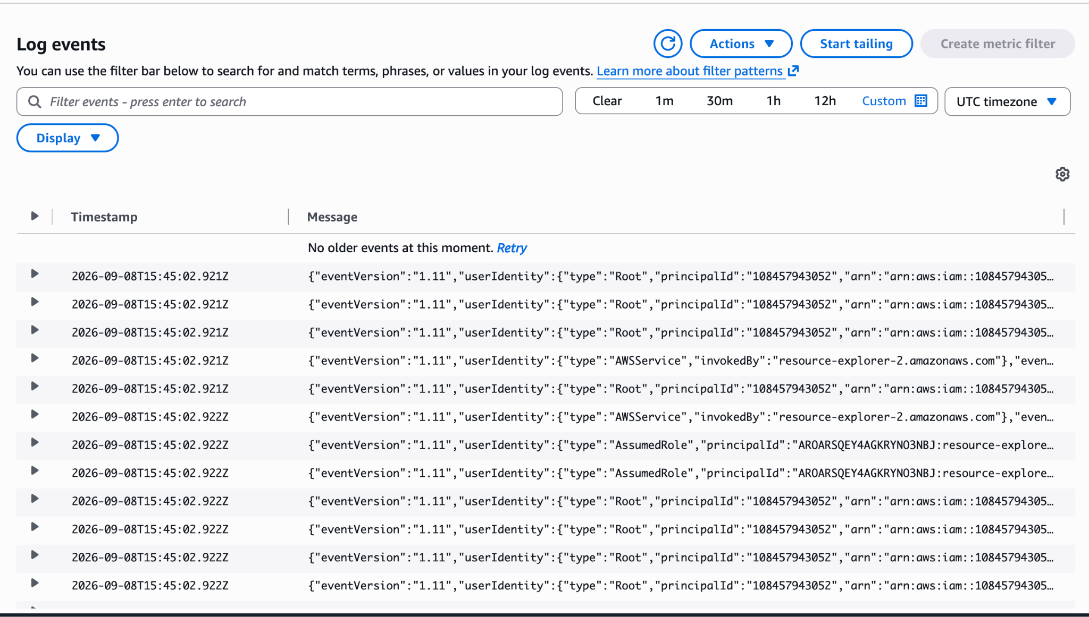
2. Enable SNS for CloudTrail to send alerts via email.
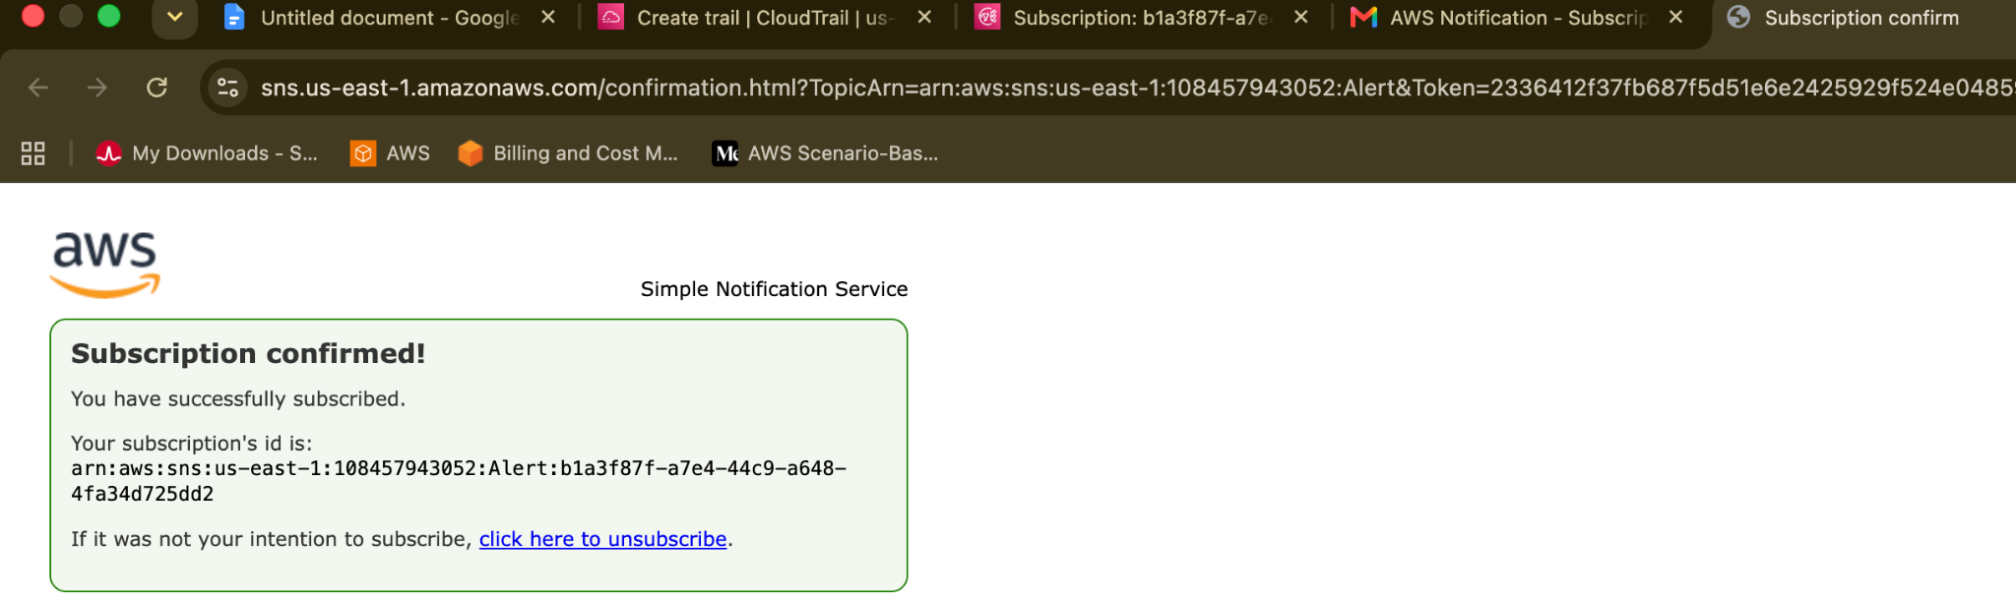
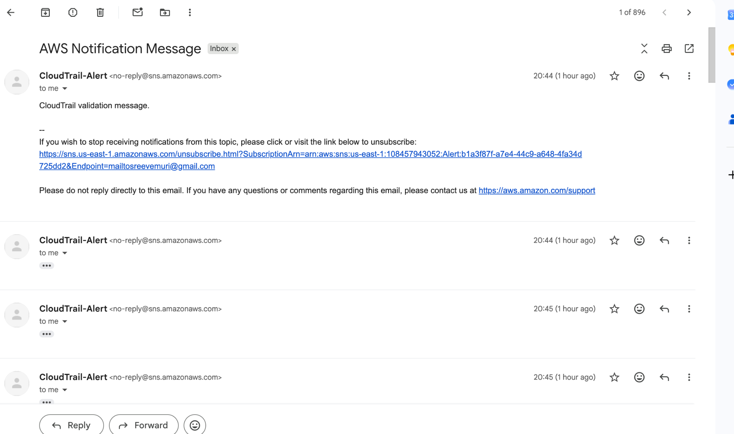
- Configure CloudWatch monitoring and record the CPU utilization and other metrics of EC2.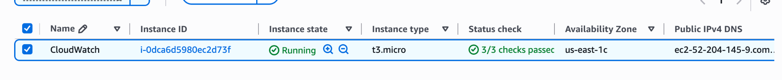
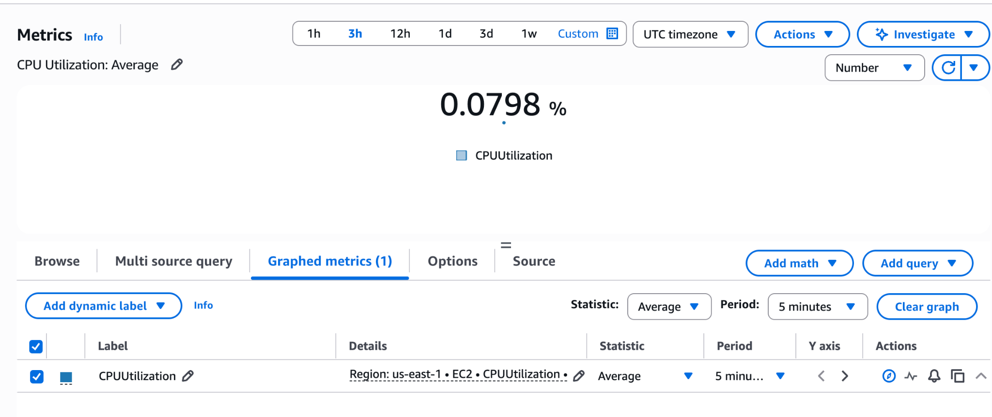
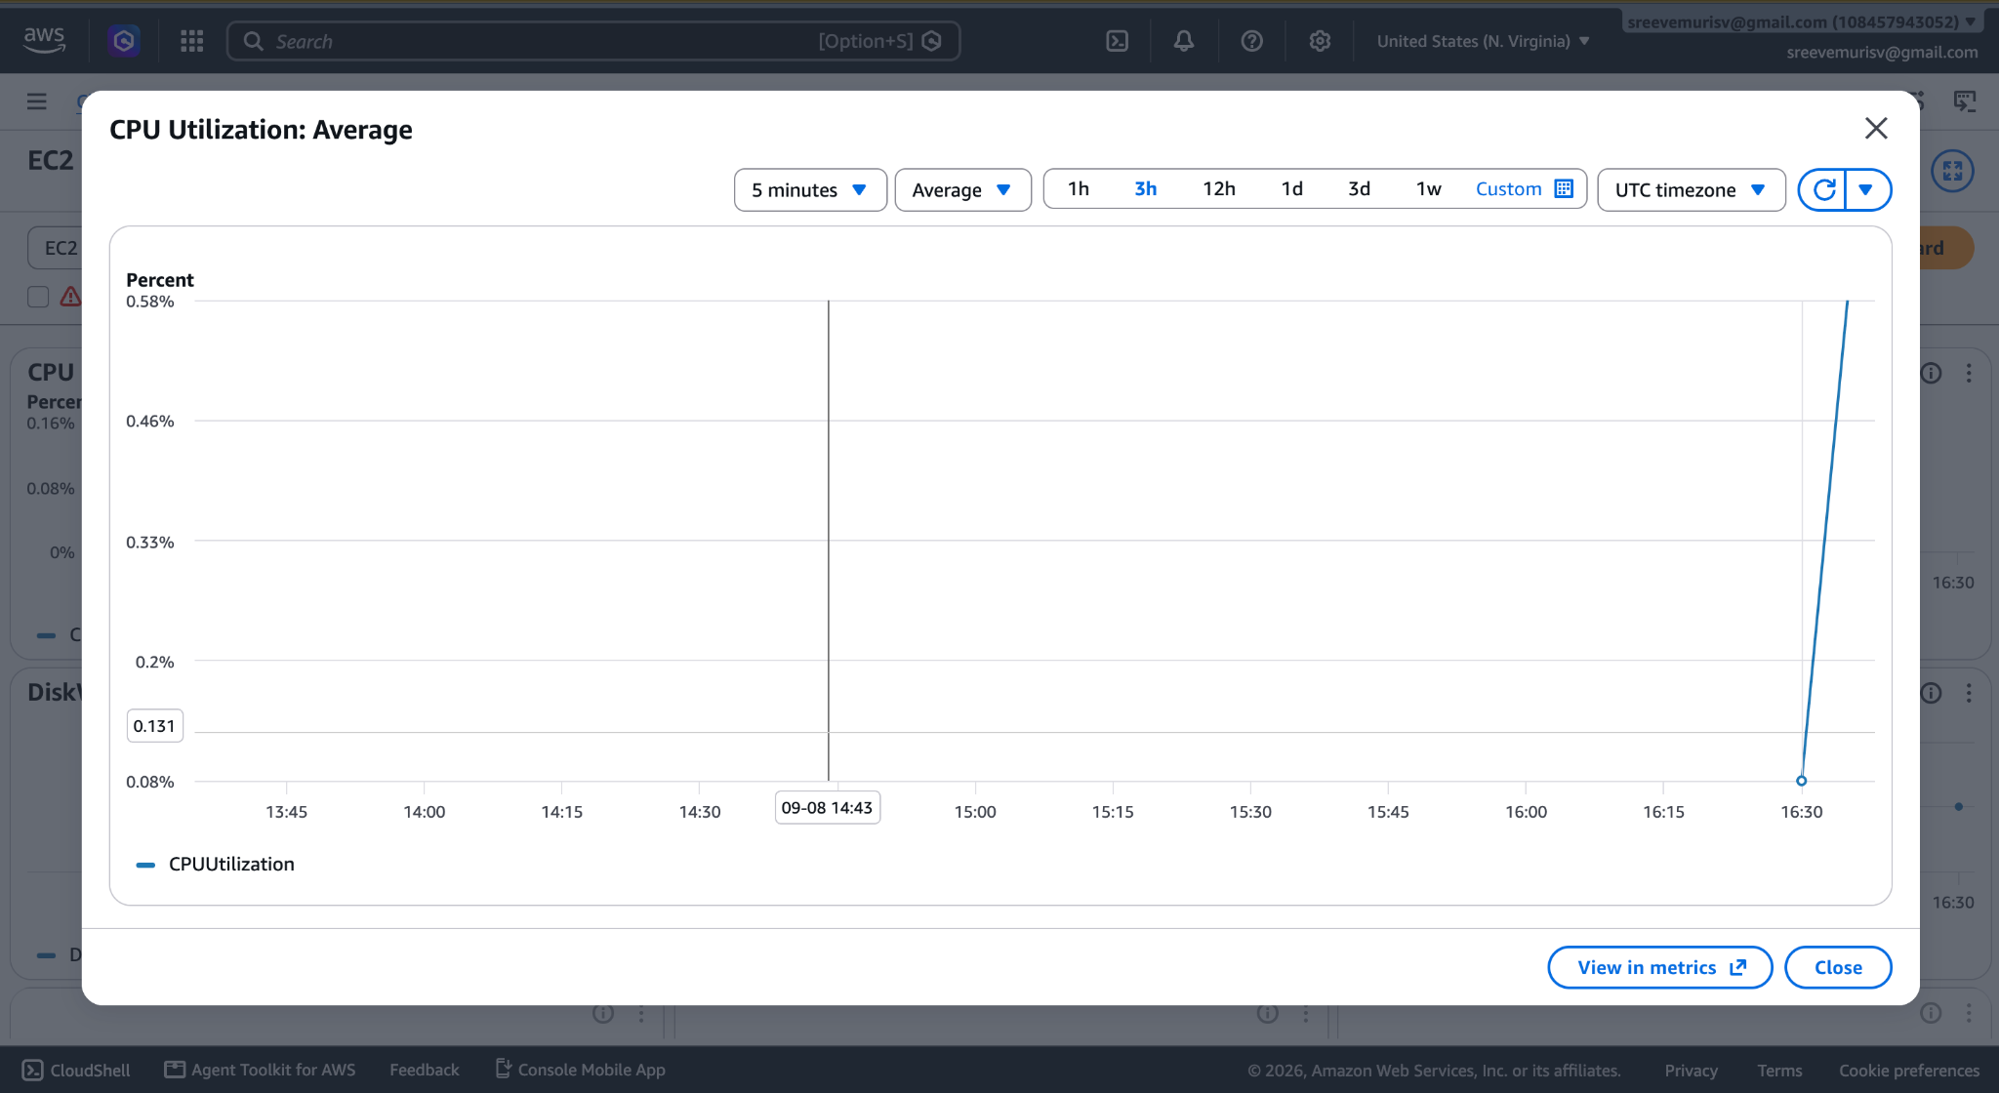
- Create one alarm to send an alert to email if the CPU utilization is more than 70
Percent.
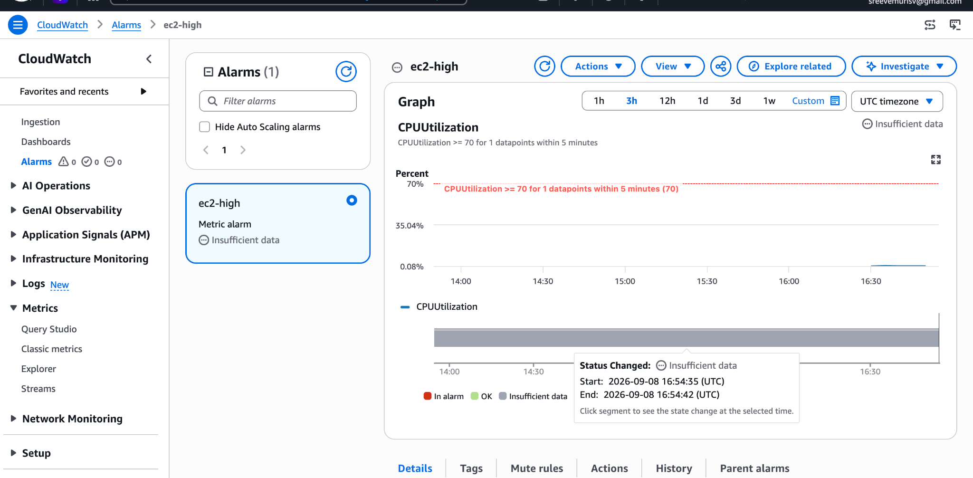
- Create a Dashboard and monitor the Tomcat service whether it is running or not and
send the alert.
2. Set Up the SNS Alert Topic for Tomcat
- In the AWS Console, open Amazon SNS > Topics > Create topic.
- Select Standard, name it tomcat-alerts-topic, and click Create topic.
- In the topic page, click Create subscription:
⚬ Protocol: Email
⚬ Endpoint: Your email address
⚬ Click Create subscription.
- Check your email and click Confirm subscription.
3. Create the Tomcat CloudWatch Alarm
- Navigate to CloudWatch Console > Alarms > All alarms > Create alarm.
- Click Select metric:
⚬ Under Custom namespaces, choose TomcatMonitoring.
⚬ Click InstanceId, pattern, pid_finder.
⚬ Check procstat_lookup_pid_count (pattern: org.apache.catalina.startup.Bootstrap).
⚬ Click Select metric.
- Under Conditions:
⚬ Statistic: Average
⚬ Period: 1 minute
⚬ Threshold condition: Lower than (<) threshold
⚬ Define threshold value: 1
⚬ Click Next.
- Under Actions:
⚬ Alarm state trigger: In alarm
⚬ Send a notification to: Choose tomcat-alerts-topic.
⚬ Click Next.
- Set Alarm name to tomcat-service-down and click Create alarm.
Verification: The alarm will transition to OK within 1–2 minutes.
4. Create the Dedicated Tomcat Dashboard
- In the CloudWatch Console, click Dashboards > Create dashboard.
- Name it Tomcat-Dedicated-Dashboard and click Create dashboard.
- Select Number (or Line) widget type and click Next.
- Go to Metrics > TomcatMonitoring > select procstat_lookup_pid_count.
- Click Create widget, then click Save dashboard.
Verification: The widget displays a steady count of 1.00.
5. Verify Tomcat Alarm & Recovery
# Stop Tomcat to test the alert
sudo systemctl stop tomcat.service

- CloudWatch receives a process count of 0.
- The alarm transitions to In alarm and sends an alert email.
- Start Tomcat back up to clear the alarm:
sudo systemctl start tomcat.service
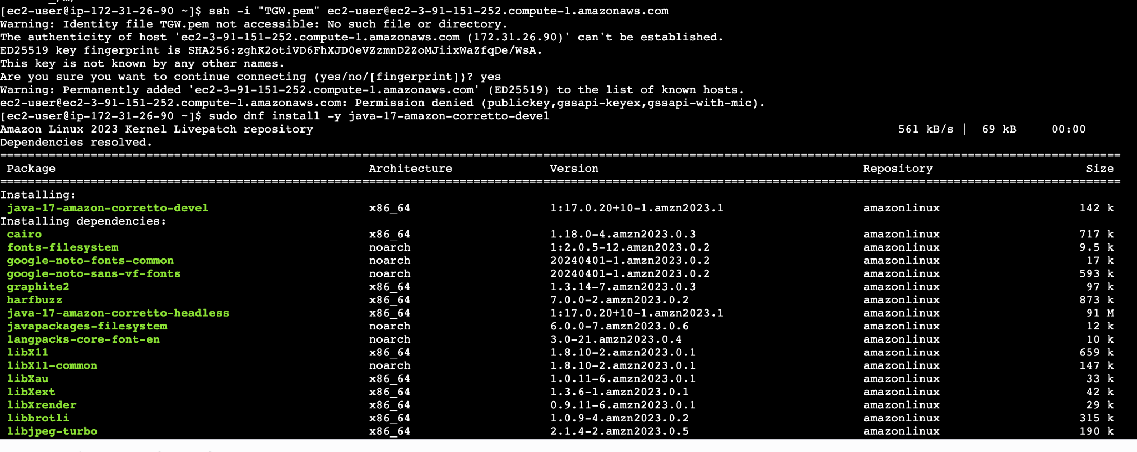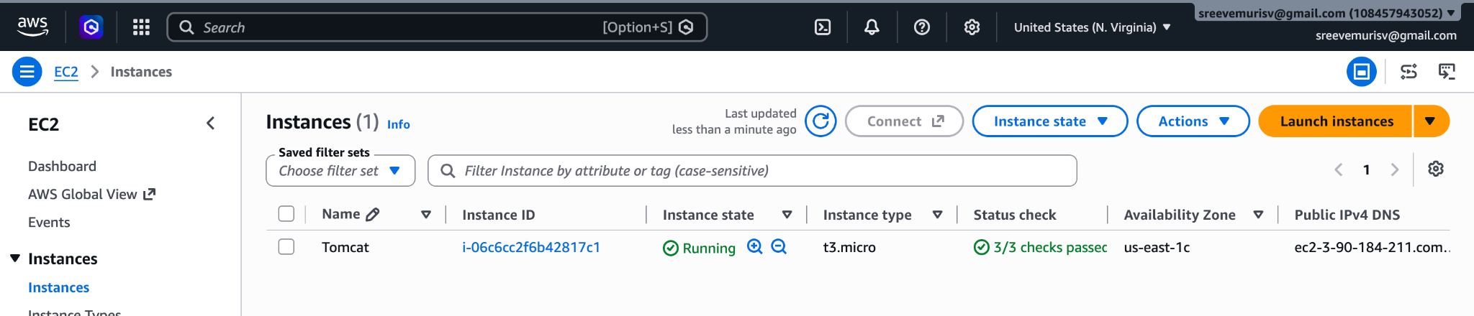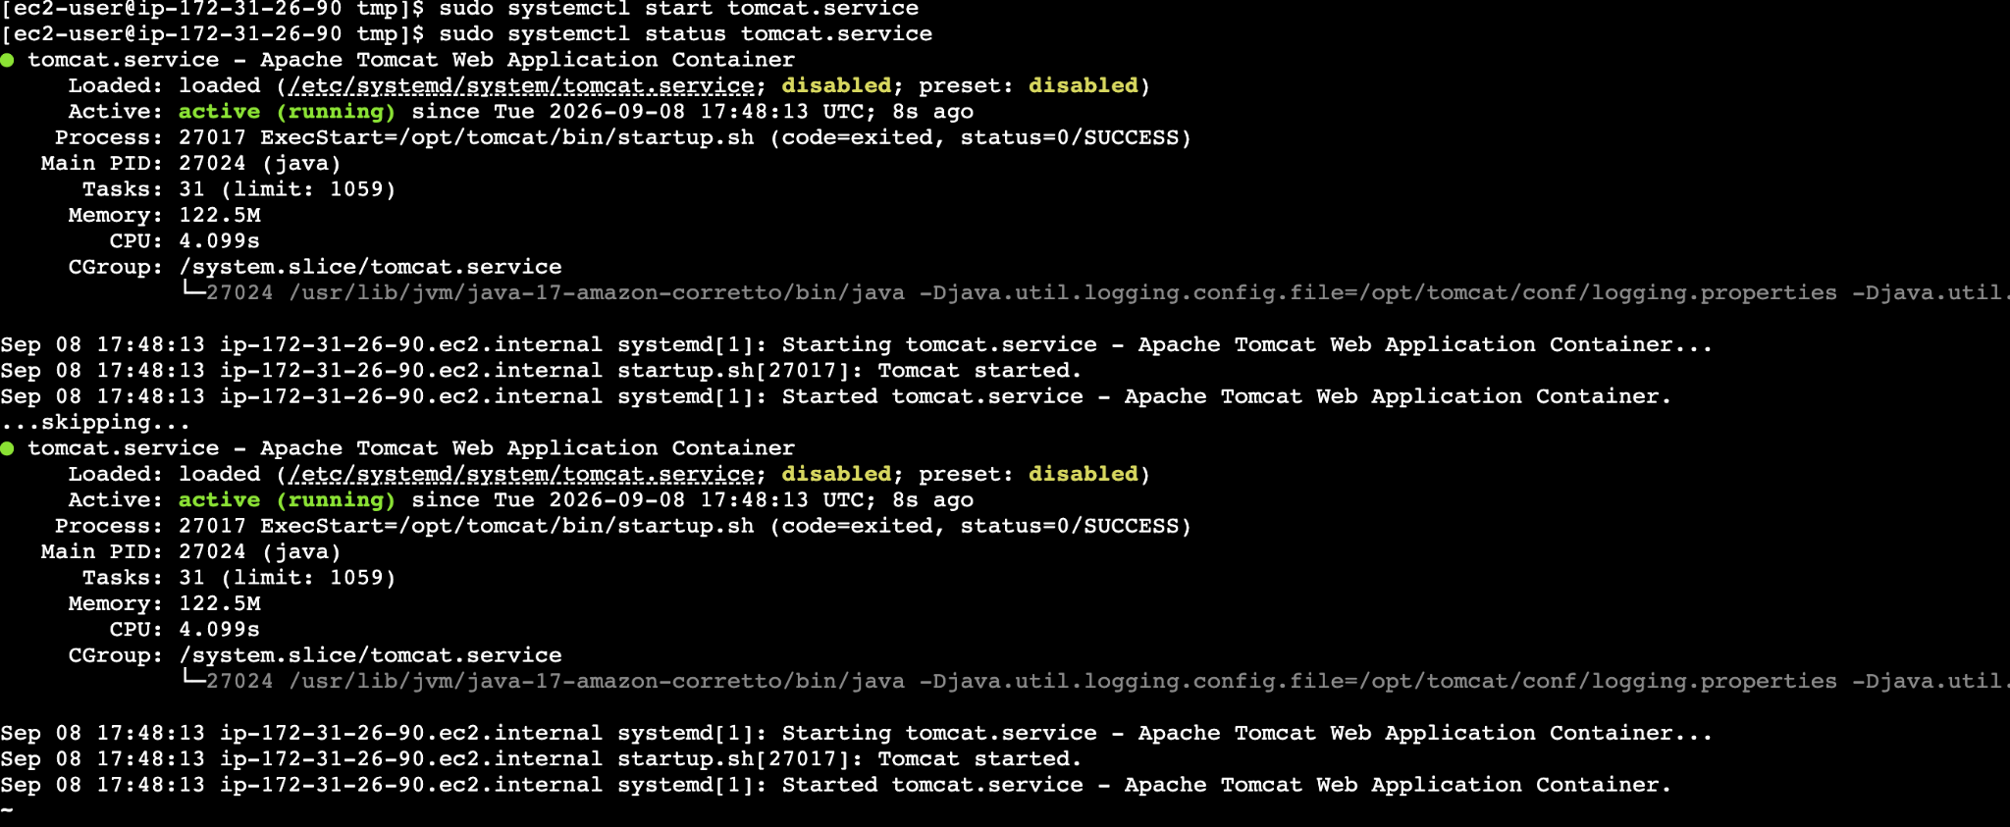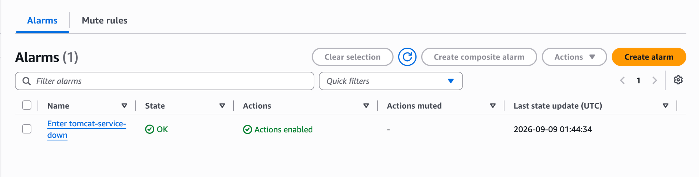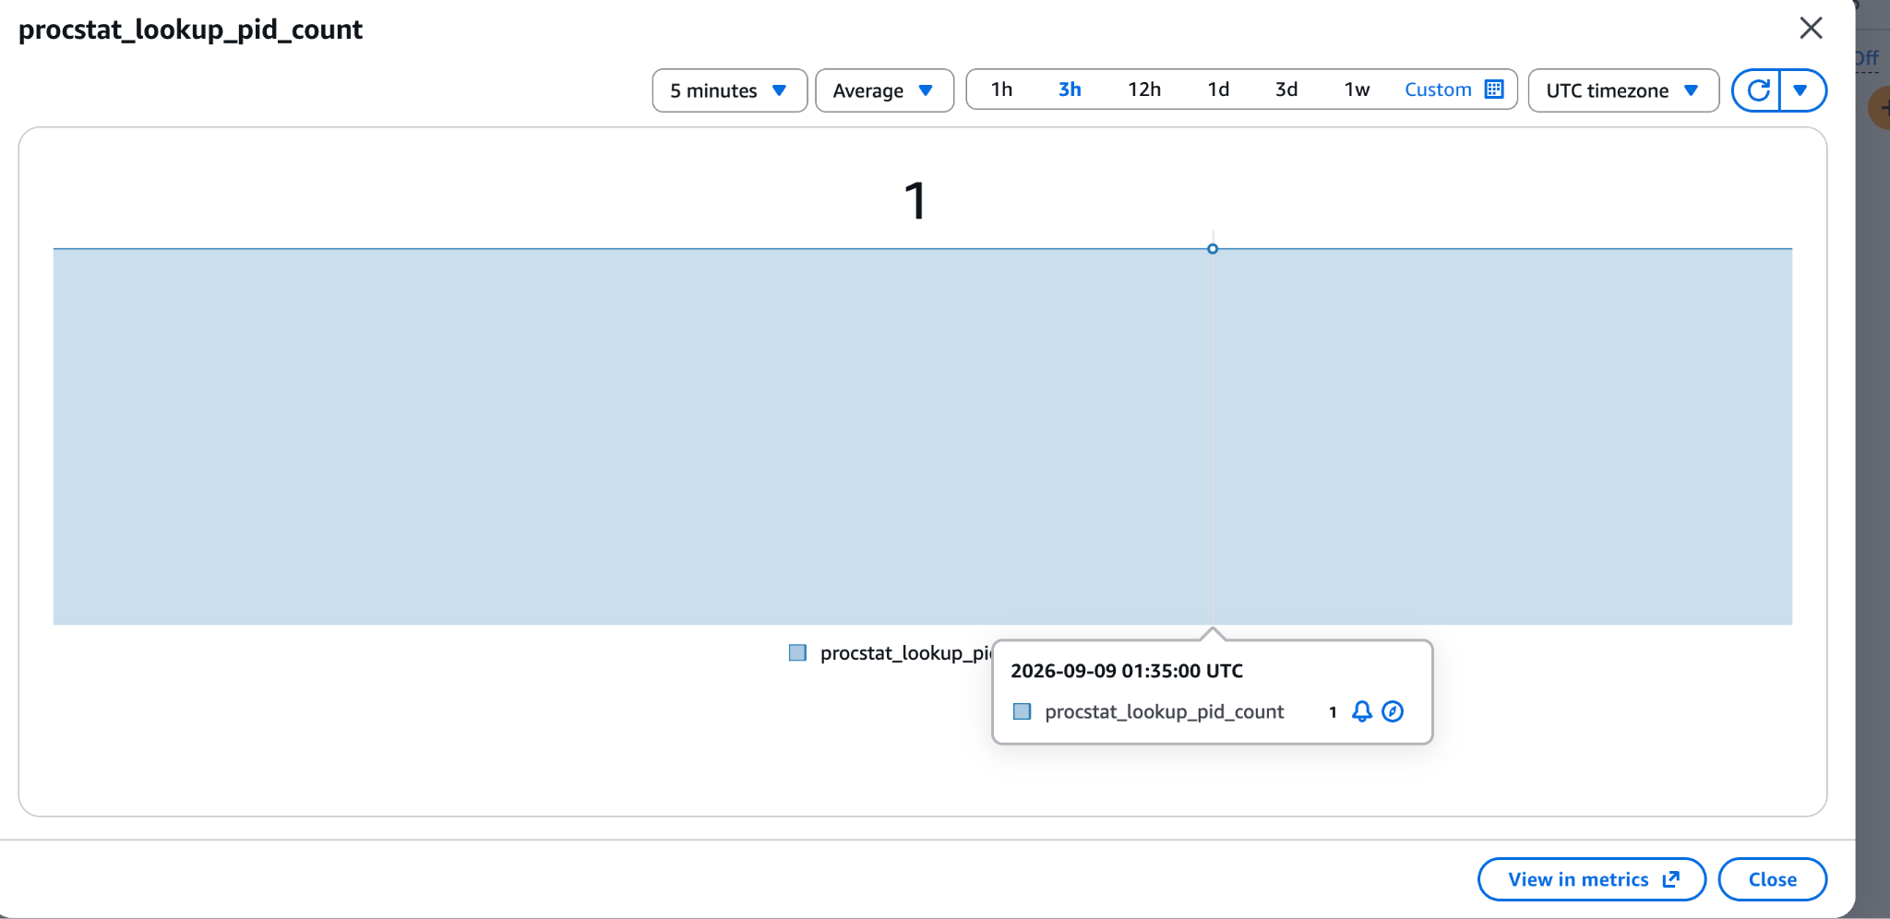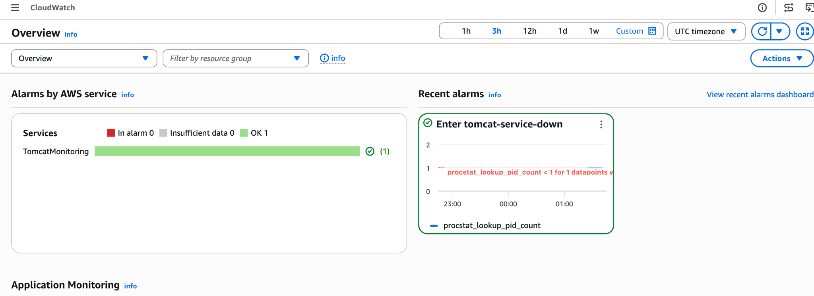
- Create a Dashboard and monitor the Nginx service to send the alert if Nginx is not running.