1)Execute the script shown in the video.

- Static way of doing..

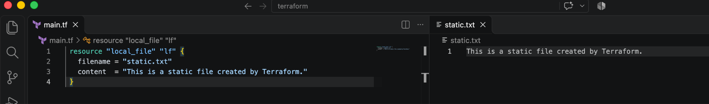

2)Dynamic
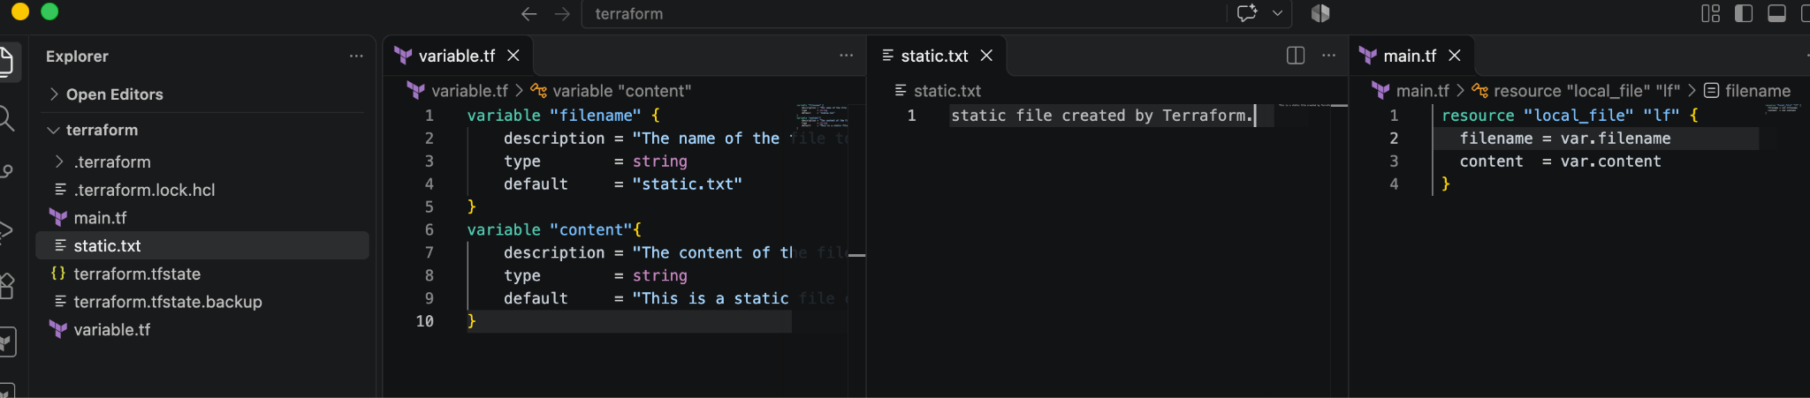
3)i Run time

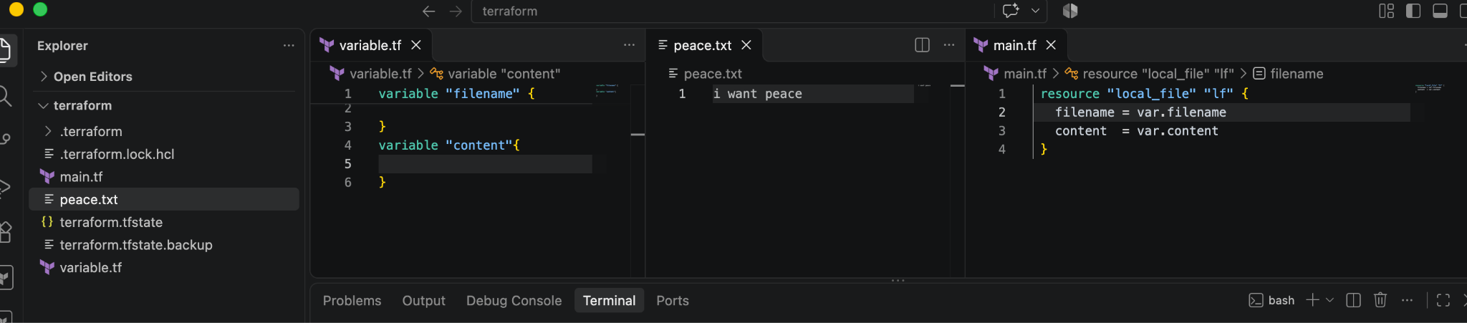
3) ii From CLI

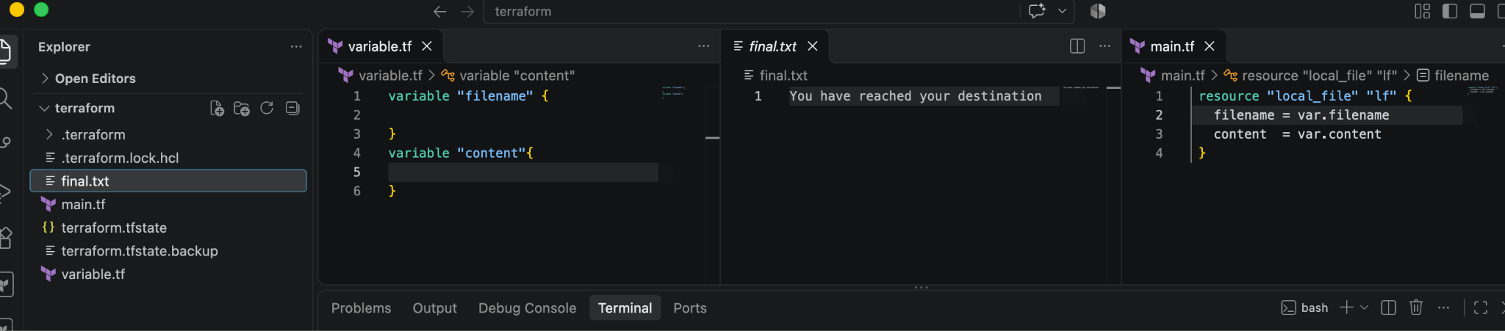

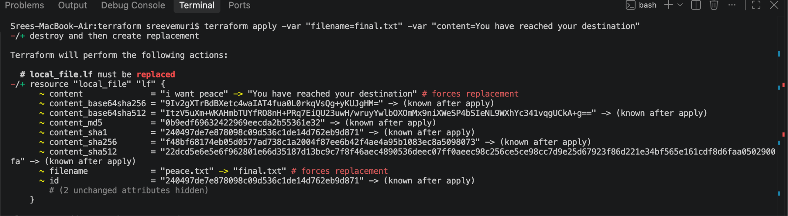

4)
Now in this below need to have a folder with the name as variable.tf
Where
We will be passing the input via CLI by Environment
export TF_VAR_filename="export.txt"
export TF_VAR_content="THis is from the content of TF_VAVR_content"
terraform apply.

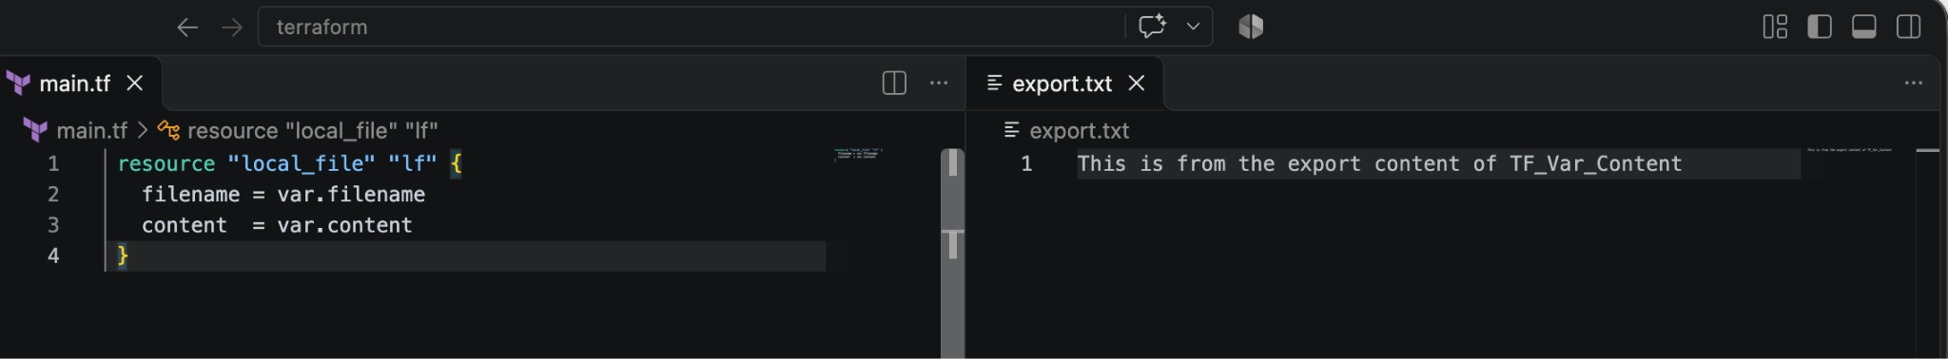

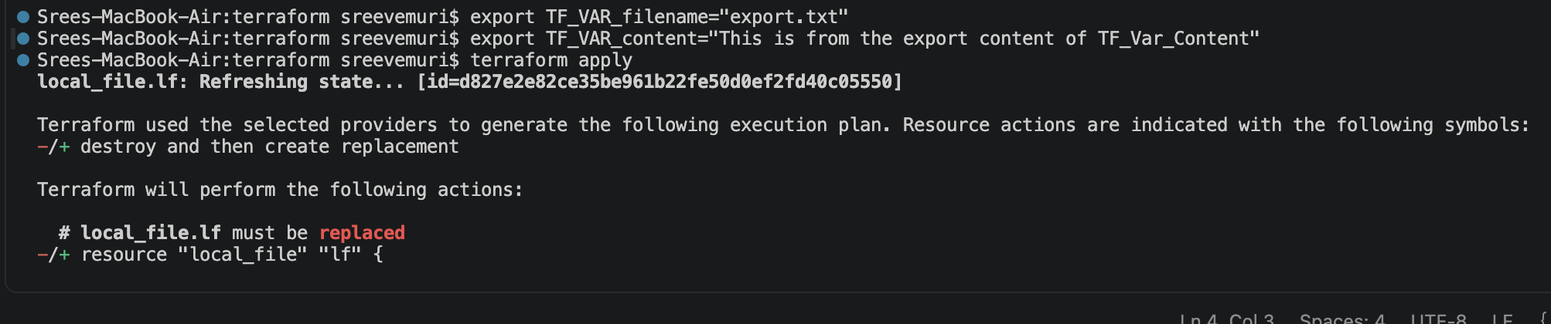

5) . auto. tfvars
Here we are creating a file with auto.tfvars, So that while executing terraform will read this file automatically

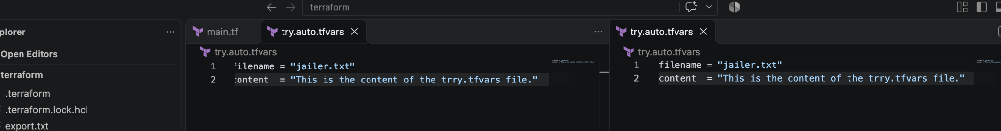
Here we have created a try.auto.tfvars → added arguments → terraform apply then it picked automatically

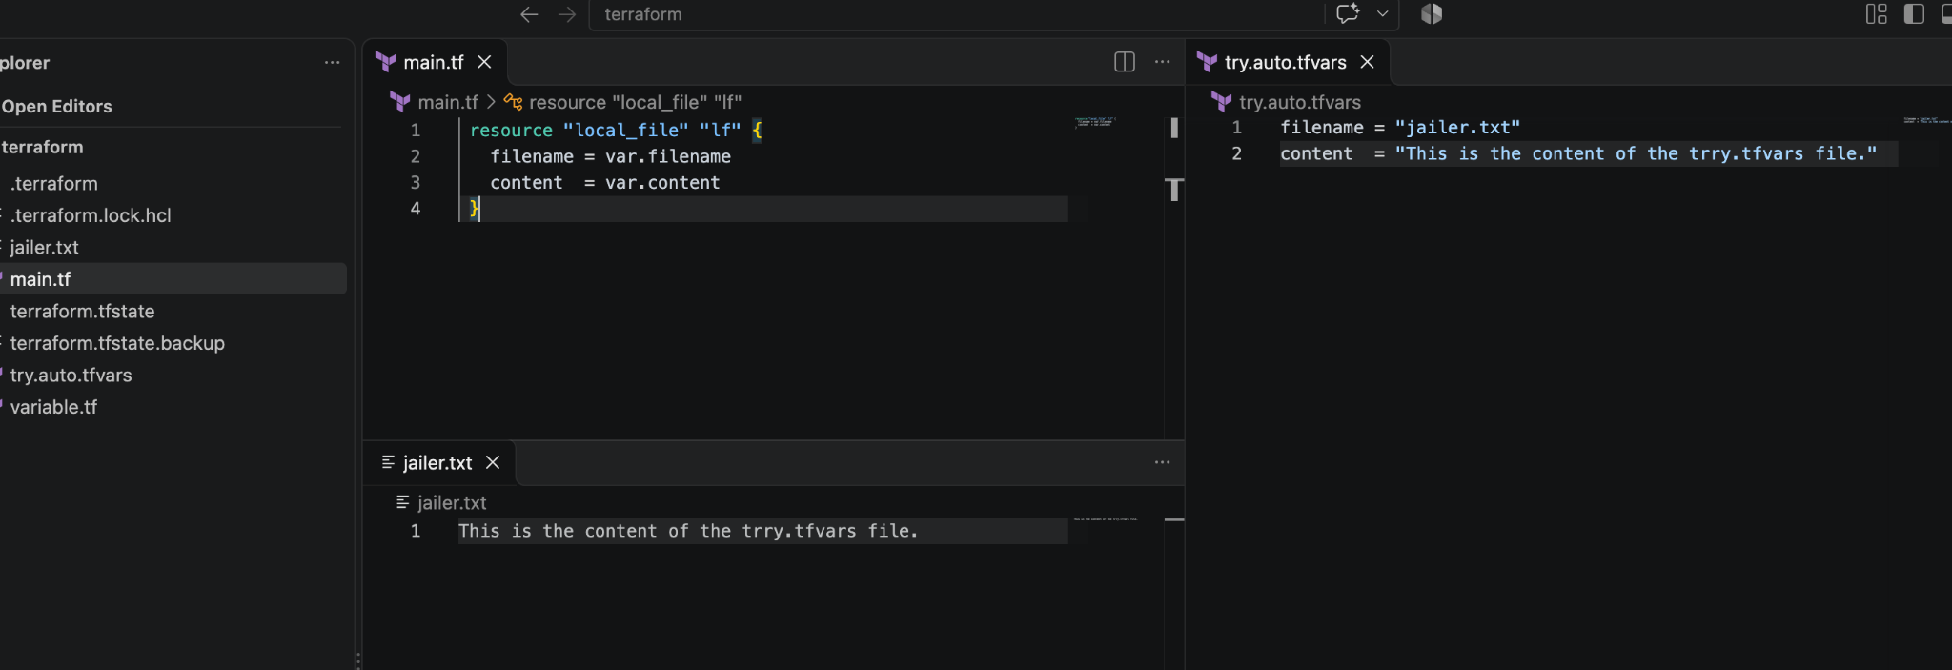

2)Step 1: Install the Terraform Plugin

Log in to your Jenkins Dashboard.

Navigate to Manage Jenkins -> Plugins -> Available plugins.

Search for the Terraform plugin.

Check the box next to it and click Install (choose to restart Jenkins after installation if prompted).

Step 2: Configure Global Tool Installation for Terraform

Once Jenkins restarts, go back to Manage Jenkins -> Tools (or Global Tool Configuration depending on your Jenkins version).

Scroll down to locate the Terraform installations section.

Click the Add Terraform button.

Fill in the configuration details:

Name: Give it a unique identifier (e.g., terraform).

Installation: Check the Install automatically box and select your desired version from the dropdown menu (Jenkins will handle downloading and setting it up on agents).

Click Apply and then Save

Question 3: Standard Two-Stage Jenkins Job / Pipeline
- Objective: Automate the continuous integration process by checking out the source code from GitHub and executing a Maven compilation build.
- Core Stages:
  - Stage 1: Git Clone: Connects to the remote GitHub repository ([https://github.com/betawins/java-Working-app.git](https://github.com/betawins/java-Working-app.git)) and checks out the source code from the default main branch.
  - Stage 2: Maven Compilation: Executes the Maven build lifecycle target (clean compile) to clean previous build artifacts and compile the source code.
- Pipeline Script Structure:
- Groovy
pipeline {
agent any
stages {
stage('Git Clone') {
steps {
git branch: 'main', url: 'https://github.com/betawins/java-Working-app.git'
}
}
stage('Maven Compilation') {
steps {
sh 'mvn clean compile'
}
}
}
}

Question 4: Parameterized Jenkins Job / Pipeline
- Objective: Extend the standard pipeline to introduce runtime flexibility, allowing users to customize build targets or arguments dynamically before execution.
- Key Enhancements:
  - Parameters Block: Declares user-input variables at the pipeline level. For example, a string parameter named BUILD_GOAL is configured with a default value of clean compile.
  - Dynamic Execution: Uses string interpolation (sh "mvn ${params.BUILD_GOAL}") inside the compilation stage to evaluate whichever build goal the user specifies at runtime.
- Pipeline Script Structure:
- Groovy
pipeline {
agent any
parameters {
string(name: 'BUILD_GOAL', defaultValue: 'clean compile', description: 'Enter Maven build goal')
}
stages {
stage('Git Clone') {
steps {
git branch: 'main', url: 'https://github.com/betawins/java-Working-app.git'
}
}
stage('Maven Compilation') {
steps {
sh "mvn ${params.BUILD_GOAL}"
}
}
}
}
- Execution Behavior: Once saved, the standard Build Now action is replaced by Build with Parameters, enabling you to modify goals (such as switching to clean package) on the fly.

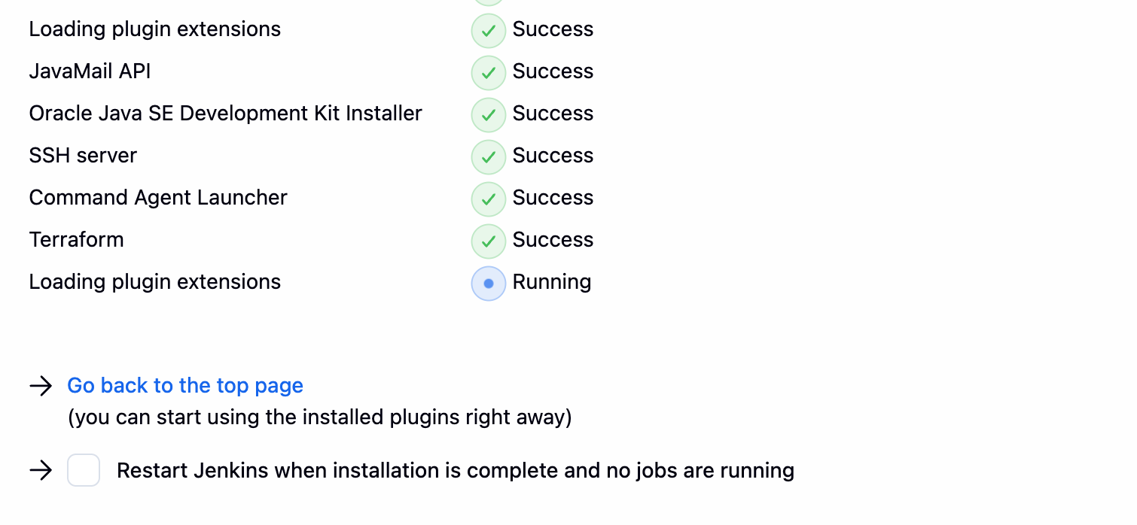

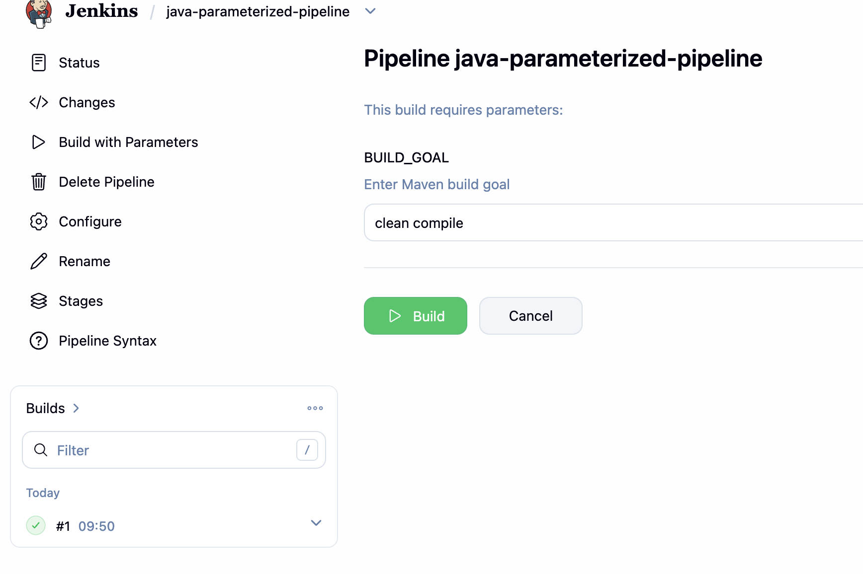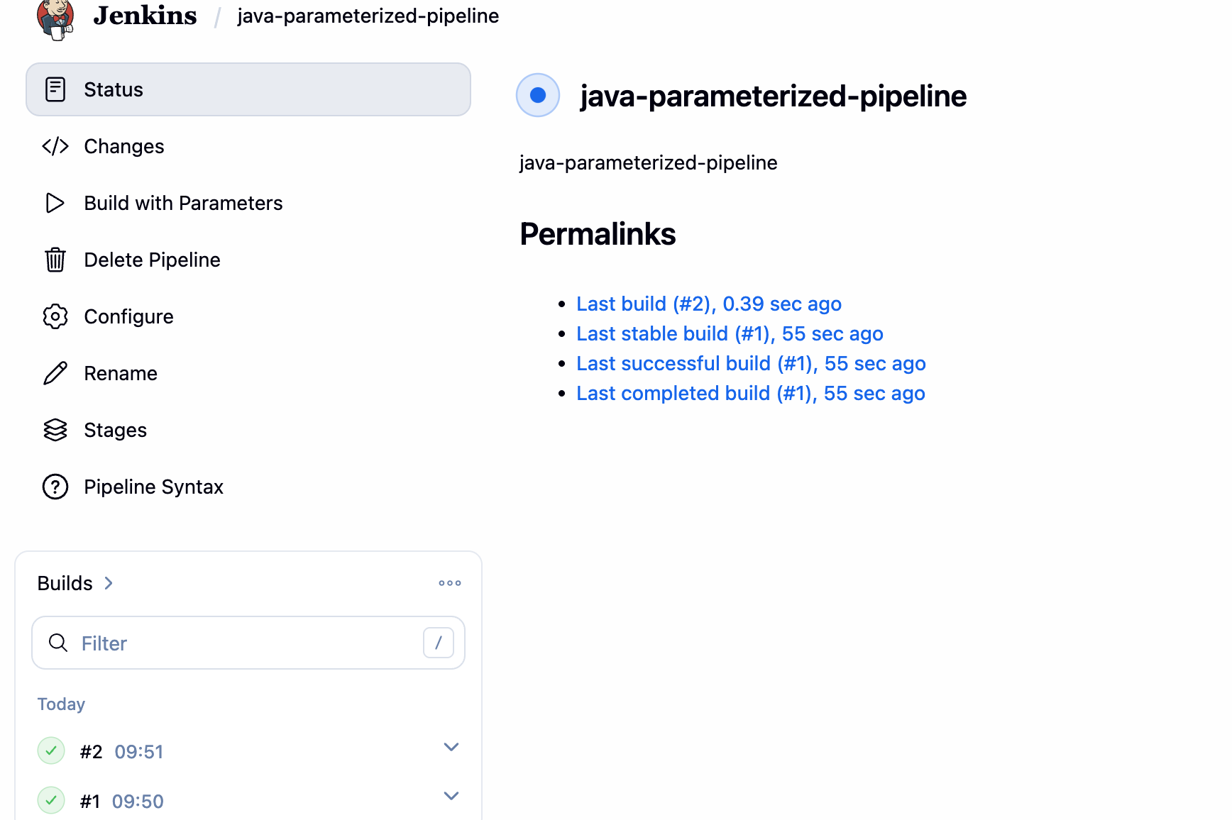

6) What are Global Variables in Jenkins?
Global variables are built-in environment variables exposed by Jenkins across all jobs and pipelines to provide runtime metadata.
- Common examples:
  - BUILD_NUMBER: The sequential number of the current build
  - JOB_NAME: The name of the project currently running.
  - WORKSPACE: The absolute file path of the job's workspace directory.
  - JENKINS_URL: The base URL of the Jenkins server.

