**Virtual Lecture Notes**

For **Circle**, we are just going to keep it simple. Circle has instance variables x and y to indicate center point and then radius. Cylinder extends Circle and adds height. Oval extends Circle and adds on a second radius. The Oval Cylinder extends Oval and adds height.

• Download the [Circle.java](https://www.connexus.com/extra/ThirdPartyProviders/FLVS/2394_2395_AP_CompSci_v9_CA/module13/javamod13/Circle.txt) file to your unit 3 Lessons folder and open it.

Notice that the public methods for Circle are **getRadius()** and **center()**. When we extend Circle to create the **Cylinder** class, we will have to include a call to the super method. We are only going to add a height attribute to our Cylinder class, so we will need instance variable **height** and method **getHeight()**.

• Download the [Cylinder.java](https://www.connexus.com/extra/ThirdPartyProviders/FLVS/2394_2395_AP_CompSci_v9_CA/module13/javamod13/Cylinder.txt) file to your unit 3 Lessons folder and open it.

• Note how the Cylinder class extends the Circle class.

Class **Oval** extends Circle as well; it adds a second radius. This will require instance variable **radius2**

and method **getRadius2()**.

• Download the [Oval.java](https://www.connexus.com/extra/ThirdPartyProviders/FLVS/2394_2395_AP_CompSci_v9_CA/module13/javamod13/Oval.txt) file to your unit 3 Lessons folder and open it.

• Note how the Oval class extends the Circle class.

Finally, **OvalCylinder** will extend the Oval class by adding a height attribute. This will require instance variable **height** and method **getHeight()**.

• Download the [OvalCylinder.java](https://www.connexus.com/extra/ThirdPartyProviders/FLVS/2394_2395_AP_CompSci_v9_CA/module13/javamod13/OvalCylinder.txt) file to your unit 3 Lessons folder and open it.

• Note how the OvalCylinder class extends the Oval class.

Note that OvalCylinder extends Oval and not Circle. This means that OvalCylinder is the direct subclass of Oval and that Oval is the direct superclass of Circle. However, both OvalCylinder and Oval are subclasses of Circle.

That is all there is to creating a class hierarchy. First you create a diagram indicating the relationships between your classes. Second, you write the classes, making sure that each class extends the correct class from your diagram.

To see it in action:

• Download the [TestPoly.java](https://www.connexus.com/extra/ThirdPartyProviders/FLVS/2394_2395_AP_CompSci_v9_CA/module13/javamod13/TestPoly.txt) file to your unit 3 Lessons folder and open it. You should get the following output:

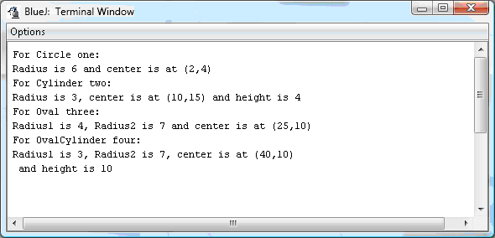

Experiment all you want with the demo programs. Make sure you understand them before you continue.