**Virtual Lecture Notes**

If we were to write a polymorphic method for our rectangle and box classes, the code would look like this:

**public void polyMorph(Rectangle r)**

**{**

**System.out.println("For " + r.getClass().getName() + " : "); System.out.println("The length is " + r.getLength() ); System.out.println("The width is " + r.getWidth());**

**}**

If this method is involved in a program, it can apply to objects of Rectangle, Box, or cube types. Note that polyMorph cannot refer to methods that Rectangle does not have! The **getClass()** and **getName()** methods are inherited from the Object class, which is a superclass for every class created in Java! With **r.getClass()**, we will get the actual class of the parameter **r**,

and **r.getClass().getName()** will give use the actual name of the class. This will help us verify that polymorphism is taking place.

• Download the [Rectangle.java](https://www.connexus.com/extra/ThirdPartyProviders/FLVS/2394_2395_AP_CompSci_v9_CA/module13/javamod13/Rectangle.txt) file to your unit 3 Lessons folder and open it.

• Download the [Box.java](https://www.connexus.com/extra/ThirdPartyProviders/FLVS/2394_2395_AP_CompSci_v9_CA/module13/javamod13/Box.txt) file to your unit 3 Lessons folder and open it.

• Download the [Test2.java](https://www.connexus.com/extra/ThirdPartyProviders/FLVS/2394_2395_AP_CompSci_v9_CA/module13/javamod13/Test2.txt) file to your unit 3 Lessons folder and run it. The output from running the test2.java demo program will be:

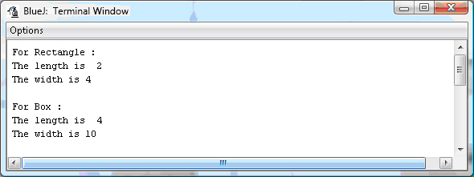

Notice that the output tells us which object was used in each call. Just remember that no

reference can be made to **getHeight()** in **polymorph()**, as that is not part of the Rectangle class.

Also, we could have used the **toString()** method of Object if we wanted a direct reference to the object passed (instead of just its name). You could do that by switching:

**System.out.println(“For “ + r.toString()); or**

**System.out.println(“For “ + r);**

with:

**r.getClass().getName();**

Experiment with the demo programs until you are confident that you understand what polymorphism is doing in this example.