Assignment Instructions: Passwords

Instructions: Write a program to generate random passwords; the user should be able to select the character set and the length.
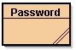
- Create a new project called 5.07 Password Generator in the Mod05 Assignments folder.
- Create a class called Password in the newly created project folder.
- Display a menu that gives the user a choice of character sets to use to construct the password. (Note: Do not use the first range of punctuation symbols with ASCII values from 33–47).
- Allow the user to select the number of characters in the password (at least up to 14).
- Create a randomly generated password from the character sets selected by the user.
- Check the strength of three passwords of different length from each menu option with the Kaspersky Secure Password Check. Tabulate the strength of your 12 passwords (see instructions that follow).
- Create two strong, memorable passwords and test them with the password checker. Report your memorable passwords, what they stand for, and their strength (see instructions that follow).
Suggestions: Make an outline on paper, use pseudocode, or diagram logic sections with a flowchart. Would it be easier to write the first or the fourth menu option first?
Expected Output: The output of your program should resemble the following screenshot:
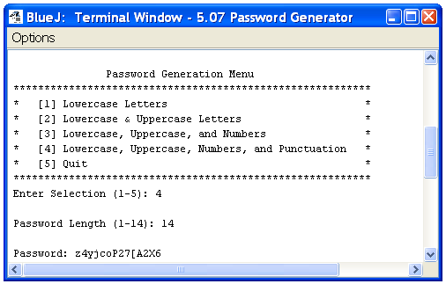
Some additional sample results from the program are shown as follows with their strength ratings determined by the password checker.
Menu Selection | Password Length | Password | Strength
1  2  3  4 | 6  10  12  14 | mwpvys  KIxsmhhJyR  j4xUnj4E7Nkv  {C5lEak]\qQ0Ly | Weak  Medium  Strong  Best
Copy and paste the following information into a Microsoft® Word® or word processing document to submit along with your program. Answer the questions and fill in the table. Adjust the spacing as needed to adequately answer each question.
- List your two memorable passwords created for this assignment and what they stand for.
- In your opinion, are memorable or random passwords better? Explain your answer.
- Highlight, circle, or otherwise indicate each of the following that apply to you.
- Have you told anyone your password?
- Is your password written down somewhere?
- Are you still using the default password for any accounts (e.g., password, student, your user name, etc.)?
- Do you use the same password for multiple accounts?
- Is your password more than six months old?
- Does your password contain only letters?
- Is your password fewer than eight characters?
- Does your password contain any recognizable words?
- Does your password contain the name of a pet, friend, or relative?
- Fill in the following table for each of your randomly created passwords.
Menu Selection | Password Length | Password | Strength
1
1
2
2
3
3
4
4

