**Virtual Lecture Notes: Trajectory of a Projectile**

The following diagram probably intuitively makes sense to you. A projectile shot from a tank follows a familiar trajectory to its target some distance down range (R).

It could just as easily be a baseball player throwing a ball from centerfield into home plate. All projectiles follow the same general path.

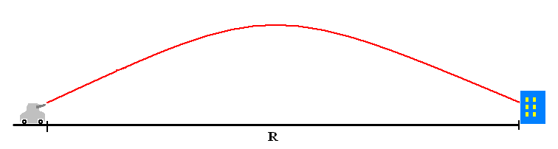

You may recognize this as a typical calculus problem, but the distance (R) can easily be calculated using the following simple algebraic formula if a few complicating factors are ignored (e.g., wind speed, drag coefficient, etc.).

where, vo is the launch speed,

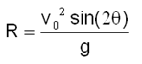

θ is the launch angle, and

g is the acceleration due to gravity

Suppose you could launch a projectile at a speed of 40 meters/second (about 90 miles per hour) and a launch angle of 25 degrees. How far down range (R) could the projectile be hurled?

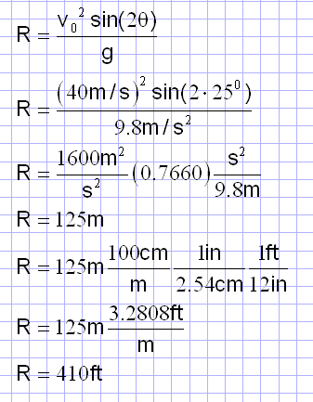

The solution for finding the down range distance of a projectile launched at a speed of

40 m/s and a launch angle of 25o is shown here.

Be sure that you can work through the algebra and solve the equation with a calculator. Soon you will turn it into an arithmetic expression in Java. (See review sites listed below.)

These are exactly the kinds of calculations that had to be done by hand or with early calculators prior to World War II. Extensive tables of the different combinations of angle and speed took hours, sometimes days to prepare. Your computer, with the right program, could prepare projectile tables in a matter of seconds.

Trig Review Sites

Dave’s Short Trig Course: [http://www.clarku.edu/~djoyce/trig/](http://www.clarku.edu/%7Edjoyce/trig/)

Trigonometry and Tutorials: <http://www.physics.uoguelph.ca/tutorials/trig/trigonom.html>