PRACTICE QUIZ

**Question 1**

**Which are the two common types of supervised learning? (Choose two)**

Regression

Classification

**Question 2**

**Which of these is a type of unsupervised learning?**

Clustering

Practice quiz: Regression

**Question 1**

**For linear regression, the model is f_{w,b}(x) = wx + b*fw*,*b*​(*x*)=*wx*+*b*.**

X

**Question 2**

**For linear regression, if you find parameters w and b so that J(w,b)*J*(*w*,*b*) is very close to zero, what can you conclude?**

The selected values of the parameters w and b cause the algorithm to fit the training set really well.

Practice quiz: Train the model with gradient descent

**Question 1**

**Gradient descent is an algorithm for finding values of parameters w and b that minimize the cost function J.**

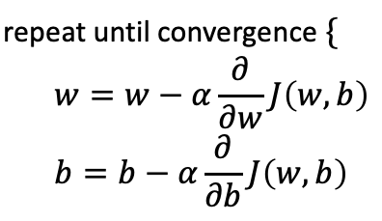

**When \frac{\partial J(w,b)}{\partial w}∂*w*∂*J*(*w*,*b*)​ is a negative number (less than zero), what happens to w*w* after one update step?**

*w* increases.

**Question 2**

**For linear regression, what is the update step for parameter b?**

