PRACTICE QUIZ

**Question 1**

**In the training set below, what is x_4^{(3)}*x*4(3)​? Please type in the number below (this is an integer such as 123, no decimal points).**

30

**Question 2**

**Which of the following are potential benefits of vectorization? Please choose the best option.**

It makes your code run faster

It can make your code shorter

It allows your code to run more easily on parallel computer hardware

**Question 3**

**True/False? To make gradient descent converge about twice as fast, a technique that almost always works is to double the learning rate alpha*alpha*.**

False

Practice quiz: Gradient descent in practice

**Question 1**

**Which of the following is a valid step used during feature scaling?**

Subtract the mean (average) from each value and then divide by the (max - min).

**Question 2**

**Suppose a friend ran gradient descent three separate times with three choices of the learning rate \alpha*α* and plotted the learning curves for each (cost J for each iteration).**

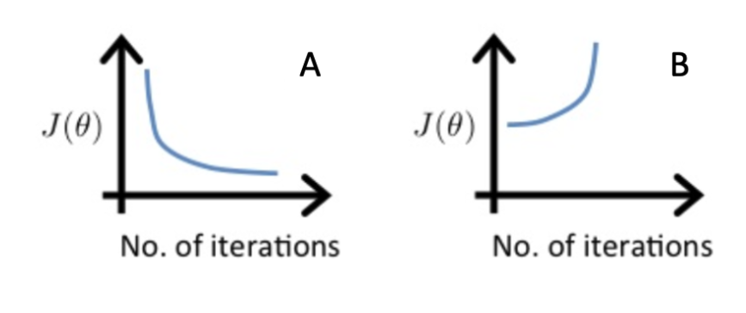

case B only

**Question 3**

**Of the circumstances below, for which one is feature scaling particularly helpful?**

Feature scaling is helpful when one feature is much larger (or smaller) than another feature.

**Question 4**

**You are helping a grocery store predict its revenue, and have data on its items sold per week, and price per item. What could be a useful engineered feature?**

For each product, calculate the number of items sold times price per item.

**Question 5**

**True/False? With polynomial regression, the predicted values f_w,b(x) does not necessarily have to be a straight line (or linear) function of the input feature x.**

True