PRACTICE QUIZ

**Question 1**

**Which is an example of a classification task?**

Based on the size of each tumor, determine if each tumor is malignant (cancerous) or not.

**Question 2**

**Recall the sigmoid function is g(z) = \frac{1}{1+e^{-z}}*g*(*z*)=1+*e*−*z*1​**

*g*(*z*) is near one (1)

**Question 3**

**A cat photo classification model predicts 1 if it's a cat, and 0 if it's not a cat. For a particular photograph, the logistic regression model outputs g(z)*g*(*z*) (a number between 0 and 1). Which of these would be a reasonable criteria to decide whether to predict if it’s a cat?**

Predict it is a cat if g(z) >= 0.5

**Question 4**

**True/False? No matter what features you use (including if you use polynomial features), the decision boundary learned by logistic regression will be a linear decision boundary.**

False

Practice quiz: Cost function for logistic regression

**Question 1**

**In this lecture series, "cost" and "loss" have distinct meanings. Which one applies to a single training example?**

Loss

**Question 2**

**For the simplified loss function, if the label y^{(i)}=0*y*(*i*)=0, then what does this expression simplify to?**

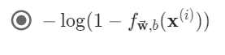

Practice quiz: Gradient descent for logistic regression

**Question 1**

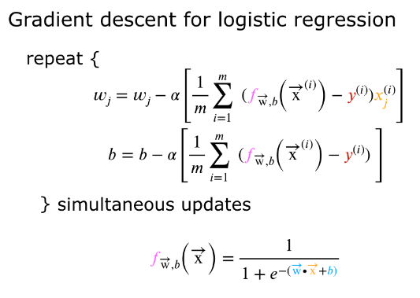

**Which of the following two statements is a more accurate statement about gradient descent for logistic regression?**



# Practice quiz: The problem of overfitting

**Question 1**

**Which of the following can address overfitting?**

Select a subset of the more relevant features.

Collect more training data

Apply regularization

**Question 2**

**You fit logistic regression with polynomial features to a dataset, and your model looks like this.**

The model has high variance (overfit). Thus, adding data is likely to help

**Question 3**

