Aim
To convert a color image into a grayscale image using OpenCV in Google Colab and display both the original and grayscale images.

Apparatus / Software Required
- Google Colab
- Python
- OpenCV (cv2)
- Matplotlib
- Any input image (.jpg, .png, etc.)

Procedure
- Open Google Colab and create a new notebook.
- Import the required libraries: OpenCV, Matplotlib, and Google Colab file upload.
- Upload the required color image.
- Read the uploaded image using cv2.imread().
- Convert the color image from BGR to grayscale using cv2.cvtColor().
- Display the original color image using Matplotlib.
- Display the converted grayscale image using a grayscale color map.
- Display both images side-by-side for comparison.
Code:
Cell 1:
from google.colab import files

uploaded = files.upload()
cell 2:
import cv2
import matplotlib.pyplot as plt

cell 3:
filename = list(uploaded.keys())[0]

image = cv2.imread(filename)

print("Image uploaded successfully:", filename)
cell 4: ( 3 program in single cell 4 )
rotated_image = cv2.rotate(image, cv2.ROTATE_180)
# Rotate image 90 degrees clockwise
rotated_image = cv2.rotate(image, cv2.ROTATE_90_CLOCKWISE)
# Rotate image 270 degrees clockwise
rotated_image = cv2.rotate(image, cv2.ROTATE_90_COUNTERCLOCKWISE)
cell 5:
plt.imshow(cv2.cvtColor(image, cv2.COLOR_BGR2RGB))
plt.title("Original Image")
plt.axis("off")
plt.show()
cell 6:
plt.imshow(cv2.cvtColor(rotated_image, cv2.COLOR_BGR2RGB))
plt.title("180 Degree Clockwise Rotation")
plt.axis("off")
plt.show()

output:
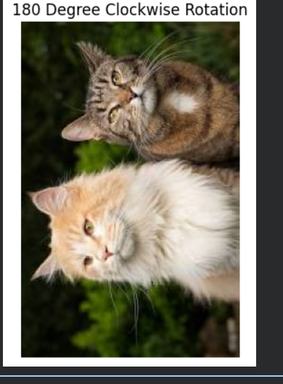

Result
The uploaded color image was successfully converted into a grayscale image using OpenCV. The original image and its corresponding grayscale image were displayed side-by-side successfully.

