Aim
To convert a color image into a grayscale image using OpenCV in Google Colab and display both the original and grayscale images.

Apparatus / Software Required
- Google Colab
- Python
- OpenCV (cv2)
- Matplotlib
- Any input image (.jpg, .png, etc.)

Procedure
- Open Google Colab and create a new notebook.
- Import the required libraries: OpenCV, Matplotlib, and Google Colab file upload.
- Upload the required color image.
- Read the uploaded image using cv2.imread().
- Convert the color image from BGR to grayscale using cv2.cvtColor().
- Display the original color image using Matplotlib.
- Display the converted grayscale image using a grayscale color map.
- Display both images side-by-side for comparison.
Code:
Cell 1: Upload Image
from google.colab import files
uploaded = files.upload()

Cell 2: import libraries
import cv2
import numpy as np
import matplotlib.pyplot as plt

cell 3: Read the uploaded image
filename = list(uploaded.keys())[0]
image = cv2.imread(filename)
print("Image uploaded successfully:", filename)

cell 4: Get Image Size
height, width = image.shape[:2]
print("Width:", width)
print("Height:", height)

Cell 5 : Select 3 points and move them
source_points = np.float32([
[50, 50],
[200, 50],
[50, 200]
])

destination_points = np.float32([
[20, 80],
[220, 50],
[80, 220]
])
Cell 6 :
matrix = cv2.getAffineTransform(source_points, destination_points)
print("Affine Matrix:")
print(matrix)
cell 7:
affine_image = cv2.warpAffine(
image,
matrix,
(width, height)
)
Cell 8:
plt.figure(figsize=(10, 5))

plt.subplot(1, 2, 1)
plt.imshow(cv2.cvtColor(image, cv2.COLOR_BGR2RGB))
plt.title("Original Image")
plt.axis("off")

plt.subplot(1, 2, 2)
plt.imshow(cv2.cvtColor(affine_image, cv2.COLOR_BGR2RGB))
plt.title("Affine Transformed Image")
plt.axis("off")

plt.show()

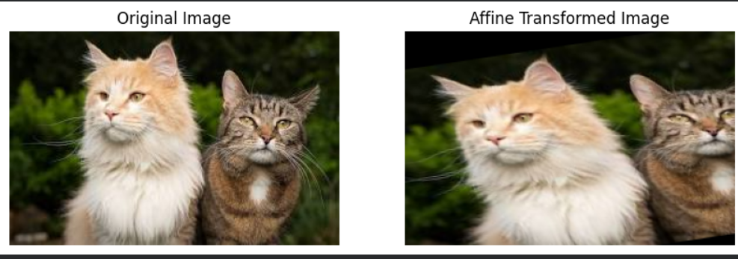

Result
The uploaded color image was successfully converted into a grayscale image using OpenCV. The original image and its corresponding grayscale image were displayed side-by-side successfully.

