Aim
To convert a color image into a grayscale image using OpenCV in Google Colab and display both the original and grayscale images.

Apparatus / Software Required
- Google Colab
- Python
- OpenCV (cv2)
- Matplotlib
- Any input image (.jpg, .png, etc.)

Procedure
- Open Google Colab and create a new notebook.
- Import the required libraries: OpenCV, Matplotlib, and Google Colab file upload.
- Upload the required color image.
- Read the uploaded image using cv2.imread().
- Convert the color image from BGR to grayscale using cv2.cvtColor().
- Display the original color image using Matplotlib.
- Display the converted grayscale image using a grayscale color map.
- Display both images side-by-side for comparison.
Code:
from google.colab import files
uploaded = files.upload()

import cv2
import numpy as np
import matplotlib.pyplot as plt

filename = list(uploaded.keys())[0]
image = cv2.imread(filename)
print("Image uploaded successfully:", filename)

gray = cv2.cvtColor(image, cv2.COLOR_BGR2GRAY)

sobel_x = cv2.Sobel(
gray,
cv2.CV_64F,
1,
0,
ksize=3
)

sobel_y = cv2.Sobel(
gray,
cv2.CV_64F,
0,
1,
ksize=3
)

sobel_x = cv2.convertScaleAbs(sobel_x)
sobel_y = cv2.convertScaleAbs(sobel_y)

sobel_combined = cv2.addWeighted(
sobel_x, 0.5,
sobel_y, 0.5,
0
)

plt.figure(figsize=(12, 8))
plt.subplot(2, 2, 1)
plt.imshow(cv2.cvtColor(image, cv2.COLOR_BGR2RGB))
plt.title("Original Image")
plt.axis("off")
plt.subplot(2, 2, 2)
plt.imshow(sobel_x, cmap="gray")
plt.title("Sobel X - Vertical Edges")
plt.axis("off")
plt.subplot(2, 2, 3)
plt.imshow(sobel_y, cmap="gray")
plt.title("Sobel Y - Horizontal Edges")
plt.axis("off")
plt.subplot(2, 2, 4)
plt.imshow(sobel_combined, cmap="gray")
plt.title("Combined Sobel Edge Detection")
plt.axis("off")
plt.show()

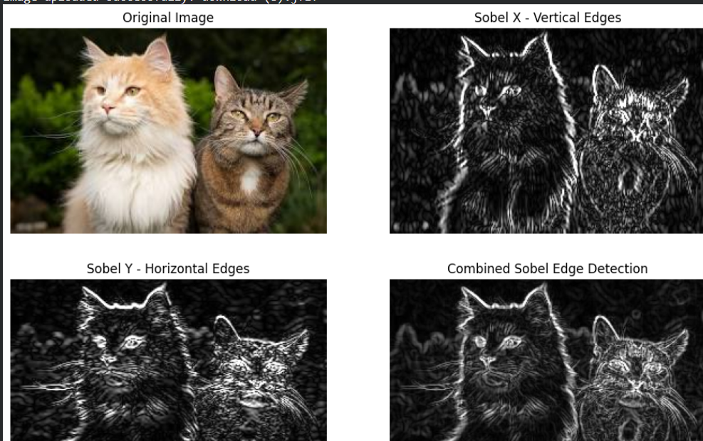

Result
The uploaded color image was successfully converted into a grayscale image using OpenCV. The original image and its corresponding grayscale image were displayed side-by-side successfully.

