Aim
To convert a color image into a grayscale image using OpenCV in Google Colab and display both the original and grayscale images.

Apparatus / Software Required
- Google Colab
- Python
- OpenCV (cv2)
- Matplotlib
- Any input image (.jpg, .png, etc.)

Procedure
- Open Google Colab and create a new notebook.
- Import the required libraries: OpenCV, Matplotlib, and Google Colab file upload.
- Upload the required color image.
- Read the uploaded image using cv2.imread().
- Convert the color image from BGR to grayscale using cv2.cvtColor().
- Display the original color image using Matplotlib.
- Display the converted grayscale image using a grayscale color map.
- Display both images side-by-side for comparison.
Code:
text = "SIMATS"

cv2.putText(
watermarked_image,
text,
(50, 100),
cv2.FONT_HERSHEY_SIMPLEX,
2,
(255, 255, 255),
3
)

plt.figure(figsize=(10, 5))

plt.subplot(1, 2, 1)
plt.imshow(cv2.cvtColor(image, cv2.COLOR_BGR2RGB))
plt.title("Original Image")
plt.axis("off")

plt.subplot(1, 2, 2)
plt.imshow(cv2.cvtColor(watermarked_image, cv2.COLOR_BGR2RGB))
plt.title("Watermarked Image")
plt.axis("off")

plt.show()

overlay = image.copy()

cv2.putText(
overlay,
"SIMATS",
(50, 100),
cv2.FONT_HERSHEY_SIMPLEX,
2,
(255, 255, 255),
3
)

watermarked_image = cv2.addWeighted(
overlay, 0.4,
image, 0.6,
0
)

plt.imshow(cv2.cvtColor(watermarked_image, cv2.COLOR_BGR2RGB))
plt.title("Transparent Watermark")
plt.axis("off")
plt.show()

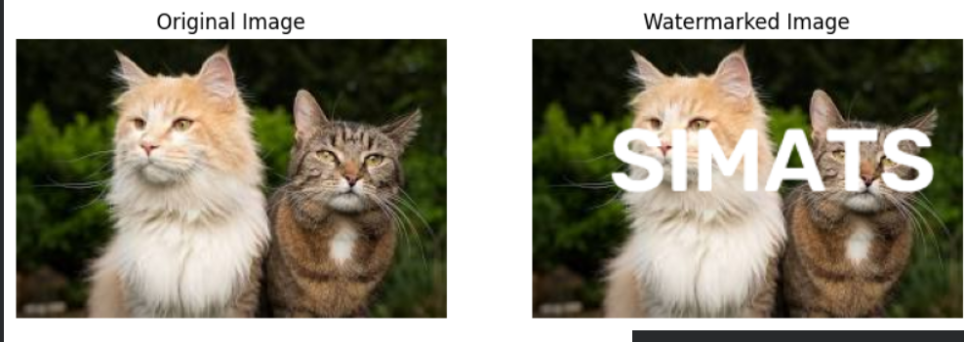
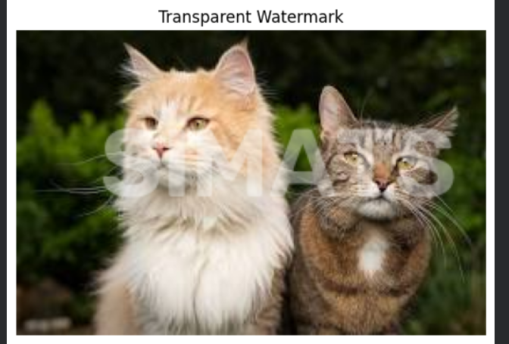

Result
The uploaded color image was successfully converted into a grayscale image using OpenCV. The original image and its corresponding grayscale image were displayed side-by-side successfully.

