Aim
To convert a color image into a grayscale image using OpenCV in Google Colab and display both the original and grayscale images.

Apparatus / Software Required
- Google Colab
- Python
- OpenCV (cv2)
- Matplotlib
- Any input image (.jpg, .png, etc.)

Procedure
- Open Google Colab and create a new notebook.
- Import the required libraries: OpenCV, Matplotlib, and Google Colab file upload.
- Upload the required color image.
- Read the uploaded image using cv2.imread().
- Convert the color image from BGR to grayscale using cv2.cvtColor().
- Display the original color image using Matplotlib.
- Display the converted grayscale image using a grayscale color map.
- Display both images side-by-side for comparison.
Code:
from google.colab import files
uploaded = files.upload()

import cv2
import matplotlib.pyplot as plt

filename = list(uploaded.keys())[0]
image = cv2.imread(filename)

roi = image[50:200, 50:200]

result = image.copy()
result[200:350, 200:350] = roi

plt.figure(figsize=(12,4))
plt.subplot(1,3,1)
plt.imshow(cv2.cvtColor(image, cv2.COLOR_BGR2RGB))
plt.title("Original Image")
plt.axis("off")

plt.subplot(1,3,2)
plt.imshow(cv2.cvtColor(roi, cv2.COLOR_BGR2RGB))
plt.title("Cropped ROI")
plt.axis("off")

plt.subplot(1,3,3)
plt.imshow(cv2.cvtColor(result, cv2.COLOR_BGR2RGB))
plt.title("Copied and Pasted ROI")
plt.axis("off")

plt.show()

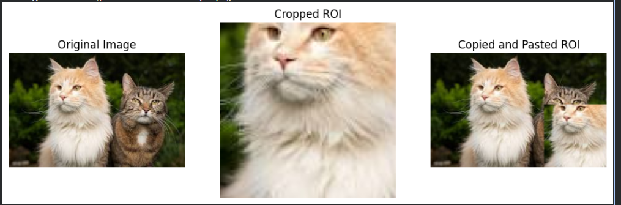

Result
The uploaded color image was successfully converted into a grayscale image using OpenCV. The original image and its corresponding grayscale image were displayed side-by-side successfully.

