Aim
To convert a color image into a grayscale image using OpenCV in Google Colab and display both the original and grayscale images.

Apparatus / Software Required
- Google Colab
- Python
- OpenCV (cv2)
- Matplotlib
- Any input image (.jpg, .png, etc.)

Procedure
- Open Google Colab and create a new notebook.
- Import the required libraries: OpenCV, Matplotlib, and Google Colab file upload.
- Upload the required color image.
- Read the uploaded image using cv2.imread().
- Convert the color image from BGR to grayscale using cv2.cvtColor().
- Display the original color image using Matplotlib.
- Display the converted grayscale image using a grayscale color map.
- Display both images side-by-side for comparison.
Code:
from google.colab import files
uploaded = files.upload()
import cv2
import numpy as np
import matplotlib.pyplot as plt
filename = list(uploaded.keys())[0]
image = cv2.imread(filename, 0)
print("Image uploaded successfully:", filename)
kernel = np.ones((9, 9), np.uint8)
closing = cv2.morphologyEx(
image,
cv2.MORPH_CLOSE,
kernel
)
plt.imshow(image, cmap="gray")
plt.title("Original Image with Small Gaps")
plt.axis("off")
plt.show()
plt.imshow(closing, cmap="gray")
plt.title("Closing Output")
plt.axis("off")
plt.show()
plt.figure(figsize=(10, 4))
plt.subplot(1, 2, 1)
plt.imshow(image, cmap="gray")
plt.title("Original Image")
plt.axis("off")
plt.subplot(1, 2, 2)
plt.imshow(closing, cmap="gray")
plt.title("Closing Output")
plt.axis("off")
plt.show()
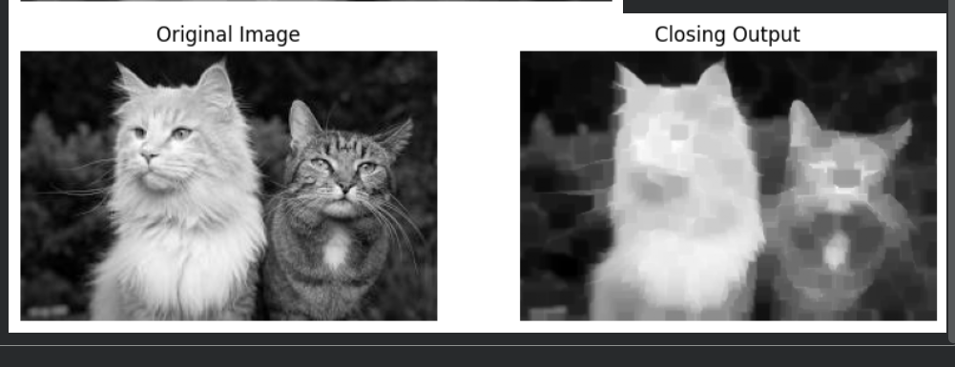

Result
The uploaded color image was successfully converted into a grayscale image using OpenCV. The original image and its corresponding grayscale image were displayed side-by-side successfully.

