Aim
To convert a color image into a grayscale image using OpenCV in Google Colab and display both the original and grayscale images.

Apparatus / Software Required
- Google Colab
- Python
- OpenCV (cv2)
- Matplotlib
- Any input image (.jpg, .png, etc.)

Procedure
- Open Google Colab and create a new notebook.
- Import the required libraries: OpenCV, Matplotlib, and Google Colab file upload.
- Upload the required color image.
- Read the uploaded image using cv2.imread().
- Convert the color image from BGR to grayscale using cv2.cvtColor().
- Display the original color image using Matplotlib.
- Display the converted grayscale image using a grayscale color map.
- Display both images side-by-side for comparison.
Code:
from google.colab import files
uploaded = files.upload()
import cv2
import numpy as np
import matplotlib.pyplot as plt
from tensorflow.keras.applications import MobileNetV2
from tensorflow.keras.applications.mobilenet_v2 import preprocess_input, decode_predictions
filename = list(uploaded.keys())[0]
image = cv2.imread(filename)
print("Image uploaded successfully:", filename)
plt.imshow(cv2.cvtColor(image, cv2.COLOR_BGR2RGB))
plt.title("Input Image")
plt.axis("off")
plt.show()
model = MobileNetV2(weights="imagenet")
img = cv2.resize(image, (224, 224))
img = cv2.cvtColor(img, cv2.COLOR_BGR2RGB)
img = np.expand_dims(img, axis=0)
img = preprocess_input(img)
predictions = model.predict(img)
results = decode_predictions(predictions, top=5)[0]
for _, label, confidence in results:
print(label, ":", round(confidence * 100, 2), "%")
best_label = results[0][1]
confidence = results[0][2] * 100
plt.imshow(cv2.cvtColor(image, cv2.COLOR_BGR2RGB))
plt.title(f"Detected: {best_label} ({confidence:.2f}%)")
plt.axis("off")
plt.show()
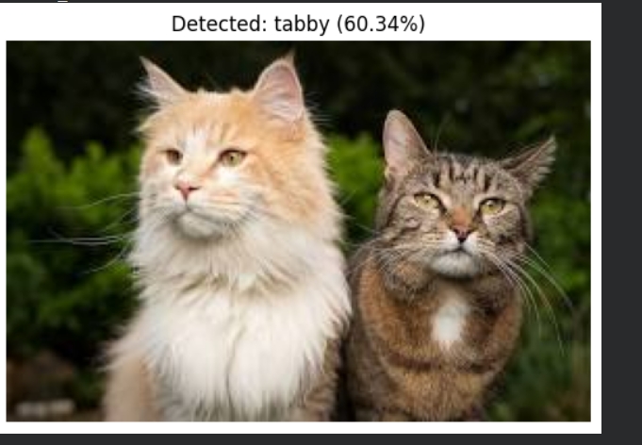

Result
The uploaded color image was successfully converted into a grayscale image using OpenCV. The original image and its corresponding grayscale image were displayed side-by-side successfully.

