Aim
To perform basic image processing by reading an image using Python and applying Gaussian Blur to reduce noise and smooth the image.

Apparatus / Software Required
- Google Colab
- Python
- OpenCV (cv2)
- Matplotlib
- Input image (.jpg, .png, etc.)

Procedure
- Open Google Colab and create a new notebook.
- Import the required libraries: OpenCV and Matplotlib.
- Upload the required image using files.upload().
- Read the uploaded image using cv2.imread().
- Apply Gaussian Blur using cv2.GaussianBlur().
- Use a 15 × 15 kernel for smoothing the image.
- Display the original image.
- Display the Gaussian-blurred image.
- Compare the original and blurred images.
Code:
from google.colab import files

uploaded = files.upload()
import cv2
import matplotlib.pyplot as plt
filename = list(uploaded.keys())[0]

image = cv2.imread(filename)

print("Image uploaded successfully:", filename)
gray = cv2.cvtColor(image, cv2.COLOR_BGR2GRAY)
equalized = cv2.equalizeHist(gray)
plt.imshow(gray, cmap="gray")
plt.title("Original Grayscale Image")
plt.axis("off")
plt.show()

plt.imshow(equalized, cmap="gray")
plt.title("Enhanced Image")
plt.axis("off")
plt.show()

plt.figure(figsize=(10, 4))

plt.subplot(1, 2, 1)
plt.imshow(gray, cmap="gray")
plt.title("Original Grayscale Image")
plt.axis("off")

plt.subplot(1, 2, 2)
plt.imshow(equalized, cmap="gray")
plt.title("Histogram Equalized Image")
plt.axis("off")

plt.show()
plt.figure(figsize=(10, 4))

plt.subplot(1, 2, 1)
plt.hist(gray.ravel(), 256, [0, 256])
plt.title("Original Histogram")

plt.subplot(1, 2, 2)
plt.hist(equalized.ravel(), 256, [0, 256])
plt.title("Equalized Histogram")

plt.show()
output:
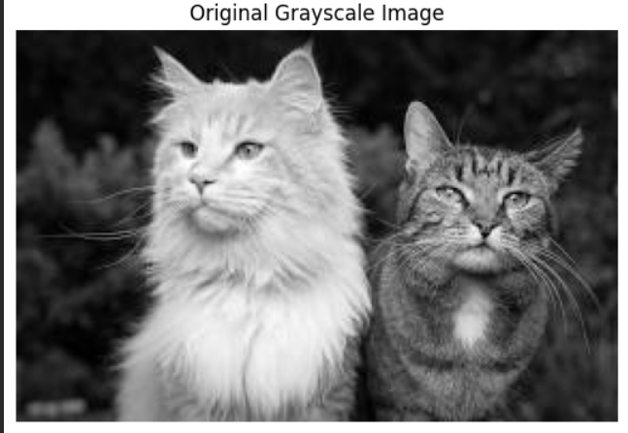
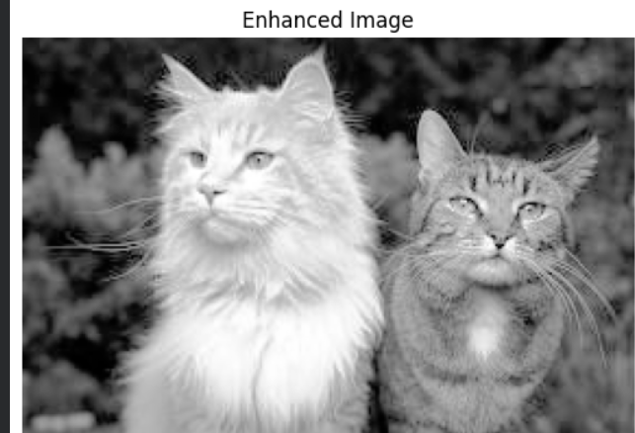

Result
The input image was successfully read using Python and Gaussian Blur was applied using OpenCV. The blurred image showed reduced noise and fine details compared with the original image.

