Aim
To perform basic image processing by reading an image using Python and applying Gaussian Blur to reduce noise and smooth the image.

Apparatus / Software Required
- Google Colab
- Python
- OpenCV (cv2)
- Matplotlib
- Input image (.jpg, .png, etc.)

Procedure
- Open Google Colab and create a new notebook.
- Import the required libraries: OpenCV and Matplotlib.
- Upload the required image using files.upload().
- Read the uploaded image using cv2.imread().
- Apply Gaussian Blur using cv2.GaussianBlur().
- Use a 15 × 15 kernel for smoothing the image.
- Display the original image.
- Display the Gaussian-blurred image.
- Compare the original and blurred images.
Code:
from google.colab import files

uploaded = files.upload()
import cv2
import matplotlib.pyplot as plt
filename = list(uploaded.keys())[0]

image = cv2.imread(filename)

print("Image uploaded successfully:", filename)
plt.imshow(cv2.cvtColor(image, cv2.COLOR_BGR2RGB))
plt.title("Original Image")
plt.axis("off")
plt.show()
olors = ['b', 'g', 'r']

for i, color in enumerate(colors):
histogram = cv2.calcHist([image], [i], None, [256], [0, 256])
plt.plot(histogram, color=color)

plt.title("Color Histogram")
plt.xlabel("Pixel Intensity")
plt.ylabel("Number of Pixels")
plt.show()

output:
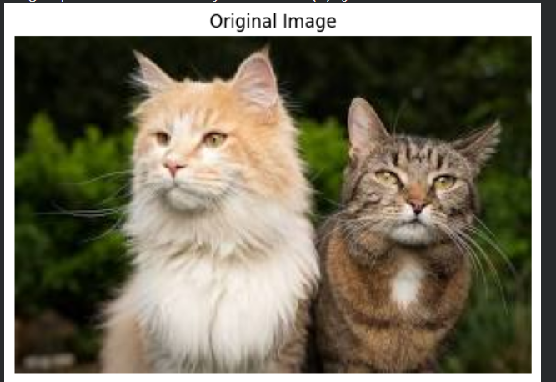

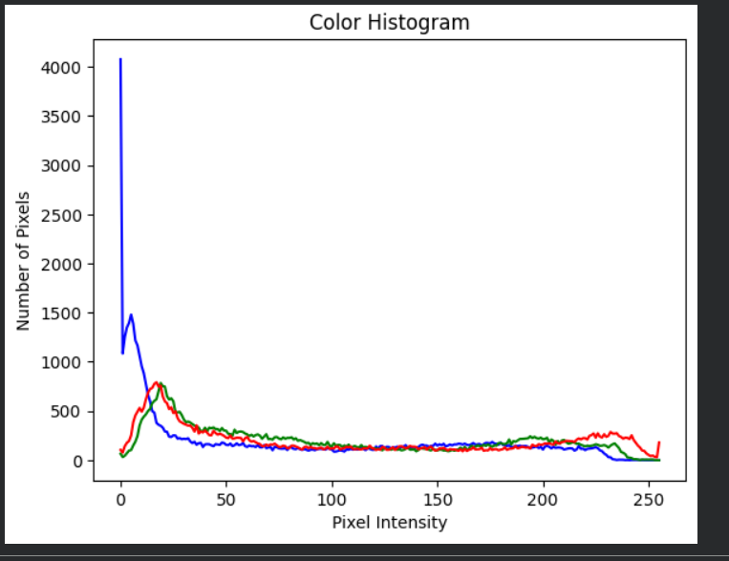

Result
The input image was successfully read using Python and Gaussian Blur was applied using OpenCV. The blurred image showed reduced noise and fine details compared with the original image.

