Aim
To convert a color image into a grayscale image using OpenCV in Google Colab and display both the original and grayscale images.

Apparatus / Software Required
- Google Colab
- Python
- OpenCV (cv2)
- Matplotlib
- Any input image (.jpg, .png, etc.)

Procedure
- Open Google Colab and create a new notebook.
- Import the required libraries: OpenCV, Matplotlib, and Google Colab file upload.
- Upload the required color image.
- Read the uploaded image using cv2.imread().
- Convert the color image from BGR to grayscale using cv2.cvtColor().
- Display the original color image using Matplotlib.
- Display the converted grayscale image using a grayscale color map.
- Display both images side-by-side for comparison.
Code:
# ============================================
# Convert Color Image to Grayscale using OpenCV
# ============================================

# Step 1: Import libraries
from google.colab import files
import cv2
import matplotlib.pyplot as plt

# Step 2: Upload image
uploaded = files.upload()

# Step 3: Get uploaded filename
filename = list(uploaded.keys())[0]

# Step 4: Read image
image = cv2.imread(filename)

# Check whether image is loaded successfully
if image is None:
print("Error: Unable to read the image.")
else:
print("Image uploaded successfully:", filename)

# Step 5: Convert BGR image to grayscale
gray_image = cv2.cvtColor(image, cv2.COLOR_BGR2GRAY)

# Step 6: Display original and grayscale images
plt.figure(figsize=(10, 4))

# Original image
plt.subplot(1, 2, 1)
plt.imshow(cv2.cvtColor(image, cv2.COLOR_BGR2RGB))
plt.title("Original Image")
plt.axis("off")

# Grayscale image
plt.subplot(1, 2, 2)
plt.imshow(gray_image, cmap="gray")
plt.title("Grayscale Image")
plt.axis("off")

# Adjust spacing
plt.tight_layout()

# Display
plt.show()
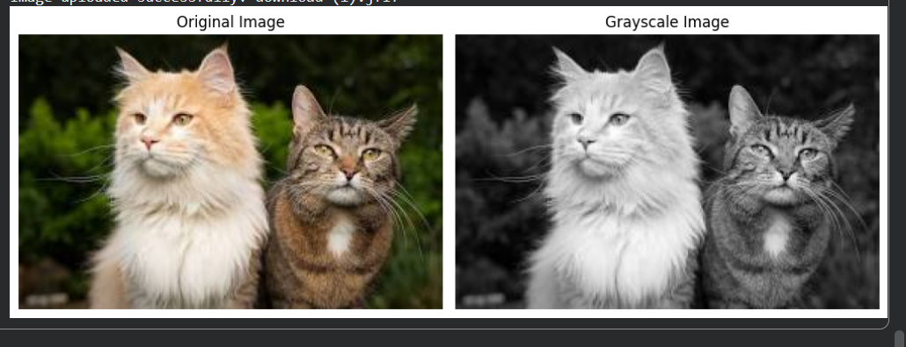

Result
The uploaded color image was successfully converted into a grayscale image using OpenCV. The original image and its corresponding grayscale image were displayed side-by-side successfully.

