EXPERIMENT 1.4
IDENTIFICATION AND ANALYSIS OF CRITICAL MODULATION IN AM

1. AIM
To generate an amplitude-modulated (AM) signal at the critical modulation condition (m = 1) using MATLAB, plot the modulating signal, carrier signal, and AM waveform with its envelope, and examine the significance of 100% modulation.

2. APPARATUS / SOFTWARE REQUIRED
- Computer or laptop
- MATLAB software
- MATLAB Editor

3. THEORY AND FORMULA
In amplitude modulation, the amplitude of a high-frequency carrier varies according to the instantaneous value of the modulating signal. The modulation index is:
m = Am / Ac
where Am is the peak amplitude of the modulating signal and Ac is the peak amplitude of the carrier. Critical modulation occurs when m = 1, also called 100% modulation. At this condition, the AM envelope just touches zero at its minimum and does not cross the time axis. This is the maximum modulation level that avoids over-modulation and allows the envelope to be recovered by an ideal envelope detector.
Given: Am = 5 and Ac = 5
m = Am / Ac = 5 / 5 = 1 = 100%
Therefore, the signal is critically modulated.

4. MATLAB CODE
clc;
clear;
close all;
% Signal parameters
Ac = 5; % Carrier amplitude
Am = 5; % Modulating signal amplitude (critical modulation)
fc = 100; % Carrier frequency in Hz
fm = 5; % Modulating frequency in Hz
fs = 10000; % Sampling frequency in Hz
% Calculate modulation index
m = Am / Ac;
fprintf('Modulation Index = %.2f\\n', m);
fprintf('Modulation Percentage = %.2f%%\\n', m*100);
% Check modulation condition
if m < 1
disp('Condition: Under-modulation');
elseif abs(m - 1) < eps
disp('Condition: Critical modulation (100 percent)');
else
disp('Condition: Over-modulation');
end
% Time vector
t = 0:1/fs:2/fm;
% Generate signals
message = Am*cos(2*pi*fm*t);
carrier = Ac*cos(2*pi*fc*t);
am_signal = Ac*(1 + m*cos(2*pi*fm*t)) .* cos(2*pi*fc*t);
% Calculate AM envelope
envelope = Ac*(1 + m*cos(2*pi*fm*t));
% Plot signals
figure;
subplot(3,1,1);
plot(t, message, 'b', 'LineWidth', 1.2);
title('Modulating Signal');
xlabel('Time (s)');
ylabel('Amplitude');
grid on;
subplot(3,1,2);
plot(t, carrier, 'k');
title('Carrier Signal');
xlabel('Time (s)');
ylabel('Amplitude');
grid on;
subplot(3,1,3);
plot(t, am_signal, 'b');
hold on;
plot(t, envelope, 'r--', 'LineWidth', 1.5);
plot(t, -envelope, 'r--', 'LineWidth', 1.5);
title('AM Signal at Critical Modulation (m = 1)');
xlabel('Time (s)');
ylabel('Amplitude');
legend('AM Signal', 'Upper Envelope', 'Lower Envelope');
grid on;

5. MATLAB OUTPUT
The MATLAB output displays the modulating signal, carrier signal, and AM waveform at critical modulation. The upper and lower envelopes meet at zero amplitude at the minimum points, indicating m = 1.
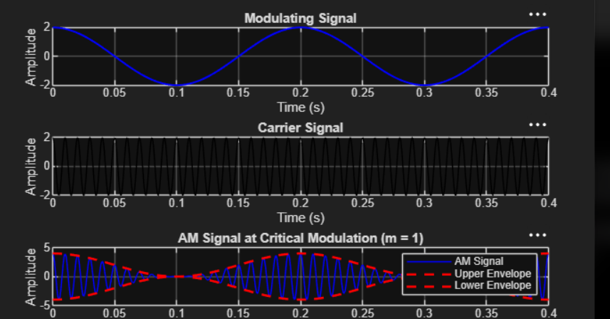
Figure 1: AM waveform at critical modulation (m = 1).

6. RESULT
The modulation index was calculated as m = Am/Ac = 5/5 = 1 (100%). The MATLAB plots show the modulating signal, carrier signal, and critically modulated AM waveform. At m = 1, the envelope just reaches zero without crossing it, representing the maximum modulation condition without over-modulation.

