EXPERIMENT 1.2
IDENTIFICATION AND ANALYSIS OF UNDER-MODULATION IN AM
1. AIM
To identify and analyze the under-modulation condition of an amplitude-modulated (AM) signal by calculating the modulation index and verifying that m is less than 1 using MATLAB.
2. APPARATUS / SOFTWARE REQUIRED
- Computer or laptop
- MATLAB software
- MATLAB Editor
3. THEORY AND FORMULA
In amplitude modulation, the amplitude of a high-frequency carrier changes according to the modulating signal. The modulation index indicates the extent of carrier amplitude variation.
m = Am / Ac
Here, Am is the peak amplitude of the modulating signal and Ac is the peak amplitude of the carrier. Under-modulation occurs when m < 1. At m = 1, the signal is 100% modulated; when m > 1, over-modulation occurs.
Given: Am = 2, Ac = 5
m = 2 / 5 = 0.4 = 40%
Since 0.4 is less than 1, the AM signal is under-modulated. Its envelope remains above zero for the selected positive carrier amplitude and can be followed by an envelope detector.
4. MATLAB CODE
clc;
clear;
close all;

% Signal parameters
Ac = 5; % Carrier amplitude
Am = 2; % Modulating signal amplitude
fc = 100; % Carrier frequency in Hz
fm = 5; % Modulating frequency in Hz
fs = 10000; % Sampling frequency in Hz

% Calculate modulation index
m = Am / Ac;

fprintf('Modulation Index = %.2f\n', m);
fprintf('Modulation Percentage = %.2f%%\n', m*100);

% Check modulation condition
if m < 1
disp('Condition: Under-modulation');
elseif m == 1
disp('Condition: 100 percent modulation');
else
disp('Condition: Over-modulation');
end

% Time vector
t = 0:1/fs:2/fm;

% Generate signals
message = Am*cos(2*pi*fm*t);
carrier = Ac*cos(2*pi*fc*t);
am_signal = Ac*(1 + m*cos(2*pi*fm*t)) ...
.* cos(2*pi*fc*t);

% Calculate AM envelope
envelope = Ac*(1 + m*cos(2*pi*fm*t));

% Plot signals
figure;

subplot(3,1,1);
plot(t, message, 'b', 'LineWidth', 1.2);
title('Modulating Signal');
xlabel('Time (s)');
ylabel('Amplitude');
grid on;

subplot(3,1,2);
plot(t, carrier, 'k');
title('Carrier Signal');
xlabel('Time (s)');
ylabel('Amplitude');
grid on;

subplot(3,1,3);
plot(t, am_signal, 'r');
hold on;
plot(t, envelope, 'b--', 'LineWidth', 1.2);
plot(t, -envelope, 'b--', 'LineWidth', 1.2);
title('AM Signal - Under-Modulation');
xlabel('Time (s)');
ylabel('Amplitude');
legend('AM Signal', 'Upper Envelope', 'Lower Envelope');
grid on;
5. MATLAB OUTPUT
The output contains the modulating signal, carrier signal, and AM waveform with upper and lower envelopes.
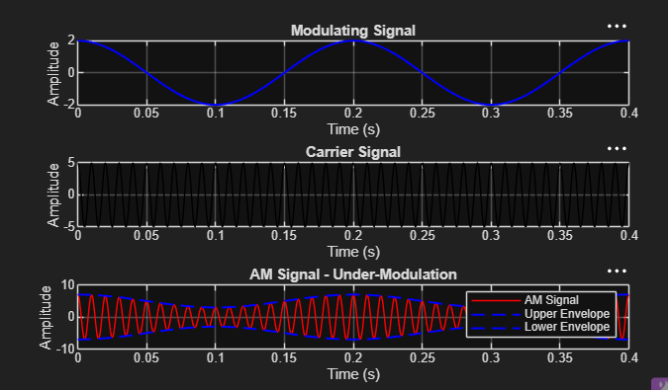
6. RESULT
The modulation index was calculated as m = Am/Ac = 2/5 = 0.4 (40%). Since m < 1, the signal satisfies the under-modulation condition. The modulating signal, carrier signal, and AM waveform with its envelope were plotted successfully in MATLAB.

