EXPERIMENT: AM MODULATION INDEX
1. AIM
To calculate the modulation index of an amplitude-modulated (AM) signal using the carrier and modulating signal amplitudes in MATLAB, and to plot the baseband, carrier, AM signal with its envelope, and demodulated output.
2. APPARATUS / SOFTWARE REQUIRED
- Computer or laptop
- MATLAB software
- MATLAB Editor for entering and running the program
3. THEORY AND FORMULA
In amplitude modulation, the amplitude of a high-frequency carrier varies according to the instantaneous value of the low-frequency modulating signal.
Modulation index: m = Am / Ac
Where Am is the peak amplitude of the modulating signal and Ac is the peak amplitude of the carrier signal. For this experiment, Am = 2 and Ac = 5.
m = 2 / 5 = 0.4
Modulation percentage = m x 100 = 40%. Since m is less than 1, the signal is under-modulated.
4. MATLAB CODE
clc;
clear;
close all;

% Signal parameters
Ac = 5;
Am = 2;
fc = 100;
fm = 5;
fs = 10000;

% Calculate modulation index
m = Am / Ac;

fprintf('Modulation Index = %.2f\\n', m);
fprintf('Modulation Percentage = %.2f percent\\n', m*100);

% Time vector
t = 0:1/fs:2/fm;

% Generate signals
message = Am*cos(2*pi*fm*t);
carrier = Ac*cos(2*pi*fc*t);
am_signal = Ac*(1 + m*cos(2*pi*fm*t)).*cos(2*pi*fc*t);

% Plot baseband signal
figure;

subplot(4,1,1);
plot(t, message, 'b');
title('Baseband Signal');
xlabel('Time (seconds)');
ylabel('Amplitude');
grid on;

% Plot carrier signal
subplot(4,1,2);
plot(t, carrier, 'k');
title('Carrier Signal');
xlabel('Time (seconds)');
ylabel('Amplitude');
grid on;

% Plot AM signal
subplot(4,1,3);
plot(t, am_signal, 'r');
hold on;
env = Ac*(1 + m*cos(2*pi*fm*t));
plot(t, env, 'b--');
plot(t, -env, 'b--');
title('Amplitude Modulated Signal');
xlabel('Time (seconds)');
ylabel('Amplitude');
grid on;

% Plot demodulated message component
subplot(4,1,4);
plot(t, env - Ac, 'r');
title('Demodulated Output');
xlabel('Time (seconds)');
ylabel('Amplitude');
grid on;
5. MATLAB OUTPUT
The following output shows the baseband signal, carrier signal, amplitude-modulated signal with its envelope, and the demodulated message component.
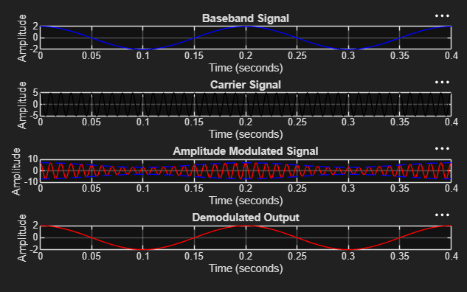
6. RESULT
The modulation index was calculated in MATLAB as m = Am/Ac = 2/5 = 0.4, corresponding to 40% modulation. The plotted AM waveform and its envelope were obtained successfully. Since the modulation index is less than 1, the signal is under-modulated.

