EXPERIMENT: AM MODULATION INDEX

1. AIM
To calculate the modulation index of an amplitude-modulated (AM) signal using the carrier and modulating signal amplitudes in MATLAB, and to plot the baseband, carrier, AM signal with its envelope, and demodulated output.

2. APPARATUS / SOFTWARE REQUIRED
- Computer or laptop
- MATLAB software
- MATLAB Editor for entering and running the program

3. THEORY AND FORMULA
In amplitude modulation, the amplitude of a high-frequency carrier varies according to the instantaneous value of the low-frequency modulating signal.
Modulation index: m = Am / Ac
Where Am is the peak amplitude of the modulating signal and Ac is the peak amplitude of the carrier signal. For this experiment, Am = 2 and Ac = 5.
m = 2 / 5 = 0.4
Modulation percentage = m × 100 = 40%. Since m is less than 1, the signal is under-modulated.

4. MATLAB CODE
clc;
clear;
close all;
% Signal parameters
Ac = 5;
Am = 2;
fc = 100;
fm = 5;
fs = 10000;
% Calculate modulation index
m = Am / Ac;
fprintf('Modulation Index = %.2f\n', m);
fprintf('Modulation Percentage = %.2f percent\n', m*100);
% Time vector
t = 0:1/fs:2/fm;
% Generate signals
message = Am*cos(2*pi*fm*t);
carrier = Ac*cos(2*pi*fc*t);
am_signal = Ac*(1 + m*cos(2*pi*fm*t)).*cos(2*pi*fc*t);
% Plot baseband signal
figure;
subplot(4,1,1);
plot(t, message, 'b');
title('Baseband Signal');
xlabel('Time (seconds)');
ylabel('Amplitude');
grid on;
% Plot carrier signal
subplot(4,1,2);
plot(t, carrier, 'k');
title('Carrier Signal');
xlabel('Time (seconds)');
ylabel('Amplitude');
grid on;
% Plot AM signal
subplot(4,1,3);
plot(t, am_signal, 'r');
hold on;
env = Ac*(1 + m*cos(2*pi*fm*t));
plot(t, env, 'b--');
plot(t, -env, 'b--');
title('Amplitude Modulated Signal');
xlabel('Time (seconds)');
ylabel('Amplitude');
grid on;
% Plot demodulated message component
subplot(4,1,4);
plot(t, env - Ac, 'r');
title('Demodulated Output');
xlabel('Time (seconds)');
ylabel('Amplitude');
grid on;

5. MATLAB OUTPUT
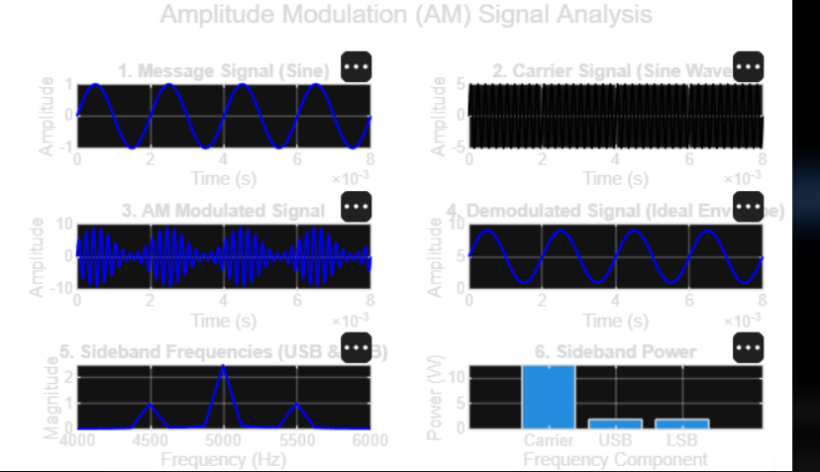
The output above shows the message signal, carrier signal, AM modulated signal, demodulated signal, sideband frequencies, and sideband power.

6. RESULT
The modulation index was calculated in MATLAB as m = Am/Ac = 2/5 = 0.4, corresponding to 40% modulation. The plotted AM waveform and its envelope were obtained successfully. Since the modulation index is less than 1, the signal is under-modulated.

