EXPERIMENT: FREQUENCY SPECTRUM OF AM SIGNAL

1. AIM
To generate an amplitude-modulated (AM) signal in MATLAB and analyze its frequency spectrum by identifying the carrier frequency and the lower and upper sideband frequencies.

2. APPARATUS / SOFTWARE REQUIRED
- Computer or laptop
- MATLAB software
- MATLAB Editor for entering and running the program

3. THEORY AND FORMULA
An AM signal consists of a carrier component and two sideband components. For a carrier frequency fc and a message frequency fm:
Lower Sideband (LSB) frequency = fc − fm
Carrier frequency = fc
Upper Sideband (USB) frequency = fc + fm
In the obtained spectrum, the carrier is at 1000 Hz, the LSB is at 900 Hz, and the USB is at 1100 Hz.

4. MATLAB CODE
clc;
clear;
close all;
% Signal parameters
Ac = 1;
Am = 0.2;
fc = 1000;
fm = 100;
fs = 10000;
% Time vector
t = 0:1/fs:0.1;
% Generate AM signal
m = Am/Ac;
am_signal = Ac*(1 + m*cos(2*pi*fm*t)).*cos(2*pi*fc*t);
% Frequency spectrum using FFT
N = length(am_signal);
Y = fft(am_signal);
P2 = abs(Y/N);
P1 = P2(1:N/2+1);
P1(2:end-1) = 2*P1(2:end-1);
f = fs*(0:N/2)/N;
% Plot frequency spectrum
figure;
plot(f, P1, 'b', 'LineWidth', 1.5);
hold on;
% Mark LSB, carrier and USB
xline(fc-fm, 'r--', 'LSB');
xline(fc, 'k--', 'Carrier');
xline(fc+fm, 'g--', 'USB');
title('Frequency Spectrum of AM Signal');
xlabel('Frequency (Hz)');
ylabel('Amplitude');
legend('AM Spectrum', 'LSB', 'Carrier', 'USB');
grid on;
xlim([700 1300]);
ylim([0 1.2]);

5. MATLAB OUTPUT
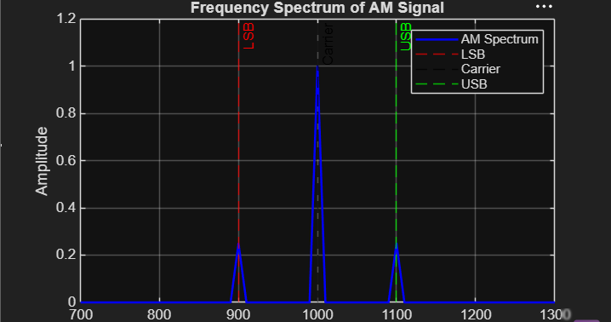
The frequency spectrum shows three major components: the lower sideband at 900 Hz, the carrier at 1000 Hz, and the upper sideband at 1100 Hz.

6. RESULT
The frequency spectrum of the AM signal was obtained successfully in MATLAB. The carrier component occurs at 1000 Hz, while the lower and upper sidebands occur at 900 Hz and 1100 Hz respectively.

