EXPERIMENT – 6
GENERATION AND ANALYSIS OF FREQUENCY MODULATED (FM) AND PHASE MODULATED (PM) SIGNALS USING MATLAB
AIM
To generate and analyze Frequency Modulated (FM) and Phase Modulated (PM) signals using MATLAB and to observe the message signal, carrier signal, FM signal, and PM signal.
SOFTWARE REQUIRED
• MATLAB (MATLAB R2020a or later recommended)
PARAMETERS USED
Parameter | Value
Message amplitude (Am) | 1
Carrier amplitude (Ac) | 1
Message frequency (fm) | 5 Hz
Carrier frequency (fc) | 50 Hz
FM modulation index (β) | 5
PM sensitivity (kp) | 5
Sampling frequency (fs) | 1000 Hz
Duration | 1 second
MATLAB CODE
clc;
clear;
close all;
Am=1;
Ac=1;
fm=5;
fc=50;
beta=5;
kp=5;
fs=1000;
t=0:1/fs:1;
m = Am*cos(2*pi*fm*t); % Message signal
c = Ac*cos(2*pi*fc*t); % Carrier signal
fm_sig = Ac*cos(2*pi*fc*t + beta*sin(2*pi*fm*t)); % FM
pm_sig = Ac*cos(2*pi*fc*t + kp*m); % PM
Df = beta*fm; % Frequency deviation
fprintf('Frequency Deviation = %d Hz\n',Df);
fprintf('FM Modulation Index = %d\n',beta);
subplot(4,1,1), plot(t,m), title('Message Signal')
subplot(4,1,2), plot(t,c), title('Carrier Signal')
subplot(4,1,3), plot(t,fm_sig), title('FM Signal')
subplot(4,1,4), plot(t,pm_sig), title('PM Signal')
RESULT / EXECUTION OF OUTPUT
The MATLAB program was executed successfully. The output displays four waveforms: the message signal, carrier signal, frequency modulated (FM) signal, and phase modulated (PM) signal. For the given values, the frequency deviation is 25 Hz and the FM modulation index is 5.
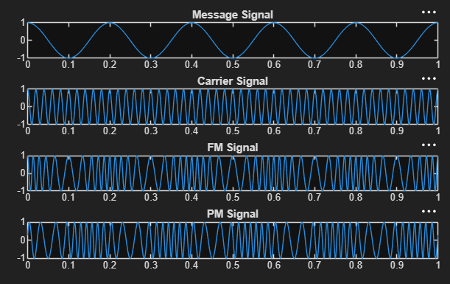
Figure: MATLAB execution output showing Message, Carrier, FM and PM signals
OBSERVATION
The message signal is a 5 Hz cosine waveform and the carrier is a 50 Hz cosine waveform. In FM, the instantaneous frequency of the carrier varies according to the message signal, while in PM, the instantaneous phase of the carrier varies according to the message signal. The FM signal therefore shows changes in the spacing between successive cycles, whereas the PM signal shows phase variations relative to the carrier.
CONCLUSION
Thus, FM and PM signals were successfully generated and analyzed using MATLAB. The frequency deviation for the given FM signal is 25 Hz, and the FM modulation index is 5.

