EXPERIMENT – 7
CALCULATION AND VERIFICATION OF FREQUENCY DEVIATION AND MODULATION INDEX OF FM SIGNALS USING MATLAB SIMULATION
AIM
To calculate and verify the frequency deviation and modulation index of a Frequency Modulated (FM) signal using MATLAB simulation and to observe the message signal and FM signal.
SOFTWARE REQUIRED
• MATLAB (MATLAB R2020a or later recommended)
PARAMETERS USED
Parameter | Value
Message amplitude (Am) | 2 V
Message frequency (fm) | 500 Hz
Carrier amplitude (Ac) | 1 V
Carrier frequency (fc) | 10000 Hz
Frequency sensitivity (kf) | 250 Hz/V
Sampling frequency (fs) | 100000 Hz
Simulation duration (T) | 0.01 s
FORMULAE USED
Frequency Deviation:
Δf = kf × Am
FM Modulation Index:
β = Δf / fm
CALCULATION
Given: kf = 250 Hz/V, Am = 2 V, and fm = 500 Hz.
Frequency deviation: Δf = 250 × 2 = 500 Hz.
Modulation index: β = 500 / 500 = 1.
MATLAB CODE
% Calculation and Verification of Frequency Deviation
% and Modulation Index of FM Signal
clc;
clear;
close all;
%% Message Signal Parameters
Am = 2; % Message amplitude (V)
fm = 500; % Message frequency (Hz)
%% Carrier Signal Parameters
Ac = 1; % Carrier amplitude (V)
fc = 10000; % Carrier frequency (Hz)
%% FM Parameters
kf = 250; % Frequency sensitivity (Hz/V)
fs = 100000; % Sampling frequency (Hz)
T = 0.01; % Simulation duration (s)
%% Time Vector
t = 0:1/fs:T;
%% Message Signal
m = Am*cos(2*pi*fm*t);
%% Frequency Deviation
delta_f = kf*Am;
%% Modulation Index
beta = delta_f/fm;
%% FM Signal
fm_signal = Ac*cos(2*pi*fc*t + beta*sin(2*pi*fm*t));
%% Display Parameters
fprintf('Carrier Frequency (fc) = %.0f Hz\n',fc);
fprintf('Message Frequency (fm) = %.0f Hz\n',fm);
fprintf('Message Amplitude (Am) = %.0f V\n',Am);
fprintf('Frequency Sensitivity (kf) = %.0f Hz/V\n',kf);
fprintf('\nFrequency Deviation (Delta f) = %.2f Hz\n',delta_f);
fprintf('Modulation Index (Beta) = %.2f\n',beta);
%% Verification
beta_verify = delta_f/fm;
fprintf('Verified Modulation Index = %.2f\n',beta_verify);
%% Verification Check
tolerance = 1e-6;
if abs(beta - beta_verify) < tolerance
fprintf('\nVerification Successful\n');
else
fprintf('\nVerification Failed\n');
end
%% Plotting
figure;
subplot(2,1,1);
plot(t,m,'LineWidth',1.5);
grid on;
title('Message Signal');
xlabel('Time (s)');
ylabel('Amplitude (V)');
subplot(2,1,2);
plot(t,fm_signal,'LineWidth',1);
grid on;
title('FM Signal');
xlabel('Time (s)');
ylabel('Amplitude (V)');
RESULT / EXECUTION OF OUTPUT
The MATLAB program was executed successfully. The calculated frequency deviation is 500 Hz and the FM modulation index is 1. The calculated modulation index was verified using β = Δf/fm, and the verification was successful.
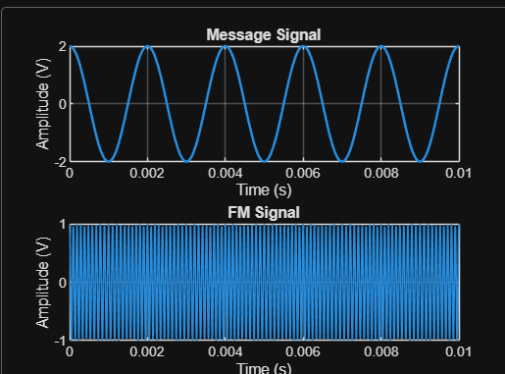
Figure: MATLAB execution output showing Message Signal and FM Signal
OBSERVATION
The message signal is a 500 Hz cosine waveform with an amplitude of 2 V. The FM signal has a carrier frequency of 10 kHz and its instantaneous frequency varies according to the message signal. The frequency deviation is 500 Hz, resulting in an FM modulation index of 1.
CONCLUSION
Thus, the frequency deviation and modulation index of the FM signal were successfully calculated and verified using MATLAB simulation. The frequency deviation obtained is 500 Hz and the modulation index is 1. The verification was successful.

