EXPERIMENT – 10
PERFORMANCE ANALYSIS OF FM SYSTEM UNDER GAUSSIAN WHITE NOISE USING MATLAB
AIM
To generate a Frequency Modulated (FM) signal, introduce Gaussian White Noise through an Additive White Gaussian Noise (AWGN) channel, and analyze the performance of the FM system under noisy channel conditions using MATLAB.
SOFTWARE REQUIRED
• MATLAB with Communications Toolbox (for the awgn function)
PARAMETERS USED
Parameter | Value
Sampling frequency (fs) | 100000 Hz
Message frequency (fm) | 500 Hz
Carrier frequency (fc) | 5000 Hz
Frequency sensitivity (kf) | 100 Hz
Simulation duration | 0.02 s
AWGN SNR | 10 dB
METHOD / WORKING
1. Generate the message signal and carrier signal.
2. Generate the FM signal using frequency sensitivity and the accumulated message signal.
3. Add Gaussian White Noise using an AWGN channel with 10 dB SNR.
4. Plot the original message signal, carrier signal, FM signal, and noisy FM signal.
5. Compare the FM signal before and after the addition of Gaussian White Noise.
MATLAB CODE
clc;
clear;
close all;
% Parameters
fs = 100000;
t = 0:1/fs:0.02;
fm = 500; % Message frequency
fc = 5000; % Carrier frequency
kf = 100; % Frequency sensitivity
% Message Signal
m = cos(2*pi*fm*t);
c = cos(2*pi*fc*t);
% FM Modulation
fm_sig = cos(2*pi*fc*t + 2*pi*kf*cumsum(m)/fs);
% Add Gaussian White Noise
noisy = awgn(fm_sig,10,'measured'); % 10 dB SNR
% Display
figure;
subplot(4,1,1)
plot(t,m)
title('Message Signal')
grid on
subplot(4,1,2)
plot(t,m)
title('Carrier Signal')
grid on
subplot(4,1,3)
plot(t,fm_sig)
title('FM Signal')
grid on
subplot(4,1,4)
plot(t,noisy)
title('FM Signal with Gaussian White Noise')
grid on
RESULT / EXECUTION OF OUTPUT
The MATLAB program was executed successfully. The FM signal was generated and Gaussian White Noise was added using an AWGN channel with an SNR of 10 dB. The output clearly shows the effect of noise on the FM waveform.
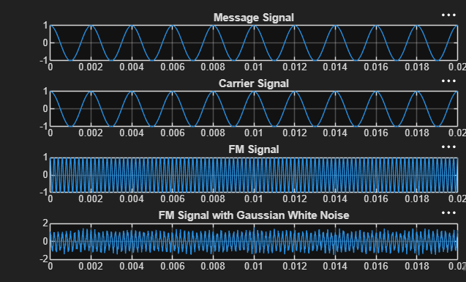
Figure: MATLAB execution output showing Message Signal, Carrier Signal, FM Signal, and FM Signal with Gaussian White Noise
OBSERVATION
The message signal is a 500 Hz cosine waveform and the carrier frequency is 5 kHz. The FM signal has a frequency that varies according to the message signal. After adding Gaussian White Noise at 10 dB SNR, the FM waveform becomes distorted and additional random variations are observed in the signal.
CONCLUSION
Thus, the performance of an FM system under Gaussian White Noise was successfully analyzed using MATLAB. The FM signal was generated and transmitted through a noisy channel using AWGN. The comparison of the clean and noisy FM signals demonstrates the effect of channel noise on FM communication.

