EXPERIMENT – 8
POWER SPECTRAL DENSITY (PSD) ANALYSIS OF PHASE MODULATED (PM) SIGNALS USING MATLAB
AIM
To generate a Phase Modulated (PM) signal and analyze its Power Spectral Density (PSD) and frequency spectrum using MATLAB, and to estimate the bandwidth of the PM signal.
SOFTWARE REQUIRED
• MATLAB (MATLAB R2020a or later recommended)
PARAMETERS USED
Parameter | Value
Message amplitude (Am) | 1 V
Message frequency (fm) | 100 Hz
Carrier amplitude (Ac) | 5 V
Carrier frequency (fc) | 1000 Hz
Sampling frequency (fs) | 20 × fc = 20000 Hz
Phase sensitivity (kp) | π/2 rad/V
FORMULAE USED
Phase deviation / PM modulation index:
β = kp × Am
Approximate bandwidth:
BW ≈ 2(β + 1)fm
CALCULATION
Given: kp = π/2 rad/V, Am = 1 V, and fm = 100 Hz.
Phase deviation: β = (π/2) × 1 = π/2 ≈ 1.57 radians.
Estimated bandwidth: BW ≈ 2(1.57 + 1) × 100 ≈ 514.16 Hz.
MATLAB CODE
clc;
clear;
close all;
% Parameters
Am = 1; % Message Amplitude (V)
fm = 100; % Message Frequency (Hz)
Ac = 5; % Carrier Amplitude (V)
fc = 1000; % Carrier Frequency (Hz)
fs = 20*fc; % Sampling Frequency (Hz)
kp = pi/2; % Phase Sensitivity (rad/V)
% Time Vector
t = 0:1/fs:4/fm;
% Message Signal
m = Am*sin(2*pi*fm*t);
% PM Signal
pm = Ac*cos(2*pi*fc*t + kp*m);
% Phase Deviation
beta = kp*Am;
% FFT
N = length(pm);
f = linspace(-fs/2,fs/2,N);
PM_FFT = abs(fftshift(fft(pm)))/N;
% Power Spectral Density
PSD = (abs(fftshift(fft(pm))).^2)/(N*fs);
% Approximate Bandwidth
BW = 2*(beta+1)*fm;
fprintf('Phase Deviation = %.2f radians\n',beta);
fprintf('Estimated Bandwidth = %.2f Hz\n',BW);
% Plotting
figure('Name','PSD Analysis of PM Signal','NumberTitle','off');
subplot(2,2,1);
plot(t,m);
title('Message Signal');
xlabel('Time (s)');
ylabel('Amplitude');
grid on;
subplot(2,2,2);
plot(t,pm);
title('Phase Modulated Signal');
xlabel('Time (s)');
ylabel('Amplitude');
grid on;
subplot(2,2,3);
plot(f,PM_FFT);
title('Frequency Spectrum of PM Signal');
xlabel('Frequency (Hz)');
ylabel('Magnitude');
grid on;
subplot(2,2,4);
plot(f,PSD);
title('Power Spectral Density');
xlabel('Frequency (Hz)');
ylabel('PSD');
grid on;
RESULT / EXECUTION OF OUTPUT
The MATLAB program was executed successfully. The PM signal, its frequency spectrum, and Power Spectral Density (PSD) were obtained. The calculated phase deviation is approximately 1.57 radians and the estimated bandwidth is approximately 514.16 Hz.
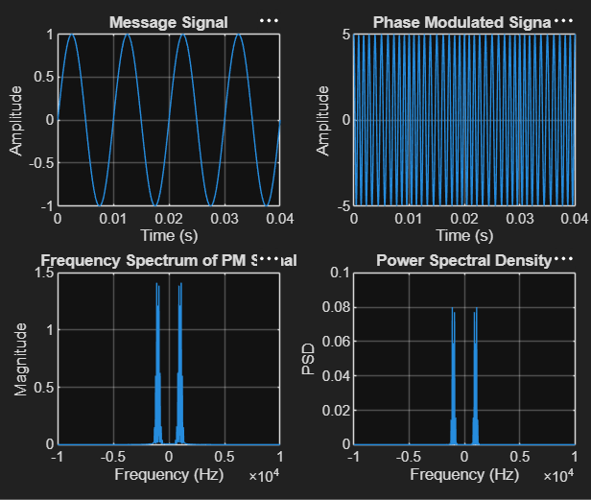
Figure: MATLAB execution output showing Message Signal, Phase Modulated Signal, Frequency Spectrum and Power Spectral Density
OBSERVATION
The message signal is a 100 Hz sinusoidal signal with an amplitude of 1 V. The PM signal has a carrier frequency of 1000 Hz and carrier amplitude of 5 V. The frequency spectrum shows the spectral components around the carrier frequency, while the PSD plot represents the distribution of signal power with frequency.
CONCLUSION
Thus, the Power Spectral Density and frequency spectrum of the Phase Modulated (PM) signal were successfully analyzed using MATLAB. The phase deviation is approximately 1.57 radians and the estimated bandwidth is approximately 514.16 Hz.

