EXPERIMENT – 9
PERFORMANCE EVALUATION OF AM GENERATION AND DETECTION UNDER NOISY CHANNEL CONDITIONS USING MATLAB
AIM
To generate an Amplitude Modulated (AM) signal, introduce Additive White Gaussian Noise (AWGN), recover the message signal using envelope detection, and evaluate the performance of AM generation and detection under noisy channel conditions using MATLAB.
SOFTWARE REQUIRED
• MATLAB with Communications Toolbox (for the awgn function)
PARAMETERS USED
Parameter | Value
Sampling frequency (fs) | 100000 Hz
Message frequency (fm) | 500 Hz
Carrier frequency (fc) | 5000 Hz
Simulation duration | 0.02 s
SNR | 10 dB
METHOD / WORKING
1. Generate the message signal and carrier signal.
2. Generate the AM signal using conventional AM modulation.
3. Add AWGN with a signal-to-noise ratio of 10 dB.
4. Perform envelope detection using the Hilbert transform.
5. Plot and compare the original message, carrier, AM signal, noisy AM signal, and recovered signal.
MATLAB CODE
clc;
clear;
close all;
% Parameters
fs = 100000;
t = 0:1/fs:0.02;
fm = 500;
fc = 5000;
% Message Signal
m = cos(2*pi*fm*t);
c = cos(2*pi*fc*t);
% AM Modulation
am = (1 + m).*cos(2*pi*fc*t);
% Add AWGN Noise
noisy = awgn(am,10,'measured'); % 10 dB SNR
% Envelope Detection
env = abs(hilbert(noisy));
% Display Results
figure;
subplot(5,1,1)
plot(t,m)
title('Message Signal')
grid on
subplot(5,1,2)
plot(t,c)
title('Carrier Signal')
grid on
subplot(5,1,3)
plot(t,am)
title('AM Signal')
grid on
subplot(5,1,4)
plot(t,noisy)
title('AM Signal with AWGN Noise')
grid on
subplot(5,1,5)
plot(t,env)
title('Recovered Signal')
grid on
RESULT / EXECUTION OF OUTPUT
The MATLAB program was executed successfully. The AM signal was generated and AWGN noise with 10 dB SNR was added. Envelope detection was then applied to the noisy AM signal. The output shows the message signal, carrier signal, AM signal, noisy AM signal, and recovered signal.
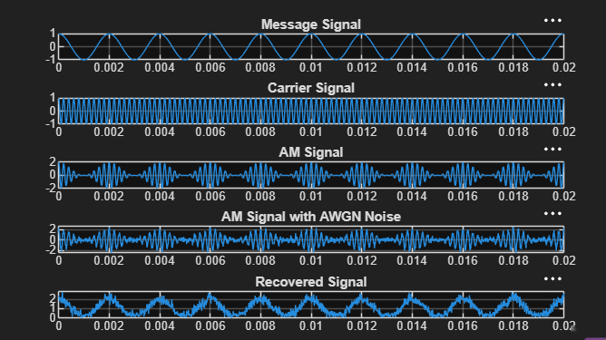
Figure: MATLAB execution output showing AM generation, AWGN noise, and recovered signal
OBSERVATION
The original message signal is a 500 Hz cosine waveform. The AM signal is obtained by modulating the 500 Hz message onto a 5 kHz carrier. After adding AWGN at 10 dB SNR, the AM waveform becomes distorted by noise. The envelope detector successfully recovers the message waveform, although some noise is visible in the recovered signal.
CONCLUSION
Thus, the performance of AM generation and detection under noisy channel conditions was successfully evaluated using MATLAB. The AM signal was generated, AWGN noise was introduced, and the message signal was recovered using envelope detection. The result demonstrates that AM detection can recover the original information even in the presence of channel noise.

