Sean Reilly

Lab 2 – Identify requirements for a program. Document the requirements using a simplified class hierarchy.

I’m going to identify the requirements for a program that stores employee data in a database. First, we have to identify what we need. So for an employee of the company we would store data like how much money they make, name, address, title, etc. This employee would report to a supervisor. Within this supervisor class we would have similar data like the supervisor’s name, address, pay rate, etc. We could also add who the supervisor reports to, the manager, and also add the same information to a class. Our class hierarchy, therefore, would look like this:

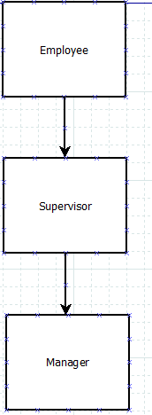

Because in this example we are using similar data for each class it would be prudent to have the supervisor and manager be able to use the same data that is written in the employee class. We can do this using inheritance. When supervisor inherits from employee it will automatically receive the functions within the employee class. It would look like this:

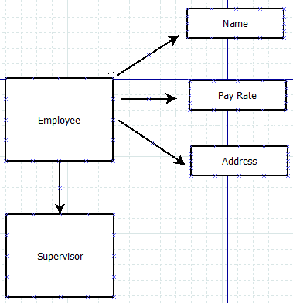

The supervisor class inherits all these functions. The same can be done with the manager class.