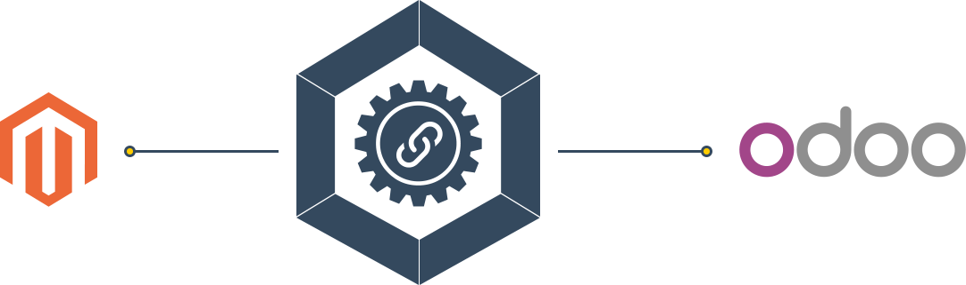

Magento1x Odoo Bridge
User Guide

A guide to cover all aspects of using Magento1x Odoo Bridge For Odoo.

By:Prakash Kumar
Webkul Software Pvt. Ltd.

USER MANUAL VER. 1.0.0

Extension Version: 1.x
Compatibility : CE / EE 9.x,10.x
Website: http://webkul.com
Support: https://webkul.uvdesk.com

Versions of this document

Version | Date | Description
VER. 1.0.0 | May 16 2016 | First published version

Contents

- Overview
- Installation
  - Module Dependencies
  - Installing Module
- Configuration
  - Prerequisite
  - Creation of Magento1x Instance + Credentials Placement
  - Generic Configuration
    - State Mapping
    - Price-list
    - Product SKU Sequence
    - Language
    - Default Delivery Product
    - Warehouse and Stock Location
  - Test Connection
  - Advance Configuration
    - Product
      - Default Attribute Set ID
      - Default Tax Class ID
      - Default Product Visibility
      - Default Product Type
    - Cron Automation
      - Import Categories
      - Import Products
      - Import Partners
      - Import Orders
- User Manual
  - How Import Operation Work ?
  - Import Categories
  - Import Products
  - Import Partners
  - Import Orders
  - Export/Update Products
- FAQs
- Support

Overview

Magento1x Odoo Bridge Odoo Extension provides seamless and automatic integration between Magento version 1.x and Odoo. It allows you to manage product, order and stock smoothly on both ends by providing effortless import /export functionality.

The admin can synchronize Products, Quantities, and Sale orders from Magento1x to Odoo as well as Odoo to Magento. The admin can connect multiple Magento1x stores with one Odoo store.

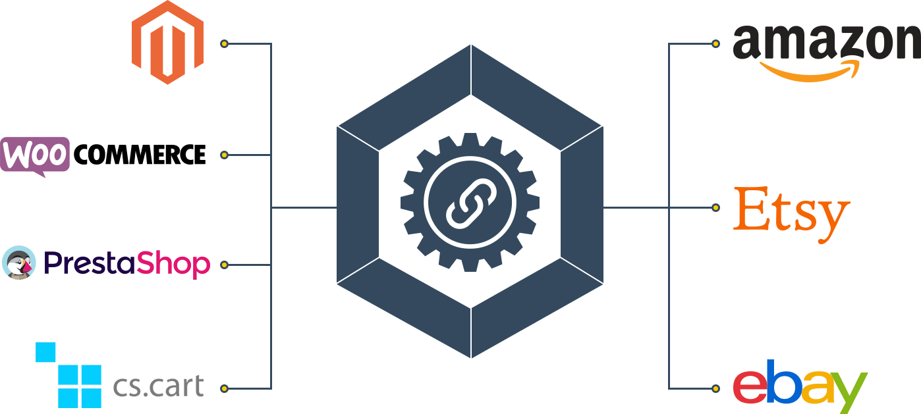

If you are an Magento Seller and also running you store over
multiple marketplaces/eCommerce (like etsy, ebay, amazon,
prestashop, Cs-cart,woocommerce etc. ) you must need a comprehensive solution like Magento1x odoo bridge Odoo Extension which allows you to manage your data of all channels from a centralized single interface.

Magento1x Odoo bridge Extension works in Support with Odoo Multi Channel Module which can easily solve your data management problems by providing a centralized single interface for managing records of various channels at a single place.

With help of Magento1x Odoo bridge and Odoo Multi Channel module user can connect with multiple channels at a same time along with Magento1x.
It leads to saving the User's time and money by reducing efforts required in managing consistent data over all channels at once.

Installation

Module Dependencies :

Magento1x Odoo Bridge required these module dependencies :
- Odoo Multi Channel Sale
- Product Dimension
- Product Variant Extra Price

Installing Module :
After placing all required module dependencies in addons folder along with Magento1x Odoo Bridge module , Proceed to module installation in Odoo by following the steps mentioned below:

- Go to Apps Menu & Activate Developer Mode .
- Update Module List.
- Magento1x Odoo Bridge In Apps.
- Click On Install.
For more details about module installation in odoo visit How to install Module in Odoo .

Configuration

Prerequisite :

Before Instance Creation/Configuration you need to follow these
prerequisite steps :

Registering to use Magento1x .

Enable Multi Currency and Activate Magento1x Store Currency.
- Enable Multi Language and load Magento1x store Language.
- Create Price list with Magento1x Marketplace Currency .

Creation of Magento1x Instance :

The first step after installation is to create a instance of Magento1x channel in Odoo, for this go to :
Multi Channel ==> Channel ==> Instance

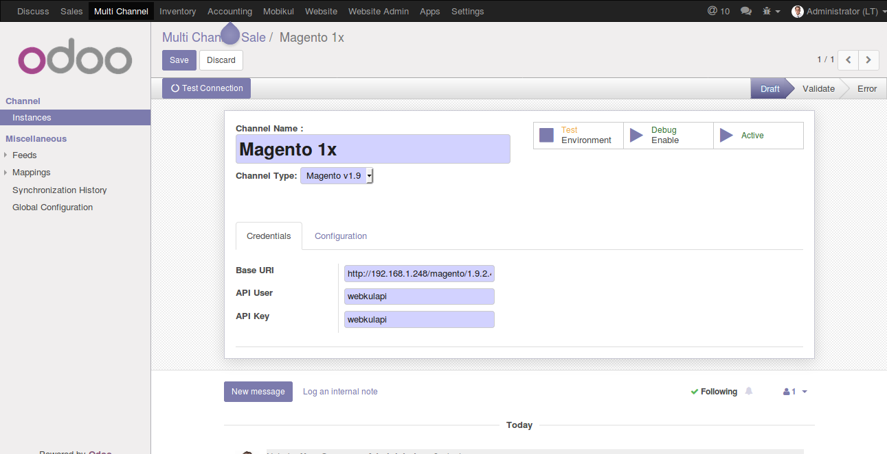
Here for new Magento1x Instance creation you need to Select “Channel Type”: “Magento1x” and place the Magento1x Credentials obtained while Prerequisite(Registering to use Magento1x )

- Base URI
- API User
- API Key
NOTE:
Here you can manage multiple instances of different channels(like amazon, etsy, ebay, magento, prestashop, cs-cart, woocommerce etc. )

Generic Configuration :
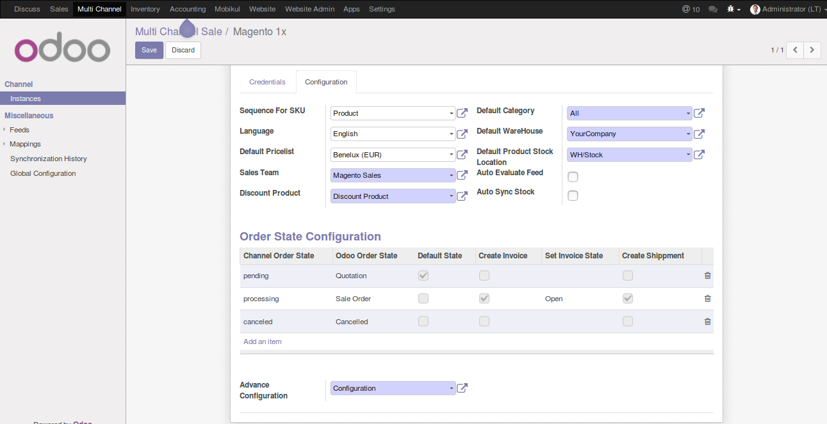
During Magento1x Instance creation you can configure these general things:
- State Mapping
  - Choose the Odoo Order/Invoice/Delivery state based on Magento1x order state.
  - For example -you can select confirm state of an order and open state of paid state of invoice over odoo for unshipped state over Magento1x.
- Price-list
  - Select the Price-list according to the currency you are using in Magento1x.
  - The currency of Price-list in Odoo and Price-list in Magento1x Marketplace should be same.
- Product SKU Sequence
  - Select the Default Code / SKU Sequence object which will be used during the product export. In case object does not have Default Code / SKU.
- Language
  - Select the language you are using in the instance.
- Default Delivery Product
  - Select the Default Delivery Product which will be used to manage delivery cost by adding delivery cost as a sale order line.
- Warehouse and Stock Location
  - Select the Warehouse and Stock Locations where you want to manage your instance's stock.

Test Connection :
After Basic configuration, you can validate credentials as well by clicking test connection button.

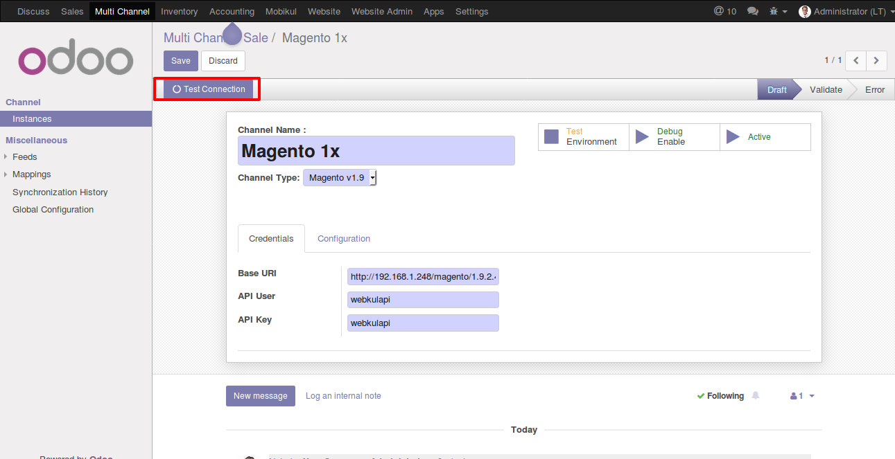

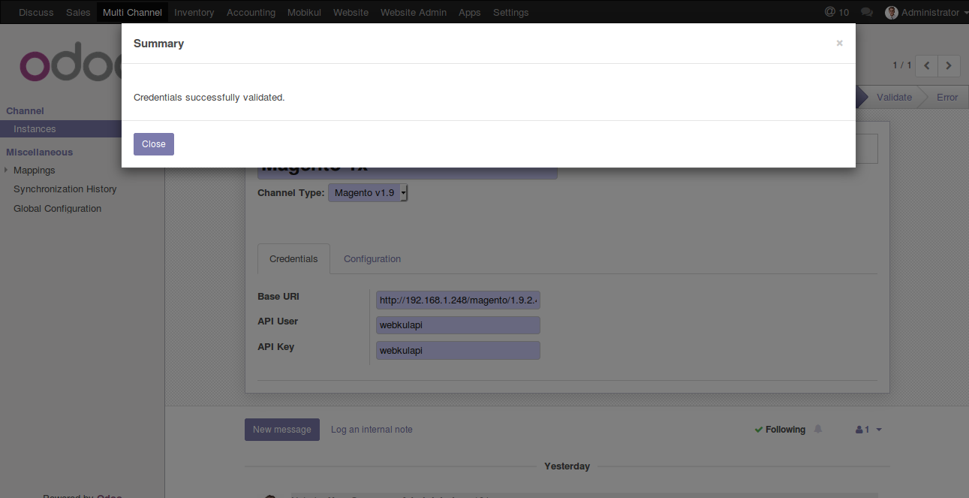

In case of no error, you will get a message about successful validation.

Advance Configuration :
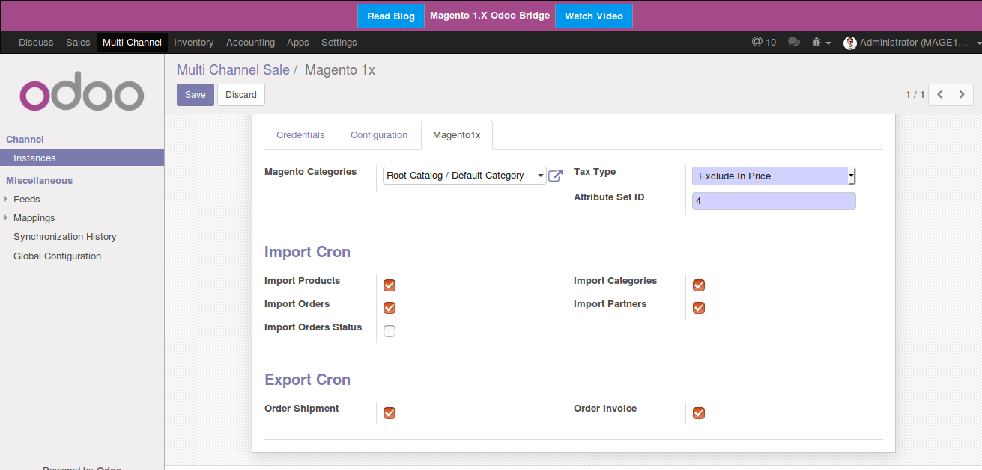

Under advance configuration, you can configure following things:

- Product
  - Tax Type
    - Tax Type using at magento .
  - Attribute Set ID
    - Default attribute set of magento to be used during product export.

- Import Cron Automation
  - Import Products
    - Using this you can set the cron to import the products automatically after an interval.
  - Import Categories
    - Using this you can set the cron to import the categories automatically after an interval.
  - Import Orders
    - Using this you can set the cron to import the orders automatically after an interval.
  - Import Partner
    - Using this you can set the cron to import the partners automatically after an interval.
- Export Cron Automation
  - Orders Shipment
    - Using this you can automatic create the order shipment at magneto for the imported order when they transfer at odoo.
  - Orders Invoice
    - Using this you can automatic create the order invoice at magneto for the imported order when they paid at odoo.
User Manual

How Import Operation Works ?
Import Operation is done using two steps process.
- Feed Creation
  - Import Operation creates feeds like product/category feed, order/partner feed etc.
- Feed Evaluation.
  - Actual record creation is done at the time of evaluation .
  - NOTE: It can be done automatically by selecting enable auto evaluation .

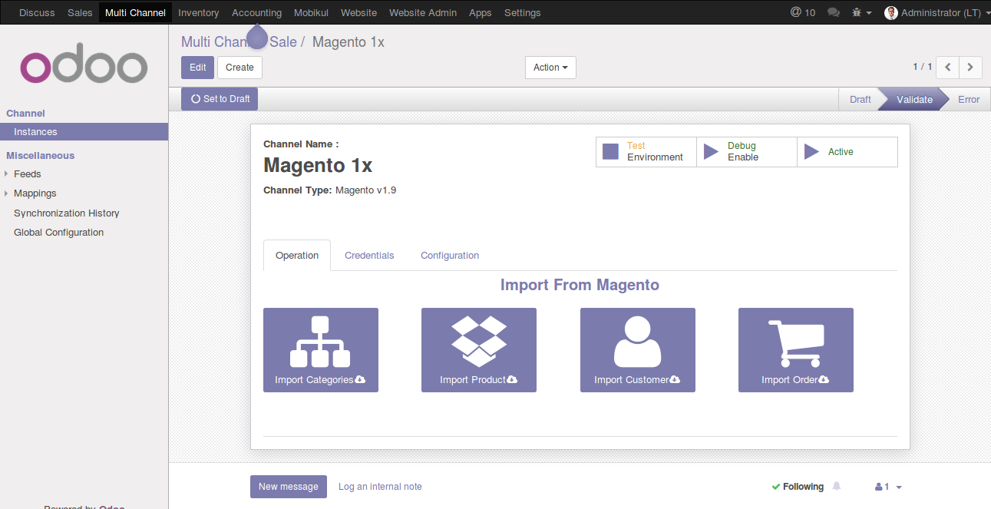
Import Categories :

As mentioned earlier, the import operation works in a two steps process-
Categories Feed Creation and Categories Feed Evaluation.

Categories Feed Creation :

In order to create feeds, follow these steps-

Step 1: Go to Multi Channel ==> Channel ==> Instance

Step 2: Open the Operation Tabs
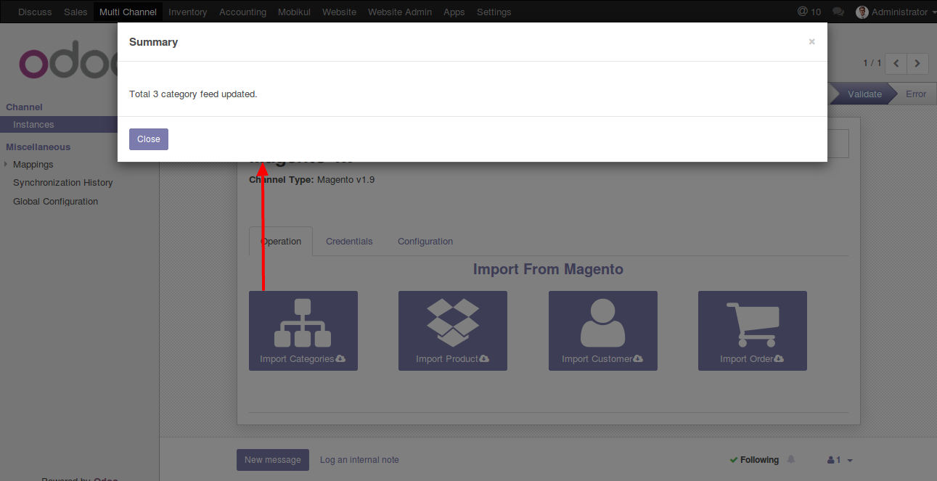
Step 3: Click on Import Categories

Categories Feed Evaluation :

Now after successful feed import, you will have to manually evaluate the feed in case the auto evaluate is not enabled for the channel .

For Feed Evaluation- Follow these steps:

Step 1: Go to Multi Channel ==> Miscellaneous
==> Feeds==>Category Feeds

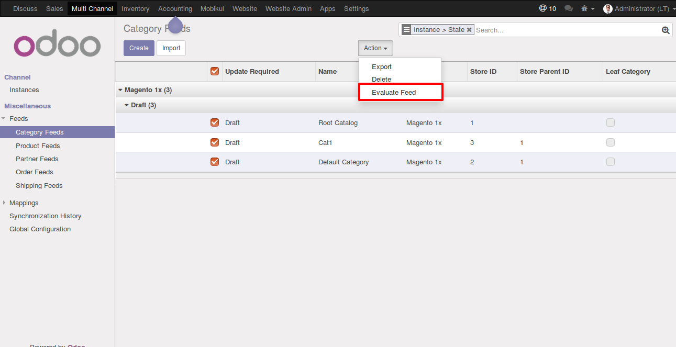
Step 2: Select the Feeds and Click on Evaluate Feed in Action

Import Products :

For product import follow the same two step process-

Product Feed Creation and Product Feed Evaluation .

Product Feed Creation :

In order to create feeds, follow these steps-

Step 1: Go to Multi Channel ==> Channel ==> Instance

Step 2: Open the Operation Tabs
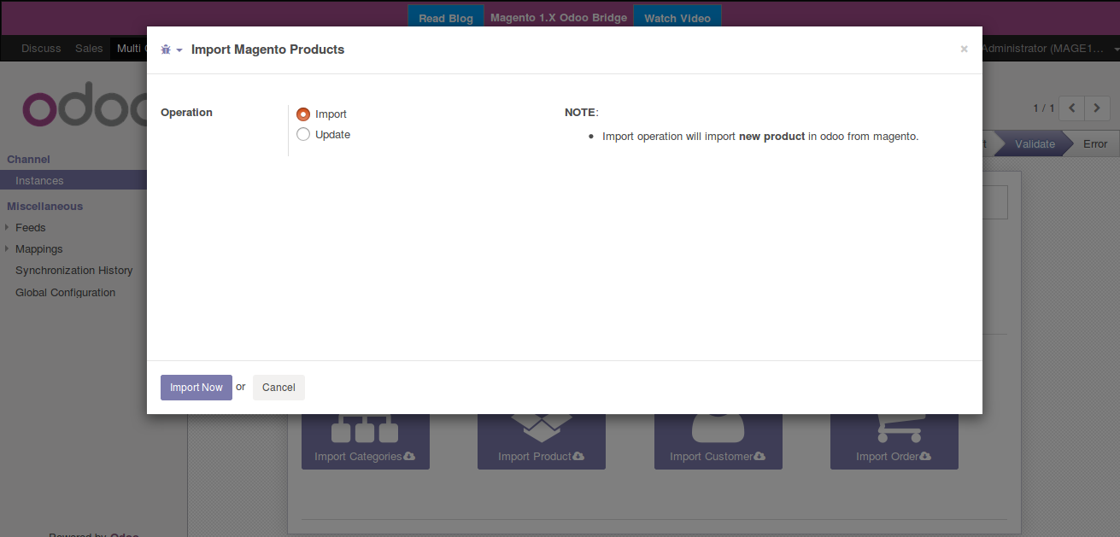
Step 3: Click on Import Products
Step 4: Select Import for import operation
Step 4: Click on Import Now

Product Feed Evaluation :

Now after successful feed import, you will have to manually evaluate the feed in case the auto evaluate is not enabled for the channel .

For Feed Evaluation- Follow these steps:

Step 1: Go to Multi Channel ==> Miscellaneous
==> Feeds==>Product Feeds

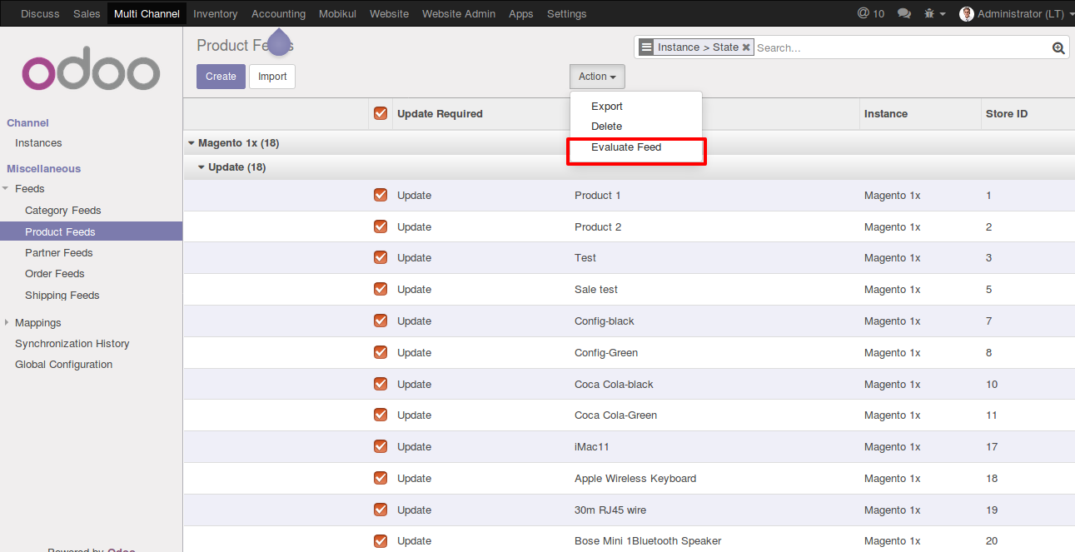
Step 2: Select the Feeds and Click on Evaluate Feed in Action

Import Partners :

For order import follow the same two step process-

Partners Feed Creation and Partners Feed Evaluation .

Partners Feed Creation :

For Feed Creation, Follow these steps:

Step 1: Go to Multi Channel ==> Channel ==> Instance

Step 2: Open the Operation Tabs
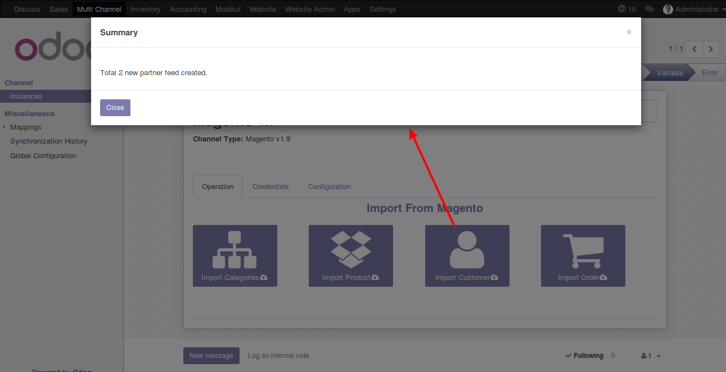

Step 3: Click on Import Partners

Partners Feed Evaluation :

Now after a successful feed import, you will have to manually evaluate the feeds in case the “auto evaluate” is not enabled for the channel .

For Feed Evaluation-

Follow these mention steps:

Step 1: Go to Multi Channel ==> Miscellaneous
==> Feeds==>Partners Feeds

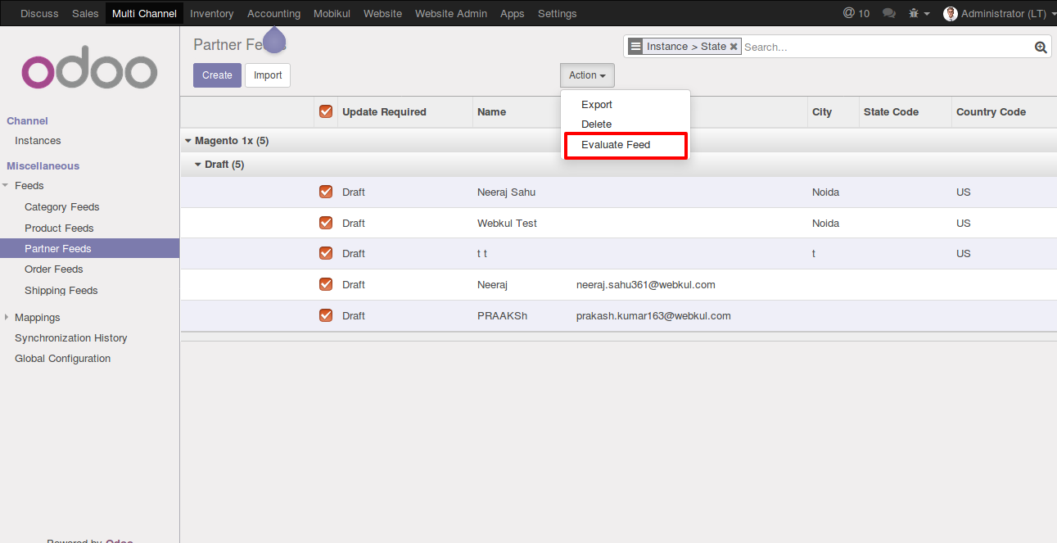
Step 2: Select the Feeds and Click on Evaluate Feed in Action
Import Orders :

For order import follow the same two step process-

Order Feed Creation and Order Feed Evaluation .

Order Feed Creation :

For Feed Creation, Follow these steps:

Step 1: Go to Multi Channel ==> Channel ==> Instance

Step 2: Open the Operation Tabs
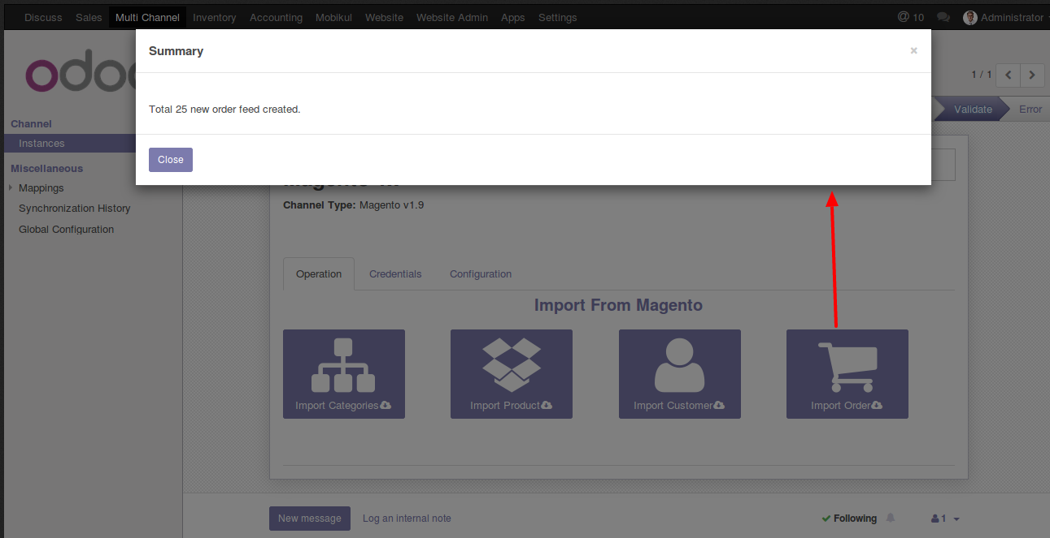

Step 3: Click on Import Orders

Order Feed Evaluation :

Now after a successful feed import, you will have to manually evaluate the feeds in case the “auto evaluate” is not enabled for the channel .

For Feed Evaluation-

Follow these mention steps:

Step 1: Go to Multi Channel ==> Miscellaneous
==> Feeds==>Order Feeds

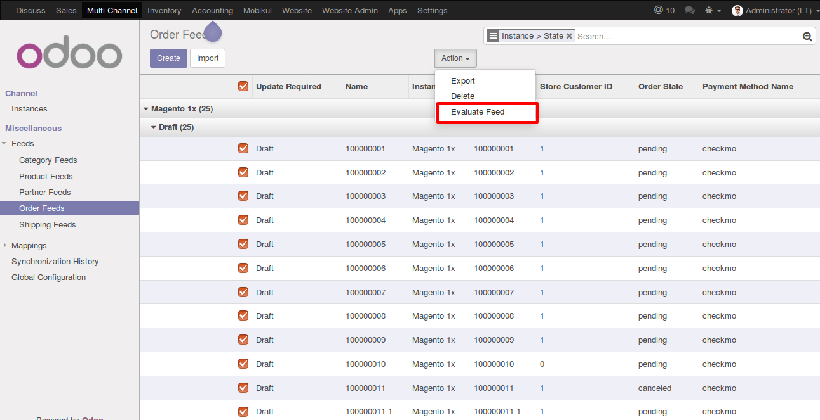
Step 2: Select the Feeds and Click on Evaluate Feed in Action
Export/Update Product :

In order to export the order over Magento1x, your product must have a unique SKU Code placed in the barcode field.

For Product Export follow these steps:

Step 1: Go to Sale ==> Product Variants
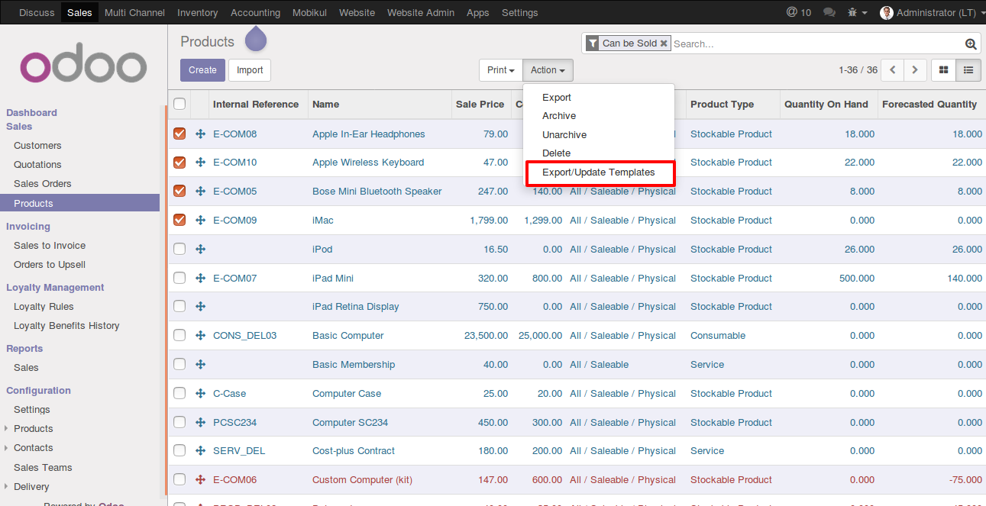

Step 2: Select the products
Step 3: Click on Export/Update Products in Action Bar
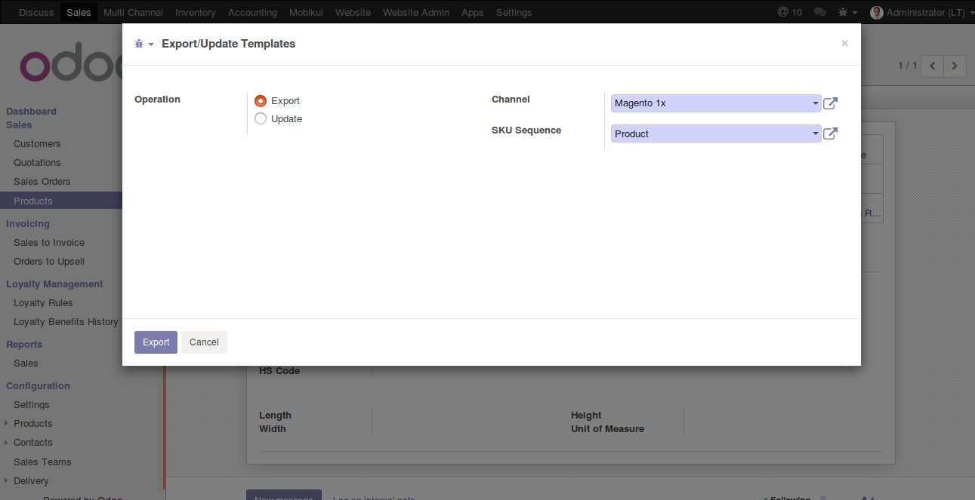

Step 4: Select Magento1x Channel and Sequence .
Step 5: Click on Export Products

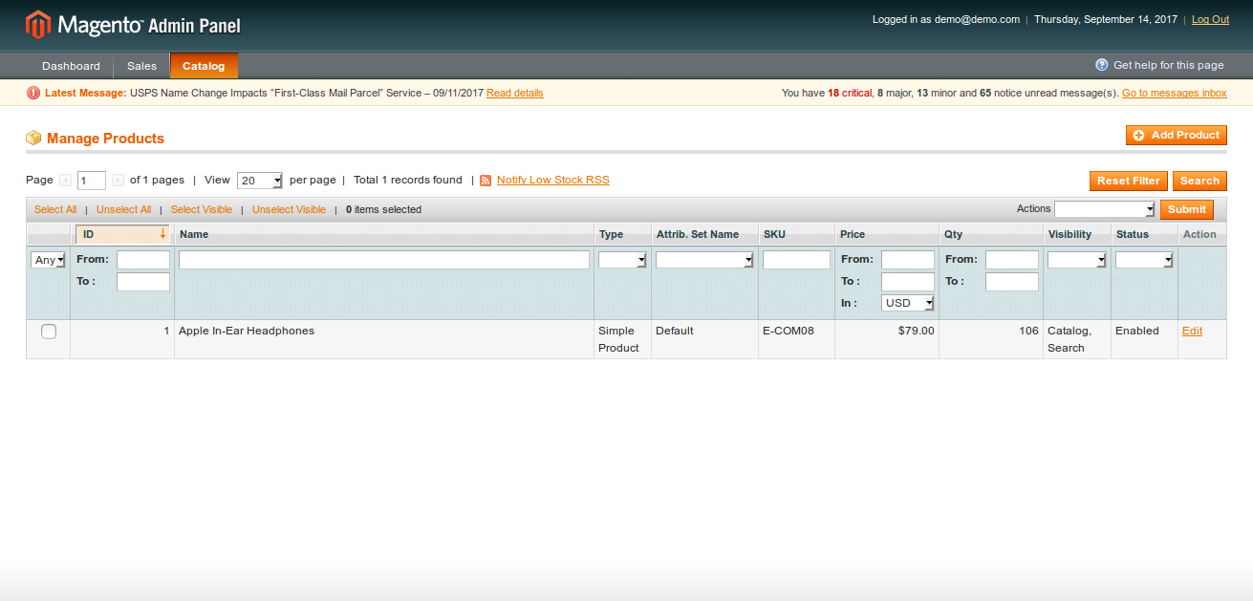

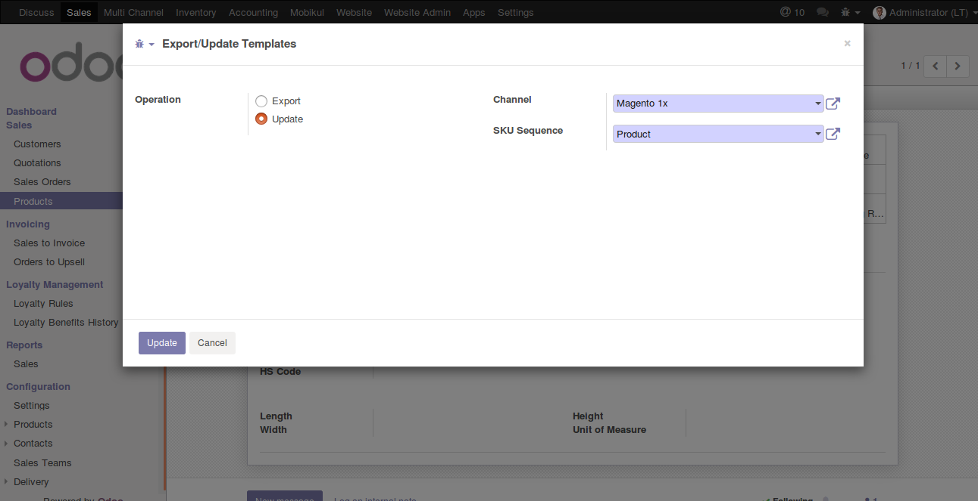

The Update process is same as export process,Under the popup wizard select operation update and click on Update .

FAQ

- Blog
  - Magento1x Odoo Bridge
  - Multi Channel Sale

- General
  - Activate Developer Mode
  - How to Install Module in Odoo

Registering to use Magento1x
  - Enable Multi Currency in Odoo

Support

If you need a support or have any suggestion regarding features of our extensions. Please use our online support desk to contact our support team using https://webkul.uvdesk.com .

