**Central Processing Unit (CPU)**

A Central Processing Unit is also called a processor, central processor, or microprocessor. It carries out all the important functions of a computer. It receives instructions from both the hardware and active software and produces output accordingly. It then performs calculations, manipulates data, and produces output based on those instructions. It stores all important programs like operating systems that manage the computer's resources and allows you to interact with it and application software that you use to perform tasks like word processing, web browsing, and gaming. Your computer couldn't execute these essential programs without the CPU.

CPU also helps Input and output devices to communicate with each other. The CPU translates these inputs when you click, move the mouse, or click on a key on the keyboard, and it works with the relevant software program to produce the intended result. The CPU ensures that the input and output devices communicate without any troubles, whether it means printing a paper, playing music through the audio system, or showing text on the display screen. Owing to these features of CPU, it is often referred to as the brain of the computer.

CPU is installed or inserted into a CPU socket located on the motherboard. Furthermore, it is provided with a heat sink to absorb and dissipate heat to keep the CPU cool and functioning smoothly.

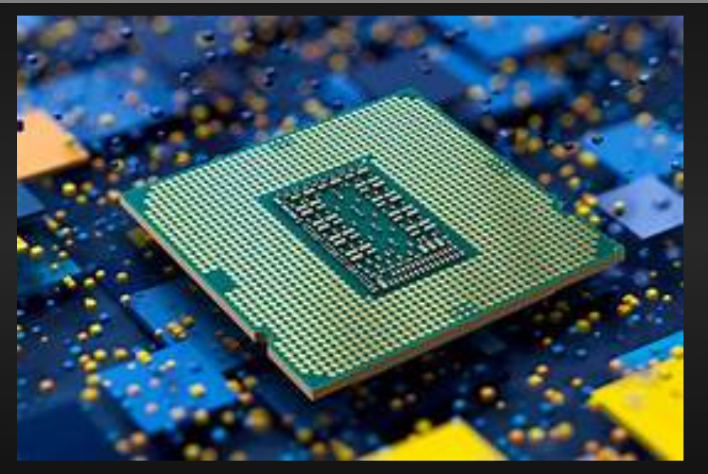

**Hard Disk**

A hard disk is one of the most essential components of a computer, serving as the primary storage device for all data and programs. It plays a crucial role in the operation of computers by storing operating systems, applications, and personal files. Hard disks have evolved over time, becoming more efficient and capable of handling larger amounts of data with greater speed and reliability.

**Introduction to Hard Disks**

A hard disk, also known as a hard drive, is a non-volatile storage device that retains data even when the computer is powered off. Unlike volatile memory, such as RAM, which loses all information upon shutdown, hard disks provide permanent data storage. They are widely used in personal computers, laptops, servers, and data centers.

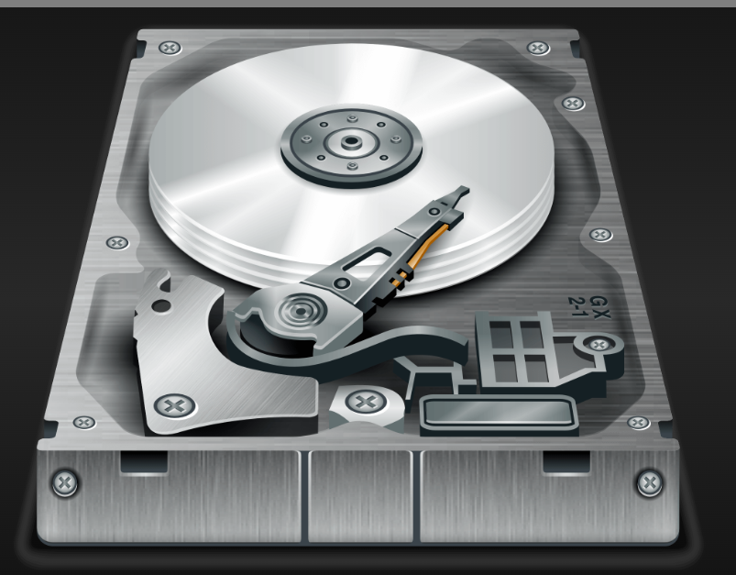

**The Motherboard of a Computer**

A motherboard is the central circuit board of a computer, serving as the backbone that connects all components together. It plays a crucial role in ensuring that different hardware components, such as the processor, memory, and storage devices, communicate effectively. Motherboards have evolved over time, incorporating advanced technologies to enhance computer performance and efficiency.

**Introduction to Motherboards**

The motherboard, also known as the mainboard or system board, is a printed circuit board (PCB) that houses essential components such as the CPU, RAM, storage interfaces, expansion slots, and various connectors. It facilitates communication between these components, ensuring the smooth operation of the computer system.

**Components of a Motherboard**

Motherboards consist of several key components, each playing a specific role in computer functionality:

1. **CPU Socket:** The slot where the central processing unit (CPU) is installed. It determines the compatibility of the motherboard with different processors.
2. **RAM Slots:** These slots accommodate memory modules (RAM), which temporarily store data for quick access by the CPU.
3. **Chipset:** The chipset controls data flow between the processor, memory, and other peripherals, determining system performance.
4. **Storage Connectors:** These include SATA and NVMe slots for connecting hard drives and solid-state drives.
5. **Expansion Slots:** PCIe slots allow users to install additional components such as graphics cards, sound cards, and network adapters.
6. **Power Connectors:** The motherboard has connectors for power supply input to provide electricity to all components.
7. **Input/Output (I/O) Ports:** These include USB, HDMI, Ethernet, and audio jacks that allow external devices to connect to the computer.

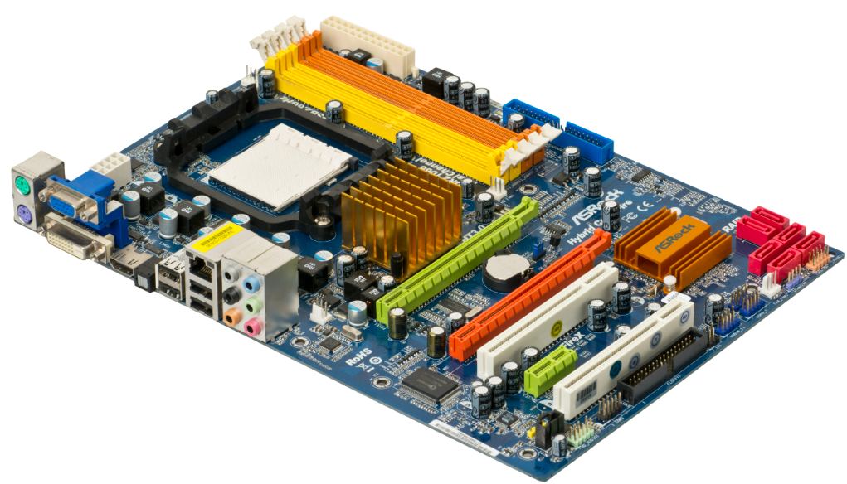

**The RAM of a Computer**

Random Access Memory (RAM) is a crucial component of a computer that temporarily stores data and instructions needed for processing. It plays a significant role in determining the system’s performance and responsiveness, allowing applications to run smoothly and efficiently.

**Introduction to RAM**

RAM is a volatile memory, meaning it loses all stored data when the computer is turned off. Unlike hard drives or solid-state drives (SSDs), which provide long-term storage, RAM serves as a high-speed memory for active processes. It enables quick access to frequently used data, reducing the time it takes for the processor to retrieve information.

**Types of RAM**

There are different types of RAM, each designed for specific purposes and varying performance needs:

1. **Dynamic RAM (DRAM):** The most common type of RAM used in computers, requiring constant refreshing to retain data.
2. **Static RAM (SRAM):** Faster and more efficient than DRAM, often used in cache memory for processors.
3. **Synchronous DRAM (SDRAM):** Operates in sync with the CPU clock speed, enhancing performance.
4. **Double Data Rate (DDR) RAM:** Available in multiple versions (DDR, DDR2, DDR3, DDR4, and DDR5), with each generation offering faster speeds and improved efficiency.

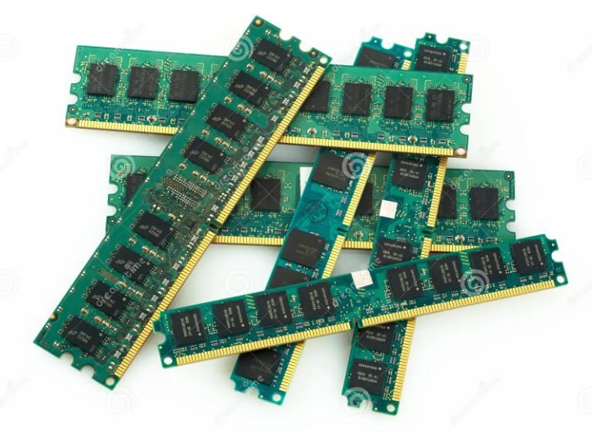

**The Daughter Cards of a Computer**

Daughter cards, also known as daughterboards, are secondary circuit boards that connect to a main motherboard or primary circuit board to extend the computer’s functionality. They serve a variety of purposes, including adding additional processing power, expanding connectivity, or enhancing multimedia capabilities.

**Introduction to Daughter Cards**

A daughter card is an auxiliary board that provides additional features not built into the motherboard. Unlike expansion cards, which typically fit into PCI or PCIe slots, daughter cards often attach directly to the motherboard via specialized connectors. They are commonly found in laptops, embedded systems, and specialized computing devices.

**Bus Slots in a Motherboard**

A **bus slot** (also called an **expansion slot**) on a motherboard is a connector that allows you to install additional hardware components like graphics cards, sound cards, network adapters, and storage controllers. These slots connect to the motherboard’s data pathways, allowing communication between the CPU and expansion devices.

**Types of Bus Slots in a Motherboard**

**1. PCIe (Peripheral Component Interconnect Express) - Modern Slot**

* **Most common and fastest bus slot in modern motherboards**
* Used for **graphics cards (GPUs), NVMe SSDs, network adapters, and expansion cards**
* Comes in different sizes:
  + **PCIe x1** – Small devices (e.g., sound cards, network adapters)
  + **PCIe x4** – High-speed SSDs and RAID controllers
  + **PCIe x8** – Some high-end RAID or network cards
  + **PCIe x16** – **Graphics cards (GPUs)** use this slot for maximum performance

**2. PCI (Peripheral Component Interconnect) - Legacy Slot**

* **Older standard** before PCIe, now mostly obsolete
* Used for **sound cards, network cards, and other expansion cards**
* Still found in some older or industrial motherboards

**3. AGP (Accelerated Graphics Port) - Obsolete**

* Designed specifically for **graphics cards**
* **Replaced by PCIe** due to speed limitations

SMPS( Switched-Mode Power Supply)

SMPS (Switched-Mode Power Supply) is a crucial component in a computer that converts the high-voltage AC (Alternating Current) from the wall socket into low-voltage DC (Direct Current) that the computer components can use.

**Functions of SMPS in a Computer**

1. **Power Conversion** – Converts 230V AC (in India) or 110V AC (in some countries) into DC voltages like +12V, +5V, and +3.3V.
2. **Voltage Regulation** – Maintains stable voltage output even if the input fluctuates.
3. **Efficiency** – Uses switching regulators to improve energy efficiency compared to traditional linear power supplies.
4. **Protection** – Includes protection circuits for overvoltage, overcurrent, and short circuits.

**SMPS Output Voltages in a Computer**

* **+12V** – Powers components like CPU, GPU, and cooling fans.
* **+5V** – Used for USB ports and some older motherboard components.
* **+3.3V** – Used for RAM, chipset, and other low-power devices.
* **-12V** – Used in some legacy components like serial ports.
* **5VSB (Standby Power)** – Provides power when the system is off but plugged in (for features like Wake-on-LAN).

**Types of SMPS Based on Form Factor**

* **ATX SMPS** – Used in standard desktop PCs.
* **SFX SMPS** – Smaller version for compact builds.
* **TFX SMPS** – Thin form factor for slim desktops.

