Create three pages and provide a capability to navigate to and fro, also show a confirmation page before final submission

Page 1:

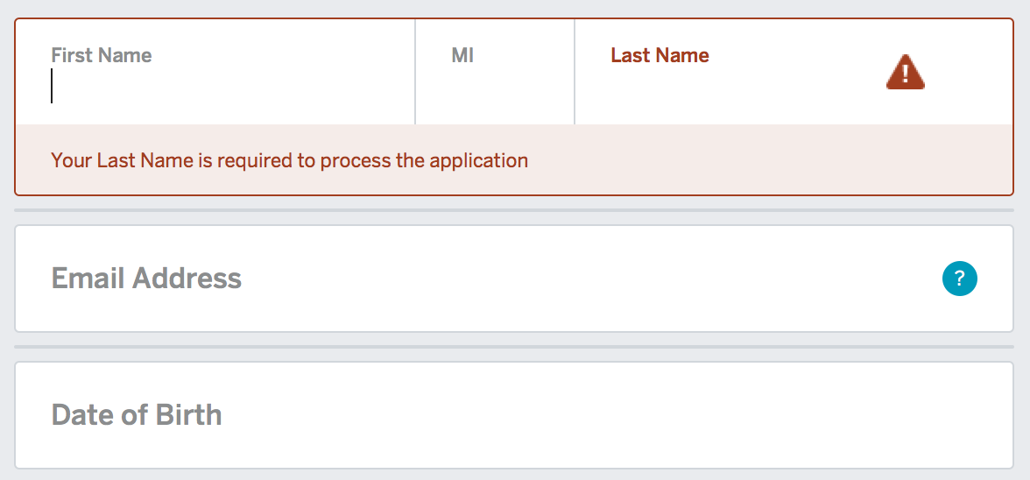



Page 2:

/Users/rmaddine/Desktop/Screen Shot 2017-07-20 at 4.12.04 PM.png

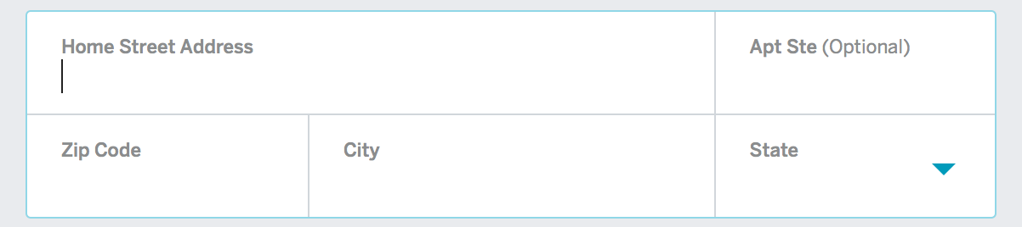



Page 3:

/Users/rmaddine/Desktop/Screen Shot 2017-07-20 at 4.12.04 PM.png

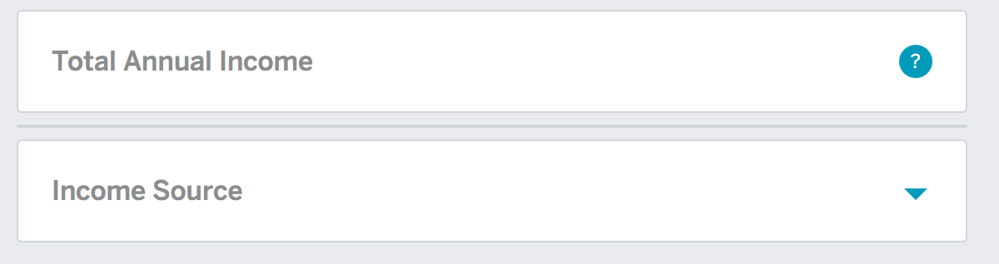



Page 4: Provide a confirmation page with all the details entered and give an option to go back and edit the data.