EC3

KPI Description

Version 1.0 - 2016-02-25

1 Overview 3
1.1 Re-arranging note 4

1 KPI Activity 5

2 KPI average speed 6

3 KPI Operators load factor 7

4 KPI Backlog 8

5 KPI Taxi trips 9

6 KPI Bus load factor 10

7 Install 11

Figure 1 : All KPI's 3
Figure 2 : Emphasis on hover 3
Figure 3 : Emphasis on threshold alert 4
Figure 4 : re-arranging KPI 4

Overview
Six KPI are displayed on the upper left screen of the EC3 layout.
- They can be re-arranged with the mouse
- They are emphasized on mouse hover
- Two of them are animated (data refresh every min, and they flash on threshold violation)

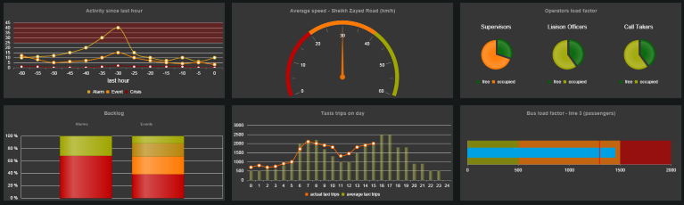
Figure 1 : All KPI's

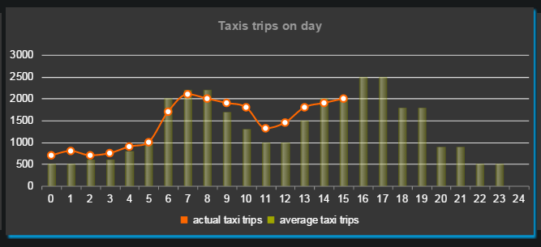
Figure 2 : Emphasis on hover

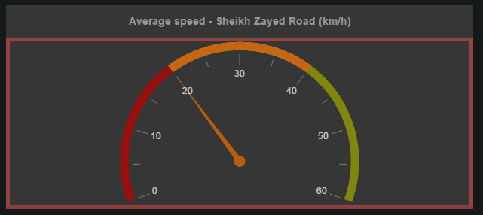
Figure 3 : Emphasis on threshold alert

Re-arranging note

- 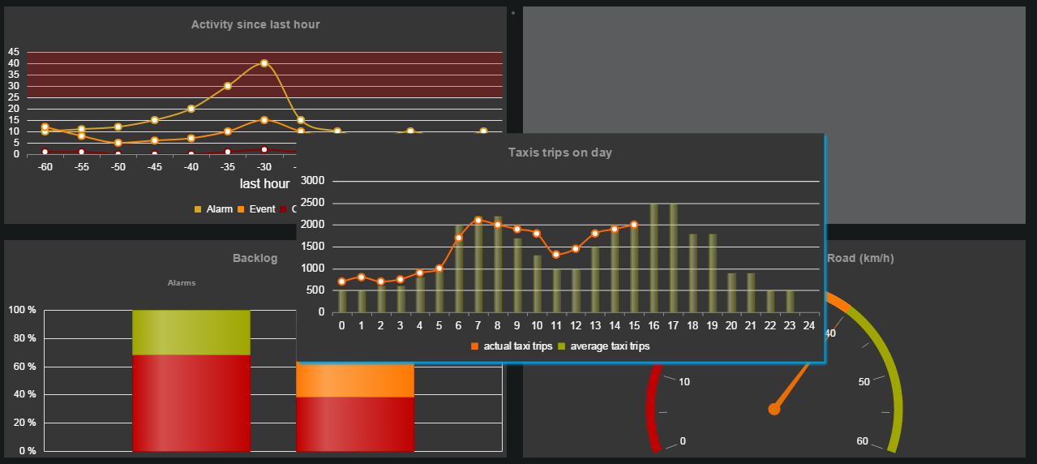
Figure 4 : re-arranging KPI

The moved KPI will take the place of the targeted one which will move, in turn, downside and then disappear from the visible part of the KPI screen part !
To have all of them back again, move the KPI above the hidden one to the place left empty by the moved one.

KPI Activity
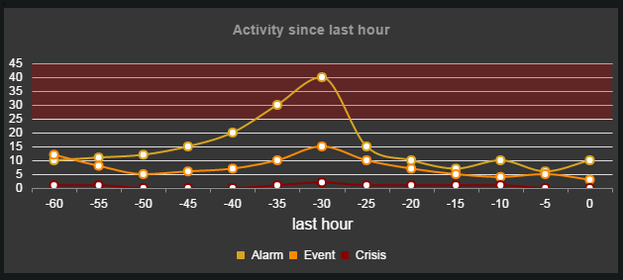

This KPI shows the number of Alarms (yellow), Events (orange), and Crisis (red) for the last 24h.

- Hover on lines gives the pointed value.
- The red area shows the threshold on the Alarms processing capacity of the operators

This KPI is NOT animated

KPI average speed
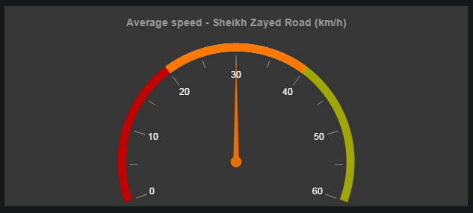

This KPI shows the current average speed on Sheikh Zayed city highway in Dubaï

- The red area is the threshold a indicating possible traffic jam
- The orange one is under the regular average speed
- The green one is for a free driving highway

This KPI is animated every minutes and will flash beneath the 20 km/h threshold

KPI Operators load factor
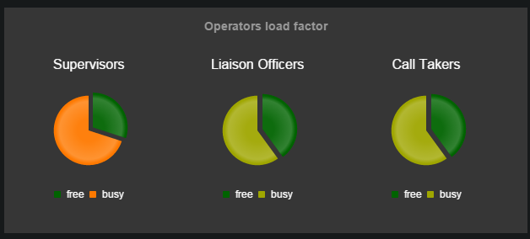

This KPI shows the load factor of the EC3 operators

- Hover on sections gives the load factor.
- The exploded section is for free operators (in %)
- The other one or busy operators (in %)
- Sections color is :
  - green if load is under 20 (dark green for free)
  - orange if load is between 20 to 80
  - red above 80

This KPI is animated every minutes and will flash if any operators group reach the 80% threshold

KPI Backlog
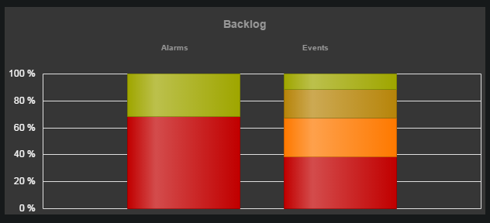

This KPI shows the current backlog (in %) of the EC3 operators on Alarms (on the left) and Events (on the right)
Alarms
- Hover on sections gives the section value.
- red for the un-processed (un-red) alarms
- green for the processed ones (red)

Events
- Hover on sections gives the section value.
- red for the un-processed (un-red) events
- orange for the red events
- yellow for the in-progress events
- green for solved events

This KPI is NOT animated

KPI Taxi trips
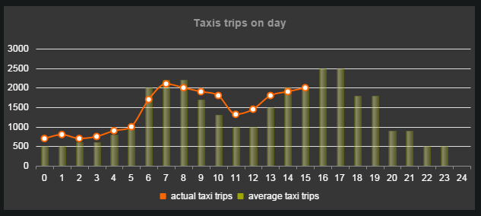

This KPI shows
- The curve of the taxis trips of the current day until now.
- The bars of the average taxis trips.

- Hover on bars or line gives the pointed value.

This KPI is NOT animated

KPI Bus load factor
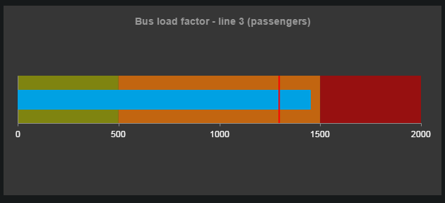

This KPI shows the current number of passengers for one bus line

- Hover on the gauge gives the current number of passenger and the average (the red vertical line)
- green for low load factor
- orange for regular one
- red for overload

This KPI is NOT animated

Install

To install these KPI in EC3 you have first to install the proper EC3 layout in
{Tomcat install}\conf\tvs-conf\projectConf

Them unzip and deploy the html site (site.zip) in
{Tomcat install}\webapps\dashboard

Restart your EC3 Tomcat.

